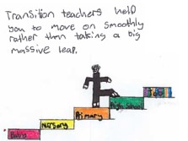
Talking and Listening Skills

Listening and talking are vital skills that are needed for everyday communication. From communication our needs, following instructions and socialising without friends, we really on these skills to help us make sense of the world around us.
How can we support the development of listening and talking?
Talk with your children: This help the children to develop both their listening and talking skills within a social context i.e. taking turns in conversation, using eye and body language to show they are listening. Talking to you children also opens up the opportunities for them to learn new language and increase their vocabulary. Life can be busy but making time to talk with you child allows you to explore your child day with them while taking time to answer their questions and commands as these lead to rich learning conversations.
Modelling listening skills: Listening is an important part of communication and is as every bit important as talking. As much as possible give your children your full attention when they are talking and repeat back important pieces of information, so they know you are listening. If you can listen at the time the children want to talk, explain your reasons why, promise to talk to them later and follow through with this promise.
Activity ideas:
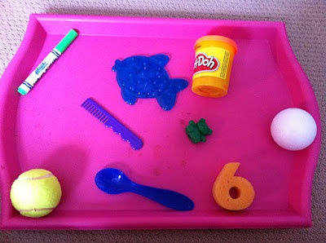
Guess the missing object: Place 3 object in front of the child and ask them to take some time looing at the objects. Ask the children to cover their eyes and remove 1 object. Then ask the child to tell you what is missing.
Tip: As you child becomes more confident remembering the objects you could add more and remove more

Eye Spy Games: Take turns choosing and guess objects around you using colours or phonics letters to help the children guess. I spy with my little eye something the colour green! I spy with my little eye something beginning with a!

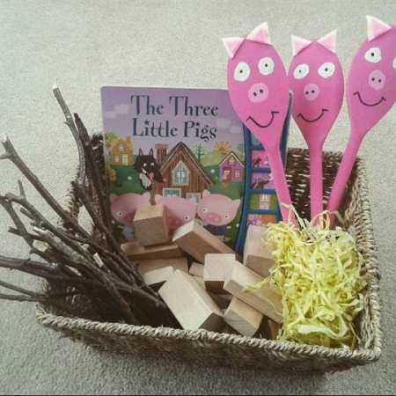
Story tell with props: Take turns telling stories using a variety of storytelling props i.e. Hand and finger puppets, story spoons and stones. Encourage the children to be creative with their stories while offering suggestions and ideas i.e. I wonder what would happen if……..?
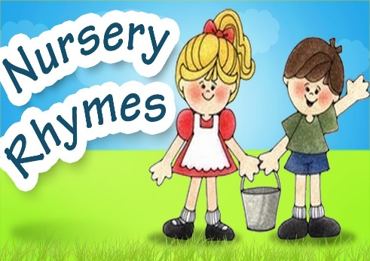
Singing songs: Take turn choosing nursery rhymes and songs to sing with you child. Encourage your child to recite familiar songs and rhymes themselves or pause during songs and rhymes to allow them to add familiar words or part or the song i.e. Twinkle Twinkle little …………..! You could use resources for around your house to create a song box which will make choosing the songs and rhymes more exciting. Useful resources: https://www.scottishbooktrust.com/songs-and-rhymes - Bookbug song and Rhyme library.
Memory game: Name 2 items that you would like you child to find around the house i.e. Can you find me a slipper and socks? It is important that you ask you child to repeat the list back to you this helps them remember what you have asked for.
Tip: As your child becomes more confident add more items to your list.

