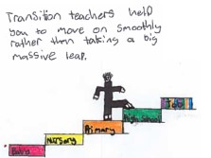
Benefits of reading to children

Sharing books with children is the first step to developing a love for reading while building their language and communication skills using a range of reading materials such as books, comics, papers and environmental print. Sharing books can help to develop literacy, because it gets children excited about the power of stories and motivates them to learn to read themselves. They can also discover books about all the things they are interested in, which can open up new worlds for them (Scottish book trust, Online).

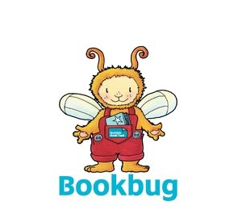
For older children reading stories helps develop their early reading skills by allowing them to develop their understanding of the different between words, pictures while providing them with opportunities asking and answering questions developing their comprehension. Bust most importantly is it a time for you to spend with your child cuddled up and relaxing while you share your favourite books and talk about the different pictures you see.

Activities you can do at home while reading:
Allow the children to choose the book.
Talk about why they choose the book using the front cover.
Talk about the picture you see on the cover and ask them to share their thoughts of what the book might be about.
Encourage your child recite familiar parts of the story alongside you.
Pause and encourage the children to fill in the missing words.
5. Ask questions throughout the story but also encourage the children to ask questions. (3 sharing’s)
- What they liked/ disliked
- Their puzzles – anything that confused them
- Their connections – things that linked the story/ programme etc to their own life experiences

Questions you could ask:
How do you think the character feels?
How many ……………..can you see?
Can you find the ……..?
What would you do if…………………….?
What do you think will happen next?
What do you think would happen if ………….?
Can you find the letters in your name?

Useful websites:
https://www.scottishbooktrust.com/bookbug
https://www.scottishbooktrust.com/reading-and-stories/why-read-to-babies-and-young-children

Online stories:
https://www.youtube.com/watch?v=kAo4-2UzgPo
https://www.youtube.com/watch?v=9xTuavyZ7BI
https://www.youtube.com/watch?v=cfiPrA8E3qE
https://www.youtube.com/watch?v=MuQm8Qb64EI

