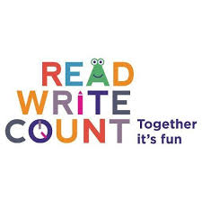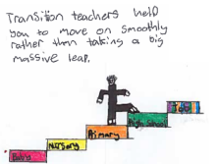

Family

Learning

Ideas

*Literacy across Transition*

**Dictionary games** – Ask your child to open their dictionary at a random page and note it down. This page could provide inspiration for a story. You can choose to go in different directions with this – for example, ask them to choose five words to incorporate in to their story, or challenge them to include as many as they can from the page within a set time.

**Speed Word** – Who can find a given word or definition in the quickest time. Make it a family competition.

**Daring Definitions** – Ask your child to choose an unfamiliar/new word from the dictionary. They should write down two incorrect definitions along with the correct one on a piece of paper. They can read out the definitions to the family and they have to decide which of the definitions are true and which are false. Whoever guesses correctly receives a point.

**Books I’d like to read** – Search online for top ten books for 11 – 12 year olds. Record the titles that you like the look of in the ‘Books I’d like to read’ section of your journal. Visit your local library together and ask if they have any of the books on your list, or anything similar.

**Read Together** – there is no age limit for reading out loud and enjoying books together!

**Future Me** – Discuss as a family your hopes and dreams for the future. Use the lined paper in your journal to write a letter to your future self. Include your hopes, dreams and ambitions for High School. You will enjoy looking back at this in the future!



Family

Learning

Ideas

*Numeracy across Transition*

**Calculator Game** – Get used to the keys on the scientific calculator (if you have one) by seeing who can make the numbers 1-20 using only the digit ‘4’ and the operations buttons. You could even put a time limit on it!

**At the shops -** Ask them to estimate what the weekly shop will come to – check the receipt using their calculator.

**Travelling -** Ask your child to help you work out whether it's cheaper to drive or take public transport. Are there any deals you can get on public transport?

**Talk to them about getting a bank account -** Look together at what's on offer for young people opening their first account and see which the best deal is.

**Super Seven –** Start by asking your child to put 1 million in to the display of the calculator. Challenge them to reduce this to 7, using only the following buttons: the 7 key, add, subtract, multiply, divide, equals as many times as you like. Encourage them to investigate the shortest possible way to get to 7.

**New bedroom layout –** Have a go at reorganising the layout of your child’s bedroom together. Encourage them to draw a plan of the layout before and after using the ruler and protractors to make them as accurate as possible.

**Design Challenge –** Design a logo or crest that represents you and your hopes and dreams for the future. Remember to use your ruler, protractor and set square in the design stages.