# **Top 10 tips for cooking with kids**

*The smallest of hands can be surprisingly good in the kitchen, get those sleeves rolled up for some good cooking fun with your kids.*

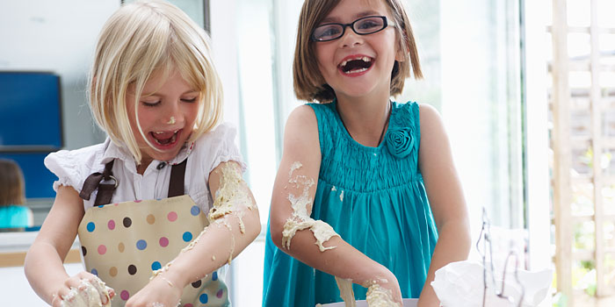

Most kids love to cook, it's hands on, it's messy and there's plenty of room for creativity, not to mention a sense of achievement at the end. Teach your kids this life skill and you really will set them up for life, combine it with making their meal and you've set them up for the day too. Here are ten tips that'll help you and your kids enjoy cooking together:

**1/ Take your time** - expect everything to take longer than it usually would so set aside extra time for cooking and be aware, that particularly for younger children, the journey is as much fun as the destination!

**2/ Expect a lot of mess** - cooking is a messy business and when kids are involved there'll be even more. Exercise a bit of damage control by putting a plastic tablecloth down on the floor or a tray underneath their work station but ultimately you'll all have more fun if you just let the mess happen and then clear up together at the end.

**3/ Plan ahead** - select an appropriate recipe, one that they'll enjoy and that involves plenty of activities that are suitable for their age. Make sure you have all the ingredients and equipment at the ready. If necessary, do some preparation, before you ask them to join you. Baking is fun but if you need to get the evening meal ready, think about how they might help you to do that.

**4/ Get them ready** - put them in clothes you don't mind getting dirty (!), put an apron on and tie back long hair.

**5/ Teach children about food hygiene** - ensure they wash their hands beforehand and in between touching raw and cooked or ready-to-eat foods.

**6/ Talk through the recipe** - with older children, you can get them to read out the steps beforehand and get out what will be needed, talk through the processes and plan who's going to do what. With younger children, simply explain what you're making and show any pictures to help with understanding and a sense of purpose.

**7/ Learning opportunities** - as you're cooking, talk about ingredients and their origins, cooking processes and techniques. Cooking can be a great way to learn about science, geography and maths (through weighing) in a practical way. It's good for fine motor skills and coordination too.

**8/Touching and tasting** - this will make the experience more enjoyable for them, encourage more adventurous eating plus it's a good opportunity to teach children which foods are safe to eat raw. Ask them to use a clean spoon to taste, not fingers and stirring spoons (at least not until the end!)

**9/ Age and ability** - many children's recipes have age guidelines but look at your own child and recognise what they are capable of doing. There are always activities for every child, even if it's just messing around in the sink washing vegetables and plastic containers while grown-ups and older children chop and cook.

**10/ Make it fun!** Children will learn to love cooking if you relax and have fun with them in the kitchen. If you feel nervous, start with basic recipes, they're still a good learning experience. Only step in when it's absolutely necessary, otherwise let them enjoy and create.

Cooking with 3-5 year olds

  
In addition to the skills listed for under 3s, 3 - 5 year olds with their increased common sense, ability to follow instructions and dexterity can undertake a wide range of skills. It will depend on your knowledge of your child, as skills can still vary greatly at this age. Many children really don't want to listen to what mummy or daddy say so think safety first and don't try and tackle anything your feel unsure about.  
  
**Activities to try with 3 - 5 year olds**

* Weighing - pouring or spooning ingredients into scales. Using measuring spoons
* Washing fruit and vegetables
* Cutting soft ingredients eg butter, mushrooms, strawberries using a strong plastic knife
* Breading and flouring - you can set up three stations with flour, beaten egg and breadcrumbs for fish fingers
* Mixing - using either a spoon or hands to mix together ingredients
* Tearing and squashing - tearing herbs and lettuce or squashing fruit
* Sieving - it's best to balance the sieve over a bowl and tap it rather than shaking it around!
* Using a pestle and mortar - a light wooden one is better than a heavy one
* Kneading - light kneading can be fun but you'll need to step in to complete the task

 Rolling, shaping and cutting dough - choose plastic cutters and a small rolling pin

* Spreading - buttering bread and spreading icing
* Podding, picking and hulling - podding broad beans, picking leaves, tomatoes or grapes off the vine and hulling strawberries

**Recipes for 3 – 5 years olds**

* 1. **Baked Dippy Eggs**
* 1 large slice of ham
* 8 small spinach
* 8 cherry tomatoes
* 4 eggs
* 1 matchbox – size piece of cheese
* 4 slices of bread, toasted, buttered and cut into dippers to eat with them

## Method

1. **Ask a grown-up helper** to switch the oven on to 180C/160C fan/gas 4. Put 4 ramekins in front of you. Cut the ham and spinach into strips with your scissors. Put some in each ramekin.
2. Squash the cherry tomatoes into a bowl using your fingers. Spoon 2 tomatoes and some juices into each ramekin.
3. Break an egg into a bowl. Scoop out any pieces of shell with a spoon, then tip the egg carefully into the ramekin. Do the same with the other 3 eggs.
4. Grate the cheese and sprinkle some on top of each egg. **Ask a grown-up helper** to put them in the oven on an oven tray for 15-18 minutes or until the egg white has set.
   1. **Easy Strawberry Ice Cream**

* 1 x 400g punnet strawberries
* 1 x 250g tub mascarpone
* ½ x 397g can condensed mik
* cones and sprinkles, to serve

## Method

1. Pull the green hulls out of the strawberries. If they are still quite hard, cut them in half or quarters with a table knife. Tip them into a flat-bottomed dish.
2. Use a potato masher to squash the strawberries as much as you can. Tip into a bowl. **Ask your grown-up** helper to give you a hand if you need to.
3. Add the mascarpone and mash this in – don’t worry if it is a bit lumpy. Add the condensed milk and mix everything together. Don’t worry if the mix is streaky.
4. Spoon the mixture into a metal or plastic box and put it in the freezer. Wait until the next day or at least 6 hours before scooping into bowls or cones. Decorate how you like.

Cooking with 5-7 year olds

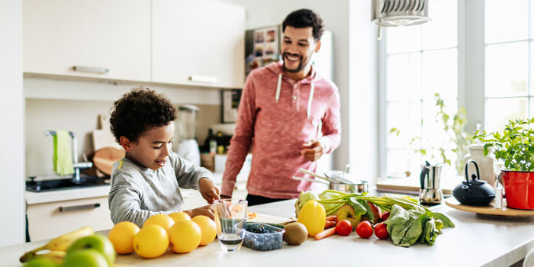  
Along with the skills suggested for 3-5 year olds, you can now introduce your child to trickier techniques and equipment. At this stage, you could think about buying your child a knife designed for young cooks or using a small adult one.

 With the introduction of sharp cutting tools like knives and scissors, always consider the ability of your child and if you're not comfortable, then leave it for a while. There are still other more complex skills they can enjoy. If you do think they can manage then still always keep an eye on them as it's very easy to slip even for adults.  
**Activities to try with 5 - 7 year olds**

* Cutting using a small knife - children should learn how to form their hand into a claw to keep fingertips out of danger, take a look at our knife skills video
* Cutting with scissors - if you can get smaller scissors or children's scissors, use them to snip herbs
* Grating - fingers can easily be grated so keep watch and make sure they don't get too close to the end of whatever they're grating
* Measuring - even the very youngest children can do this but as children learn to read and do basic maths, this is a great opportunity for them to do this with less supervision
* Rubbing in - rubbing in flour and butter with fingertips is called for in many recipes
* Beating and folding - show children how to beat cake mixture with a wooden spoon or fold in egg whites without knocking out too much air
* Greasing and lining a cake tin or tray
* Peel oranges or hard-boiled eggs - make sure eggs aren't too hot, run them under the cold tap first and be careful of residual heat
* Setting the table - encourage them to cherish the ritual of family meals

**Recipes for 5 – 7 Year Olds**

### **Spaghetti & meatballs with hidden veg sauce**

* 300g pork sausage
* 500g lean beef mince
* 1 small onion
* 1 carrot
* 1 tbsp dried oregano
* 1 medium egg
* 1 tbsp olive oil
* 50g [parmesan, finely grated](https://www.bbcgoodfood.com/glossary/parmesan)

**For the tomato sauce**

* 3 garlic cloves, finely grated
* Pinch caster sugar
* 2x 400g tins chopped tomato
* 1 tbsp tomato purée
* splash red wine vinegar

## Method

1. **Children:** Squeeze all the sausage meat out of the sausage skins into a large bowl and add the mince. Tip all the rest of the meatball ingredients, except the olive oil, into the bowl and season with black pepper then squish everything together through your hands until completely mixed. Keep an eye on younger children to make sure they don’t taste any of the raw mix.
2. **Children:** Roll the meatball mix into walnut-sized balls and place them on a plate – this is a job children as young as 2 can help with and a great job to help teach older children basic division.
3. **Grown ups:** While the children are rolling the meatballs make the sauce. Heat the oil in a large saucepan. Add the courgette and garlic and cook for 5 mins until soft and mushy. Stir in the tomato puree, sugar and vinegar leave for 1 min then tip in the tomatoes and simmer for 5 mins. If your children like courgettes then you can leave the sauce chunky. But if, like mine, they hate courgettes then blitz the sauce with a hand blender – either way continue to simmer sauce gently while you cook the meatballs. If your child is confident with heat, from 7+ they can cook the sauce with supervision.
4. **Grown ups:** Heat the oil in a large frying pan and, working in batches, brown the meatballs on all sides then pop them into the sauce – continue to simmer the sauce for 15 mins, stirring very gently until the meatballs are cooked through. Serve with cooked spaghetti, extra grated Parmesan and a few torn basil leaves your child has picked and torn.
   1. **Strawberry Jellies**

## Ingredients

* 1 sachet gelatine
* 15 – 18 very ripe strawberries
* 450ml strawberry or apple juice
* Whipped cream

## Method

1. **Ask a grown-up** to put 6 tsp boiling water into a jug. Sprinkle on the gelatine, then whisk carefully until it dissolves.
2. Pour in the juice and whisk, making sure it’s all mixed in.
3. Pull the green hulls out of the strawberries. Use a knife to cut them into slices or small chunks.
4. Put some pieces of strawberry into 6 glasses leaving a few to decorate at the end. They should be full but with plenty of room around them.
5. Pour the juice into 6 glasses, filling them almost to the top. Put them on a plate or tray in the fridge to set. They will take about 4 hours to set.
6. When the jellies are set, decorate with whipped cream and extra strawberries

Cooking with 8-11 year olds

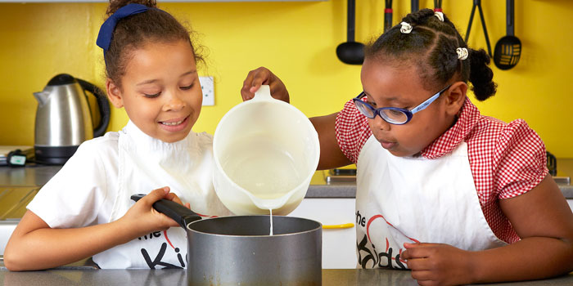

Along with the skills suggested for 3 - 5 and 5 - 7 year olds, when children reach 8 +, they can start to get involved with planning and undertake activities with a bit more independence. Supervision is still key due to the number of hazards in the kitchen but take a hands off approach where possible.  
  
**Activities to try with 8 - 11 year olds**

* Planning the family meal
* Following a simple recipe
* Finding ingredients in the cupboards and fridge
* Using a peeler
* Whisking, using a balloon whisk or handheld mixer
* Using heat on a hob, oven and microwave
* Making salads
* Opening cans

Gradually introduce your children to the above and make sure they are aware of the dangers involved. If you feel they are not ready, hold off for a while. Cuts and burns are common in the kitchen so always keep an eye on them. However capable they may be, it's easy to get distracted or try to rush an activity.

**Recipes for 8-11 Year Olds**

* 1. **Chicken and Sweetcorn Pies**

## Ingredients

* 500g puff pastry, plus flour for dusting
* 3 tbsp frozen peas, defrotsted
* 3 tbsp canned or frozen, defrosted sweetcorn
* 2 skinless cooked chicken breasts
* 6 tbsp double cream
* 1 tsp Dijon mustard
* 1 egg, beaten
* oil, for brushing

## Method

1. **Ask a grown-up helper** to turn the oven on to 180C/160C fan/gas 4. Roll out the pastry on a floured surface and trim to make a rectangle about 24 x 36cm.
2. Cut the pastry in half, lengthways, then cut each half into 3 equal squares, about 12cm along each side, using a small knife or scissors.
3. Push each square into the oiled tin, making sure it is pushed right into the edges
4. Use scissors or a small knife to cut the chicken into strips, then cut into chunks. Put chunks in a bowl. Add the sweetcorn, peas, cream and mustard. Mix together.
5. Divide mixture between the pies. Fold the tops of the pies over roughly and press together. Don’t worry if they don’t cover all the filling.
6. Brush the pastry with the beaten egg. **Ask your grown-up helper** to put them in the oven for 35 minutes or until they brown and the filling bubbles.
   1. **Very Chocolate Cake**

* 3 eggs
* 200g golden caster sugar
* 200g self raising flour
* 22g very soft butter
* 1 tsp baking powder
* 3 tbsp cocoa powder
* 100g chocolate drops

### **For the icing**

* 300g soft butter
* 100g icing sugar
* 400g melted plain chocolate

## Method

1. **Ask a grown-up** to switch the oven on to 180C/160C fan/ gas 4. Break the eggs into a small bowl and scoop out any bits of shell, then tip them into a large bowl.
2. Put the sugar and butter in a bowl, then sift over the flour, baking powder and cocoa.
3. Beat everything together using a wooden spoon or electric beaters, then stir in the chocolate drops.
4. Spoon half of the mixture into each tin and smooth the tops.
5. **Ask a grown-up** to bake the cakes for 20-25 mins or until risen and a skewer comes out clean. Cool in the tin for 5 mins, then turn out onto a rack.
6. Beat the butter and icing sugar, then fold in the chocolate. Spread over the middle, sandwich the cakes together, then dust with icing sugar.

Cooking with 12+ year olds and learning opportunities for all

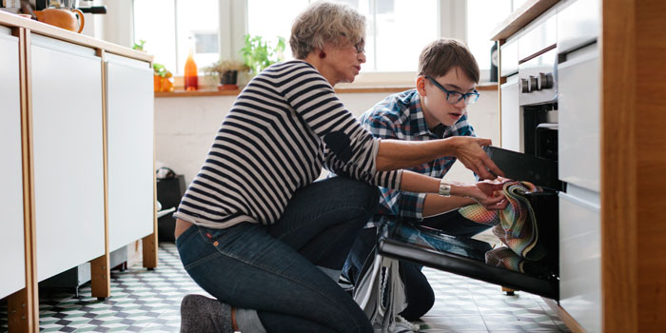  
Along with the skills suggested for 5 - 7 and 7 - 11 year olds, when children reach 12 +, they can begin to prepare more complex recipes and even start improvising. How much they can achieve depends on how interested they are in cooking and how much they've done before.  
  
Even much older children should have some supervision to avoid accidents in the kitchen  
**Learning opportunities**

* Food hygiene - washing hands at the beginning and in between touching raw and ready-to-eat ingredients
* Maths - counting, dividing portions, doubling recipes, adding and subtracting
* Recognising ingredients and learning their origin
* Recognising kitchen equipment and learning how to use it
* Reading and following recipes in order to create the final dish
* Following instructions - young children are particularly inclined to want to add more, jump stages or taste when they shouldn't
* Different tastes, textures and foods
* Time and patience
* The science of cooking â what happens to things when you apply heat or cold
* Dexterity, fine motor skills and coordination â carrying or pouring without spilling, opening containers and packets, weighing

 When children learn to look, they will do so by following the recipes carefully with your help. As they become older and more experienced, let them experiment with quantities, although remember that most baking recipes have specific quantities that will not work if changed. Give them opportunities to let their imagination run wild when it comes to presentation of the final dish.

**Recipes for 12 +**

* 1. **Slow Roast Chicken with homemade gravy**

## Ingredients

* 2kg chicken
* 2 tsp fresh thyme leaves (or 1 tsp fried)
* 1 lemon
* 11 chicken stock
* 2 tbsp flour
* 1 tsp marmite
* 50g soft [butter](https://www.bbcgoodfood.com/glossary/butter)

**Method**

1. Heat oven to 160C/140C fan/gas 3 and put the chicken in a roasting tin. Put the butter into a small bowl and add the herbs and plenty of seasoning. Grate in the zest from the lemon and mash everything together with the butter using a fork. Rub this over the chicken breasts, legs and wings, then push the whole grated lemon into the big cavity of the chicken. Pour half the stock into the tin. Use a large sheet of tin foil (or a couple of smaller pieces) to cover the chicken and scrunch together the foil along the edges of the tin so the whole thing is sealed. Put in the oven and set your timer for 2 hrs.
2. Carefully remove the foil from the chicken, increase oven to 220C/200C fan/ gas 7, and put the chicken back in for another 30 mins. If you’re making the Crunchy roast potatoes (see 'Goes well with'), put them in now, under the chicken. After 30 mins, take the chicken out of the oven and lift it onto a serving dish (move the potatoes up). Snugly cover the chicken with foil and set aside while you make the gravy.
3. Tip the chicken juices and stock from the tin into a jug. Put the tin over a medium heat on your hob and use a wooden spoon to stir in the flour and Marmite, if using, with a splash of the juices to make a paste. If you want, spoon the fat off the top of the chicken juices in the jug, then gradually stir this into the tin to make a smooth gravy. Add as much of the rest of the stock as you need to make a good gravy, then serve with the chicken.
   1. **Melting Chocolate Puddings**

## Ingredients

* 85g self-raising flour
* Oil, for brushing
* ½ tsp baking powder
* 40g cocoa
* 100g golden caster sugar
* 2 eggs
* 6 Lindt milk chocolate balls
* 40g ground almond
* 125g [butter, softened](https://www.bbcgoodfood.com/glossary/butter)

**Method**

1. **Ask your grown-up helper** to switch the oven on to 180C/160C fan/gas 4. Use a pastry brush to brush the muffin tin or pudding moulds with oil.
2. Sift the flour with the baking powder and cocoa into a bowl, then stir in the ground almonds.
3. Beat the butter with the sugar using a wooden spoon or electric beaters.
4. Add the eggs and flour mix, and beat everything together. Add 1 tbsp water if the mixture is too thick to fall off the spoon.
5. Spoon the mixture into the tins or moulds and level the tops. Push a chocolate into the middle of each one – but don’t push it right to the bottom.
6. **Ask a grown-up** to put the puds in the oven for 20-25 mins. Leave for 10 mins or until cool enough to handle, then carefully turn out onto plates.