Learning at Home
Early Level Numeracy
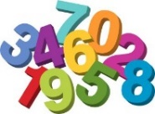
I am working towards…

Counting strategies (concrete items and mental strategies)

Things I could do at home to help me….

- Ring games
- Counting songs
- Finger counting
- Counting out amounts (toys or helping put shopping away etc…)
- Counting on steps (forwards and backwards)
- Using counting throughout the day
- Counting cars, buses, trees etc… when out and about

I am working towards…

Number word sequences 0-30

Things I could do at home to help me….

- Local area walks (counting amounts of things they see around)
- Setting the table at home (counting amounts)
- Counting steps
- Hopscotch
- What’s the time Mr Wolf
- Counting toes and fingers
- 10 green bottles

I am working towards…

Numerals to 20

Things I could do at home to help me….

- Number hunt around the house/garden
- Finding/drawing numbers and putting them in correct order
- Snakes and Ladders
- Number songs, stories and rhymes
- Spot numbers indoors and outside e.g buses, door numbers, signs, car registration plates

I am working towards…

Ascribe number to spatial pattern

Things I could do at home to help me…

- Make a dice and roll it, then jump the amount it lands on
- Dominos to learn dot pattern numbers
- Drawing dot patterns in a different way (random array)
- Dot to dot in the air

I am working towards…

Finger patterns for numbers to 10

Things I could do at home to help me….

- Finger songs (1,2,3,4,5 once I caught a fish alive etc…)
- Songs, rhymes and stories
- Jumping amounts
- Hiding fingers
- Bunny ears
- Counting on fingers aloud

I am working towards…

Copying and counting temporal patterns and sequences

Things I could do at home to help me….

- Music and movement
- Copying beats to music by clapping, stamping, marching
- Hammering golf tees or nails into clay or fruit and veg
- Clapping out a given number
- Clapping and stamping when counting

I am working towards…

Ideas of equal groups and sharing

Things I could do at home to help me….

- Helping to cut fruit or veg
- Playdough
- Baking and cooking
- Encourage sharing
- Sorting items or toys into groups

I am working towards…

Money

Things I could do at home to help me….

- Playing shops
- Playdough
- Environmental walks to local shops/cafes
- Chatting about money and playing with old coins at home to help recognise different coins and amounts

I am working towards…

Time

Things I could do at home to help me…..

- Looking at different types of clocks (analogue,digital)
- Looking at calendars and talking about months and seasons in the year
- Looking for different things around the house that tell us the time e.g phones, cookers, alarm clocks etc…

I am working towards…

Shape, position and movement

Things I could do at home to help me….

- Shape hunts in local environment
- Gluing and sticking
- Junk modelling
- Painting
- Drawing
- Patterns
- Looking at colours

I am working towards…

Information handling

Things I could do at home to help me…

- Season hunt e.g conkers leaves etc…
- Voting for favourite bedtime book to read with family
- Making lists (shopping, baking)
- Creating own designs and plans

I am working towards…

Patterns and relationship

Things I could do at home to help me…

- Songs e.g Head, Shoulders, Knees and Toes
- Lining up toys in a pattern in shape or colour
- Go on a pattern talk and walk (talk about patterns you see in nature, buildings, clothing etc)
- Make patterns with duplo or lego or coloured blocks

Some More Activities
Numbers to 20
Throw and catch

- Throw a ball to each other counting each number as you go
- Count backwards or start at different numbers each time e.g. 7,6,5,4 or 9,10,11,12. if you drop the ball start again
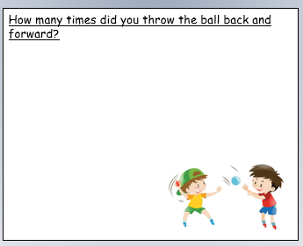

Numbers to 20
Hide and Seek
- With a friend or adult find a good place in the house or outside to play a game of hide and seek
- The seeker covers their eyes and the hider hides somewhere.
- Count to ten from zero or from ten backwards to zero
- The hider can try to count how long it takes the seeker to find them just for fun !
- See who takes longer
- To add a bit more challenge try counting on from a different number eg 7,8,9,10,11
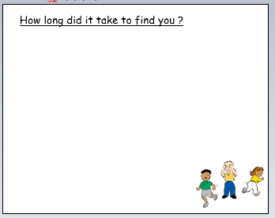

Numbers to 20
Count your steps
- Count your steps from your bedroom to the kitchen
front door to the bathroom, which one has the most steps
- Which one has the least steps?
- Now do it backwards (count backwards and walk backwards) can you do this outside your house to the shop, front door to the car

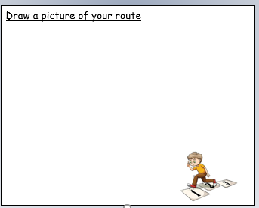

Numerals to 20
Number Hunt
- Go on a number hunt outside
- Look around as you walk for numbers on doors, signs, buses, cars, shops
- Try it inside too where do you spot some? Try the kitchen first, do you see a clock? What numbers do you see?
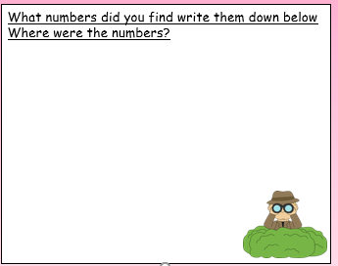

Numerals to 20
Chalk numbers

- Use chalk to write numbers on the ground
- Can you write giant numbers?
- can you write little small numbers?
- Try and go around the big numbers with your feet and around the little numbers with your fingers or on your tiptoes
- Can you find all the numbers when they’re called out?
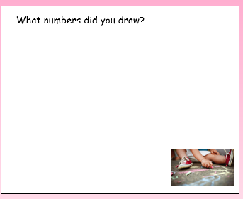

Numerals to 20
Chalk houses
- Draw ten houses on the ground with chalk or on pieces of paper
- Number them 1-10
- Can you put them in order?
- Hide some and work out what numbers are missing?

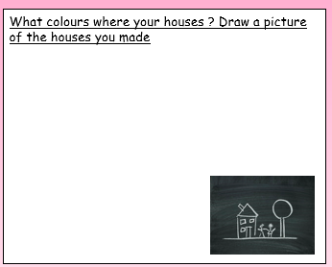

Counting visible items
Throw and Catch game
- Using small pebbles or jems place them in your hand and throw them up in the air
- Try to catch as many as you can
- Count them out
- Can you catch more each time?
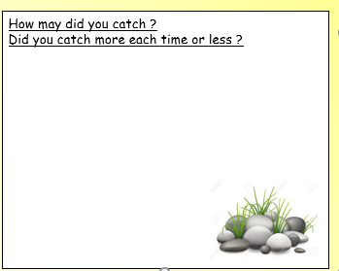

Counting visible items
Picnic Invites
- Invite ten toys to a picnic
- When they arrive count how many have came to the party and how many snacks you need
- Is there more visitors than you had invited or less
- How many have came altogether?
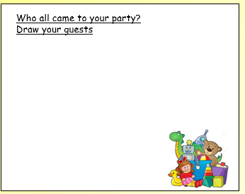

Counting visible items
Object hunt
- Go on a leaf, sticks, stones hunt in the garden or park
- Count how many you have gathered altogether
- Hide some from the adult your playing with
- Can you work out how many are missing?
