Family Learning and Learning at Home

‘Learning at Home’ is the learning which happens in the home, outdoors or in the community. It can take place through everyday activities that families already do.
Learning at Home is a really valuable way of supporting your child’s learning progress.
The following diagram shows just how important learning at home and learning out of school can be:
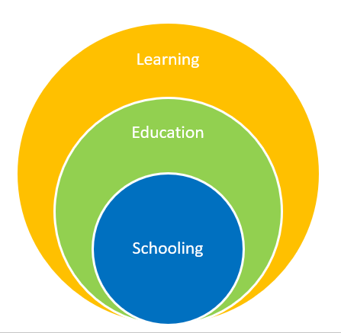

Parents are the primary educators of their children and the activities that you do with your children at home and the community helps them greatly to develop the knowledge, skills and confidence that they need for moving forward in school learning, life and work.

There are lots of websites you can go to which will give you ideas of how you can create fun learning activities for you to do with you children at home. These are examples of a few:

Family Learning Online Resources
Main site for parents on what learning at home is and how it can benefit children

https://education.gov.scot/parentzone/learning-at-home/

Resource | Level | Notes
https://activategood.org | ALL | This website gives ideas about how families can help others in their community remotely during coronavirus
www.bbcgoodfood.com/how/guide | ALL | This website is a guide to cooking at home – guiding parents showing cookery skill by age
www.jamieoliver.com/family | ALL | This website supports families to cook at home on a budget
https://www.parentclub.scot/ | ALL | This website has tips for parents: Early years – teenagers - includes ‘food, eating and recipes’, ‘behaviour’ and ‘play and learn’ available here
www.parents.com/fun/activities/indoor | ALL | This website has lots of ideas for families with children of all ages which supports lots of learning at home – science, creative arts etc
www.oxfordowl.co.uk/for-home | ALL | This website supports literacy learning at home for different ages and stages
https://education.gov.scot/parentzone/learning-at-home/supporting-literacy-at-home/  https://www.spellingcity.com/spelling-games-vocabulary-games.html | ALL | These websites support parents to support literacy at home for different ages and stages
https://education.gov.scot/parentzone/learning-at-home/supporting-numeracy/introduction-to-supporting-numeracy/  https://www.topmarks.co.uk/  https://mathsframe.co.uk/  https://www.mathplayground.com/ | ALL | These websites support parents to support numeracy at home for different ages and stages
https://www.dancemattypingguide.com/dance-mat-typing-level-1/stage-1/  https://www.bbc.co.uk/bitesize/topics/zf2f9j6/articles/z3c6tfr | ALL | These websites support parents to support ICT skills, including typing and using a keyboard at home
https://scratch.mit.edu/ | ALL | This website supports parents to support learning and using computer coding
https://www.gonoodle.com/  https://www.cosmickids.com/ | ALL | These websites can be used for exercise as well as relaxation and mindfulness.  You can also use Joe Wicks for Kids videos on YouTube.
https://www.sleepscotland.org/education/teen-zone/ | ALL | Good advice here if your children are struggling to sleep during the crisis
https://www.actionforhappiness.org/friendly-february | ALL | Great website for keeping spirits up and building relationships
www.verywellfamily.com/fun-learning-activities | Early and First Level | This website has some fun activities for families to do together which support learning. E.g:  Making paper  Plant a garden  Simple science experiments
www.learning4kids.net | Early Level | This website supports learning through play at home with ideas to support creativity, fine motor skills, literacy, numeracy etc
www.goodtoknow.co.uk/family-things-to-do-with-kids | Early Level | This website gives parents ideas of things to do at home and on a budget with children
www.small-talk.org.uk | Early Level | This website supports early level literacy through talking and playing at home
https://www.jamesdysonfoundation.co.uk/resources/challenge-cards.html | Second level | The challenge cards in this website gives lots of great ideas for science challenges you can do at home
https://www.npfs.org.uk/wp-content/uploads/edd/2020/02/learner_journey_2002_E.pdf  https://www.myworldofwork.co.uk/  https://www.planitplus.net/  https://barclayslifeskills.com/young-people/ | Second level and upwards | These websites have some activities for children and young people to do at home around choices and destinations

