**Impact/ Conclusion** *.*

*Silver Mini Duke – around 35 showed interest. 26 engaged in weekly sessions. 22 gained award – 22 progressing to next level (Gold Mini – P3)*

*Bronze Junior Duke – 60 enrolled. Around 30-35 engaged in varying details. 22 gained award – 21 progressing to next level ( Silver Junior – P5)*

*Both groups of children were proud of their achievements, learned new skills, raised self esteem, more family time and really keen to be involved in next level. Parents in P2 group – very involved.*

**Contact**

Name: Gill Scott

Email: gillian.scott@renfrewshire.gov.uk

Phone: 03003000177

**Wider Achievement Awards Storyboard**

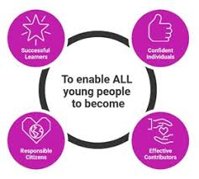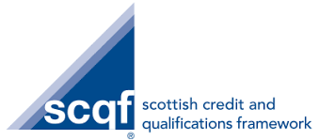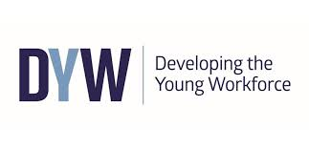

**Name of Establishment**: West Primary_______________________________

**Award:** Junior Duke **Level:** Silver&Gold Mini, Bronze, Silver, Gold&Platinum Junior

**Delivery Model**

*Silver Mini award was offered to the P2 year group as a family learning project. We eventually had two hour long groups – one after school and one early evening. Parents chose the most suitable group for them and their child. There were approx. 13 families attending each group over the 4 weeks the groups ran.*

*Bronze Junior award was delivered to the whole P4 year group. This was intended to be school guided with challenges completed at home and assessed by various staff members at school.*

*Due to lockdown occurring and schools closed, the award was delivered by the Inclusion Support Assistant via the Google classroom, with children submitting their completed challenges online to be assessed.*

*The Cost of the award is £10 per pupil and this includes the challenge journal, certificate and metal badge.*

**Top Tips for delivery**

*It is important to keep communication channels open – especially with the parents, as children weren’t always passing on important information via the Google classroom. We are now using Seesaw, so this should rectify this matter. If possible, find a community/public figure ambassador, who is willing to give a small amount of time for the launch of the scheme, check in and presentation of awards. Due to lockdown, we had a remote presentation with our ambassador recording video messages and presenting each child with their award.*

**Key Learning**

**What works**

*The family learning model was very popular and also very successful with 22 out of the 26 attending completing the award.*

*The home/school model had a similar success rate, but from a larger group of participants. It isn’t able to accurately assess this model of delivery due to the school closures and lockdown.*

**Next Steps**

***With regards to the P4 group, I would look at completing the challenges which would be more difficult to complete in a lockdown situation. I would encourage parents to look at a challenge each month which could be completed easily at home and under restrictions.***