**Key Learning**

**What works**

Delivery through PSE was a natural fit for us.

Using external partners to deliver the assessment outcomes on the brain and supports for mental health was more engaging for the young people.

**Next Steps**

We have made changes each year to how we deliver the award. We felt that it was too much to cover in one period a week in PSE and it also took the full year leaving no coverage for other topics*.*

The change to staggering the units over three years was better, however we felt that a lot of focus on UCAS etc in S6 meant limited time to dedicate to the unit.

This year we will do two of the units in S5 and one in S4.

**Impact/ Conclusion**

Young people are more comfortable with discussing Mental Health and Wellbeing and know where to seek advice. We believe it is helping break down the stigma of Mental Health.

**Contact**

Name: Carolanne Calderwood

Email: carolanne.calderwood@renfrewshire.school

Phone: 03003001414

**Wider Achievement Awards Storyboard**

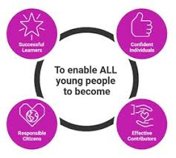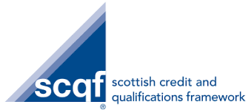

**Name of Establishment**: _Renfrew High School___________________________________

**Award:**  _Mental Health and Wellbeing Award_______ **Level:** _4 and 5_______________

**Delivery Model**

The first year of delivery was to all S5 through one period per week PSE. To be able to cover all content, we had a Mental Health and Wellbeing day for S5 where we had external speakers in to deliver aspects of the course.

Year two we moved to one-unit delivery in each of S4/5/6 through PSE.

This year in our third year, we have moved to one-unit delivery in S4 and two units in S5.

**Top Tips for delivery**

The staff delivering the award must be comfortable with the content, therefore teacher recruitment for this is essential*.*

ICT research is particularly helpful, particularly for the unit on coping strategies.