**Contact**

Name: Karen Todesco

Email: karen.todesco@renfrewshire.school

Phone: 03003001444 / 07956343478

**Impact/ Conclusion**

The delivery of the award in Trinity has meant that pupils take ownership of a worthwhile project to give something back to the school community in S6 contributing to the overall ethos of the school. Pupils report that they ‘find out more about themselves and others.’ Empowering S6 students to take forward a meaningful initiative gives them the confidence required to move into university/college life post school. Pupils find it useful to talk about the experience gained during the leadership award in personal statements.

**Top Tips for delivery**

*Some students think that they can use websites to copy and paste ideas for their essays and struggle with the independent research part. They need to be encouraged to use their own words and give their own opinions on what makes a great leader, or what skills are important, backing up their opinions with research. Making suitable books available in the school library makes it a bit easier as they must use four different types of sources (not just websites!) Students often do not realise the importance of keeping an up to date folio of evidence. This has to be monitored or they may not be able to gain the award.*

**Key Learning**

**What works**

It is important to allow students to choose what they want to do as a project that fits best with their skillset. Students should be encouraged to be as creative as possible whilst doing something that supports the whole school priorities.

**Next Steps**

Our school attempted to encourage S6 students to complete the award during study periods but it was not as successful. I feel pupils need to check in with a member of staff at least one period per week that is timetabled for support and advice. We would like to increase the uptake in future.

**Delivery Model**

At Trinity, Leadership is timetabled together with Volunteering Skills in three columns. Pupils can choose to complete the Volunteering Award only, or both awards over 6 periods. They have one tutorial with a member of staff for each award and the other periods are allocated for working on their essay or organising their group project/event in groups without supervision. The first few tutorials are teacher led; introducing the idea of Leadership styles, skills and qualities and providing examples of typical projects, events and clubs that have been successful in the past. Once pupils have agreed on the task they would like to complete and groups have been allocated, they work more independently but with support.

**Wider Achievement Awards Storyboard**

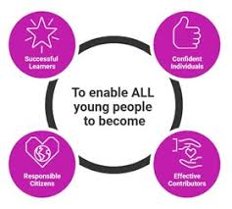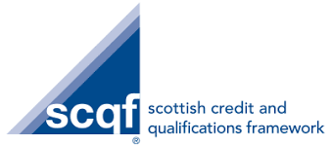

**Name of Establishment**: Trinity High School

**Award:**  Leadership **Level:** 6