Directions

Excuse me. Where is the ___________________ ?

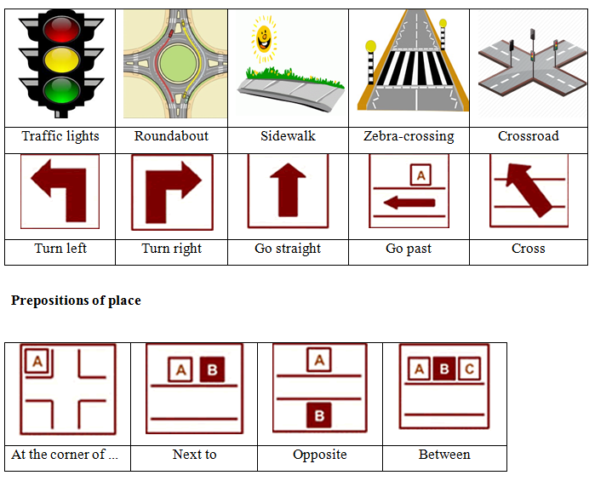
Pavement

https://wordwall.net/resource/460474/directions
https://www.liveworksheets.com/ea270101il

