Where I live
Where do you live? | I live in ________________.
Where is that? | It’s in Scotland.  It’s in England.  It’s in Wales.  It’s in Northern Ireland.
What is there where you live? | There is … (1 thing)  There are… (2+ things)

There is | a swimming pool.
There is | a cinema.
There is | a park.
There is | a shopping centre.
There is | a stadium.
There is | a museum.
There is | a leisure centre.
There is | a library.
There is | a golf course.
There is | a theatre.
There is | a train station.
There are | shops.
There are | restaurants.

There are shops and restaurants.
There is a big shopping centre with a cinema and an ice-rink.
There is a swimming pool and a leisure centre.
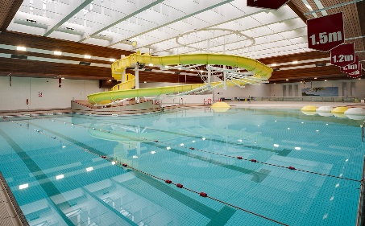 |  | 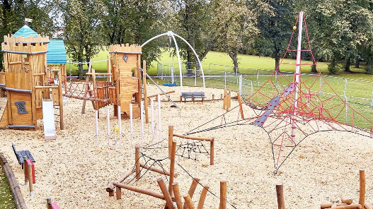
swimming pool | cinema | park
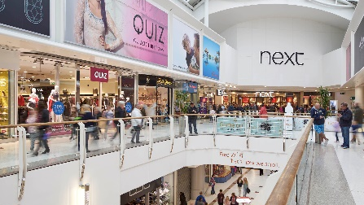 | 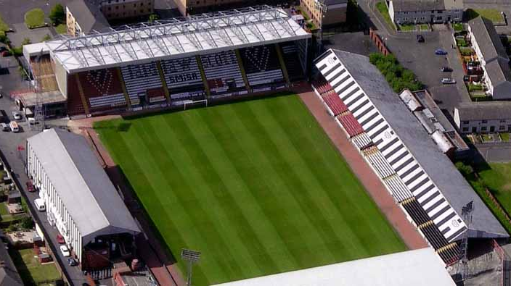 | 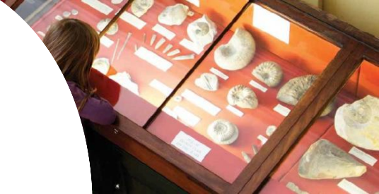
shopping centre | stadium | museum
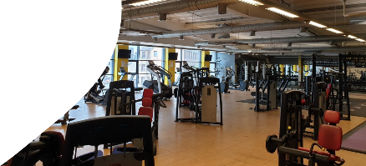 | 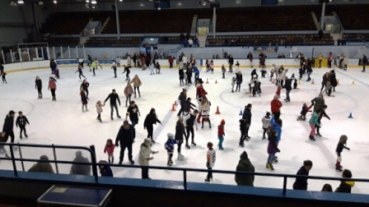 | 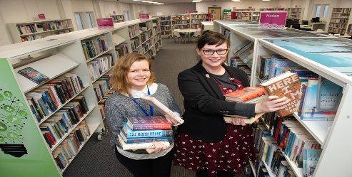
leisure centre | ice-rink | library
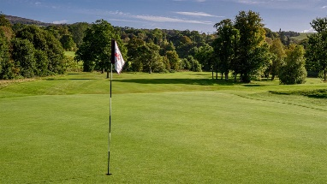 | 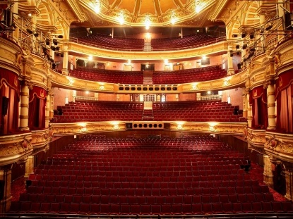 | 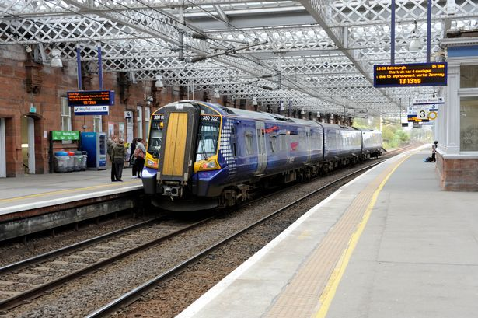
golf course | theatre | train station
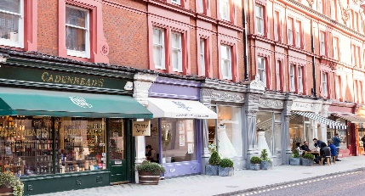 | 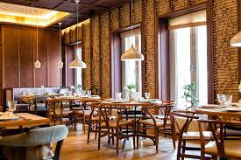
shops | restaurants

