Questions |  |  |  (1) | (2+) | Mix
Do you have any | brothers or sisters? | No, I don’t. | Yes, I have one brother / sister. | Yes, I have two sisters. | Yes, I have two sisters and one brother.
Do you have any | aunts or uncles? | No, I don’t. | Yes, I have one aunt / uncle. | Yes, I have three uncles. | Yes, I have two uncles and six aunts.
Do you have any | cousins? | No, I don’t. | Yes, I have one cousin. | Yes, I have five cousins.
Do you have any | children? | No, I don’t. | Yes, I have one child. | Yes, I have children.
Do you have any | grandchildren? | No, I don’t. | Yes, I have one grandchild. | Yes, I have grandchildren.

Questions
Are you married? | Yes, I am. | No, I am single. | 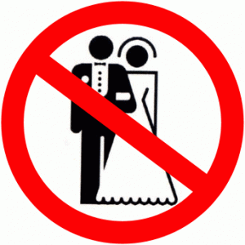
Are you married? | Yes, I am. | No, I am in a relationship. | 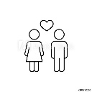
Are you married? | Yes, I am. | No, I am divorced. | 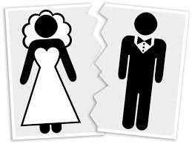
Are you married? | Yes, I am. | No, I am widowed. | 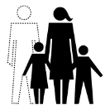

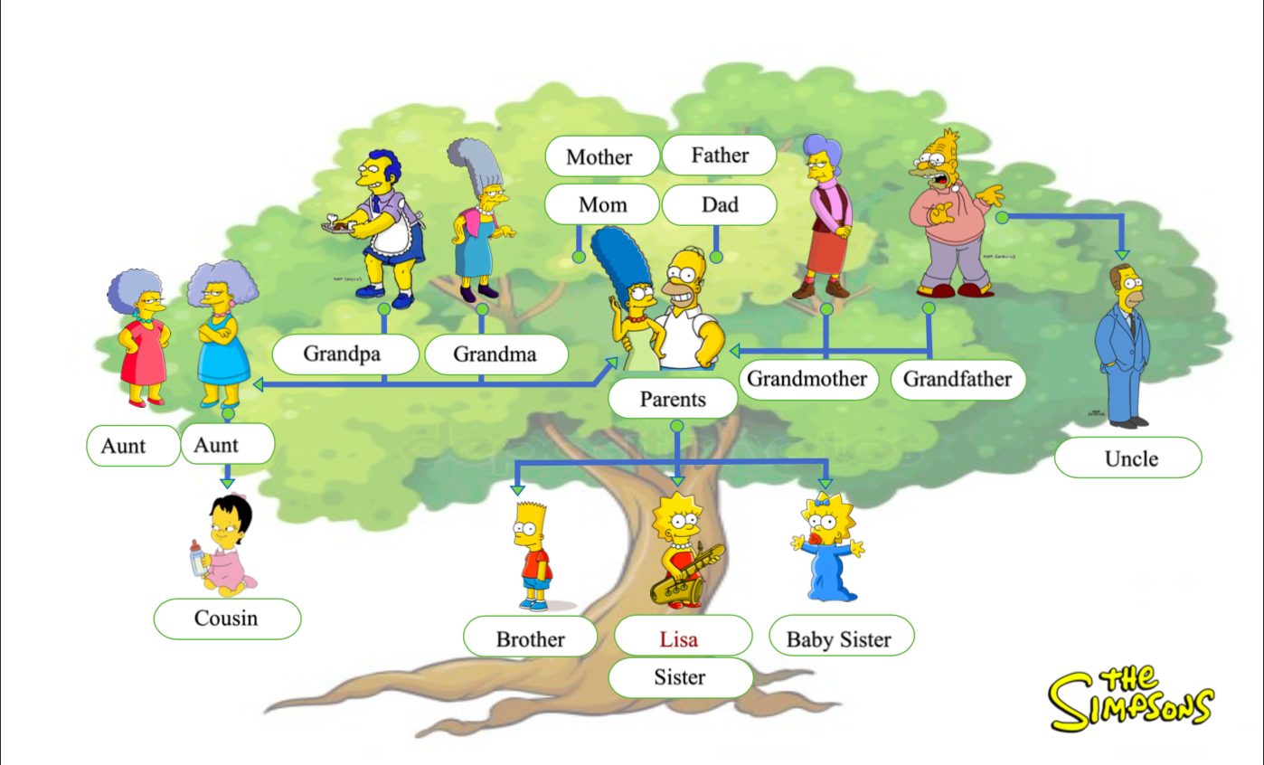
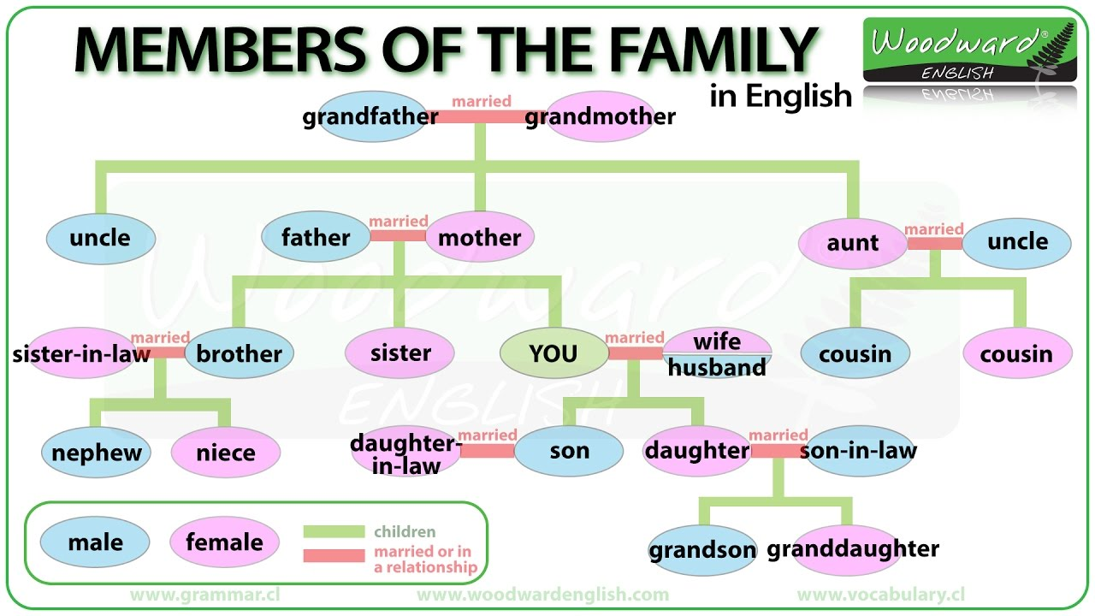

https://www.vocabulary.cl/english/family-members.htm

https://www.liveworksheets.com/sr1159219gr

https://www.liveworksheets.com/tr366794uf

