Lesson 5: Seasons and the Weather

The 4 seasons in the UK
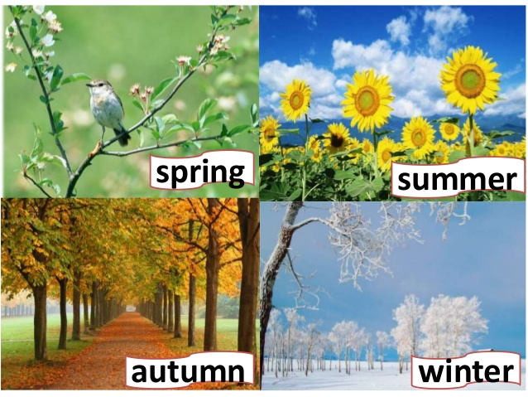
What is the weather like?
What is the weather like today?
What is the weather like in spring?
What is the weather like in summer?
What is the weather like in autumn?
What is the weather like in winter?
It is / It’s …

https://www.liveworksheets.com/vk313886xg
https://www.youtube.com/watch?v=z8VkgKgVhys
