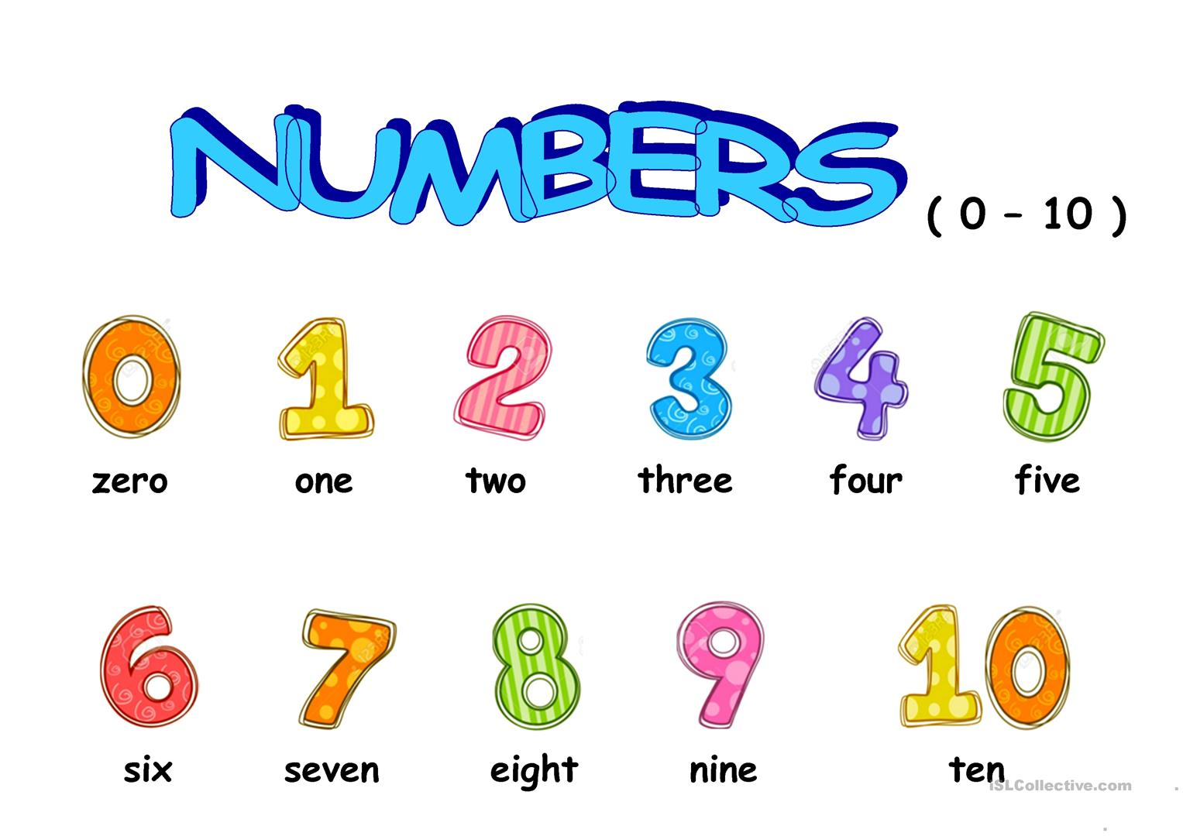
https://www.youtube.com/watch?v=HcuHUiEyjPc
https://www.youtube.com/watch?v=D-Jk4msfEfs

Phone = telephone
Mobile phone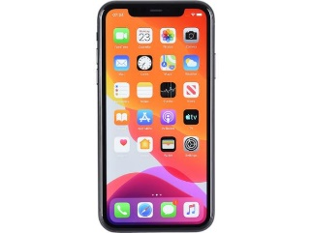Landline phone 

What is your phone number?
What is your telephone number?
What is your number?
My number is…

5 Rules for saying phone numbers:
- Break the number into chunks.
- Say each number individually.
- We sometimes say oh not zero.
- We say double oh for 2 zeros before a number (007=double oh seven)
- We say hundred for 2 zeros after a number (0800= oh eight hundred)

https://www.youtube.com/watch?v=qgQGSwnMv6w
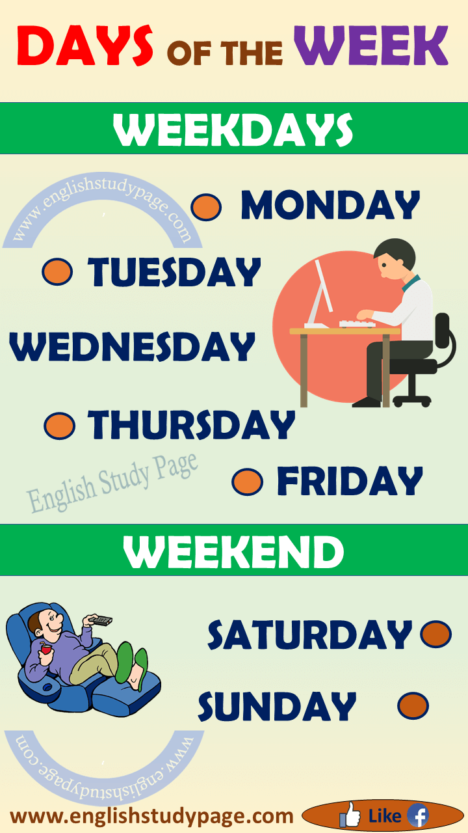

https://www.youtube.com/watch?v=xNZwlw5haTM
https://www.youtube.com/watch?v=2IRl7kKuV9I
Months of the year
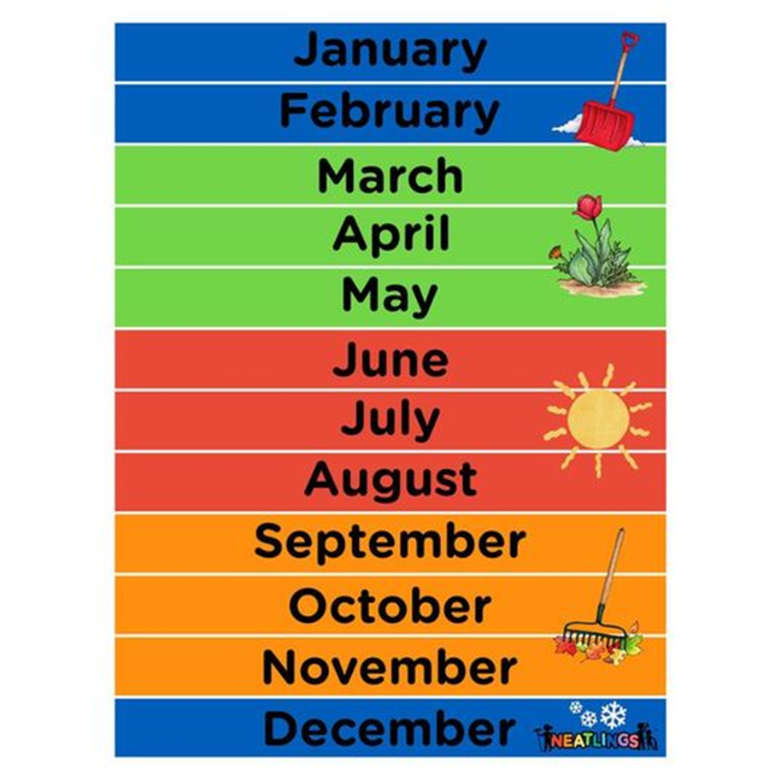

https://www.youtube.com/watch?v=snMsPa0zNMY
https://www.youtube.com/watch?v=weGhyXqZg2c

