How are you? |  |  |  | How are you doing?  How are things?  How have you been?  How is it going?
I am / I’m great, thanks. And you? |  |  | I’m tired | 
I’m fine, thanks. And you? |  |  | I’m hungry | 
I’m okay, thanks. And you? |  |  | I’m stressed | 
I’m not so good. And you? |  |  | I’m sad. I’m upset. | 
Why? What’s wrong? |  |  | I’m ill. I feel sick. | 
 |  |  | I’m ill.  I have a fever. | 
I have a sore …

I have a sore head. |  |  | 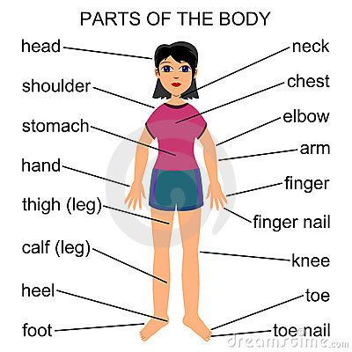
I have a sore throat. | 
I have a sore back. | 
I have a sore stomach.  I have a sore tummy. | 
I have a sore tooth. | 
I have a sore ear. | 

https://www.youtube.com/watch?v=Zo9fQ9A60rU
https://www.youtube.com/watch?v=INY3ETimTjg

