 https://www.youtube.com/watch?v=ocqlNUwolUA

A: Hello
B: Hi
A: What is your name?
B: My name is __________________. What is your name?
A: My name is __________________. Where are you from?
B: I am from ____________________. Where are you from?
A: I am from ____________________. It is nice to meet you.
B: It is nice to meet you too.

https://www.youtube.com/watch?v=k6tMgxne_bI
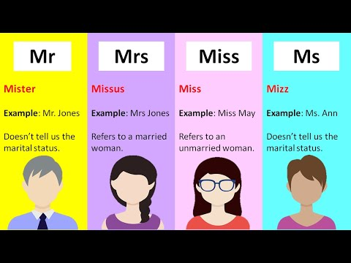
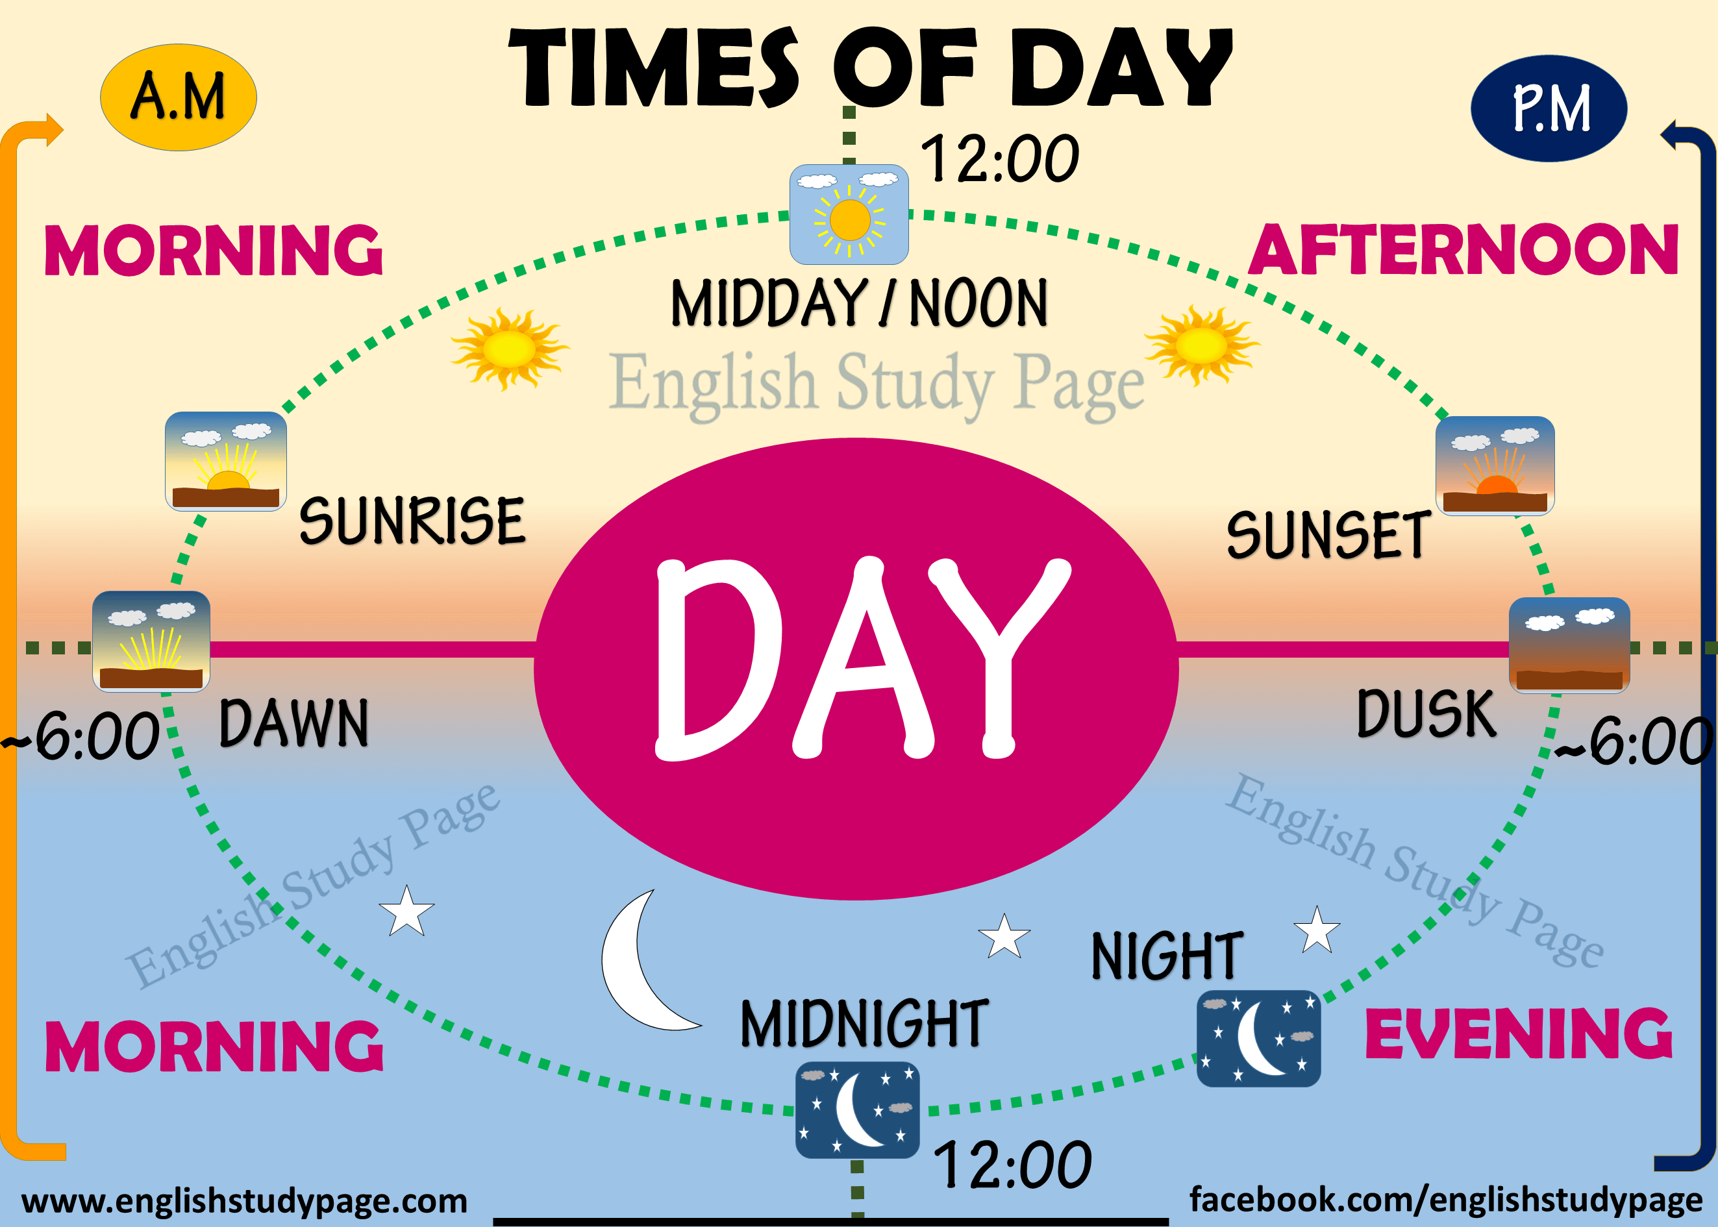

Good morning | 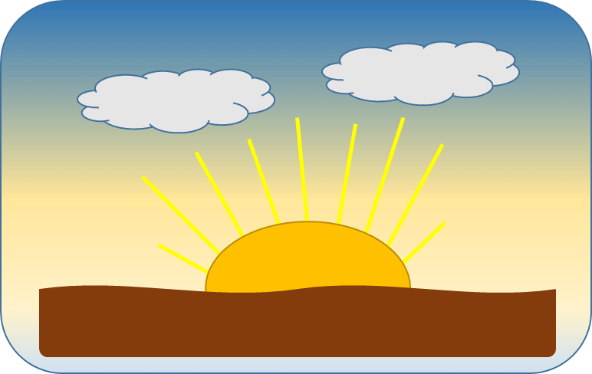
Good afternoon | 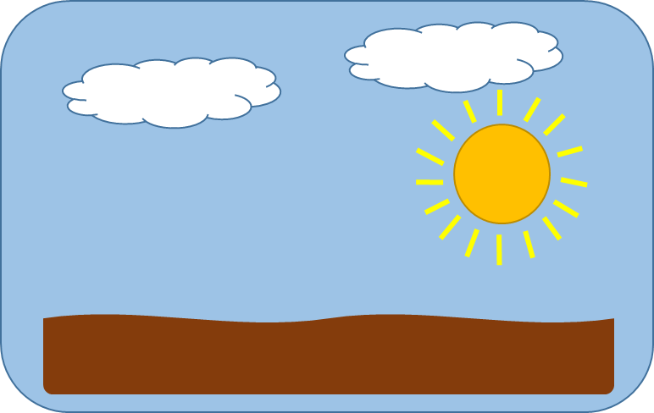
Good evening | 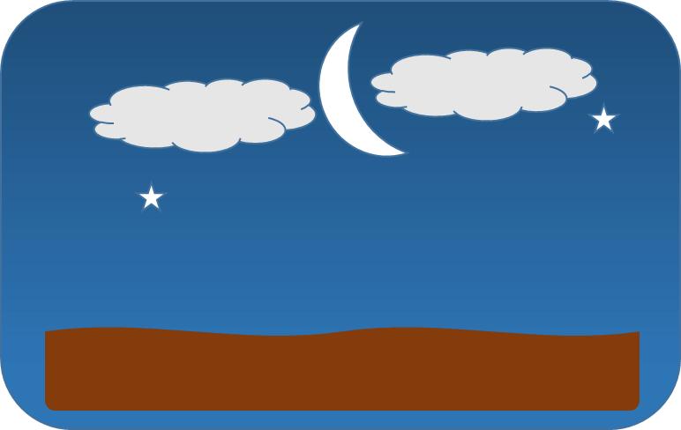
Good night  when you are leaving  | 

