Rules for Using Zoom

Before the meeting:
- Be in a quiet room
- Check the sound on your computer is on and turned up
- Test the microphone and audio

When the tutor is talking: 
- Be on mute
- Turn on the camera
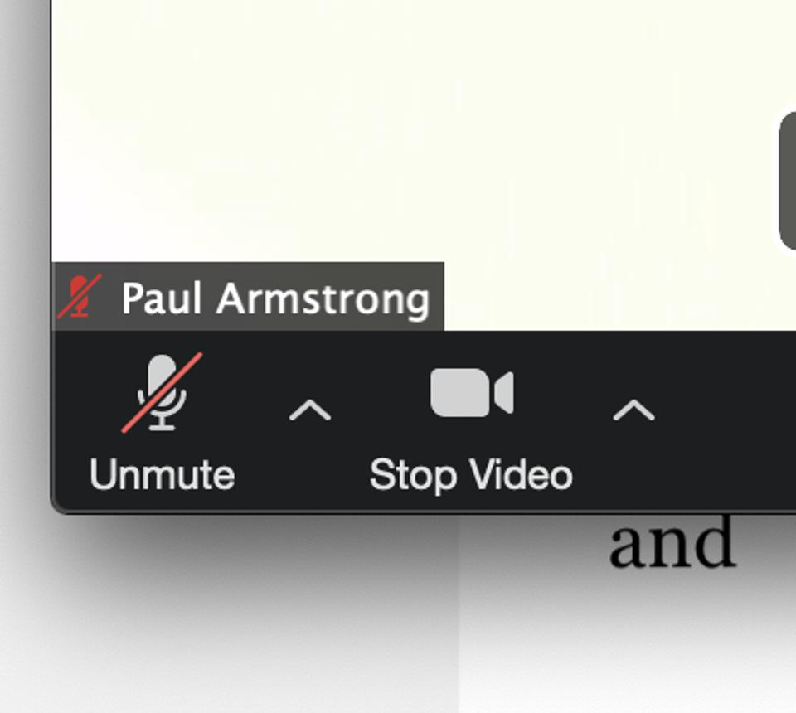
- Raise your hand to speak
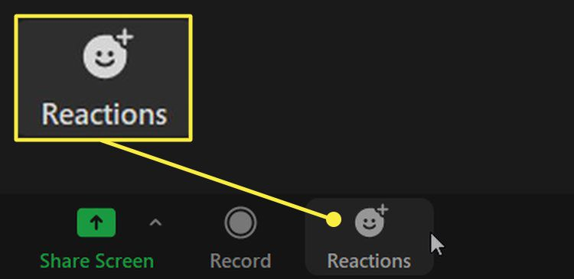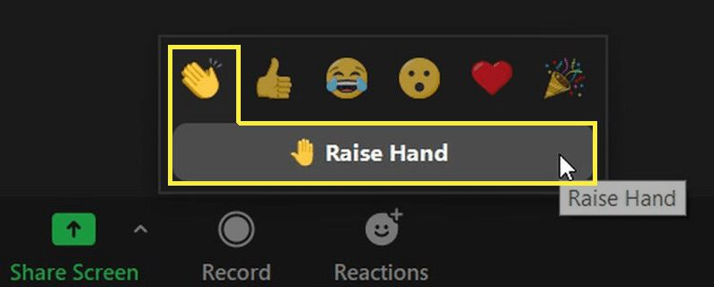
- Use chat to type a question or comment



