
Macbeth Act 4
DARTs activities – answers
Subject: | English
Age range: | 10–12, 12–14
Topic: | Macbeth

EAL Nexus resource

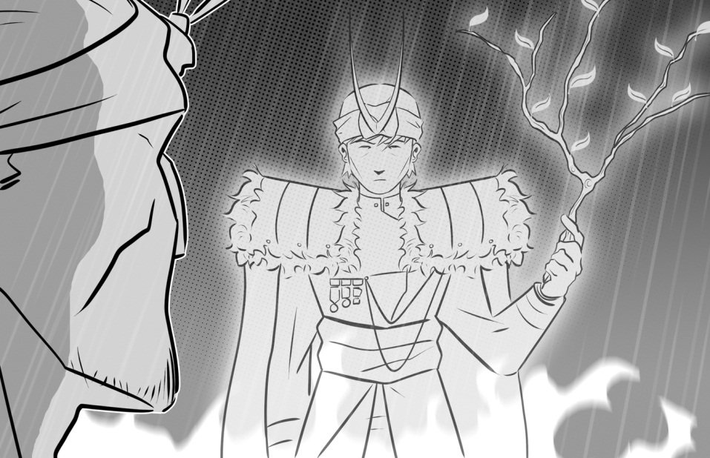

This project and its actions were made possible due to co-financing by the European Fund for the Integration of Third-Country Nationals.

This project and its actions were made possible due to co-financing by the European Fund for the Integration of Third-Country Nationals.

This project and its actions were made possible due to co-financing by the European Fund for the Integration of Third-Country Nationals.





Act Four: Scene 1
The three apparitions
Match the apparition with the prophecy:
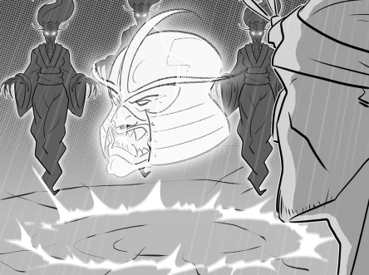
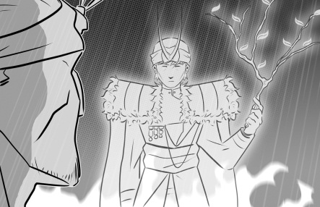
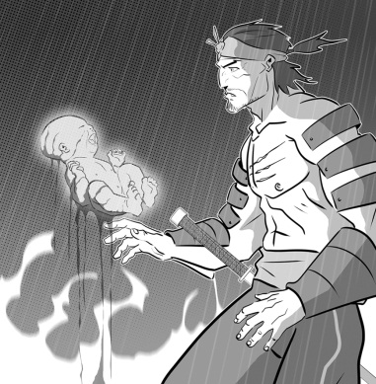
First apparition
Third apparition
Second apparition
No man born to a woman will harm you!
You won’t be defeated until Birnam Wood comes to Dunsinane Hill.
Be careful of Macduff!

Complete the sentences explaining what the apparitions are and what they say to Macbeth.

- The first apparition is a head with a helmet. It tells

Macbeth that he should be careful of Macduff.

- The second apparition is a child covered with blood.

It tells Macbeth that no man born to a woman can harm him.

- The third apparition is a child with a crown on his head and a
branch in his hand. It tells Macbeth that he will not be defeated until Birnam Wood comes to Dunsinane Hill.

First apparition
Third apparition
Second apparition

Act Four: Scenes 1 and 2
Macbeth, Macduff and Lady Macduff
Use the substitution table to write some sentences about Macbeth, Macduff and Lady Macduff in these scenes.
Macbeth  Macduff  Lady Macduff | has  is | run away | that  to  by | England.
Macbeth  Macduff  Lady Macduff | has  is | sent some men | that  to  by | her husband has run away.
Macbeth  Macduff  Lady Macduff | has  is | angry | that  to  by | kill all of Macduff’s family.
Macbeth  Macduff  Lady Macduff | has  is | killed | that  to  by | Macbeth’s men.
Macbeth  Macduff  Lady Macduff | has  is | warned | that  to  by | a messenger to run away.

You could make lots of different sentences using the table. Here are some examples.
- Macduff has run away to England.
- Macbeth has sent some men to kill all of Macduff’s family.
- Lady Macduff is angry that her husband has run away.
- Lady Macduff is warned by a messenger to run away.
- Lady Macduff is killed by Macbeth’s men.


Act Four: Scene 3
Comparing Macduff and Malcolm
Fill in the Venn diagram to show which words and phrases from the box below describe Macduff, Malcolm or both of them.

has gathered an army to fight Macbeth
talk about
events in Scotland
wife and children killed by Macbeth
decides to go back to Scotland to fight
think Malcolm is the true King of Scotland

do not trust each other at first

devastated
Macduff
talk about events in Scotland do not trust each other at first devastated has gathered an army to fight Macbeth think Malcolm is the true King of Scotland wife and children killed by Macbeth decides to go back to Scotland to fight
Malcolm

