
Macbeth Act I
Scene summaries
Subject: | English
Age range: | 10–12, 12–14
Topic: | Macbeth

EAL Nexus resource

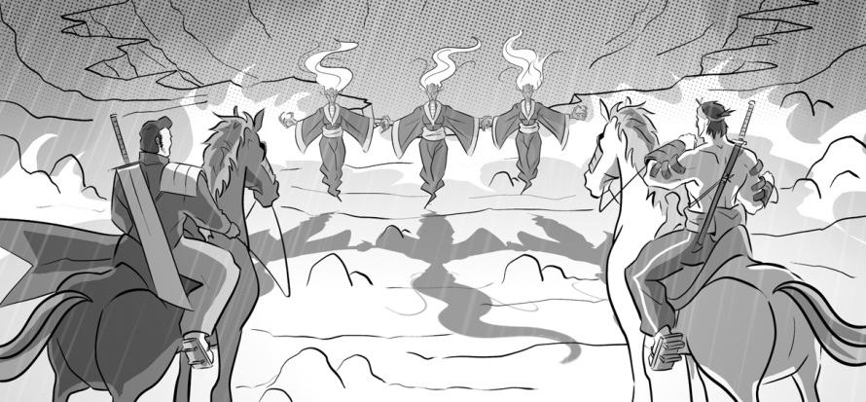





This project and its actions were made possible due to co-financing by the European Fund for the Integration of Third-Country Nationals.

This project and its actions were made possible due to co-financing by the European Fund for the Integration of Third-Country Nationals.

This project and its actions were made possible due to co-financing by the European Fund for the Integration of Third-Country Nationals.

Macbeth Act 1: Scene Summaries

Scene 1 On the heath
There is thunder and lightning. Three witches come in. They decide to meet again on the heath before sunset. They are going to meet Macbeth there.

Key words or phrases with pictures
the heath three witches thunder and lightning

sunset three witches Macbeth

Key words to translate
Word or phrase | Translation | Meaning
to decide
to meet
before sunset

Scene 2 An army camp near Duncan’s palace at Forres
The King of Scotland, Duncan, and his sons, Malcolm and Donalbain, are waiting for news about a battle. A soldier tells them that two Scotsmen, called Macbeth and Banquo, have won the battle. Macbeth fought very bravely. In the battle Macbeth and Banquo fought against Duncan’s enemies, the King of Norway and a traitor, the Thane of Cawdor. (A Thane is a powerful and important man in Scotland.) The Thane of Cawdor is now a prisoner. Duncan says the Thane of Cawdor should be killed and Macbeth will become the new Thane of Cawdor because he fought so bravely in the battle.

Key words or phrases with pictures
Banquo a battle Donalbain Duncan
to fight (fought) the King of Norway Macbeth

Malcolm a prisoner a soldier

Key words to translate
Word or phrase | Translation | Meaning
an army camp
to become
bravely
to be killed
king
enemy
powerful and important
Thane |  | A powerful and important man in Scotland
a traitor
to wait for news
to win (won)

Scene 3 On the heath
Macbeth and Banquo are coming back from the battle when they meet the three witches on the heath. The first witch calls Macbeth ‘Thane of Glamis’. This is not surprising because ‘Thane of Glamis’ is Macbeth’s title. The second witch calls Macbeth ‘Thane of Cawdor’. Macbeth is surprised because he does not know that Duncan has given him the title of Thane of Cawdor. The third witch says that one day Macbeth will become king.
The witches also talk to Banquo. They say three things to him.
- He is not so important as Macbeth, and more important.
- He is not so lucky as Macbeth, and luckier.
- He will not become king, but his sons will become kings.

Ross and Angus come in. They tell Macbeth that the Thane of Cawdor has been killed and that Duncan has given him the title. Macbeth realises that the witches’ first prophecy has come true. He begins to wonder if their second prophecy will come true and he will become king.

Key words or phrases with pictures
to become king

Key words to translate
Word or phrase | Translation | Meaning
to call
to come true
first, second and third
luckier
more important
not so important
not so lucky
one day (in the future)
a prophecy
to realise
surprised
surprising
title |  | Term of respect added to a person’s name, e.g. Mr, Mrs, Prince, Queen
to wonder

Scene 4 Duncan’s Palace at Forres
Malcolm tells his father, King Duncan, that the Thane of Cawdor has been killed.
Macbeth and Banquo arrive. Duncan thanks Macbeth and Banquo for fighting bravely in the battle. Duncan then tells everybody that he is giving the title of Prince of Cumberland to his son, Malcolm. He makes it clear that Malcolm will be King of Scotland after Duncan dies.
Macbeth realises that, for the witches’ prophecy to come true and for him to become king, Malcolm will have to die as well as Duncan. Duncan says he will visit Macbeth’s castle.

Key words or phrases with pictures
a castle a palace

Key words to translate
Word or phrase | Translation | Meaning
after he dies
as well as
father
to make it clear
prince
to realise
to thank
to visit

Scene 5 Macbeth’s Castle at Inverness
Macbeth’s wife, Lady Macbeth, is reading a letter from her husband. The letter tells Lady Macbeth about Macbeth’s meeting with the witches and about the witches’ prophecy. Lady Macbeth decides that Macbeth must kill Duncan, but she is worried that he will not do it. She decides she must give her husband the courage to murder the king.
A messenger arrives from Macbeth warning his wife that Duncan is coming to stay at their castle. Macbeth arrives and talks to his wife. They decide that Macbeth must kill Duncan that night, while he is staying at their castle.

Key words or phrases with pictures
Lady Macbeth letter

Key words to translate
Word or phrase | Translation | Meaning
courage
husband
to murder
to warn
wife
worried

Scene 6 Macbeth’s castle at Inverness
Duncan and his sons arrive at Macbeth’s castle. Lady Macbeth welcomes them politely.
Word or phrase | Translation | Meaning
to arrive
politely
to welcome

Scene 7 Macbeth’s castle at Inverness
Macbeth is alone. He tries to decide if he should murder Duncan or not. He decides he will not because Duncan is his king, his relative and his guest.
Lady Macbeth arrives. She persuades Macbeth to murder Duncan. Lady Macbeth has made a plan. She will make sure the two grooms who guard the king are drunk. Macbeth will kill Duncan, using the grooms’ daggers. Then he will smear blood on the grooms so everybody will think they have killed Duncan.

Key words or phrases with pictures
a dagger

Key words to translate
Word or phrase | Translation | Meaning
alone
blood
drunk
grooms |  | The men guarding Duncan
to guard
a guest
to make a plan
to make sure
to persuade
a relative
to smear
to try

