
Macbeth Act I
DARTs activities
Subject: | English
Age range: | 10–12, 12–14
Topic: | Macbeth

EAL Nexus resource




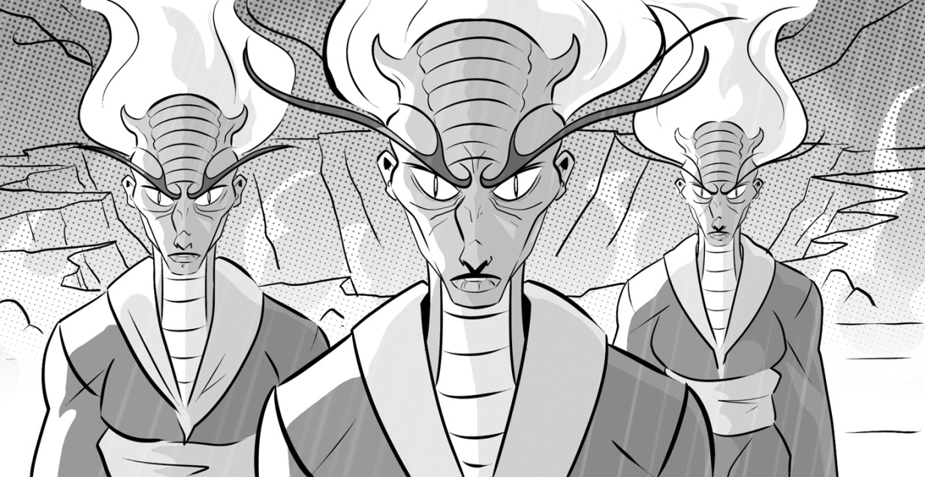

This project and its actions were made possible due to co-financing by the European Fund for the Integration of Third-Country Nationals.

This project and its actions were made possible due to co-financing by the European Fund for the Integration of Third-Country Nationals.

This project and its actions were made possible due to co-financing by the European Fund for the Integration of Third-Country Nationals.

Act One: Scenes 1 and 2
What do we find out about Macbeth?
Put the words in the hexagons in the right order to make sentences about Macbeth.
want Three Macbeth to meet
witches
is Macbeth a soldier brave

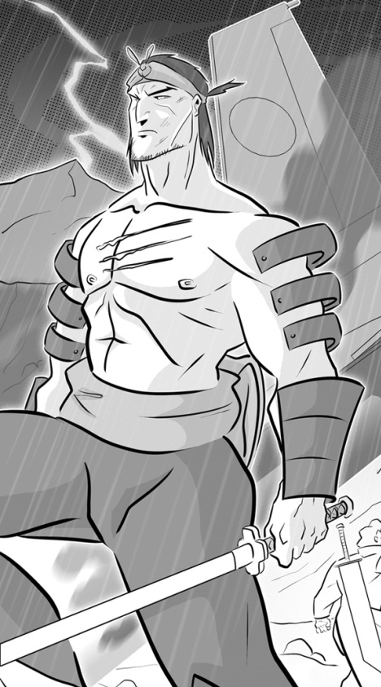
fought
Macbeth enemies
Duncan’s
lives Macbeth Scotland in

Duncan Macbeth Thane of Cawdor make will
and Macbeth
of Norway Banquo against the battle the King won
Act One: Scene 2
The battle
Fill in the names of the characters:

____________________ is the King of Scotland.

Duncan’s friends | Duncan’s enemies
_______________  (a brave soldier)  _______________  (another Scotsman) | The King of ____________  The _________ of _________  (a traitor)

Before, during and after the battle
Choose a word from the box to complete the sentences:
before during after

Macbeth became Thane of Cawdor _______ the battle.
___________ the battle three witches met on the heath.
Macbeth and Banquo fought bravely ___________ the battle.
__________ the battle a soldier brought Duncan and his sons news.
_________ the battle the Thane of Cawdor fought against Duncan.
The Thane of Cawdor was killed ___________ the battle.
Act One: Scene 3
What the witches say to Macbeth
Match the witch with what she says to Macbeth:
One day you will be King
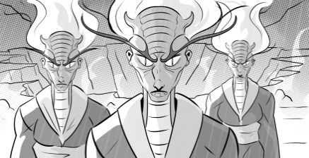
First witch
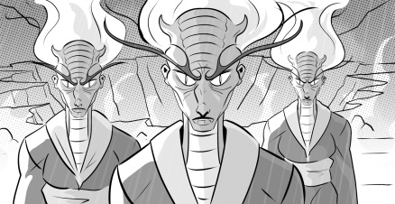
Second witch
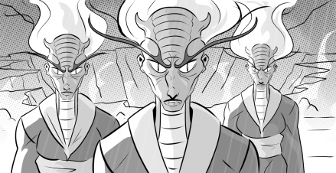
Third witch
Hello Thane of Cawdor!

Hello Thane of Glamis!

What the witches say to Banquo
Match the two halves to form three sentences:
You are not as lucky as
Macbeth
You are more important than
Macbeth
but also luckier than Macbeth.

but also less important than
Macbeth.
You will never
become King of
Scotland

but your sons will become Kings
of Scotland.

Act One: Scene 4
Copy the table below and sort the thoughts into what Duncan is thinking and what Macbeth is thinking.
Duncan’s thoughts  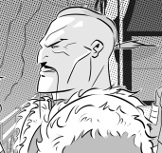 | 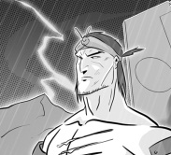  Macbeth’s thoughts
I want my son, Malcolm, to become King when I die.
He is a brave soldier and I can trust him.
I will reward him by making him Thane of Cawdor.
If he comes to my castle I will have a chance to kill him.
I can’t become king unless Malcolm and Duncan both die.
I will be safe at his castle because I can trust him.

Predicting what will happen in the play

Fill in the table putting things that you think will happen in the Very likely column and things that you think won’t happen in the Not very likely column. You can use the suggestions below and add more of your own.

  Very likely |   Not very likely

- Lady Macbeth will kill Duncan.
- Macbeth will kill Duncan.
- Duncan will kill Macbeth.
- Macbeth will kill Lady Macbeth.
- Macbeth will become king.
- Banquo will become king.
- Malcolm will become king.
- All of the witches’ prophecies will come true.
- Some of the witches’ prophecies will come true.
- None of the witches’ prophecies will come true.

What do you think?
Write three sentences about what you think will happen in the play:
- I think …
- I also think that …
- At the end of the play I think …
Act One: Scenes 5 and 6
True or False?
Put a tick () by the true statements and a cross (×) by the false ones.
or ×
Lady Macbeth wants her husband to kill Duncan so he will become king.
Lady Macbeth does not believe the witches prophecies.
Lady Macbeth is worried her husband will want to kill Duncan and become king.
Lady Macbeth is worried her husband will not have enough courage to kill Duncan.

Use the substitution table below to make some sentences about what Lady Macbeth and Macbeth are thinking and doing during these two scenes.
When | he  she  they | reads the letter  arrive at the castle  arrives at the castle  talk together | Macbeth | thinks  welcomes  is worried  talks to  decide to | her husband  kill Duncan  Duncan and his sons  his wife  she | politely.
 |  |  |  |  |  | must kill Duncan.
When | he  she  they |  | Lady Macbeth | thinks  welcomes  is worried  talks to  decide to | her husband  kill Duncan  Duncan and his sons  his wife  she | won't kill Duncan.
 |  |  |  |  |  | about what to do.
When | he  she  they |  | Macbeth and Lady Macbeth | thinks  welcomes  is worried  talks to  decide to | her husband  kill Duncan  Duncan and his sons  his wife  she | must give him courage.
 |  |  |  |  |  | that night.

Act One: Scene 7
- Colour in the clouds that show what Macbeth is thinking in blue.
- Colour in the clouds that show what Lady Macbeth is thinking in red.
- Arrange Macbeth and Lady Macbeth’s thoughts in the table according to if they are thinking about whether to kill Duncan or how to kill Duncan.
I shouldn’t kill him because he is my king.
If I kill him I can become king.

I will make sure the two grooms are drunk.
I shouldn’t kill him because he is my relative.

I shouldn’t kill him because I am his host.
He should use the grooms’ daggers.
He should smear the grooms with Duncan’s blood.

Whether to kill Duncan | How to kill Duncan

Conclusion
Fill in the gaps to complete the two sentences:
- At the end of Act 1 Macbeth is trying to decide __________ to kill Duncan.

- At the end of Act 1 Lady Macbeth is trying to decide _______ to ___________ ____________ .

.

