**Remote Online Learning**

**Pupils with a Hearing Impairment**

Pupils finding it difficult to hear live lessons or recorded lessons can try:

* Good **headphones or earphones** for direct input of the sound. A pupil with a unilateral hearing loss (hearing in one ear) should have headphones that send the signal to both ears equally; the signal should not be split
* a **radio system** if the pupil has been issued with one. There is information on how to connect the radio system to a device at

<https://blogs.glowscotland.org.uk/re/renfrewshiresensoryteam/2020/08/10/covid-19-update/>

Be aware that voice overs are more difficult to follow than being able to see the speaker’s face. When possible use video instructions rather than audio as this allows the pupil with a hearing impairment to lip read while they are listening.

**Class teachers may find when they ask pupils with a hearing impairment if they are able to follow the lesson that many are able to do so by using headphones or a radio system.**

**If pupils continue having difficulty then the following can be tried:**

* **closed captions, cc, subtitles**. When using be mindful that live closed captions are good but can be inaccurate.

Meetings in Teams

They can be accessed in Teams when using a desktop app. If a pupil is using an iPad they can download the Teams app and access Glow and the captions when in a meeting through this. They cannot be accessed using Teams through a browser or through a school Chromebook.

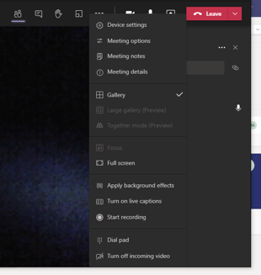

PowerPoint presentations

Allan Boak from Castlehead High School has very kindly produced a video about using subtitles during live lessons

<https://www.youtube.com/watch?v=pKMPj1-wa3c>

Google Meet

Once you have the meeting up and running, you can click the three little dots at the bottom right.

Then choose ‘captions’ from the pop up menu:

Then choose the appropriate language you will be speaking in, then click apply:

The subtitles will appear along the bottom of the screen.

If there continues to be difficulties accessing live or recorded lessons, please contact Eliz Quinn, PT sensory support (elizabeth.quinn@renfrewshire.school)

Further information from the NDCS is available at https://www.ndcs.org.uk/blog/deaf-friendly-remote-learning-a-checklist-for-teachers/