|  |  |
| --- | --- |
|  | gLASGOW MOTIVATION AND WELLBEING PROFILE |

**Contents Page**

Page 1 Contents

Page 2 GMW Programme

Wellbeing Questions

Page 3 Areas of Motivational Theory

Page 4 Links to Wellbeing Indicators

How to use the data

Page 5 Strengths & Needs

Page 6 Suggestions & Strategies (pupil)

Page 7 -9 Suggestions & Strategies (teacher)

Page 10-12 Data Analysis

**Glasgow Motivation and Wellbeing Programme**

The Wellbeing Profile (Glasgow Motivation and Wellbeing Profile GMWP) is a 20-item questionnaire that explores motivation and sense of wellbeing in the learning context. It elicits children and young people’s views of themselves and their emotions; it gives them an opportunity to reflect on their feelings and current experiences and encourages them to consider how they can increase their own determination, motivation and sense of wellbeing.

|  |  |  |  |
| --- | --- | --- | --- |
| **Affiliation**  **Nurtured & Included** | **Agency**  **Achieving & Active** | **Autonomy**  **Respected & Responsible** | **Safe**  **Healthy & Safe** |

**The 20 questions appear in the following order:**

|  |  |  |
| --- | --- | --- |
| 1 | I like this school | Affiliation |
| 2 | I work hard in this school | Agency |
| 3 | I am good at working with others | Autonomy |
| 4 | I like being chosen to do things in school | Autonomy |
| 5 | Other pupils look out for me in school /make sure I am feeling okay | Safe |
| 6 | I have friends in this school | Affiliation |
| 7 | I am proud of the work I do in school/my work is good | Agency |
| 8 | I can wait my turn | Autonomy |
| 9 | I can stand up for myself in school | Autonomy |
| 10 | Adults look out for me in school/make sure I am feeling okay | Safe |
| 11 | People help me if I am upset in school | Affiliation |
| 12 | People tell me what I am good at | Agency |
| 13 | I follow the school rules | Autonomy |
| 14 | People listen to me in school | Autonomy |
| 15 | I feel safe in school | Safe |
| 16 | I belong to this school/I feel important to this school | Affiliation |
| 17 | I keep trying even if the work is hard | Agency |
| 18 | I stay calm when I am told ‘no’ | Autonomy |
| 19 | I would complain if I felt picked on by anyone in school | Autonomy |
| 20 | I feel good about myself in school | Safe |

**Key Areas of Motivational Theory**

**The Wellbeing** **Profile** is founded on self-determination theory. This theory suggests that people can become self-determined, or motivated when their needs for agency, affiliation and autonomy are fulfilled. The theory of motivation suggests that people tend to be driven by a need to grow and gain fulfilment. What is important in the learning context is that all such students have their basic needs of affiliation, agency and autonomy met. Self-esteem is key here as it energises, and is energised, through a sense of affiliation in the classroom. Self-belief is something that comes from a sense of agency, and self-determination is built on a positive exercising of autonomy

**Agency:** People need to gain mastery of tasks and learn different skills. When people feel that they have the skills needed for success, they are more likely to take actions that will help them achieve their goals.

**Affiliation:** People need to experience a sense of belonging and attachment to other people.

**Autonomy:** People need to feel in control of their own behaviours and goals. This sense of being able to take direct action that will result in real change plays a major part in helping people feel self-determined.

|  |  |
| --- | --- |
| **AGENCY – Resilience**  *Competence & Skills* | I work hard in this school |
| I am proud of the work I do/my work is good |
| Achieving & Active  Trying hard / Giving up | People tell me what I am good at |
| I keep trying even if the work is hard |

|  |  |
| --- | --- |
| **AFFILIATION – Nurture**  *Belonging* | I like this school |
| I have friends in this school |
| Nurtured & Included  Getting along / not getting along | People help me if I am upset in school |
| I belong to this school/I feel important to this school |

|  |  |
| --- | --- |
| **AUTONOMY – Respectful**  *Capable & trusted* | I am good at working with others |
| I wait my turn |
| Respected & Responsible / Negotiating  Sharing / Getting own way | I follow the school rules |
| I stay calm when I am told ‘No’ |

|  |  |
| --- | --- |
| **AUTONOMY – Responsible**  *Capable & trusted* | I like being chosen to do things for the school |
| I can stand up for myself in school |
| Respected & Responsible  Expressing yourself / Hiding | People listen to me in school |
| I would complain if I felt picked on by anyone in school |

|  |  |
| --- | --- |
| **SAFE –** | Other pupils look out for me in school / make sure I am feeling okay |
| Adults lookout for me in school / make sure I am feeling okay |
| Feeling Healthy / Safe | I feel safe in school |
| I feel good about myself in school |

**Relation to Wellbeing Indicators**

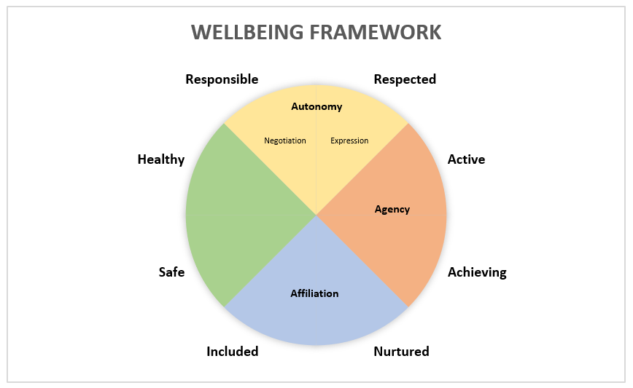The GMWP process is informed by the eight wellbeing indicators.

**How can the data be utilised?**

The raw data will provide an overview of areas of strength and identify potential gaps in each section, Agency, Affiliation, Autonomy & Health and Safe and there are a range of ways in which the information can be used.

* The class teacher can use this data to inform professional dialogue at tracking meetings with the SMT and to identify targets at whole school, class, group or for individuals
* The class teacher can use the data to create a personalised dialogue around the results, identifying strengths and needs along with agreeing next steps together, during individual learner conversations.
* The Wellbeing Profile empowers children and young people to take part in meetings about themselves and gives them a framework with which to express their views and help to identify next steps within their own learning, linking to the Getting It Right for Every Child process
* The Wellbeing Profile can be repeated throughout the school year or at transition stages for the school or setting to track the impact of interventions at school level, class or group level or on an individual basis

**Strengths and Needs**

The analysis of the data will highlight areas of strength and areas of improvement at school, class, group or individual needs.

This data will provide the basis to collaborate with staff, children and young people to identify and agree goals (see Fig.1/2 for example of an individual’s goal setting template) or next steps and how these will be achieved.

Timescales for achieving goals and next steps should be identified, as well as timescales for repeating the profile to measure progress over time.

|  |  |  |  |
| --- | --- | --- | --- |
| **Individual Strengths:** | | | |
| Area of need (circle one) | | | |
| Agency | Affiliation | Autonomy | Healthy & Safe |
| My goals are: | | | |
| Timescale: | | | |

*Fig.1*

|  |  |  |  |
| --- | --- | --- | --- |
| **Individual Needs:** | | | |
| Area of need (circle one) | | | |
| Agency | Affiliation | Autonomy | Healthy & Safe |
| My goals are: | | | |
| Timescale: | | | |

*Fig. 2*

**Suggestions and Strategies to support goal setting**

This section takes you through suggestions and strategies for both pupils and teachers which could be used to support goal setting, targeted interventions, or whole class activities.

**(1) Pupils -** Suggestions for pupils:

|  |  |
| --- | --- |
| **Agency: Achieving and Active** | |
| **Achieving**   * Don’t give up – find another way of doing things * Tell people about things you do outside of school * Get advice from people who have achieved the goals you are aiming towards * Keep reminding yourself of your own strengths and achievements * Concentrate on doing your best rather than getting focused on who is the best * Accept the areas you need to work on and believe you can change * Focus on specific and clear goals: work out where you are now and where you want to go | **Active**   * Select and choose activities that make you feel good * Select and choose activities that give you a sense of purpose * Take part in a wide range of activities, particularly sport |
| **Affiliation: Nurtured and Included** | |
| **Nurtured**   * Ask for support from others when you need it * Make an effort to show an interest in others | **Included**   * Think of things you are proud of about your school and share these with others * Respect others opinion even when it is different to your own * Try to understand different beliefs and cultures |
| **Autonomy: Respected and Responsible** | |
| **Respected**   * Try to see things from other people’s point of view * Work out what you would like teachers to say about you * Work on holding others attention * Learn to express both positive and negative emotions * Find activities that let you express yourself * Don’t let criticism stop you expressing your ideas and opinions | **Responsible**   * Make an effort to be a good listener and contributor when you are working in a group * Accept that you can’t always get your own way * Try to ask good questions * Be a positive role model for others * Seek opportunities to help others * Be prepared to take the lead when you can * Keep a sense of humour * Resist other people’s attempts to distract you * Accept responsibility for your own learning |
| **Healthy & Safe** | |
| * Talk to someone you can trust if you are not feeling okay or safe * Remember to wash hands regularly * Remind yourself of things to be grateful for each day | |

**(2) Teachers:**

Strategies/activities that can be implemented:

|  |  |
| --- | --- |
| **Autonomy - Responsible** | |
| **Expectation** | **Strategy** |
| **Make an effort to be a good listener and contributor when you are working in a group** | 1) Introduce discussion activities in small groups initially or use paired activities and then move to the next stage as required  2) Allow young person to act as observer of discussion activity (e.g. note taker, noting who is talking, who is listening etc)  3) Offer degrees of responsibility and autonomy for the discussion to the young person  4) Breakfast Club – Develop purposeful discussions over meals |
| **Accept responsibility for your own learning** | 1) Promote participation by supporting the young person’s organisation  2) Do not assume the young person knows what is needed or what is expected  3) Understanding regularly and reduce language content as and when necessary  4) Use pupil learning diary to check understanding and place post it notes into prompt organisation i.e. this is what you will need for tomorrow for this task  5) Rehearse and practise the skills required  6) Model the skills required (adults and peers) with commentary  7) Create checklists and symbols to assist  8) Reward successful outcomes  9) Keep an equipment store to prevent an escalation of difficulties where mistakes have been made  10) Verbal reminders and prompts, visual reminders, reminders from peers and mentors |
| **Keep a sense of humour** | 1) Model good humour but never use sarcasm  2) Create a joke book and start the day with laughter  3) Don’t assume that the young person is aware of the offence caused by inappropriate humour and teach the difference  4) Address inappropriate humour carefully: be explicit about why offence has been caused. Be explicit about the boundaries within the school/classroom/care environments  5) Consider stereotyping issues and the dangers of inappropriate humour |
| **Affiliation – Included** | |
| **Includes another YP legitimate needs** | 1) Discuss within the classroom setting the need to include everyone, in different situations and at different points in life  2) Recognise and allow for the fact that some young people will need and want separation in the first instance and the next step to inclusion may require an incremental approach  3) Model inclusion of other pupils  4) Reflect on any difficulties that arise from the young person not feeling included |
| **Shows genuine concern and thoughtfulness for other people** | 1) Consider narratives that elicit these qualities  2) Reflect on real life situations (in the media, in school) and brainstorm how those struggling might be helped  3) Consider supporting a charity or fund-raising activity  4) Consider designing activities for younger peers or less able peers |
| **Autonomy – Respected** | |
| **Work on holding others attention** | 1) Create opportunities for the young person to engage and hold the attention of their peers, i.e., group work, presentations, hot seat activities |
| **Promote appropriate engagement with others through the following activities:** | 1) Explicit teaching of interactive skills e.g. giving attention, pausing, replying, asking questions  2) Creating opportunities to practice interactive skills with structured pair work and small group work  3) Presentation tasks in small stages with Question and Answer plenary built into the task  4) Creating different roles within the group discussion e.g. Chair, note taker, point of view 1, point of view 2  5) Request the class to recount key pieces of information from the lesson |
| **Affiliation - Nurtured** | |
| **Ask for support from others when you need it** | 1) Create opportunities for friendships to be developed (clubs, small group work, off-site activities)  2) Reflect on social interactions (what went well? What didn’t work?)  3) Reflect on how others might feel  4) Develop self-awareness and awareness of others  5) Develop empathy for others through guidance, modelling and reflecting on the views of others  6) Explore friendship as a topic or discussion |
| **Turns to an adult for help & reassurance in expectation that support will be forthcoming** | 1) Reiterate your role as teacher: you are there to help should help be required  2) Be consistent with your positive, unconditional regard for the young person  3) Build in opportunities for help to be requested  4) Offer help to another young person in parallel to model the request for help and the subsequent support  5) Reverse the role by asking the young person for help or reassurance. Reflect on that process |
| **Agency - Achieving** | |
| **Accept the areas you need to work on and believe you can change** | 1) Where possible, prepare the young people for the usual event or change the plan to maximise chances of success  2) Where possible, make any new and unexpected experience relatively small and manageable  3) Model problem-solving approaches  4) Promote resilience and tenacity with encouragement |
| **Accepts disappointments** | 1) Reflect on the nature of success and the nature of disappointment  2) Promote resilience as a skill and trait that is best understood in the context of disappointment  3) Flag up resilience as a strong trait; a mature trait; a trait and skill to aspire to  4) Introduce texts, films that explore disappointment and the resilience of the characters in the texts. How did they overcome disappointment? Can good come from disappointment? |

**Data Analysis and Interpretation**

By using an excel analysis grid, the pupil’s responses can be viewed either individually or as a group. The following worksheets can be found to help with interpretation. Once you have copied over the excel spreadsheet data from the Microsoft Form, the GMWP Master Spreadsheet organises the pupil’s responses via a series of differing methods.

**(Worksheet 1) Point A Raw Results –** All pupils responses to individual questions.

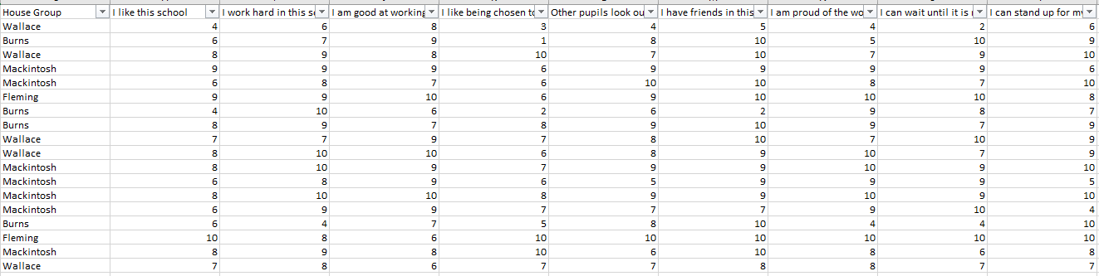

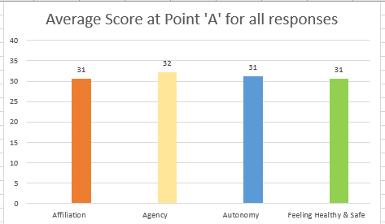**(Worksheet 2) Summary Graphs -** Summary graphs will give you a score out of 40 for all the pupils as a cohort.

**Analysis**: Each strand is out of 40. Affiliation, Agency and Healthy & Safe strand has four questions, with autonomy having eight questions. Each question is scored out of 10, resulting in the max for each strand being a total of 40. As autonomy has eight questions, the total is divided by 2, to make sure it is equal to other strands – total score for

autonomy may carry half marks at times.

This group of children has 31/40 for Affiliation,

32/40 for Agency, 31/40 for Autonomy and 31/40

for Healthy and Safe.

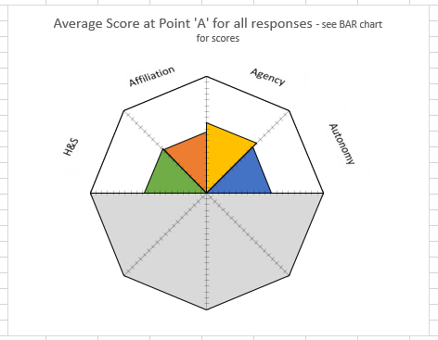When looking at the average score on the radar graph, it highlights that this group have a higher sense of Agency than other areas.

**Radar Charts** - Radar Charts are used to look at individual children. The aim is to see quickly a visual of any areas of concern. If a pupil’s data is presented on the bottom half of the chart, this presents as a low score for that area. This would be viewed as a concern.

If there is a particular area that the child presents as low in, referring to specific questions on Point A worksheet can be of benefit.

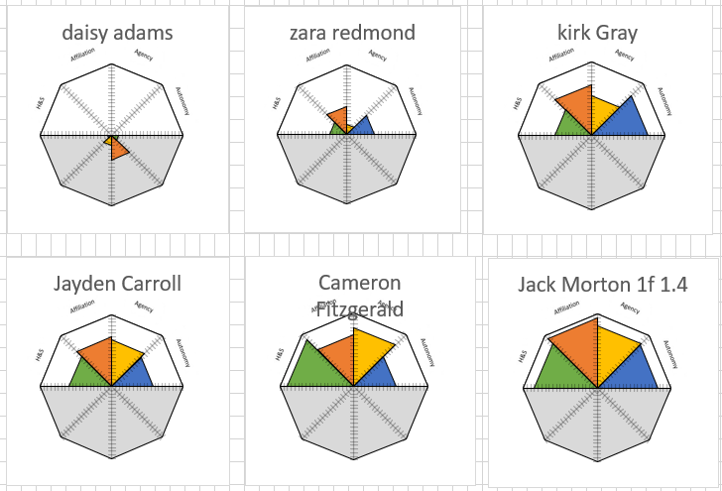



**Bar Charts** - Bar charts present the same data as Radar but in a different format.

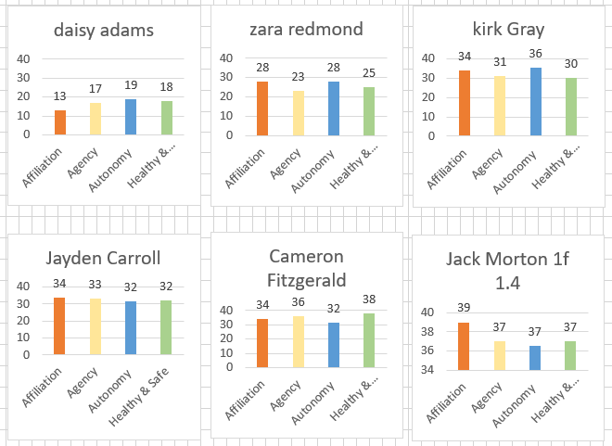

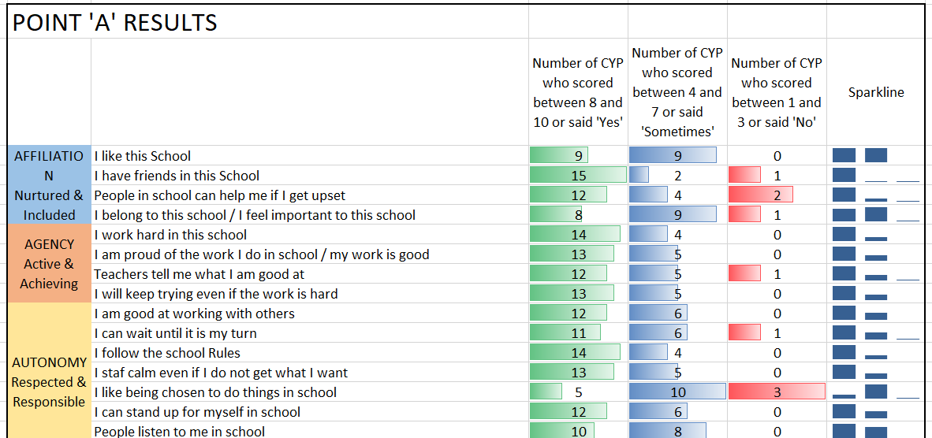**(Worksheet 5) Overall Results/Question Changes -** The spark line is the guide – Left hand column aim is to have thick blue lines, the middle column very thin and the third column no lines at all, which correlates with the results in the previous columns. Comparing high scores with low scores, provides an opportunity for deep discussions and helping pupils take responsibility for their own wellbeing by planning the next steps. The benefit of this programme that the information is not coming from the teacher but the young people themselves.

**End of Year comparison results**

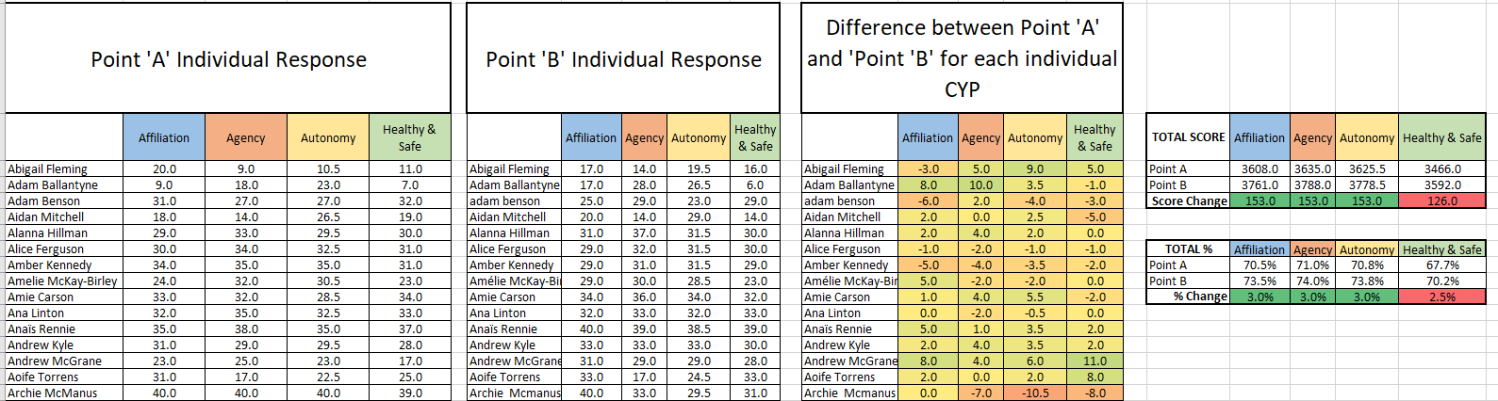

When completing final analysis, it is imperative that you ensure all names are exact same spelling at Point A and B of raw results and are sorted in alphabetical order. If pupils are missing from point A or B either input data or delete their name from point A.

Further information and training videos can be found at: <https://blogs.glowscotland.org.uk/glowblogs/gmwp/>