1. Anxiety and depression

One in six young people will experience an anxiety disorder at some point in their lives and identified rates of anxiety and depression in young people have increased by 70% over the past 25 years. Our own research has shown that young people themselves say four of the five most used social media platforms actually make their feelings of anxiety worse.

Anxiety can have a hugely detrimental impact on a young person’s life. Feelings of overwhelming worry and panic can take over and make it hard for them to leave the house, attend classes or lectures, or perform at work. Anxiety may be diagnosed as a specific mental health disorder such as Generalised Anxiety Disorder (GAD), panic disorder, social anxiety disorder or Obsessive Compulsive Disorder (OCD).

Research suggests that young people who are heavy users of social media - spending more than two hours per day on social networking sites such as Facebook, Twitter or Instagram - are more likely to report poor mental health, including psychological distress (symptoms of anxiety and depression). Seeing friends constantly on holiday or enjoying nights out can make young people feel like they are missing out while others enjoy life. These feelings can promote a ‘compare and despair’ attitude in young people. Individuals may view heavily photo-shopped, edited or staged photographs and videos and compare them to their seemingly mundane lives. The findings of a small study, commissioned by Anxiety UK supported this idea and found evidence of social media feeding anxiety and increasing feelings of inadequacy.

The unrealistic expectations set by social media may leave young people with feelings of self- consciousness, low self-esteem and the pursuit of perfectionism which can manifest as anxiety disorders. 17 Use of social media, particularly operating more than one social media account simultaneously, has also been shown to be linked with symptoms of social anxiety.

As well as anxiety disorders, nearly 80,000 children and young people in the UK suffer with severe depression. There is growing evidence linking social media use and depression in young people, with studies showing that increased use is associated with significantly increased odds of depression. Using social media for more than two hours per day has also been independently associated with poor self-rating of mental health, increased levels of psychological distress and suicidal ideation. This phenomenon has even been labelled as ‘Facebook depression’ by researchers who suggest that the intensity of the online world - where teens and young adults are constantly contactable, face pressures from unrealistic representations of reality, and deal with online peer pressure - may be responsible for triggering depression or exacerbating existing conditions.

One piece of research has even gone as far as attempting to predict depression in individuals based solely on their social media postings. They were able to predict depression with up to 70% accuracy merely by studying an individual’s posts on Twitter.

Anonymous • 20-24 y/o Northern England
“....it has increased my level of anxiety and social anxiety... I’m constantly worried about what others think of my posts and pictures.”

80,000 children and young people in the UK with severe depression

2. Sleep

Sleep and mental health are tightly linked. Poor mental health can lead to poor sleep and poor sleep can lead to states of poor mental health. Sleep is particularly important for teens and young adults due to this being a key time for development. The brain is not fully developed until a person is well into their twenties and thirties. Sleep is essential for allowing us to function properly during waking hours and teens need around 1-2 hours more sleep every night than adults. Poor sleep is linked to a wide range of both physical and mental health conditions in adults including high blood pressure, diabetes, obesity, heart attack, stroke and depression.

Anonymous • 14-16 y/o Northern Ireland
“...the time you can spend on some of these apps - they can be very addictive. I lose time to revise, can’t do homework, can’t interact with family/friends and lose a lot of sleep at night time.”

Numerous studies have shown that increased social media use has a significant association with poor sleep quality in young people. Using social media on phones, laptops and tablets at night before bed is also linked with poor quality sleep, even more so than regular daytime use of social media. It is thought that the use of LED lights before sleep can interfere with and block natural processes in the brain that trigger feelings of sleepiness, as well as the release of the sleep hormone, melatonin. This means it takes longer to fall asleep and individuals end up getting fewer hours of sleep every night.

One in five young people say they wake up during the night to check messages on social media, leading them to be three times more likely to feel constantly tired at school than their classmates who don’t use social media during the night.
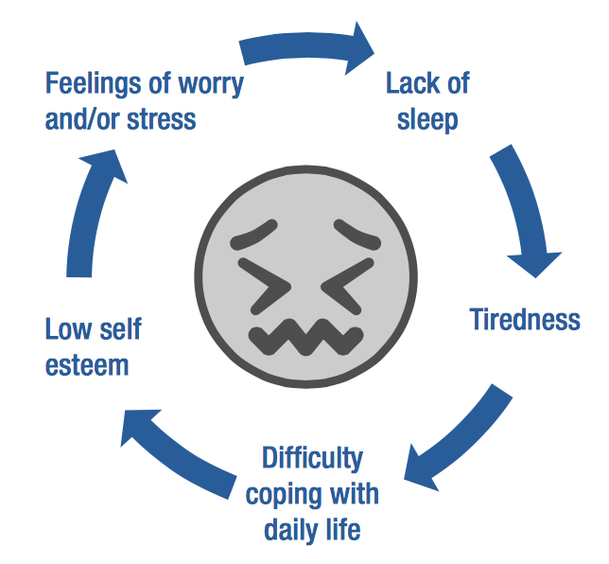

3. Body image

Body image is an issue for many young people, both male and female, but particularly females in their teens and early twenties. As many as nine in 10 teenage girls say they are unhappy with their body.

There are 10 million new photographs uploaded to Facebook alone every hour, providing an almost endless potential for young women to be drawn into appearance-based comparisons whilst online. Studies have shown that when young girls and women in their teens and early twenties view Facebook for only a short period of time, body image concerns are higher compared to non-users.

One study also demonstrated girls expressing a heightened desire to change their appearance such as face, hair and/or skin after spending time on Facebook. Others have suggested social media is behind a rise in younger generations opting to have cosmetic surgery to look better in photos, which has implications for physical health through unnecessary invasive surgery. Around 70% of 18-24 years olds would consider having a cosmetic surgical procedure.

Recent decades have seen increased discussion and awareness of the impact of the images of women and girls we see on TV and in other traditional media. However, very little research and focus has been directed towards the impact social media is having on our young people as regards body image. Given how many young people are using social media and how many images they are viewing on a daily basis, it is important that further research is carried out into the consequences of social media for body image.

4. Cyberbullying

Bullying during childhood is a major risk factor for a number of issues including mental health, education and social relationships, with long-lasting effects often carried right through to adulthood. The rise of social media has meant that children and young people are in almost constant contact with each other. The school day is filled with face-to-face interaction, and time at home is filled with contact through social media platforms. There is very little time spent uncontactable for today’s young people. While much of this interaction is positive, it also presents opportunities for bullies to continue their abuse even when not physically near an individual. The rise in popularity of instant messaging apps such as Snapchat and WhatsApp can also become a problem as they act as rapid vehicles for circulating bullying messages and spreading images.

Seven in 10 young people have experienced cyberbullying, with 37% of young people saying they experience cyberbullying on a high-frequency basis. Young people are twice as likely to be bullied on Facebook than on any other social network. These statistics are extremely worrying for the overall health and wellbeing of our young people. Victims of bullying are more likely to experience low academic performance, depression, anxiety, self-harm, feelings of loneliness and changes in sleeping and eating patterns – all of which could alter the course of a young person’s life as they undertake important exams at school or university, and develop personally and socially.

Anonymous • 20-24 y/o Midlands
“I was bullied in person and then on Facebook by a group of girls from school... I began to stop eating, hardly slept and became extremely anxious leaving the house and going to school... it has definitely affected my mental health and wellbeing.”

Anonymous • 14-16 y/o
“Anonymous bullying online over Twitter around personal things has led to me self-harming and left afraid of going to school. Bullying on Instagram has lead me to attempt suicide and also self-harm. Both caused me to experience depressive episodes and anxiety.”

Cyberbullying can take many forms including the posting of negative comments on pictures and directed abuse via private messages. Almost all social networking sites have a clear anti-bullying stance. However, a national survey conducted by Bullying UK found that 91% of young people who reported cyber bullying said that no action was taken. Ensuring our young people are safe from abuse online via social media must be a top priority for parents, schools and social media companies.

5. Fear of Missing Out (FoMO)

The concept of the ‘Fear of Missing Out’ (FoMO) is a relatively new one and has grown rapidly in popular culture since the advent and rise in popularity of social media. The term is particularly used by young people, with digital language research showing that 40% of parents do not know what the term means. In essence, FoMO is the worry that social events, or otherwise enjoyable activities, may be taking place without you present to enjoy them. FoMO is characterised by the need to be constantly connected with what other people are doing, so as not to miss out. FoMO is associated with lower mood and lower life satisfaction.

The sharing of photos and videos on social media means that young people are experiencing a practically endless stream of others’ experiences that can potentially fuel feelings that they are missing out on life – whilst others enjoy theirs – and that has been described as a ‘highlight reel’ of friends’ lives. FoMO has been robustly linked to higher levels of social media engagement, meaning that the more an individual uses social media, the more likely they are to experience FoMO. Many people experience some degree of FoMO and for many it may not be a problem. Increasingly, however, young people are reporting that FoMO is causing them distress in the form of anxiety and feelings of inadequacy.

Anonymous • 17-19 y/o Northern England
“I have to have my phone charger to get on Facebook, otherwise I feel disconnected and start biting my nails.”

Anonymous • 17-19 y/o Scotland
“During my fourth year exams (when I was 16) I was put under the pressure due to the fact I was under the impression I’d be missing out if I switched off from social media. Therefore, I could not fight my urge and focus properly on studying due to my worry.”

