SQA Mental Health
Award
UNIT 1: Understanding Mental Health Issues ​
Pupil Name/Class:
Teacher:

Outcome 1:
Describe what is meant by the terms “mental health” and “wellbeing” for individuals and wider society. ​
Performance criteria ​
- Describe the needs and wants of individuals.
- Describe terms in relation to mental health and wellbeing​.
- Describe how mental health and wellbeing is portrayed in the media​.
- Describe myth busting in relation to mental health issues​.
- Explain legislation and strategy in relation to mental health.
Evidence Requirements:
- Describe 2 needs and 2 wants of individuals.
- Describe 2 terms in relation to mental heath and wellbeing, giving a definition of each.
- Describe 2 myths and 2 facts in relation to mental health issues.
- Explain 1 policy and 2 pieces of legislation/ strategy relevant to mental health.
- Myths and Facts
Lesson 3
Learning intentions:
- Describe 2 myths and 2 facts in relation to mental health issues.
Success Criteria:
- I understand that there are myths surrounding mental health which add to the stigma of mental health issues.
- I can describe 2 myths and 2 facts relating to mental health issues.
There are many different myths about mental health concerns and they often contribute to the stigma that many people still face. It is so important that we challenge these myths so we can understand the real facts around a mental illness.

Task 1 (starter task): Write down, in the space below, myths and facts you know in relation to mental health and wellbeing.
Myths:

Facts:

Task 2: Using 2 different colours, show which is a myth or a fact in relation to mental health.

Myths or Facts
Only certain people have mental health issues.
Physical health problems are worse than mental health problems.
You can’t recover from a mental illness.
People with mental illness hold down successful jobs.
Mental health problems are rare.
Mental health problems are a sign of weakness.
People with mental health problems are more likely to be a victim than a perpetrator of violence.

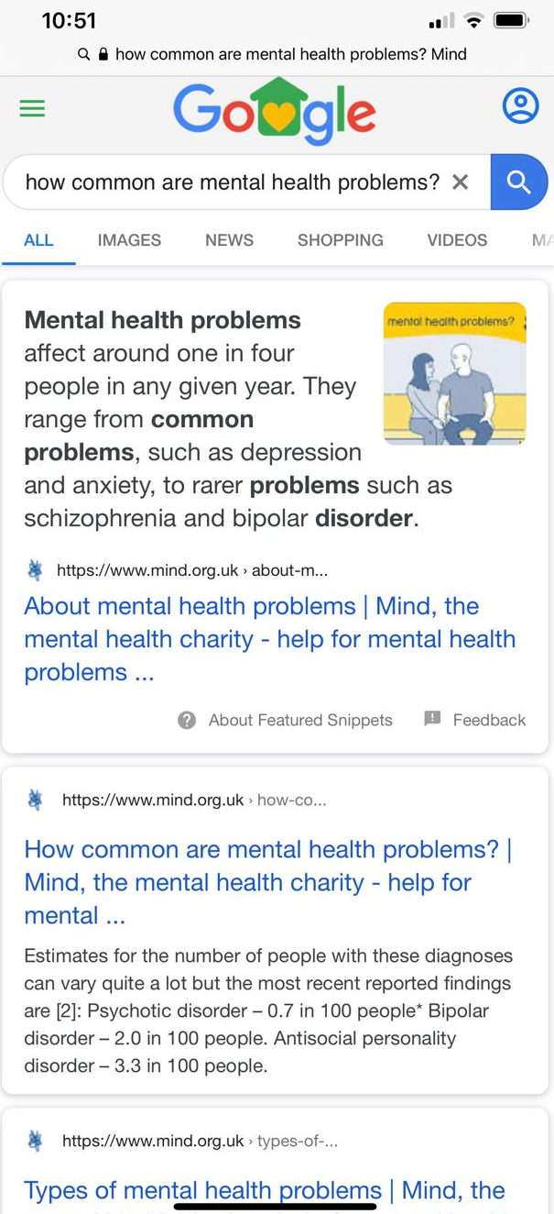
- Task 3:
- Complete the table below using the statistics from the website.
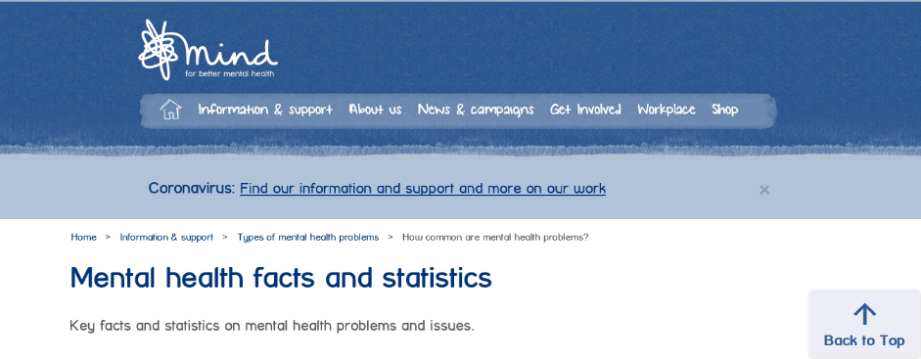
Approximately 1 in ____ people in the UK will experience a mental health problem each year.
Generalised anxiety disorder – ______ in _____ people.
Depression – _____ in _____ people.
Obsessive-compulsive disorder (OCD) – ______ in ______ people.
Post-traumatic stress disorder (PTSD) – _____ in _____ people.

Task 4: Read through Violet’s story. Violet has experienced stigma because of her mental health condition.
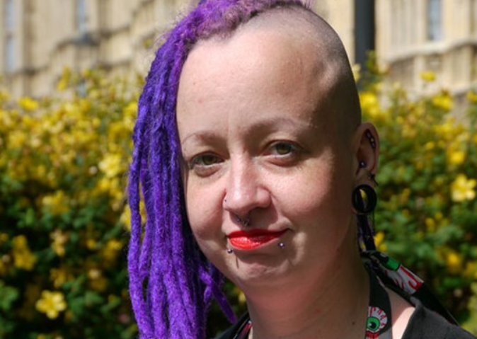

How I challenged stigma
Violet shares her story of experiencing stigma and discrimination because of a mental health problem.

When you are unwell you hope that people will be there to support you. I find when you are physically ill people can't seem to do enough to for you. They will go out of their way to help and support your recovery, even if the illness is mild. However, during my struggle with mental health problems I have found that some people are not supportive and can make things considerably worse.
Some people told me that they didn't believe in mental health problems, as if mental health problems are a myth that they could choose not to believe in. Even when presented with evidence and facts regarding mental health they refused to accept that I was ill. They thought I (and presumably everyone else with the same conditions) were lying. There have been many occasions when I've been told that I was lazy and selfish. Some people were of the opinion that I should easily be able to pull myself together and shrug off my problems. Hearing these statements so often from different people made me question everything about myself. “Did I really have mental health problems?” “Was I just a weak, flawed person?”
These thoughts consumed my mind and had a devastating effect on my emotions which were already incredibly negative. When I thought I had hit rock bottom, these people had shown me I could feel even worse. I felt completely worthless and, like everyone, despised me simply because I was ill. Luckily my parents were completely supportive of me. They often said that it was “us three against the world”, which reassured me that no matter what anyone else said, they would be there for me. My parents were also the target of horrible comments. One person said it was their fault that I was ill, telling my parents they should have “beat that out of her when she was younger”. I found that the stigma surrounding mental health problems doesn't just effect the person with the illness but all those who support them too.
It took me a long time to come to terms with the fact that people who I'd been close to had turned their back on me. It made me terrified of disclosing the fact I had mental health problems to anyone, because I was convinced everyone would hate me. I avoided making new friends and pushed away the ones I already had. I felt completely isolated and I was so ashamed of having mental health problems. Now I realise that everything those people say is nonsense. My mental health problems are no one’s fault. I am not lazy or selfish, but someone who has to cope with a horrible illness.
Things first started to change for me was when I went to my local Mind and met others with mental health problems. I realised that I was not the only one suffering mental health problems. I was surrounded by positive, supportive people and this gradually gave me the confidence to speak openly about my own mental health. The more open I became about it the more people I met who were supportive. Over time I began to realise I didn't have to deal with the negative people so I avoided them whenever possible. I created a positive memories scrapbook and also kept a note of compliments I've received. When I do get insults I prove to myself they're not true by referring to these.
I feel so angry that mental health stigma still exists and find challenging it can be so frustrating. Mental health problems can be life threatening, and are just as serious as physical health problems. There is no excuse for people being nasty to those who suffer with any health issues. I will work to fight mental health stigma until no one has to go through negative experiences like mine.

https://www.mind.org.uk/information-support/your-stories/how-i-challenged-stigma/

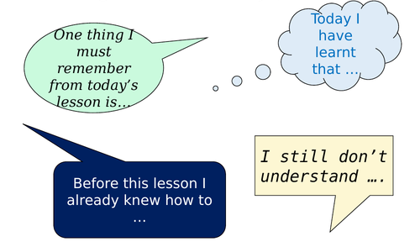
Task 5 (plenary task): Complete two of the sentences from the image below.

- ____________________________________________________________________________________________________________

- ____________________________________________________________________________________________________________

Well Done! Lesson 3 is finished
Teacher Feedback:

PC1d A NA

