SQA Mental Health
Award
UNIT 1: Understanding Mental Health Issues ​
Pupil Name/Class:
Teacher:

Outcome 1:
Describe what is meant by the terms “mental health” and “wellbeing” for individuals and wider society. ​
Performance criteria ​
- Describe the needs and wants of individuals.
- Describe terms in relation to mental health and wellbeing​.
- Describe how mental health and wellbeing is portrayed in the media​.
- Describe myth busting in relation to mental health issues​.
- Explain legislation and strategy in relation to mental health.
Evidence Requirements:
- Describe 2 needs and 2 wants of individuals.
- Describe 2 terms in relation to mental heath and wellbeing, giving a definition of each.
- Describe 2 myths and 2 facts in relation to mental health issues.
- Explain 1 policy and 2 pieces of legislation/ strategy relevant to mental health.
Needs and Wants of Individuals
Lesson 1
Learning intentions:
- Describe 2 needs and 2 wants of individuals
Success Criteria:
- I can describe 2 needs and 2 wants of an individual
- I understand the differences between needs and wants
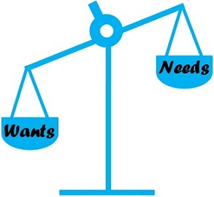
Task 1 (starter task): Write down what you think a person’s ‘needs’ and ‘wants’ are in the space below.
Needs:

Wants:

A need is something we must have for survival.
A want is a desire, something that is wished for, it can often make life more enjoyable or pleasurable, but it isn’t required for survival.

Add these terms to your learning diary.
Task 2:
- Using 5 different colours or by using a different symbol for each, identify the different needs of an individual: Social, Physical, Emotional, Cognitive and Culture.
- Complete the mind map with at least 6 different ‘wants’ of an individual.
- Then write your own definition of a ‘need’ and a ‘want’ of an individual and describe the difference between the two.
Needs of an Individual
Relationships | Security | Expressions of emotion | Imagination | Thinking and problem solving
Sleep | Identity | Love | Warmth | Feeling connected
Shelter | Sex | Values and Belief | Safety | Food

Key:
Social
Physical
Emotional
Cognitive
Culture
Designer Clothes
Wants of an individual

A need of an individual is ________________________________________________________________________________________________________________________________________________________________________

A want of an individual is
________________________________________________________________________________________________________________________________________________________________________

Describe the difference between a need and a want:
________________________________________________________________________________________________________________________________________________________________________________________________________________________________

Task 3: Read the case study below and identify two needs and two wants that Kate has.
Kate is 13 years old and lives with her parents and younger sister. She has recently been diagnosed with anxiety and depression, is self-harming, and is struggling with her day-to-day life. She shuts herself in her room, doesn’t want to go to school and always makes excuses about not going out with her family and friends. She is telling her friends on social media that she is feeling very low and mentions that she can’t cope with the bullying she receives at school with people calling her names. She feels that using social media helps her and that a new mobile phone will let her keep in touch more with her friends. Her mum and dad don’t really understand why she is like this and tell her that she must get better before they buy her a new mobile phone.

Two wants Kate has are:

Two needs Kate has are:

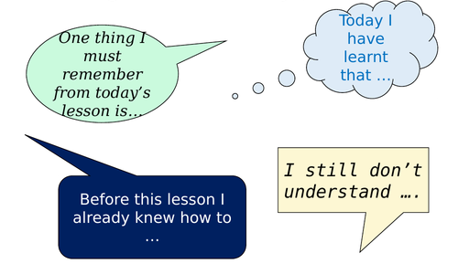
Task 4 (plenary task): Complete two of the sentences from the image below.

- ____________________________________________________________________________________________________________

- ____________________________________________________________________________________________________________
Well Done! Lesson 1 is finished
Teacher Feedback:

PC1a Achieved A NA
Mental Health and Wellbeing terms
Lesson 2
Learning intentions:
- Describe 2 terms in relation to mental health and wellbeing, giving a definition of each.
Success Criteria:
- I can name and describe 2 mental health and wellbeing terms.
- I understand why it is important to have good mental health and wellbeing.

Task 1 (starter task): Write down what your think mental health and wellbeing is in the space below.
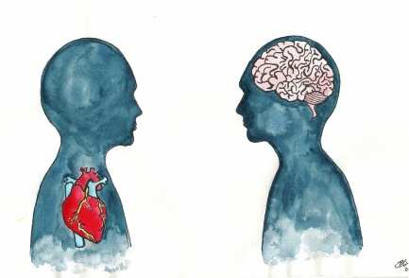
Mental health and wellbeing is:

Task 2: Compete the table below by looking up each of the terms (remember to write your source down!).

Term | Definition
Mental health

Mental illness

Mental wellbeing

Task 3: Watch the video ‘What are mental health problems?’ on YouTube. This is a 2-minute clip (1.57 minutes) from Mind, a mental health charity.
Write down any thoughts you have from the video.
________________________________________________________________________________________________________________________________________________________________________
Task 4: Read through the information below.

Term | Definition
Mental health | According to the World Health Organization mental health is defined as a state of wellbeing in which every individual realises their own potential, can cope with the normal stresses of life, can work productively and fruitfully, and is able to contribute to their community.
Mental illness | A group of conditions that affect a person’s ability to think, interact with others and cope with everyday life.
Mental wellbeing | A state of being comfortable, healthy and happy.
Add these terms to your learning diary.

If you have good mental wellbeing you can:
- feel relatively confident in yourself and have positive self-esteem
- feel and express a range of emotions
- build and maintain good relationships with others
- feel engaged with the world around you
- live and work productively
- cope with the stresses of daily life
- adapt and manage in times of change and uncertainty
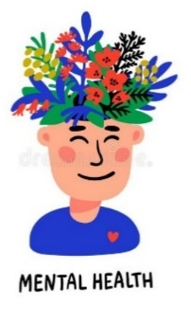

Task 5: Create an information poster or mind map.
Choose one of the mental health and wellbeing terms (mental health, mental illness or mental wellbeing) and create your poster on this term.
Success Criteria:
- Definition on the term
- More information (research on your chosen term)
- Why is having good mental wellbeing important?
- Diagram/ picture

There is space on the following page to do this.

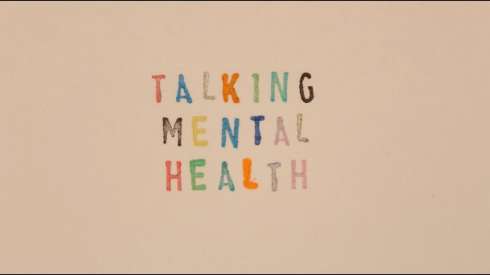

Task 6 (plenary task): Complete two of the sentences from the image below.

- ____________________________________________________________________________________________________________

- ____________________________________________________________________________________________________________

Well Done! Lesson 2 is finished
Teacher Feedback:

PC1b A NA

