LESSON FOUR – SELF CARE AND MINDSETS
STARTER TASK:

TASK ONE:
Describe Examples of Self Care | Benefit 1 | Benefit 2
Good sleep routine | Allows the body and mind to rest and be alert | More tolerant and able to deal with stresses
Visiting family regularly
Regular exercise
Meditation
Prioritising what is important
Setting personal challenges
Educating yourself
Having fun
Playing / listening to music
Doing creative activities
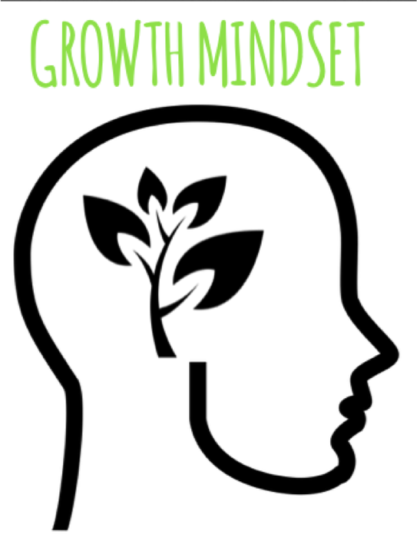
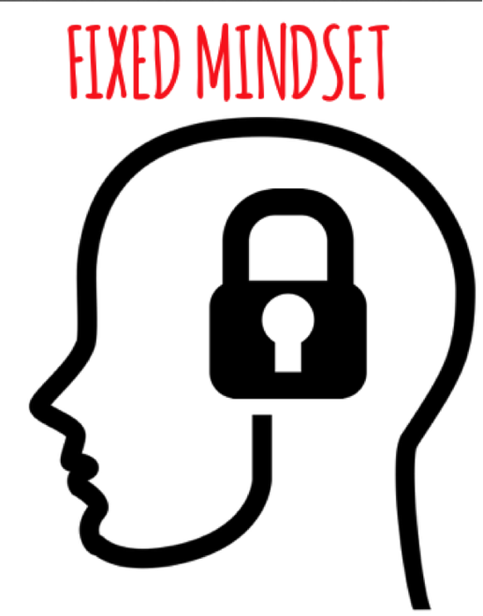
TASK TWO:

