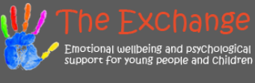

“We are Here.”

Here at The-Exchange its business as usual and online referrals for children and young people can be made in the usual way by visiting our website.

We have pulled together an update for you on how we are running through the pandemic and beyond from both our Primary and Secondary school services who are providing support to schools across Renfrewshire.

-Primary Schools

Here, in The-Exchange Primary team for Renfrewshire we are still working to provide support to those who need us. This is both through virtual 1:1 support and in online group meetings where our practitioners are delivering a selection of our Resilience boosting intervention programmes.

Currently running, we have our transitions and change intervention called The Adventure Programme, our programme which focuses on building positive friendships called The Friendship Shield and our self-esteem boosting intervention called The Key to Me.

We usually facilitate these programmes on a 1:1 basis or in small groups in schools but for the lock-down period we have taken them online on a bigger scale to support as many children as we can.

Our focus continues to be on how we can access the children in the Renfrewshire community during this challenging time. We are working in collaboration with the schools to ensure the children can access their appointments with us at a convenient time, whether they are in school using the key worker hub or at home being taught remotely.

When reaching out to those at home, we are sensitive to the challenges that virtual learning can present and are using this time to check-in with parents as well.

Here in the Primary service, we value the importance of collaboration to the well-being of children and are utilising the limitations of the pandemic restrictions to support families in the community.

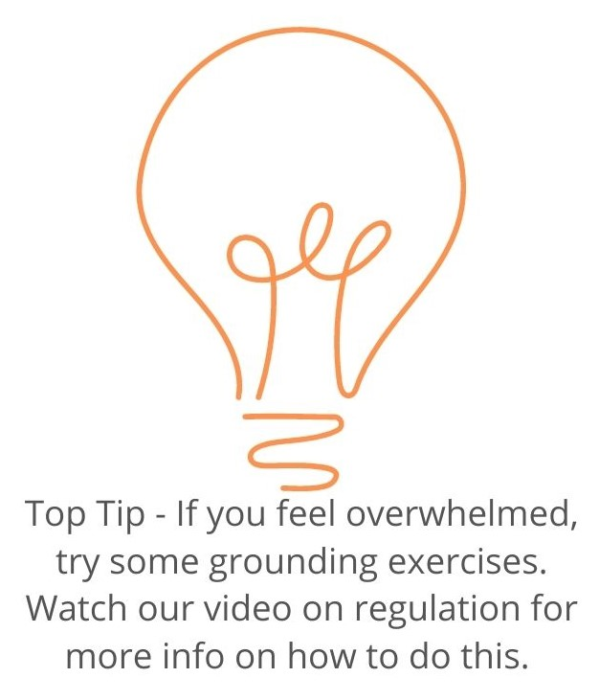
- Secondary Schools

Our blended service continues to offer emotional & psychological support to young people remotely via telephone, on-line chat or video calling. We are offering all our young people a choice of how to access and engage with our service, valuing the autonomy of each individual.

During lock-down we are offering a range of online group sessions with specific themes such as –
- Lockdown survival kit
- What’s happening to my friendships?
- Let’s talk about feeling anxious.
- Lockdown wellbeing - you either love it or hate it.

These groups are designed to help young people have a safe confidential space to talk and offer peer support using our resilience model to help raise awareness of what they are already doing well, area’s they feel less supported in and how they might reach out.
.

To submit a referral, please visit
www.exchange-counselling.com/contact_us

Click on the orange button.

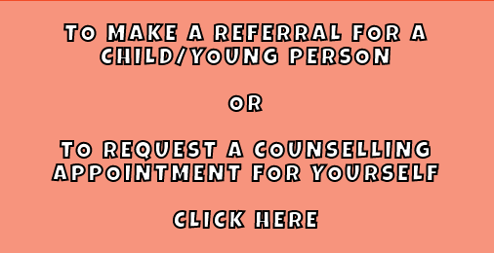

-School Staff Wellbeing

“The wellbeing of the whole school community is key!”

We are offering “one-off” on-line Reflective Practise Groups across all secondary schools for members of school staff. The purpose of these groups is to allow staff to have a confidential space with an external facilitator to think and talk about different aspects of their work, talk about interventions they might use as well as considering how to monitor the impact areas of their work are having on them and to share ways of developing healthy responses to issues, they are dealing with.

We as a service are happy to be a part of the Renfrewshire community and we hope to see you all in school very soon.

Take care,

The-Exchange

Contact us via our text-based chat service.
www.exchange-counselling.com

Click on the blue speech bubble.

Meet The-Exchange Team…

Michelle
School-based Therapist & Manager
Favourite Colour: Blue
Favourite Book: The Alchemist
Favourite food: Chocolate Most favourite thing in the world: laughing with friends so much, my ribs hurt!

Amy
School-based Therapist & Manager
Favourite Colour: Blue
Favourite Book: The Lion, The Witch and The Wardrobe
Favourite food: Pasta
Most favourite thing in the world: Animals

Lenny
School-based CBT-Therapist.
Favourite Colour: Orange
Favourite Book: The Man who loved a Polar Bear
Favourite food: Wagamama food.
Most favourite thing in the world: Notebooks & Coffee

Rebecca
School-based Therapist.
Favourite Colour: Yellow
Favourite Book: Matilda by Roald Dahl
Favourite food: Fajitas
Most favourite thing in the world: My cat, Millie

Jim
School-based Therapist
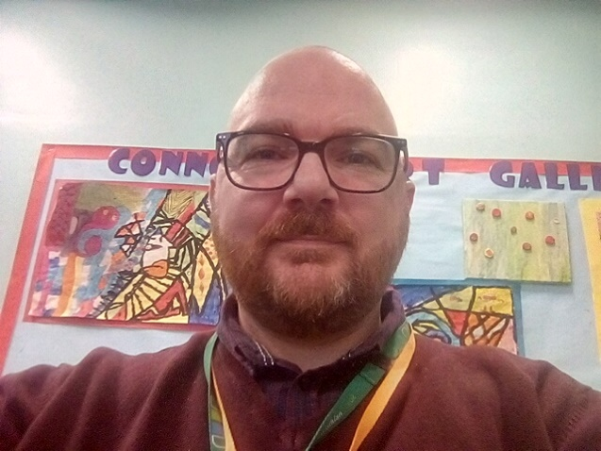
Favourite Colour: Black
Favourite Book: I don’t have one
Favourite food: Salt and Chili Chicken
Most favourite thing in the world: Watching Netflix with the family

Tracey
School-based Therapist.
Favourite Colour: Green
Favourite Book: A year of Marvellous Ways
Favourite food: Seafood Most favourite thing in the world: My Dog, Noodles

Tracy
School-based Therapist.
Favourite Colour: Pink
Favourite Book: Harry Potter
Favourite food: Italian Food
Most favourite thing in the world: Nature

Zoe
Resilience Coach

Favourite Colour: Purple
Favourite Book:
Favourite food: Steak Pie
Most favourite thing in the world: Music

Bogdan
School-based Therapist.
Favourite Colour: Blue
Favourite Book: The Power of Now
Favourite Food: Grandma’s Cake
Most favourite thing in the world: Love

Lorraine
School-based Therapist
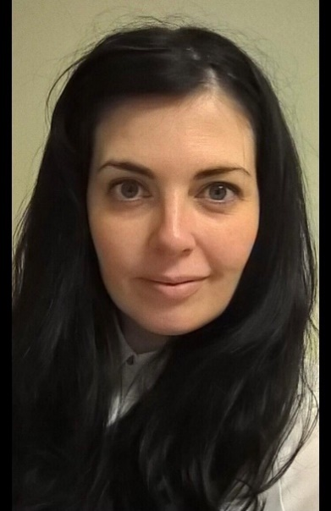
Favourite Colour: Dark Green
Favourite Book: The Velveteen Rabbit
Favourite food: Roast Potatoes
Most favourite thing in the world: Nature

Jackie
School-based Therapist.
Favourite Colour: Black
Favourite Book: Flowers in the Attic
Favourite food: Steak
Most favourite thing in the world: Pen and Paper.

Jon
School-based Therapist
Favourite Colour: Orange
Favourite Book: Jaws
Favourite Food: French Toast
Most favourite thing in the whole world: My Cat Murray

Jessica
School-based Therapist and Manager
Favourite Colour: Pink
Favourite Book: Harry Potter
Favourite food: Mexican Most favourite thing in the world: My Family

Kathleen
School-based Therapist.
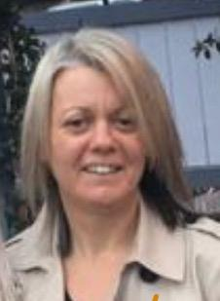
Favourite Colour: Green
Favourite Book: ‘The Parable of the Sower’
Favourite food: Veggie Curry
Most favourite thing in the world: Relaxing with family and friends.

