Relationships, Sexual Health and Parenthood – Home Activities – Second level (P5, P6 and P7)
Over the coming weeks we would have been delivering Relationships, Sexual Health and Parenthood Education lessons with your child’s class. This is a really important part of the wider health and wellbeing programme of learning and you might already find yourself answering questions about some of these themes. We thought it would be useful to provide you with some activities that we have taken from the national resource for RSHP at www.rshp.scot
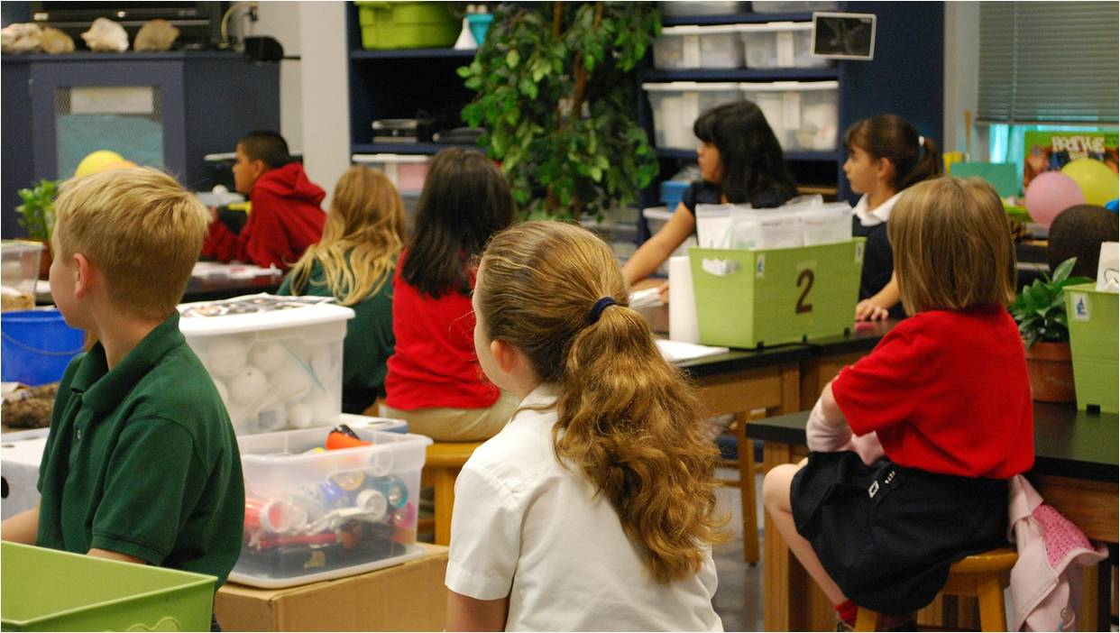
Topic/Theme | Emotional wellbeing and body image
Title | When I feel sad or worried
Activities | Explain that sometimes we have feelings that can be too big, so that you need to talk about them. Explain that today you are going to have a think about some feelings like this – so when a child feels sad or worried.  Ask:  What can make someone feel sad?  What can make someone feel worried?  Explain that you would like them to think about what someone can do when they have these feelings. Then Just chat through using these questions as prompts.  When someone feels sad, what can they do?  When someone feels worried, what can they do?  Old Wormwart’s cure for worrying. Do your children like stories and using their imagination – this is an approach that is a bit of fun but will tap into their interest in wise old bards or witches and wizards. Introduce along these lines: Children have always had feelings like being sad or being worried. A long time ago an ancient wise woman called Old Wormwart created a cure for children for whenever they had a worry. Today we will hear it, and you can decide if it’s a cure you would recommend or use yourself! Use the handout, discuss as you read  https://rshp.scot/wp-content/uploads/2019/07/Part-3.-When-I-feel-sad-or-worried-Prop.pdf  Some useful slides to compliment the learning can be found here https://rshp.scot/second-level/ (When I feel sad or worried slides)  Would your child add anything? How much of it and why?
Learning Intentions | Children learn to recognise their feelings.  Children learn help-seeking behaviours.
Key messages for Parents/Carers | Explain that you would like your child to remember some important messages about feelings and emotions, especially if they feel uncomfortable or too big to cope with.  You may want to familiarise yourself with the slides before delivering the lesson.  Managing our feelings, our emotions, is one of the most important life skills a person can develop.  Notice how you feel. Pay attention to how strong the feeling is. If a feeling feels too big then it’s time to share with someone.
Topic/Theme | Emotional wellbeing and body image
Title | My Feelings
Activities | Explain that we know it is important to keep our bodies healthy but it is also important to keep our minds healthy. The way we feel is very important and sometimes feelings can be very strong. Explain that today you are going to have a think about some feelings that people have.  Ask:  How did you feel when you woke up this morning? How do you feel right now?  Explain that people can have many different feelings. Using some sheets of paper ask them to write down as many different types of feeling as they can. Chat through the feelings written down and acknowledge that some feelings can be uncomfortable and discuss using these questions as prompts.  Which feelings are comfortable for you? Which feelings are uncomfortable for you?  Using the situation cards provided at https://rshp.scot/wp-content/uploads/2019/07/Part-1.-My-feelings-Prop.pdf , explain that the children involved are experiencing strong feelings and use the following prompt questions to discuss each scenario  • What feelings is the character experiencing?  • Can your character change or influence anything that is happening?  • Is there anything going on that they really can’t change or influence?  • What do you suggest they do?  • What would you do as their friend?  Some useful slides to compliment the learning be found here https://rshp.scot/second-level/ ( My Feelings slides)  Would your child add anything? How much of it and why?
Learning Intentions | Children learn to recognise their feelings.  Children learn help-seeking behaviours.
Key messages for Parents/Carers | Explain that you would like your child to remember some important messages about feelings and emotions, especially if they feel uncomfortable or too big to cope with. Managing our feelings, our emotions, is one of the most important life skills a person can develop. Notice how you feel. Pay attention to how strong the feeling is. If a feeling feels too big then it’s time to share with someone.
Topic/Theme | My body
Title | My body is changing
Activities | Begin by talking about how their bodies have changed as they grow up – focus on how they have physically changed. Start with this question and chat about the changes - can you name 5 ways your body has changed since you were a baby? Then, ask the question ‘What is puberty?’ the slide ‘my body is changing’ can be used here. There may be questions, some of which you will want to answer immediately, some that you might want to leave until later –it is useful to have some paper to one side, explain this is where any questions about puberty can be noted down that you will come back to them at some point today or later.  What is puberty? Puberty is the time in your life when your body begins to change. Some changes you can see. Some changes happen inside your body. You can’t see these. You can have stronger emotions and new feelings. Explain that a question that children often ask is “when will puberty happen to me?” Stress that there is no rush when it comes to puberty, everyone is different and unique, but we are talking about it now so that we understand the changes when they do happen. Puberty changes happen over several years. Usually between the ages of 9 and 16. Some changes in your body might be happening now, some will happen later. This is different for everybody. Hormones: All the changes that happen during puberty are caused by chemicals in your body. These chemicals are called Hormones. When your body is ready to begin puberty, your pituitary gland (a pea-shaped gland located at the bottom of your brain) releases these special hormones. Depending on whether you're a boy or a girl, these hormones go to work on different parts of the body. What happens when we go through puberty? Body outlines can be drawn or you can write on a sheet of paper, the puberty changes (both physical and emotional) that can happen to both boys and girls. The slides can be used to explore each area: Hair/Skin/Body shape/Breasts/Voices/Smell.  Some useful slides to compliment the learning be found here https://rshp.scot/second-level/ ( My body is changing Slides)  Would your child add anything? How much of it and why?
Learning Intentions | Children recognise that body changes with puberty impact on feelings and behaviour  Children understand the importance of personal hygiene
Key messages for Parents/Carers | Explain that puberty happens at different times for everyone and this is normal. If they have any further questions then they should ask a trusted adult  This is a good article to read yourself or with your child: http://kidshealth.org/en/kids/puberty.html

Topic/Theme | My body
Title | Feelings and puberty
Activities | Recap on the previous activity remembering the physical changes that happen to their bodies as they go through puberty. Discuss that puberty is also a time when how we feel changes. Explain along these lines: Sometimes this means that you can have very strong feelings and find it difficult to get on with people. Sometimes you might feel that you are growing up and want to be a bit more independent. It can also mean that you really like someone, have a crush on someone and want to be close to them.  Introduce the idea of feelings, moods and emotions with the 2 slides – encourage thoughts/feedback. People use different words like feelings or emotions or mood to describe how a person feels at times. When your body changes with puberty, you might feel things more strongly, or your feelings can change quickly. You might hear people say that with puberty you get moody or have mood swings.  Why does puberty affect my feelings and emotions? Use the slide to introduce the impact of hormones Introduce the Feelings Game, this can be found herehttps://rshp.scot/wp-content/uploads/2019/07/Part-3.-Feelings-and-puberty-Prop.pdf and can printed or written down. The game is to pick a card, think about when you get this feeling and then share your thoughts. You can explain your own feelings for these cards too. Remind them that there are no right or wrong answers, that feelings are very personal, and we are all different and unique when it comes to how we feel about things. Use the 2 prompt slides to ask/discuss strategies in terms of: What do you do if you feel sad? What do you do if you feel angry?  When you like someone. Introduce the idea that with strong feelings and moods it might be that the children really like someone. Of course, they can like someone as a friend or they might have different feelings for someone which mean they might want to be closer to them. Sometimes people talk about having a crush on someone or (ask what your child might say). Acknowledge that it can be a bit embarrassing if other people notice or say something without the person wanting them to. Share the slides and read together, discuss why the final point is so important? During puberty, you can start to have feelings of attraction to someone. You might ‘fancy’ other boys and girls. You may even feel like you’re in love! When you like someone. That’s okay. They might like you back. But they might not feel the same way, and that’s okay too. You should never try to make someone feel something that they don’t want to feel!  Being more independent. Explain that “the final part of what we need to think about as we grow up and experience puberty is that you might feel that you would like to be more independent”. Use the slide to discuss the meaning of independence. Independence is when you learn to think and do things for yourself. As you get older you might become more independent and want to do things for yourself. Discuss the next 2 questions on the slide. What do you do now for yourself that you didn’t used to do? Then: What things would you like to do more on your own or for yourself because you are getting older? Have some discussion about what factors influence the level of independence the child can have – for example, what parents/carers let them do, what parents/carers worry about, how confident they are to do something for themselves, needing to practice things to become more independent etc.  Some useful slides to compliment the learning be found here https://rshp.scot/second-level/ ( Feelings and puberty slides)  Would your child add anything? How much of it and why?
Learning Intentions | Children recognise that body changes with puberty impact on feelings and behaviour  Children learn strategies to manage emotions
Key messages for Parents/Carers | Recap that feelings are different for everyone and how people deal with things can be different. It’s good to talk about feelings with someone you trust  You may want to familiarise yourself with the slides before delivering the lesson.

Topic/Theme | Puberty
Title | Menstruation (Periods)
Activities | Explain to your child that you are going chat about how the female bodies change as children grow up.  There are useful slides to talk this through with them here https://rshp.scot/second-level/ (Menstruation slides)  Watch the film Menstruation: What to expect (duration 3 minutes 18) https://youtu.be/DBe7-PHRav8 and chat about any questions that come up.  It is important to explain the need for good personal hygiene and the following film clip provides a good explanation for this. Period hygiene: Tampons, Pads and Menstrual Cups (duration 2 minutes 9)  https://youtu.be/kmWbOC8Fbb0 talk through any questions that come up.
Learning Intentions | Children learn the correct names for parts of their body, including male and female genitalia, and their functions.  Children recognise that body changes with puberty impact on feelings and behaviour.  Children understand the importance of personal hygiene.
Key messages for Parents/Carers | It is important for all children to understand menstruation regardless of gender. Having positive conversations about this natural process can help dismantle the stigma around periods, and reduce teasing.  If you want to go into a bit more detail, there is more information available from Hey Girls at: https://www.heygirls.co.uk/education/schools/  This is also good article to read yourself or with your child: http://kidshealth.org/en/kids/puberty.html

Topic/Theme | How Human Life Begins – Pregnancy & Birth
Title | How Human Life Begins
Activities | Your child will already have learned about the names of parts of the body and we have shared with you some activities to talk about puberty. Before you start this activity it would be a good idea to revisit the following questions; How is their body changing? Their feelings/emotions changing? What names do they remember for  private parts of their body? The first 3 slides here might be useful for you at: https://rshp.scot/second-level/  (How Human Life Begins slides)  Before you begin to talk about human life begins you can use the slides or look at some pictures of fully-grown animals and their babies and ask your child if they can tell you the names of the animals and the name of the baby of each species. End this introduction with the slide or a picture of a human mother and child. Explain that all the babies and animals we have seen are alike, the babies are made, they grow inside the mum, and then they are  born.  Explain that you want to talk about how babies are made (this is called fertilisation), how they grow during pregnancy, and what happens when a baby is born.  Acknowledge that they might know things about this already but that today you want to talk about this together. Do they know any woman who is pregnant just now? Can they remember when anyone in the family was pregnant? What do they already know about pregnancy? Birth? (No need to correct any misinformation, just respond if you need to with there will be a chance to talk more about it now and for them to ask any questions that they might have.  The PowerPoint slides at: https://rshp.scot/second-level/ (How Human Life Begins slides), provide the story we want to tell in 3 parts, pausing, checking understanding and asking/taking questions and thoughts as you go. Encourage conversation, pause and review as often as is helpful. This slide show starts with a short film about human reproduction https://www.bbc.com/bitesize/clips/zpmqxnb (duration 1 minute 3 seconds)  When you start to talk about how the baby develops during pregnancy, there is another useful film here: (duration 4 minutes 17) https://youtu.be/h82ltr84_Yg
Learning Intentions | Children know the names for parts of their body required to understand conception, pregnancy and birth.  Children understand where living things come from.
Key messages for Parents/Carers | You might find that your child has a lot of questions about this or indeed none at all but it is important to answer any queries that they have in order that they are confident to come back and ask any follow up questions if they have any.  If you have time or want to follow this up you could do another activity where you could ask them to draw a picture that shows all the things a pregnant woman and her baby need to be healthy, happy and safe.

Topic/Theme | Being a Parent/Carer
Title | What does a parent/carer need to know and do?
Activities | Explain that you are going to talk about how important parents and carers are for children. You can use the information on the first slide here https://rshp.scot/second-level/ (What does a Parent/Carer need to know slides)  Then show the next slide with pictures of different families to establish that the role can be fulfilled by a range of adults in a child’s life.  A parent or carer is an adult in your life who looks after you and cares for you. Parents and carers are really important in a child’s life.  Ask your child to draw a picture to include the following:-  • Who looks after you?  • How would you describe them?  • What do you like to do together?  • What’s your favourite thing about the person who looks after you?  What do parents and carers do for children?  Explain that you will be having a chat now about the things that a parent or carer does for their child. As you do, acknowledge what things stay the same, and what changes as a child grows. Start with a baby (Slide) the question is: What things does a parent or carer do for a child when they are a baby to make sure they are healthy, happy  and safe? Then, explore why they do these things? Who does them? Maybe they have an example of when they or a brother or sister also help and care for others. Maybe adults in their family help and share their care. Work through the next 4 slides which show a toddler; 5-year-old; 10-year-old; 15-year-old asking the same questions.  Have a conversation about What do you think are the most important things a parent or carer does for their child? Explore why so, appreciate different views.
Learning Intentions | I know that all families are different.  Children understand and explain the role and qualities of a parent/carer.
Key messages for Parents/Carers | This lesson is about recognising how important parents and carers are, identifying all the things they do to  make sure their child is healthy, happy and safe. The lessons is part of our ongoing programme of  learning about relationships which includes supporting children to think about family life and parenthood.  For your information these sites might be helpful:  Parent Line Scotland offer a free telephone, email and online chat service with confidential help and  support available for any parent or carer https://www.children1st.org.uk/help-for-families/parentlinescotland/  Parent Club has lots of great information and support for life’s up and downs as a parent or carer:  https://www.parentclub.scot/  Parentzone provides information about schools and education: https://education.gov.scot/parentzone  Play Talk Read gives lots of helpful tips about helping your child learn from the early years – and have fun  together: http://playtalkread.scot/  Information about the United Nations Convention on the Rights of the Child:  https://www.unicef.org.uk/what-we-do/un-convention-child-rights/

