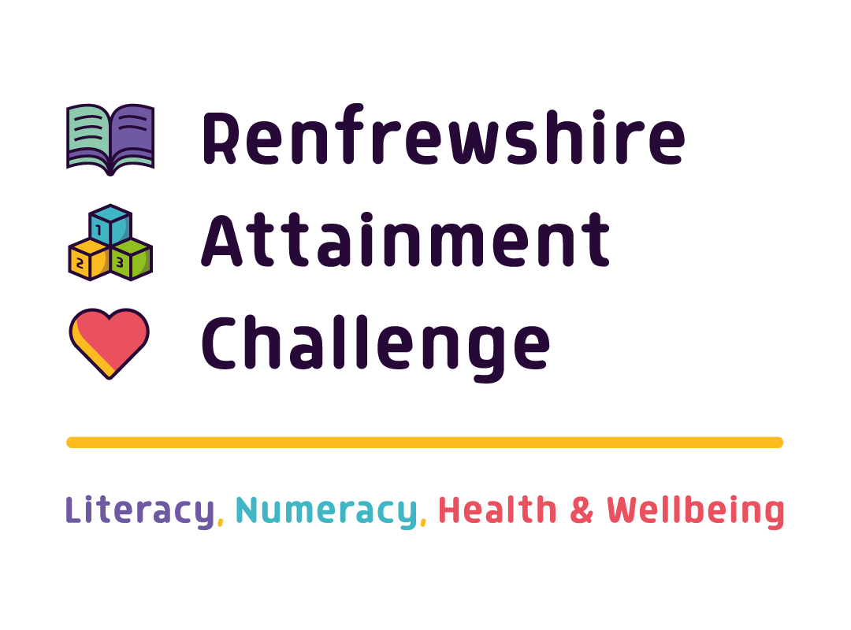
A review of Personal and Social Education across Renfrewshire Primary and Secondary Schools

Contents
Introduction 1
Summary of Key Findings 2
Health and Wellbeing – Introductory Activity (SHANARRI) 3
Recognising and Celebrating Achievements 4
Primary 4
Secondary 6
Pupil Voice – Learning and Teaching in HWB/PSE 7
Learning and Teaching – how does it help inform decisions in everyday life? 8
Primary 8
Secondary 9
Staff perceptions on topics of interest 10
Delivery of HWB/PSE and Partnership with External Services 11
Primary 11
Secondary - Who should deliver PSE? 11
Staff perceptions on external agency delivery 12
Secondary - Should teachers specialise in one area of HWB/PSE? 13
Staff perceptions on delivery of PSE lessons 13
Pupil Voice - Monitoring HWB in school 14
Primary 14
Secondary 14
Staff perspective on young people’s involvement in the planning and delivery of PSE classes 14
Pupil Voice – Equality and Diversity (Secondary) 15
Pupil Voice – How important is PSE ? (Secondary) 15
Staff perspectives - thoughts on the current PSE curriculum 16
CONCLUSION 18
Appendix 1 – Primary focus group guide 19
Appendix 2– Secondary self-completion questionnaire 28
Appendix 3 – Staff questionnaire 37

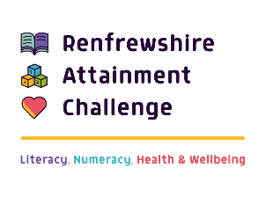
“Learning in health and wellbeing ensures that pupil and young people develop the knowledge and understanding, skills, capabilities and attributes which they need for mental, emotional, social and physical wellbeing now and in the future”

Introduction

The health and wellbeing (HWB) of young people is a key priority of the Scottish Government and is underpinned by policies such as Getting it Right for Every CHILD (GIRFEC) and the Curriculum for Excellence (CFE), both of which serve the purpose of ensuring that children and young people have the best start in life, are ready to succeed and live longer healthier lives. HWB in schools plays an instrumental role in meeting these aims. Using the report published in January 2019, following the national Personal and Social Education (PSE) thematic review, pupils across primary and secondary schools in Renfrewshire were consulted on their views/opinions of their HWB/PSE learning experience with the intention of finding out more about the following: (i) current practice that addresses the HWB needs of our pupils, (ii) to understand more about what they like to learn about and/or wish to learn more about, and (iii) identify inconsistencies in learning experiences between sectors and within clusters. The findings will be collated and will help to inform the development of an advised ‘Framework for Personal and Social Education’ in Renfrewshire from early level to senior phase in the following areas:
- Planning for Choices and Changes
- Physical Activity and Health
- Substance Misuse Education
- Relationships, Sexual Health and Parenthood Education
In primary schools, HWB is blended into whole school ethos. Schools’ vision, values and aims underpin many of the HWB related activities such as nurture, anti-bullying and learning about the SHANARRI (safe, healthy, achieving, nurtured, active, responsible, respected, included) wellbeing indicators, for example.
Focus groups were conducted with pupils across 24 of Renfrewshire’s 49 primary schools. The schools have been randomly selected with careful consideration to represent all clusters. In total, the Scottish Attainment Challenge (SAC) Health and Wellbeing Officer consulted with 265 pupils from stages Primary 5-7.
In secondary schools, the review was supported by Renfrewshire Youth Services. The process was underpinned by previous groundwork achieved by their Youth Voice Programme. As part of Year of Young People in 2018, young people were invited to propose a youth motion to leaders within the authority. Their proposal was to seek a review of PSE in schools, as youth consultation had raised the issue that young people felt it needed to be changed and improved. Participants and youth workers spent a considerable amount of time looking at wellbeing outcomes, Peer Education tools, national youth work outcomes and methods of youth engagement in schools before the PSE review took place.
Data was collated by youth services who designed and distributed self-completion questionnaires to secondary pupils. Of the 11 secondary schools, 5 schools participated. In total, 122 secondary school pupils took part across stages S1-S6. Data was also drawn from focus groups held by the Alcohol and Drugs commission, of which a further three secondary schools participated. A small survey was also conducted with secondary school staff. In total, 21 responses were received across 10 secondary schools. The data was analysed using a content analysis framework which focused on key PSE/HWB topics and the extent to which they were linked to SHANARRI wellbeing indicators which are demonstrated below:
Figure 1 SHANARRI wheel
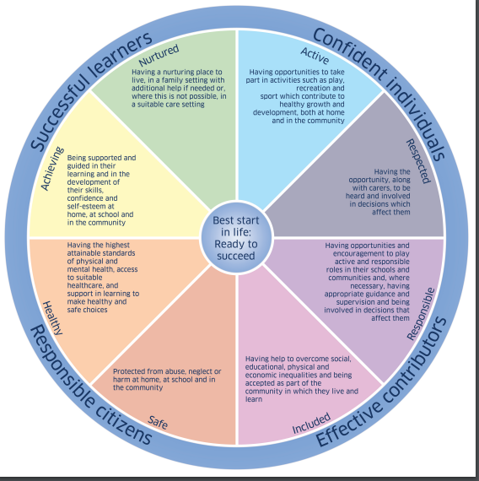
The data from the staff survey was used in two ways (i) to gain insight into the perspective of staff around the PSE curriculum and (ii) to compare and contrast staff opinions with that of pupils.

Summary of Key Findings
Pupils showed a good understanding around the purpose of celebrations and awards, although secondary pupils were less likely to emphasise such activities as playing an important part in their development.
There were key similarities around the topics that both primary and secondary pupils would like to learn more about including life skills (career/finance), drugs, mental health, sexual health and relationships. For secondary, these topics were further confirmed by staff.
On the delivery of PSE – opinions were divided suggesting that a mixture of both teaching staff and external agencies is beneficial.
Teaching staff indicated that they would benefit from further professional development around PSE topics.
Developing the PSE curriculum – staff indicated that the pupil voice plays a central role in the teaching and delivery of PSE however pupils felt this less to be the case.
Suggestions to improve PSE – pupils focused on ‘the voice of experience’ to allow them to develop a stronger understanding of how some issues can impact on their lives. Staff focused on training, consistency and continuity in the delivery of the PSE curriculum.

Health and Wellbeing – Introductory Activity (SHANARRI)

At the start of the focus groups, the team conducted an icebreaker exercise to help put the pupil at ease and to allow them some time to think about the topic that would be discussed. Participants were split into two groups and ask to prioritise the SHANARRI wellbeing indicators within a diamond shape from what they felt was ‘most’ to ‘least’ important. The exercise acted as an icebreaker and also stimulated discussion among the pupils who, debated about the importance of the indicators. The diagram that follows provides a visualisation of the general consensus among pupils with regards to how they prioritised indicators, however, it must be noted that almost all groups recognised that indicators were of equal importance.
“I think healthy and safe should be joint top because they're both really important." (Secondary pupil)
“Being safe is most important because if you're not safe at home, you will be scared or worried all the time.” (Primary pupil)

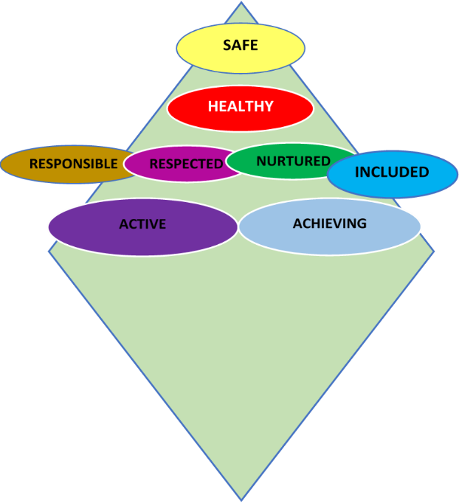
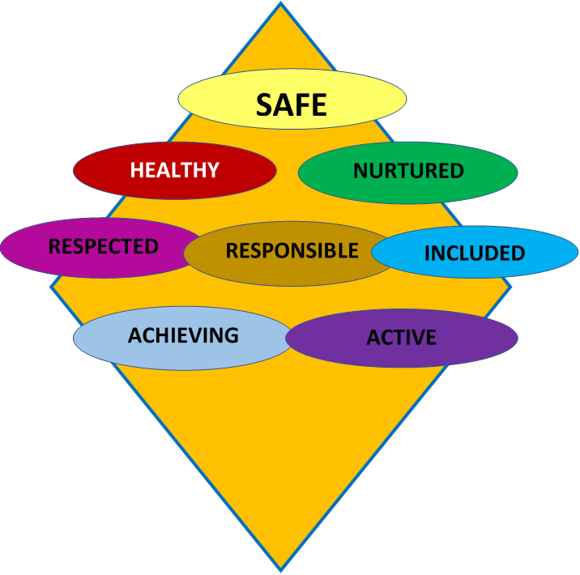
“It’s important to feel safe and secure as it can affect your mental health.”
“It’s important to be included and not left out.”

“Respect is important, your voice matters.”

“SAFE is important as if you feel safe others will follow,”
“To be active and to play it takes responsibility.”
“I wouldn’t have voted for Pupil X to be House Captain if I didn’t know he was responsible, so it is important.”
As with the primary schools, most secondary pupils also felt that being safe and healthy were the most important priorities. Conversations also focused around the importance of being included and respected
Across most primary schools, while most pupils recognised the importance of all indicators. There was a general consensus that being safe, nurtured and healthy were key priorities.
Pupil mostly identified with SHANARRI wellbeing indicators through their school values.

Pupils from primary and secondary demonstrated a good understanding of SHANARRI wellbeing indicators with both placing ‘safe’ and ‘healthy’ in priority positions. Through discussions, it was clear that most pupils felt that all of the indicators were important demonstrating that pupils across all age stages understand the importance of wellbeing towards their future development.

Recognising and Celebrating Achievements

Primary
Schools use various tools and activities to deliver the HWB curriculum and promote healthy lifestyles. The following sections explore the pupils’ observations of curriculum content and activities they identified with.
HWB is embedded into the curriculum and celebration activities are a significant part of this. Such activities aim to demonstrate whole school values and promote inclusive school communities. Pupils identified most commonly with the following activities:
Table 1 Celebration activities recognised by primary school pupils
Activity | Count | Awarded | Summary
Pupil awards | 24 | Daily  Weekly  Monthly | Also referred to as star of the day/week, teachers champion.  Most commonly awarded demonstration of school values for good behaviour and helping others
House points | 14 | Ongoing  Rewards – end of the year | House systems are used to encourage academic achievement as well as demonstration of school values and good behaviour
Values awards | 14 | Daily  Weekly  Monthly | Various titles – Behaviour cards, acts of kindness, respect sheets, speaking with your actions
Recognition Boards | 11 | Daily | Also known as star charts/wow walls. For Internal/external achievements – sporting, good behaviour, demonstrating values
Achievement books | 10 | At teacher’s discretion – presented at weekly assembly | Demonstration of academic achievement, recognition of external achievements
Assemblies | 9 | Weekly | Pupils perceived assembles to be a place where recognition for values/academic and external achievements occur
Positive Notes | 5 | At the teacher’s discretion | A note commenting on exceptionally good behaviour of pupils
Headteacher awards | 5 | Monthly/term time | Above and beyond achievements
Reflection activities | 3 | Weekly | Weekly reflections, wellbeing wheels

Of the celebration activities mentioned, pupils spoke most often about ‘pupil awards’, ‘house points’ and ‘value awards’, which can be perceived as common activities across schools that have a shared sense of purpose. The majority of pupils were very enthusiastic about participating in or being rewarded during celebration activities and were keen to provide examples around what was required to obtain recognition.
The table represents various celebration activities that recognise pupil achievement in and out of school. Overall, most primary schools offered a wide range of opportunities to recognise and celebrate pupil achievement. Furthermore, it is evident that the primary schools offer a wide range of opportunities that promote health and wellbeing for pupils. Pupils indicated that they have a clear understanding of the purpose of celebration events. The enthusiasm that pupils demonstrated when discussing how they were recognised for achievements illustrates that not only did they enjoy such activities, but the purpose also resonated with them. That aside, activities could be used to further explore their understanding in the wider context i.e. to what extent are they able to identify skills and areas of strengths and, in what ways does do pupils understand the benefits of such activities towards their development and growth. For example, explicitly linking celebration activities to SHANARRI wellbeing indicators might support such development.
Examples of the key topics discussed by pupils are illustrated in Figure 2. The topics have been placed next to the SHANARRI wellbeing indicator they were seen to address
Figure 2 Health and wellbeing in Renfrewshire primary schools – linked to SHANARRI wellbeing indicators

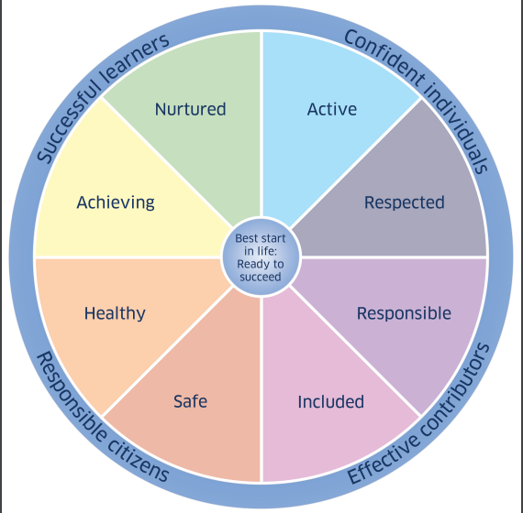
Represented by celebration activities
Safe Kids
Online safety
Road safety
Anti-bullying
Road Safety

Maths camp
PATHS
Wellbeing committees
Emotions
Celebration Activities (see table 1 )

Physical Education
Fun runs
Lunchtime/after school clubs (lunch/after)

Growth Mindset
Mindfulness
It was often the case that pupils did not know exactly what SHANARRI wellbeing indicators were linked to the celebratory activities, but their understanding was demonstrated by their ability to discuss topics around HWB that related to SHANARRI.

Secondary

The most recognised celebration activities in secondary schools were similar to the primaries in that pupils identified most with awards ceremonies and house points.
Table 2 Celebration activities recognised by secondary school pupils
Activity | Count | Awarded | Summary
Awards Ceremony | 52 | Assemblies
House system | 30 | Points collected across the year, | Rewarded by school trips and days out
Merit system | 12
Certificates | 22
Pupil of the month | 8
Newsletters | 6
Tracking reports | 5
Social Media | 5 |  | Achievements recognised on school’s twitter feed
Praise cards | 3

In comparison, the number and types of celebration activities in secondary were relatively less than in primary school. This is likely due to contextual difference between the two sectors; pupils tended not to reflect on the range of topics that covered more widely across the school and therefore appears there is a narrower curriculum. This has been further demonstrated in Figure 3, where mapping activities retrospectively with the wellbeing indicators, the perception is that the curriculum appears more limited. In fact, the general consensus among secondary pupils was that whilst they do have awards ceremonies, it was not perceived as something that was used to improve wellbeing:
“you get awards at assemblies if you have excelled in class. Also, at the end of the year, there is an awards ceremony that only certain pupils will get picked for if they have done well. The only way people will know about your achievements outside of school is if you tell someone in the school.” (Secondary pupil)

Figure 3 Health and wellbeing in Renfrewshire secondary schools – linked to SHANARRI wellbeing indicator
Represented by celebration activities
Physical Activity

Cyber safety
Anti-bullying
Abuse/relationships
Health week
Sexual health
Healthy eating
Drugs and Alcohol

Pupil Voice – Learning and Teaching in HWB/PSE

Pupils in both primary and secondary schools were asked what they like to learn about in HWB/PSE classes and what topics, if any, they would like to learn more about. Table 3 illustrates the key topics discussed by pupils. It is evident that there were some similarities around the topics with both primary and secondary pupils wishing to explore finance and budgeting, drugs and mental health in more detail. Pupils from both sectors also raised concerns about inequality and diversity issues with some indication they would like to know more about how to deal with different aspects of LGBT relationships, although secondary school pupils were interested more in how to deal with sexual relationships.
No pupils felt that physical activity was something that they required further learning about. In some cases, in primary school, pupils did not link P.E. classes to HWB.

Table 3 Topics pupils want to learn more about linked to key PSE areas of the curriculum
Sector | Planning for Choices and Change | Physical Activity  Health | Substance  Misuse | Relationships,  Sexual health and Parenthood | Equality and Diversity
Primary | Finance and budgeting |  | Drugs - more details about both legal and illegal misuse |  | Racism  Culture  Disability  LGBT
Primary | Finance and budgeting | Mental health- body positivity, disabilities, Cyberbullying / Online Safety | Drugs - more details about both legal and illegal misuse |  | Racism  Culture  Disability  LGBT
Secondary | Finance and budgeting (mortgages) | Mental health - eating disorders, stress management, emotions | Drugs | Relationships in general  Inclusive sex education | LGBT Specific  feel focus is on heterosexual relationships
Secondary | Career planning
Secondary | Life skills

Secondary pupils were specifically asked if the topics they liked learning about were progressive year on year. The majority of pupils stated that they did not think that topics were progressive (57%). Just under a quarter (23%) indicated that they did not know while 20% felt that topics were progressive. Almost all pupils (94%) indicated that they had a specific time in their timetable for PSHE, however, 89% of pupils felt they were not involved in co-designing the lessons taught or involved in the planning and delivery of the curriculum.

Learning and Teaching – how does it help inform decisions in everyday life?

Primary
The most common topic that influences decisions made in everyday life for primary pupils is emotions. Several pupils indicated that learning self-regulation was important:
“I used to lose temper very easily and lash out and harm others. PATHS taught me how to calm myself down.” (primary pupil)
“Helped me to respond to other people’s emotions as well as my own like how to walk away from someone who is angry.” (primary pupil)

Many pupils also found that they had a better understanding of the nature and consequences of bullying as a result of learning about it in school:
“Most of our class learned that when people are getting bullied it’s not nice, it makes me think of how they must feel.” (primary pupil)
“My sister’s friend was bullied for a long time and didn't want to be here anymore - that’s why I wouldn’t bully anyone as it can actually make them suicidal.” (primary pupil)


Emotions
Food Choices
Cyberbullying
Key topics primary school pupils use in everyday life

Pupils also mentioned that learning about stranger awareness, bike/road safety, swimming, smoking and drugs, and careers opportunities were other areas where they applied their learning but on a smaller scale.

Secondary
There was a varied response to this question from secondary school pupils. When asked specifically about what parts of the HWB/PSE curriculum helped them to make positive decisions in everyday life and about their futures, pupils predominantly noted that advice on career/education planning, finance, and drugs and alcohol were most useful. Others spoke about relationships and mental health:

“Learning about relationships for if I am in a relationship of how to handle it.” (secondary pupil)
“I had anxiety but didn’t know I had it, for a long time I didn’t want to do various things because of it but when I figured out I had it I stopped letting it ruin my time.” (secondary pupil)

Key topics secondary school pupils use in everyday life

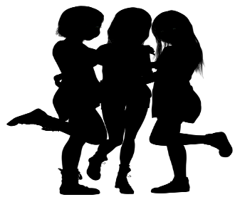
Career/Education planning/Finance
Drugs & Alcohol

Other topics of interest that young people felt were useful to learn about and relevant to their everyday lives included sexual education (consent), relationships, domestic abuse and knife crime.
The findings above illustrate topics which young people feel are the main focus of PSE while recognising that they wished to expand their understanding of certain topics. Further exploration might be required as to discover why

Staff perceptions on topics of interest

When asked about their awareness of the topics young people would like to learn more about in PSE, the majority of staff highlighted that they were aware or were aware that audits and evaluation were done an annual basis to collate this information. Topics highlighted by staff included finance, careers, sexual health/consent, LGBT, drugs and mental health:
“S2 pupils have expressed a desire to learn life skills such as setting up of bank accounts, how to save money, how to look for and secure employment after school.”

“Pupils always want to know more about sexual health and relationships and more about mental health, Financial support, how to drive, insurance etc... The new sexual health materials seem to be good but will take time for me and my colleagues to be familiar with each lesson and topic.”

It is evident that staff do indeed have a clear understanding of what PSE topics are of interest to pupils.

Delivery of HWB/PSE and Partnership with External Services

Primary

Pupils offered positive comments with regards to partners from external services coming into school to promote health and wellbeing with almost all finding it to be rewarding and useful in developing their learning, for example, anti-bullying awareness sessions. They stressed the value of this as it made them reflect on their own behaviour and also how to support others who might be experiencing bullying. In Renfrewshire, ‘SafeKids’ was mentioned regularly across primary schools as an event that was particularly beneficial in learning about HWB related topics:
“SafeKIds were really good, and they tell you what you should and shouldn’t do to stay safe.” (primary school pupil)

Table 4 Primary school pupils views on most relevant external sources of HWB
Charities | Emergency services | Anti-Bullying/Diversity awareness
NSPCC | Fire brigade | Safe Kids
RSPCC | Police | Cine/I am me bus
 | Paramedics

Secondary - Who should deliver PSE?
Secondary pupils were asked more specifically about who is best to deliver HWB/PSE lessons. Figure 4 illustrates their responses. It is evident that there was a divided response with just under half stating guidance teachers would be best placed (49%) and 43% indicating that it should be delivered by external specialists.

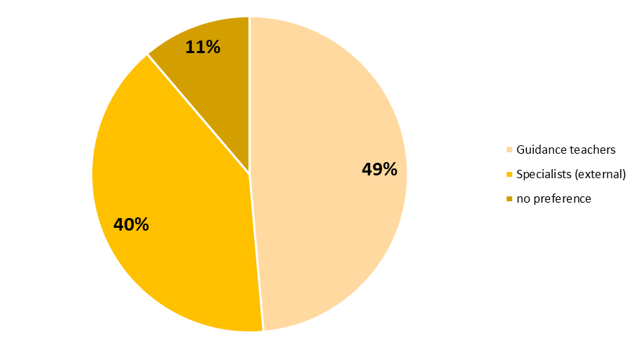
“I think if teachers know a little about everything because things are changing, and you should really be dealing with issues that are a big problem." (Secondary pupil)
“we had a woman come in for rape prevention and I learned more from her than other PSE.” (Secondary pupil)
Figure 4 Secondary pupils’ perceptions of who is best to deliver PSHE lessons

Staff perceptions on external agency delivery
Almost all staff felt that using external agencies were an effective way to deliver HWB messages to young people in Renfrewshire with only 3 out of 21 indicating that they were ‘unsure’ or did not find external partners to be effective. When asked to elaborate on their responses, the general consensus was that external agencies tend to have a greater impact:
“Sometimes pupils listen more to people from outwith school. External expertise is key in delivering some areas of the curriculum especially when some PSE teachers are not from pupil support.”
“I feel outside speakers are key to delivering HWB messages as in my experience, pupils take these issues a lot more seriously in these circumstances.”
“Definitely - Young people really listen when someone with direct experience talks to them but it needs to interactive with an activity where possible in my opinion.”
The findings suggest that PSE delivery should continue to be mixed from both teachers and external agencies with both pupils and staff highlighting the potential benefit gained from this approach.

Secondary - Should teachers specialise in one area of HWB/PSE?
While the majority (56%) of pupils felt that teachers have a basic understanding across all areas, two fifths (40%) felt that teachers should specialise in one area of PSHE (see Figure 5).
Figure 5 Secondary pupils views on how PSHE should be taught
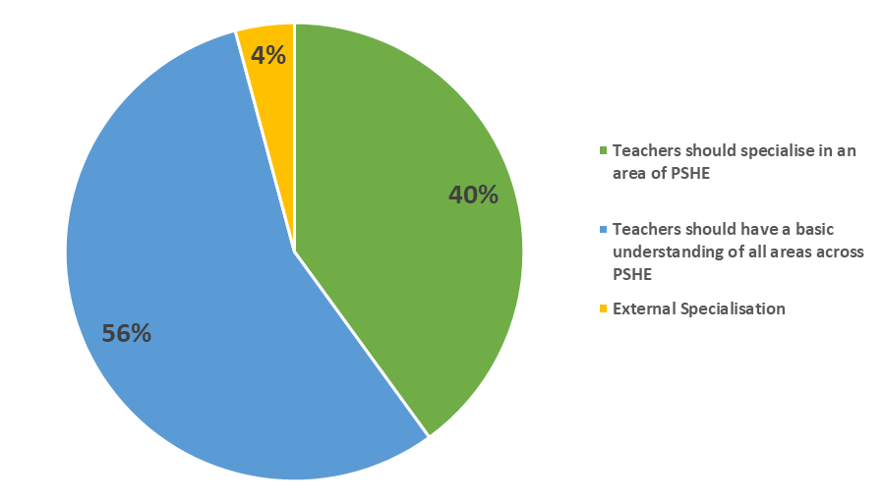

“I think they should specialise in one area and then they could teach you for a certain number of weeks then move on to another teacher, I think this as it will make you understand more clearly about the topic e.g. Drugs/ alcohol, and there will be a set structure to each lesson. You will also know what you are going to learn in the next lesson.” (Secondary school pupil)

Staff perceptions on delivery of PSE lessons
Of the 21 teachers who responded, 12 felt they were equipped to deliver relevant PSE lessons ‘whilst 8 noted that they were ‘unsure’ and only one felt that they were not equipped. However, most staff felt that CLPL or training opportunities around PSE topic was limited. Staff also felt that training was required for specific topics:
“I don't feel adequately trained in emotional health lessons and again senior lessons.”
“I have undertaken training in some aspects however would welcome more training especially relating to mental health.”
Those who had accessed a range of CPD activities noted higher levels of confidence around delivering the PSE curriculum:
“It is the Pastoral Care team who deliver the lessons and I feel this is very helpful as we know the children in our caseloads well and can often tailor lessons to meet their needs. Due to quite a bit of CLPL, I feel confident delivering lessons on e.g. mental health, self-harm and suicide and unhealthy relationships/consent.”
Another issue reported was around allocated time to attend training:
“I would like more time to attend courses and develop suitable materials.”
Furthermore, while some felt that current resources supported their ability to deliver PSE, others felt that resources needed to be simplified to ensure that materials were accessible to all staff:
“Sometimes if lots of resources need to be prepared beforehand some staff find this difficult and enter class unprepared. SE lessons should be very simple for teacher delivery with minimal gimmicks and maximum amount of pupil involvement.”
Interestingly, opinions between staff and pupils varied greatly with regards to who it should be taught by. The majority of pupils felt that PSE should be taught by teachers who specialise in PSE, this view was echoed by staff who felt that pastoral care teachers were more equipped to teach the subject. Staff members however, did not feel that they should not teach the subject, but rather that they required more training or updated resources in order to do so.

Pupil Voice - Monitoring HWB in school

Primary
Tools for monitoring health and wellbeing that reference the wellbeing indicators (SHANARRI) were mentioned by pupils in 13 schools. Time dedicated to conversations with teaching staff about their progress and goal setting varied between once to three time per term. However, many of the pupils were unaware of what ‘target’ setting was in the context of health and wellbeing.

Secondary
Approximately two thirds of young people in secondary stated that they did not have discussions with their teachers about their progression in HWB/PSE. For the 18 pupils that reported to have had such conversations, when and how the conversations occurred varied among them and are summarised below:
- Pastoral interviews (occasionally)
- Once a term
- Target setting (most commonly among this group once a year)
- Wellbeing web (mentioned by one young person)

Staff perspective on young people’s involvement in the planning and delivery of PSE classes

Of the 21 who answered, the majority of staff (n=13) indicated that they included young people in the planning and delivery of PSE classes ‘sometimes’ with only three indicating ‘yes’ and five indicating ‘no’. However, the comments indicate that most staff found that it was extremely important for young people to be involved in the planning and delivery of PSE classes:
“Pupil voice is key to pupil engagement. Our pupils thoroughly enjoyed being involved in the PSE consultation. They felt they had a better awareness of what we're trying to achieve. We already involve MVP mentors in leading lessons. Feedback from mentors and mentees is extremely positive.”
“Very involved. This is their curriculum and it is vital that their opinions are sought in order for us to deliver topics they feel will benefit them.”
“Some pupils deliver parts of the programme on issues which they have a particular interest in. e.g. mental health and wellbeing, sexual health topics such as consent.”
It is evident that the pupil voice is an area of contention, with staff indicating that young people are involved whereas young people feel that they do not have a say. One explanation for this could be related to the approach taken when consulting with pupils, where it might not be clear that their input matters to the curriculum design.

Pupil Voice – Equality and Diversity (Secondary)

Pupils were asked if equality and diversity was accepted well enough in their schools.


72% SAID YES TO EQUALITY AND DIVERSTY WAS ACCEPTED WELL ENOUGH IN SCHOOL
“I feel it could be talked about more, we do have some clubs such as LGBT, but I feel it could be spoken about more.” (Secondary pupil)
“I don’t really think it is. People are ignorant when it comes to different cultures and religion. This is because schools (especially catholic) do not talk about these things. As one of the very little amounts of people of colour in my school, we mostly only learn about Scottish culture and only one religion in catholic schools. Our school is not diverse, and people are ignorant to cultures/ religions and make fun of them instead of learning. People should embrace diversity instead of mocking it.” (Secondary pupil)

Pupil Voice – How important is HWB/PSE? (Secondary)
Pupils were also consulted on whether they thought that HWB/PSE was just as important as literacy and numeracy.
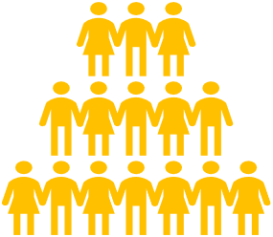
60% OF PUPILS FELT HWB/PSE WAS AS IMPORTANT AS NUMERACY AND LITERACY

“[HWB] helps us with growth mindset and mental health, it also helps us understand what is going on if one of our friends or family are suffering from a mental health issue.” (Secondary pupil)
“I think it is because there is no point in being smart if you are not enjoying life. There is no point in achieving academically if you are not going to live long enough to achieve your potential.” (Secondary pupil)

Secondary school pupils therefore, do indeed find HWB/PSE to be an important part of the curriculum. Firstly, the majority indicate that they felt it to be as important as numeracy/literacy and secondly, pupils demonstrated that they understood the impact that learning about PSE topics would have in their future lives.

Staff perspectives - thoughts on the current PSE curriculum

In general staff felt that the PSE curriculum cover a wide range of topics, although several members of staff noted that there was often a lack of continuity in delivery:
“As a pupil support team, we mostly don't deliver to our own house groups which is problematic.”
“The PL classes are not always taken by Guidance staff or teachers that necessarily want to deliver this aspect of the curriculum. Often it is dependent on who is available on the timetable and therefore the delivery is not always consistent across the classes or year groups.”
Furthermore, it was also noted that PSE was not always seen to be a priority for staff.
“I believe the PSE curriculum is interesting and relevant to the pupils, however, staff don't put it as a high priority in terms of delivery and this can affect pupil experience.”
However, it is evident that several schools have attempted to address this issue:
“Consistency of staff is important. We are trying to get away from the previous approach of “any teacher with time remaining” being given a PSE class for the session. Instead, the same staff take the courses each year."
Another common theme that emerged was around resources. Several staff commented that there was a need to update current resources in order to deliver a stronger PSE curriculum:
“Access to up to date resources would be very beneficial for us.”
“Some materials not up to date and lack of time to invest in development of the course. I really like the look of the RSHPE materials.”
How can HWB/PSE lessons be improved?
Many of the secondary pupils felt their learning experience could be enhanced by adding variation to the HWB topics covered in the curriculum across all age stages and should include more practical activities to help prepare for the future. The following extracts reflect the general consensus of around how HWB/PSE lesson can be improved:
“do real life topics e.g. Finances and real issues: how to help with climate change, how to have the best mental health from someone who has experienced poor mental health”

Outside speakers on drugs/ alcohol to get deeper impacts on kids who tend to just shrug it off.”

“Not all teachers talk about relationships but it’s an extremely important issue especially at 5th/6th year age.

The theme of bringing in people with experience was also evident in the findings from the alcohol and drugs awareness focus groups.
“Learn how to deal with mental health l from someone who has experienced poor mental health.” (secondary pupil)

“I would like the school to bring ex-drug users and alcohol abusers so that we can ask them questions”

Several pupils also felt that topics could be shorter but with time for more depth for learning. Others also suggested that it would be beneficial for them to be involved in planning.
“Need more opportunities where young people can sit down and be open and honest instead of sitting listening to teacher.”

“At the end of each lesson everyone should be given a piece of paper to anonymously write a question/point of discussion in case they do not want to directly approach the teacher or ask in front of the class.” (secondary pupil)

Staff perspectives – Raising the profile of the importance of the PSE curriculum
Staff were consistent in their opinion concerning what they feel could raise the profile of the PSE curriculum, several approaches reoccurred including: wider achievement, transitions, consistency in staff teaching and resources, access to CLPL, embedded tutor groups and pastoral staff delivery. Some of the key comments are listed below:
- Some staff feel that gaining SQA wider achievement awards through SE is the way to raise the profile but I think its profile should be raised through valuable, relevant content and learning experiences rather than trying to push pupils through or gather evidence to tick a box for an award that might not mean a great deal to the pupil but raises the school's attainment. Make PSE fun, exciting, different and relevant and pupils will enjoy their learning.
- P7 transition can be a good time to start getting this message across to future pupils. Communication with parents about topics covered in class and universal support could be helpful too.
- Consistency in teaching staff, a shared bank of resources so all pupils have similar experiences across the authority.
- Noticeboards around school, use of twitter feed for linking to useful links / articles.
- Pastoral staff need to deliver the courses and there should be more assessments. This year we are starting to deliver wider achievement awards through PSE for the first time (other than work experience)
- Ensure that all schools run a full programme and listen to what the pupils say.
- Having PSE/Tutor Group embedded within the timetable first along with staff who want to deliver it.
- I think it would be beneficial if pastoral staff could deliver to their pupils. I feel that this would be of benefit to both.
- Involve students more to ensure that the content is relevant to their lives.
- To raise the profile more, we need a more consistent approach across the school with who delivers PSE. More discussion of good practice needed between the teachers who are delivering this entitlement.

CONCLUSION

Overall, pupils demonstrated that they have a sound understanding of HWB/PSE with both primary and secondary pupils showing an understanding of the importance of wellbeing indicators. However, further exploration is required to determine the extent to which pupils understand the links between celebratory activities and wellbeing indicators.
The views of pupils and teachers clearly align around the relevance of topics in the curriculum. However, there are some issues. While staff indicated that pupils are mostly included in the design of the curriculum, pupils indicated that they do not feel their voice is heard. Further exploration is required to evaluate if this relates to design or PSE delivery. For secondary, it was also evident that staff and pupils felt that a mixture of teaching staff and external agencies or sources were best placed to deliver PSE. A point that was frequently highlighted by staff was constraint on delivery such as access to CLPL or updated resources. Further consultation might explore different models to teaching the curriculum to support a consistent approach across Renfrewshire.

Appendix 1 – Primary focus group guide

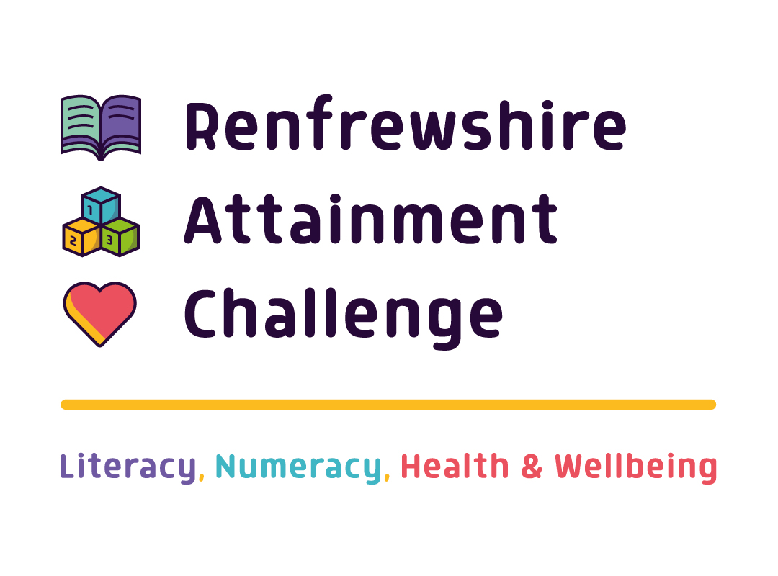

Health and Wellbeing
Consultation with Pupils

School: _________________________________________________

Date: __________________________________________________
Prequestionnaire - Can you tell me why X and Y are the most important? Take notes based on the discussion (note here the children’s priorities and their decisions for their choices)

- There will be lots of ways that your school praises you for trying your best and celebrates all the things you do well. Can you tell us about some of them?
Activity | Frequency | Health and Wellbeing purpose

Observer’s comments:

- Thinking about HWB topics listed: What kind of things do you learn about most? For example, smoking, drugs, alcohol, growing up, different types of relationships, learning about emotions, etc. What would you like to learn more about?

Current topic (y/n) | Topic | Why | General comments

Observer’s comments:

- How do you use what you have been taught in HWB in everyday life? Does it is help you make positive decisions?

Topic | Why | General comments
Observer’s comments:

- Do you speak to your teacher about your HWB and if so, how often? Do you set yourself goals? i.e. wellbeing wheel prompting conversation, learner conversations, etc.
Source | Reason why
Observer’s comments:

- Sometimes other people come to speak to you about topics related to your HWB, like the police, fire service, first aiders, etc. Do you find this useful? Who else would you like to come to speak to you?
Source | Reason why

Observer’s comments:

- Can you give examples of support/clubs in your local community that can help you lead a healthy lifestyle? e.g. Barnardo’s, Renfrewshire Life, Youth Clubs.

Activities | Comments – What do the children think of these activities? | children access these activities?
Observer’s comments:

Page for additional comments (if writing additional comments indicate the question number).

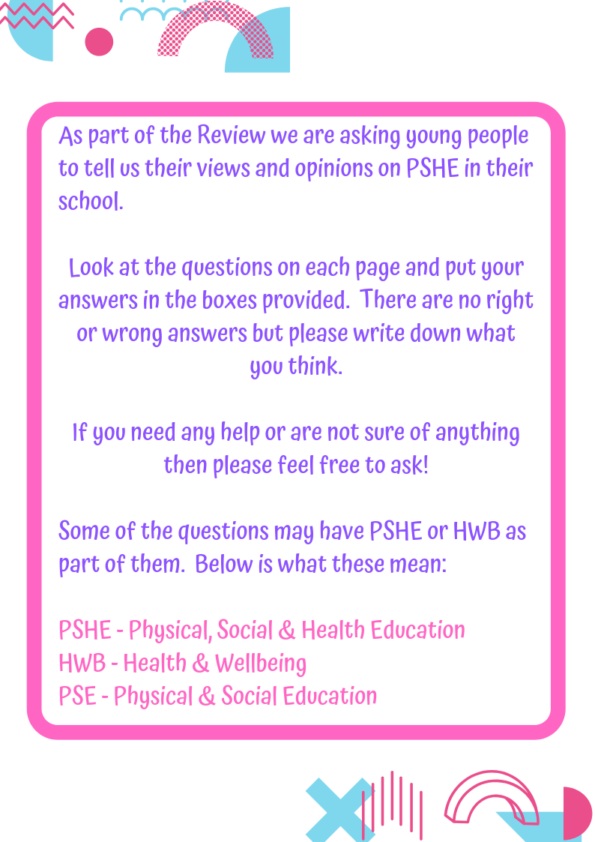
Appendix 2– Secondary self-completion questionnaire
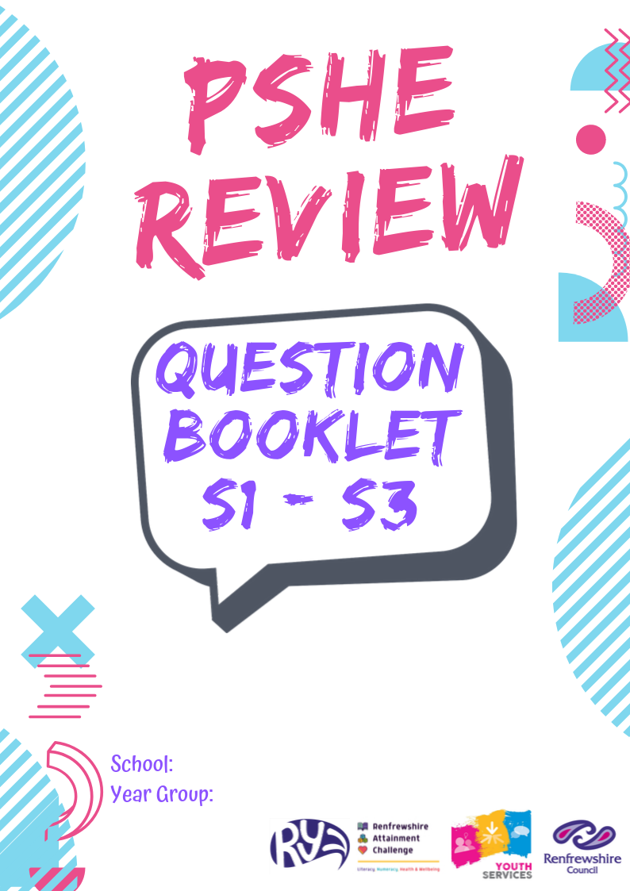

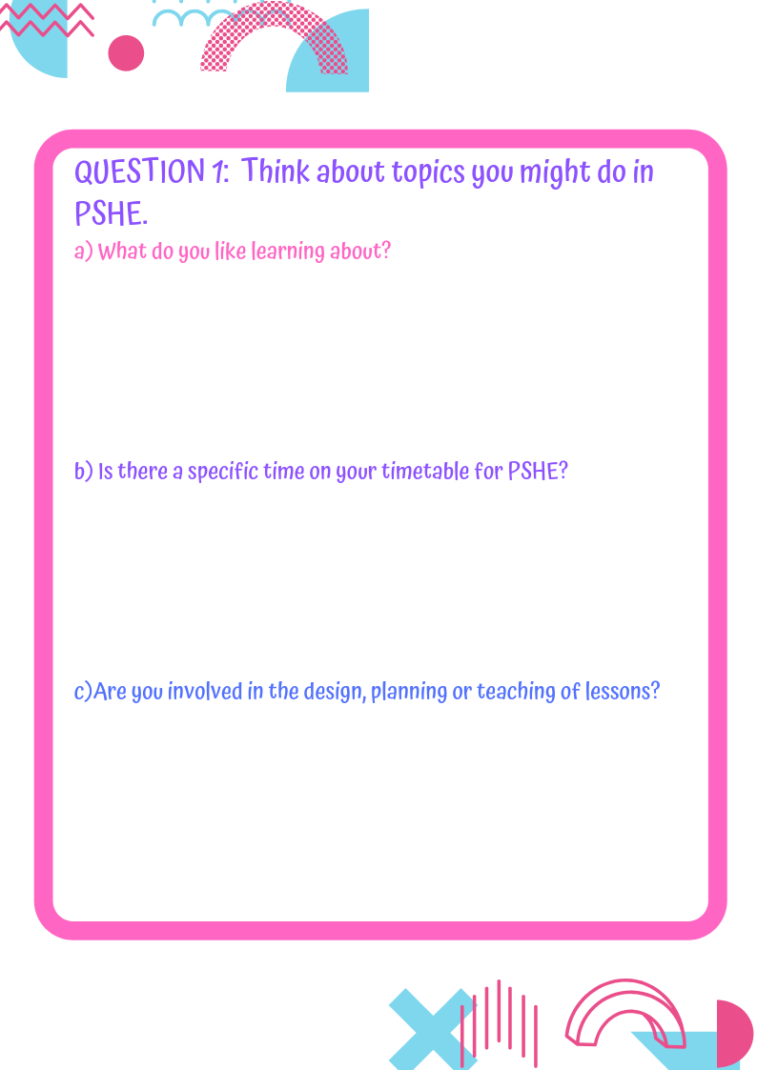

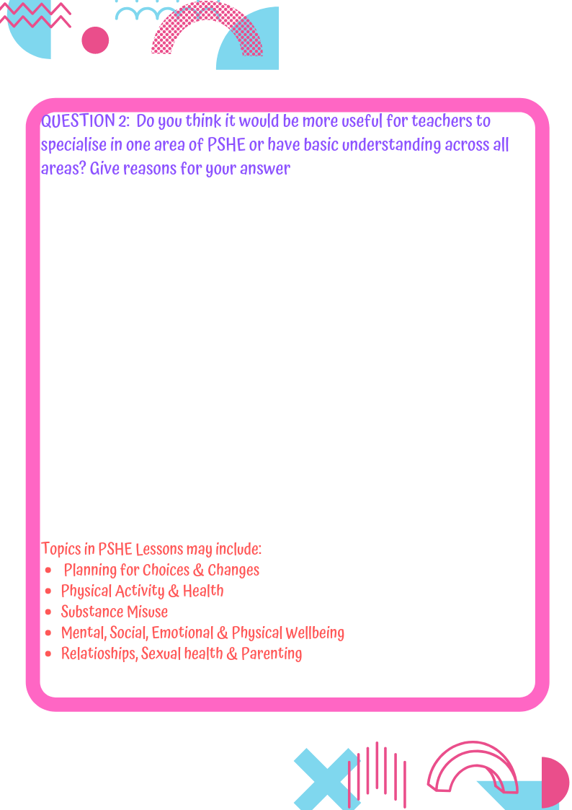

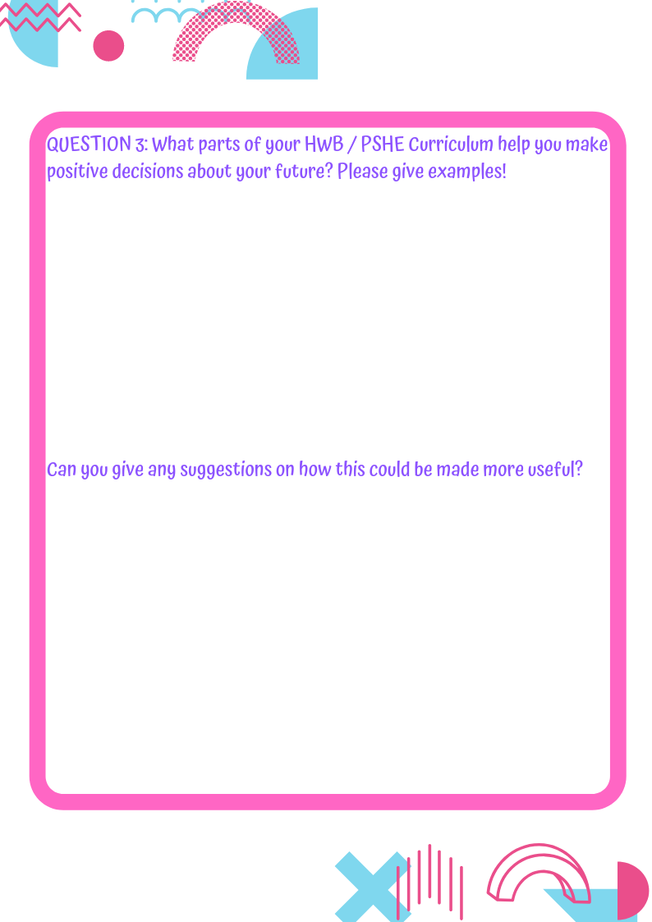

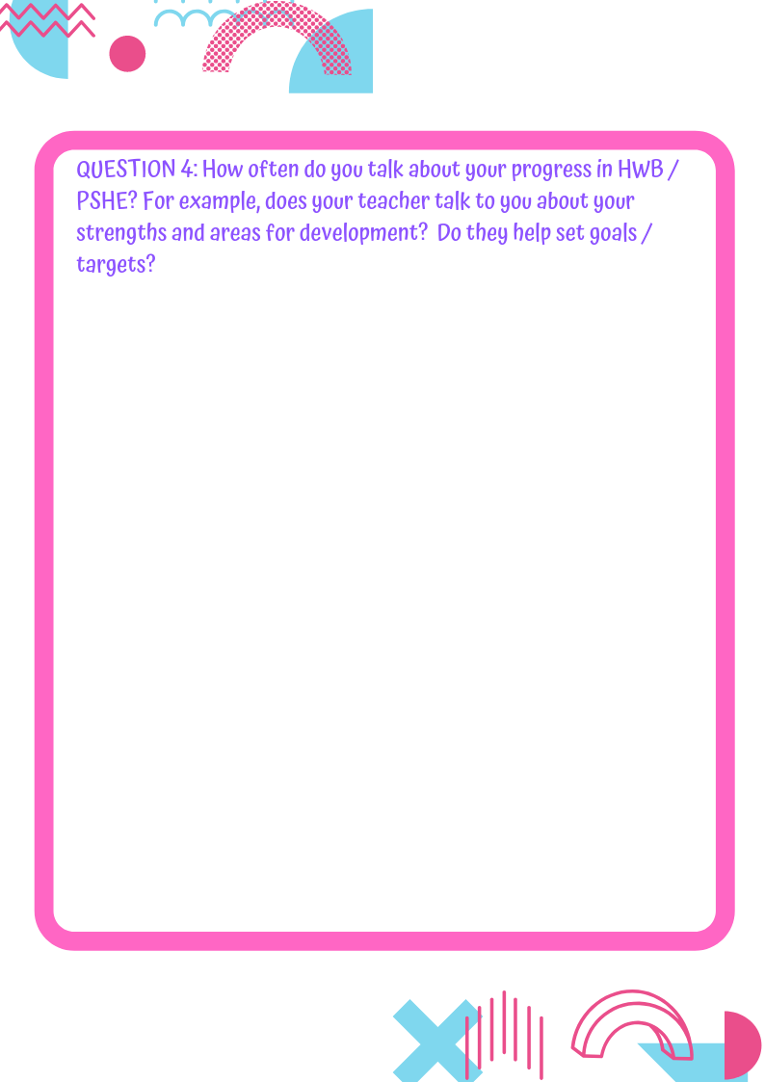

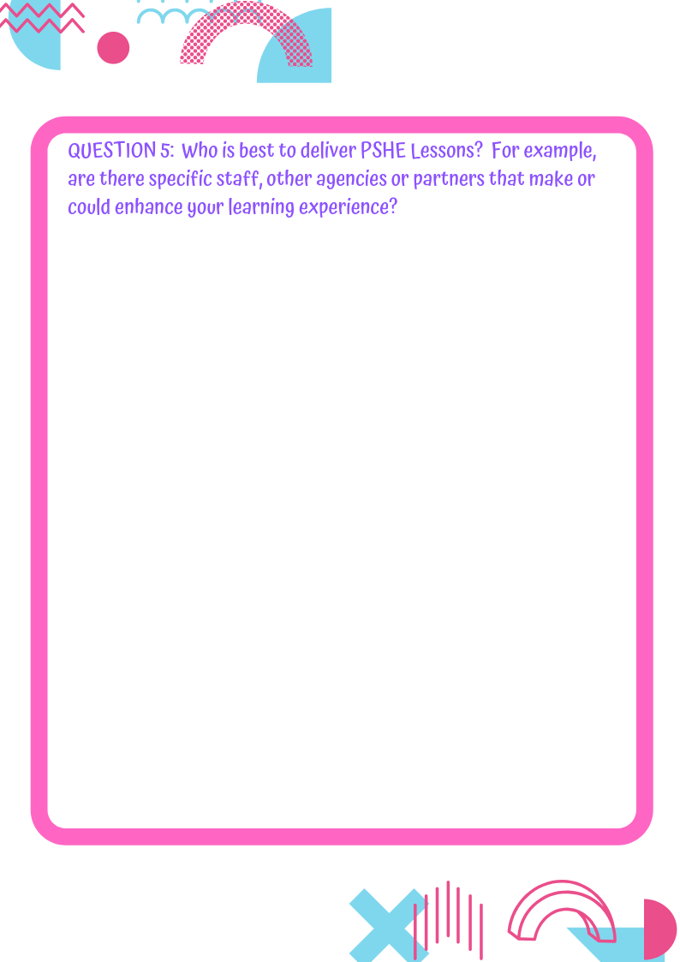

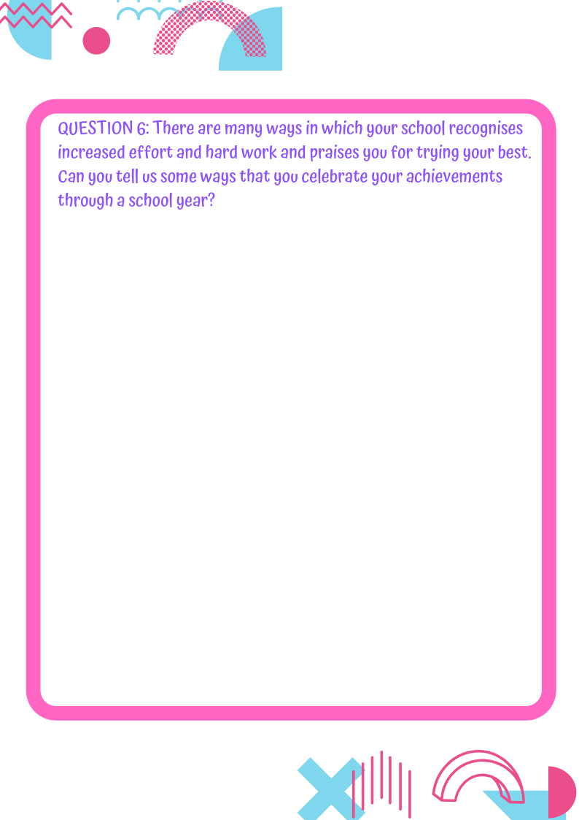
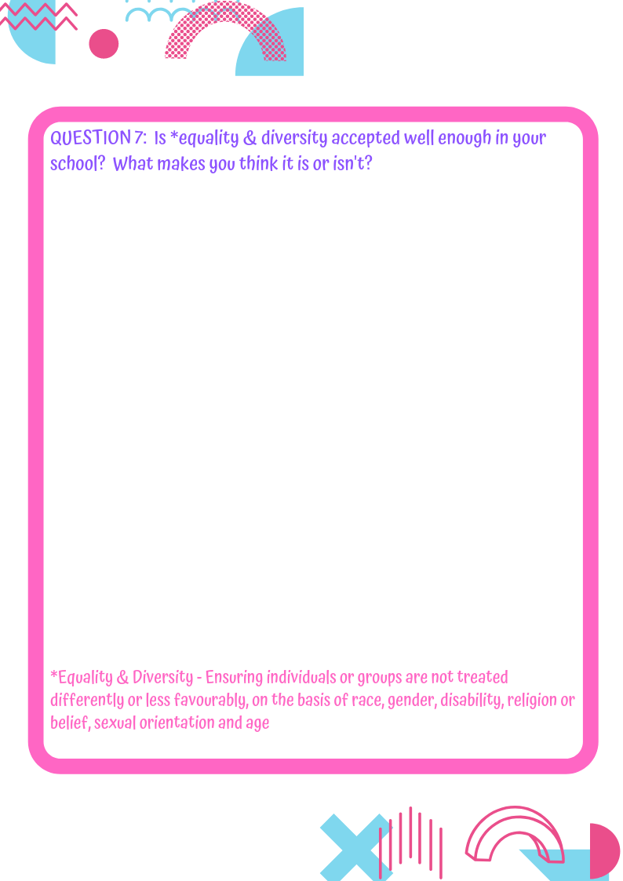

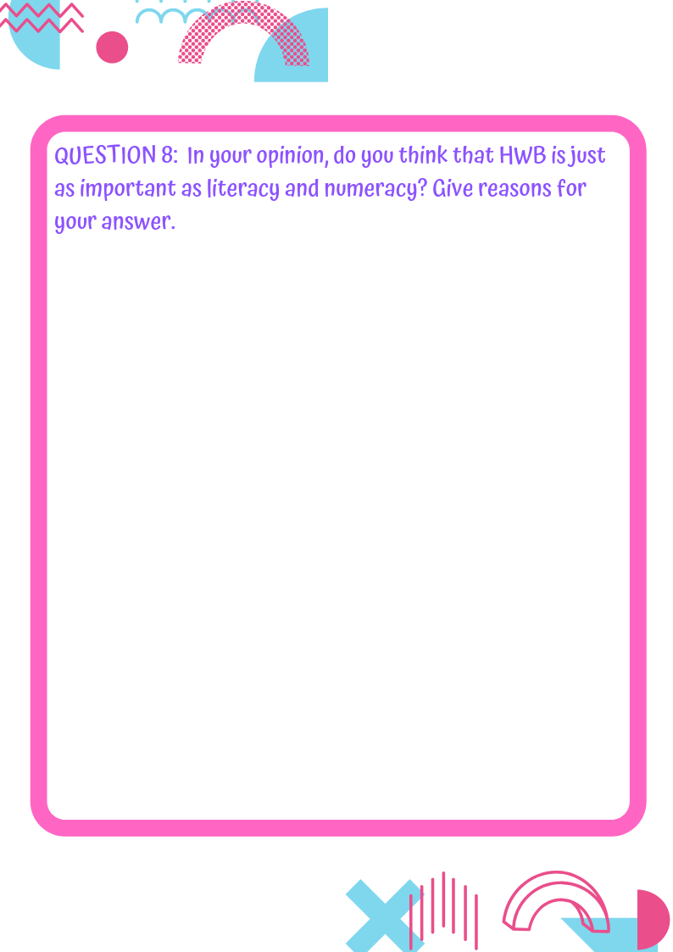

Appendix 3 – Staff questionnaire

- What are your thoughts on the current PSE curriculum in your school?
- Do you feel equipped to deliver PSE lessons that are relevant to young people?
  - Please provide more detail on your response to Q3 (including professional learning needs)
- Are you aware of the topics young people would like to learn / learn more about in PSE? Please comment in the box provided.
- To what extent do you think young people should be involved the planning and delivery of PSE classes?
- As a PSE teacher, do you involve young people in the planning and delivery of your PSE classes?
- Do you feel the use of external agencies are an effective way of providing key HWB messages to young people in Renfrewshire?
  - Please provide more detail on your response to Q8
- In your opinion, how do we raise the profile of the importance of the PSE curriculum?

In early learning and childcare settings and primary schools, the name health and wellbeing are normally used for the aspects of the curriculum, rather than PSE (Education Scotland, 2017).
Counts for PSE being progressive – yes: n=18, no: n=51, don’t know: n=21
Counts – yes: n=113, no: =7
Total number of secondary pupil responses = 107
Count- Yes: n=82, No: n=25, Don’t know n=7
Count- Yes, n=70, No: 46

