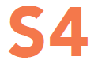
Health And wellbeing curriculum
SUBSTANCE MISUSE
PSE PACK
SECONDARY EDUCATION PACK
Pack developed by Substance Misuse Educationt Working Group 2018

S5 LESSONS | Learning Outcomes
Learner Activity 1 –  Cannabis - The facts | - Explore some of the commonly held misconceptions about cannabis  - Understand and explain some of the negative effects cannabis can have upon physical and mental health  - Understand the facts behind the theory of cannabis as a “gateway drug”
Learner Activity 2 – Risky Situations | - Develop knowledge about and understand risky situations  - Explore attitudes to substance misuse and users  - Empathise with people in difficult situations  - Anticipate and assess the dangers of drug-related situations  - Become aware of strategies and skills to use if you find yourself or a friend in a risky / unsafe situation
Learner Activity 3 – Keeping safe - Emergency action | - Understand basic first aid skills in drug-related situations  - Identify ways to avoid the risky situations on a night out
Learner Activity 4 – Social implications of substance misuse | - Understand that substance misuse, either their own or that of others, not only affects the user, but has wider implications and effects for those around them  - Consider the effects that substance misuse has on society as a whole  - Encourage responsibility in relation to substance use
SUBSTANCE MISUSE PSE PACK
- For more information on drugs discussed, effects, risks and legal status please refer to: | Know the Score  http://knowthescore.info/drugs-a-z/
- Information about alcohol, its associated harm and how it affects different sections of society as well as briefings on key alcohol issues e.g. minimum pricing and licensing | Alcohol Focus Scotland  http://www.alcohol-focus-scotland.org.uk/
- A suite of positive digital resources designed to support young people to use the internet, social media and mobile technologies to improve their mental health and wellbeing | Aye Mind  http://ayemind.com/
- Contains information, advice and facts about drugs, alcohol, tobacco and online safety | Choices for life  https://young.scot/choices-for-life/
- NHS Greater Glasgow & Clyde service with specialist support for schools and youth organisations | Quit Your Way  http://www.nhsggc.org.uk/your-health/healthy-living/smokefree/quit-your-way/
- Factual information and up-to-date advice on drugs, and a range of issues relating to substance use and misuse | Talk to Frank  http://www.talktofrank.com/
- Youth work essentials addressing tobacco prevention issues developed by Ash Scotland and Youth Scotland | Tobacco Free Generation  http://www.youthworkessentials.org/youth-tobacco.aspx
WHERE TO GO FOR FURTHER SUPPORT

ICON GUIDE

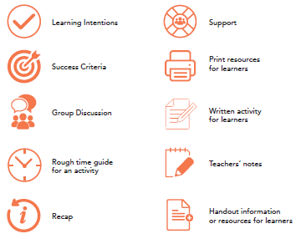
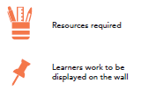

cannabis the facts – LEARNER ACTIVITY 1
Teacher’s Notes: Cannabis is one of the most likely substances that a young person may disclose to using or to a family member using. Should this situation arise follow your own organization’s policies and procedures and discuss with senior management
- Study the Cannabis Quiz Sheet - taking particular note of the points at which questions should be asked of the participants.
- Place the “Fact”, “Myth” and “Not Sure” cards in different parts of the room.
- Explain that you are going to read a series of statements about cannabis. After each statement decide without conferring whether it is a fact, myth or if they are not sure and stand by that card.
- Read out each statement one by one and when people have moved, ask them why they think the statement is a fact or myth or why they are not sure.
- What are their thoughts?
- Where appropriate ask the participants the follow up questions on the sheet.
- Feedback:
- How did people find this activity? Was it difficult?
- What did they learn? Any surprises?
- Did the exercise raise any issues that they would like to explore further?
- Explain to participants that they can find out more information from www.knowthescore.info
- Give each participant a copy of the Cannabis Quiz sheet for information
KEY MESSAGES
- Cannabis is one of the most common illegal drugs which young people may experiment with and it's important to understand the short term and long term effects of cannabis use.
- Mixing cannabis with tobacco makes it much more harmful. The only way to completely avoid the harm is to not use.
- Early onset of heavy cannabis use is correlated with poor educational outcomes, increased risks of dependence, and increased risk of mental health problems.
- Cannabis IS illegal

cannabis the facts – quiz
Question | Fact/Myth/Not Sure | Feedback
- Cannabis can worsen mental illnesses | Fact  It is well accepted that illnesses such as schizophrenia and depression can be made worse by using cannabis.  Cannabis and Brain Development  Studies have also found that teenagers who smoke cannabis regularly are likely to end up with significantly lower IQ scores than teenagers who do not use the drug. This is because cannabis interferes with the development of the adolescent brain, which continues to undergo neural growth and "rewiring" during early teenage years. Weekly cannabis use before the age of 18 could result in a decline in IQ score of eight points, which is enough to move someone of average intelligence into a category that is well below average. | Ask the participants… does cannabis cause  mental illness?  There is stronger evidence: that using cannabis increases a person’s risk of developing “schizophrenic symptoms” especially if the person is under 18 years old or has a family history of schizophrenia. There is less evidence that cannabis can cause schizophrenia in other people or depression or cognitive impairment/ under-achievement.
- Smoking cannabis is more likely to cause cancer than smoking cigarettes | Not Sure  It may be true or false, but neither has been proven yet. Cannabis itself contains more carcinogens (cancer-causing chemicals) than tobacco, it is usually smoked in a joint along with tobacco, the smoke is hotter, it is inhaled more deeply by users and held in the lungs for longer. Even where cannabis is smoked on its own, quantity is still important – 20 cigarettes a day is going to be more damaging than one joint a week. There is also some suggestion that part of the damage of cigarettes may be due to radiation picked up by the tobacco plants in the soil that does not occur with cannabis plants. | Question for Participants: Does that mean that cannabis might not be harmful to the lungs?  NO!  Cannabis use has been strongly linked to chronic bronchitis (at an early age) and poorer lung function including symptoms such as wheezing, coughing and phlegm production.

Question | Fact/Myth/Not Sure | Feedback
- Cannabis is addictive | Fact  Cannabis is psychologically addictive. This means that someone who uses cannabis regularly and then tries to stop can find it very difficult, as they are likely to feel depressed, find it difficult to sleep and they will generally be pretty agitated and crave another smoke.  Regular users who find that they don’t enjoy normal activities like listening to music or seeing a film as much unless they’re stoned may be well on the way to becoming addicted to cannabis.  Additionally, people who smoke cannabis and tobacco together will become addicted to nicotine.
- Cannabis use causes people to use harder drugs | Myth  Most people who use cannabis will not go on to use harder drugs. Life factors such as deprivation, truancy, abuse and crime will affect who will go onto harder drugs, not whether they have used cannabis.  Although most people who use harder drugs will also use cannabis or will have done in the past, it is not necessarily the cannabis that caused them to progress. It is just as likely to have been alcohol or tobacco that they are likely to have used as well – or it could be a combination of any of these plus life factors as mentioned above.
- Using cannabis in a bong is safer than smoking it in a joint | Not Sure  There are risks associated with both methods of use – smoking a joint usually means smoking cannabis with tobacco and so the user is inhaling the tars and toxins of both drugs plus the paper into the lungs. Bongs which pass the cannabis smoke directly through water before being inhaled also carry additional risks as the smoke picks up some water on the way which can mean it gets deeper into the lungs causing more damage. It is suggested that you access the website www.talktofrank.com to find out more information on how to reduce the harms associated with using cannabis. This website can be used by people who want to stop or cut down their cannabis use. | What about cannabis cakes? Are they safer? Eating cannabis cakes would avoid lung damage altogether, but would still be illegal and carry both short and long term health risks, and potential mental health risks. It can take longer to feel the effects and they can last up to 12 hours. This makes it hard to control the dose. If someone doesn’t like the effects of a joint they can stop smoking, but if they’ve eaten a big piece of cake, it’s a different story.

Question | Fact/Myth/Not Sure | Feedback
- Smoking cannabis can be good for people with diseases like MS | Myth  Sometimes young people think cannabis is safe because they think it is used by some people as a medicine.  Smoking cannabis can cause lung damage, dependence and intoxication regardless of the reason why someone is using it and could be particularly risky for someone who is already weak due to a chronic illness.  Although there are trials currently underway for medicinal cannabis that have had some success in treating various conditions, cannabis is not smoked in these trials. Instead only the painkilling/ medicinal chemicals in the cannabis plant are extracted (not the parts that make you high) and have been formulated as a medicine for example as an under the tongue spray.  Apart from people in these clinical trials, cannabis is not available legally to anyone in the UK for medical or other purposes.  Cannabis seeds are not controlled under the Misuse of Drugs Act. It is legal to sell them, but it is illegal to grow cannabis plants from them!
- You can be arrested for possessing a small amount of cannabis for your own use. | Fact  Cannabis is a Class B drug under the Misuse of Drugs Act 1971 (MDA). All reports alleging MDA contraventions are reported by the police to the Procurator Fiscal or the Reporter to the Children’s Panel for under-16s. The Procurator Fiscal then decides whether or not to institute criminal proceedings. The Procurators Fiscal have a range of options available, including alternatives to prosecution such as issuing a warning (first offences are more likely not to lead to a prosecution and conviction).  A drugs conviction has many consequences and can have a huge effect on every aspect of your life. It could affect your education, your future career plans and could even prevent you from going on holiday to certain countries.

FACT
MYTH
NOT SURE

RISKY SITUATIONS – LEARNER ACTIVITY 2

- Explain that the effects and risks of using drugs can vary greatly depending on drug, individual and environment.

- Show a picture on the whiteboard and Invite the groups to discuss what they can see happening in their photos and what drug is present in the picture.

- Give each group the Risky Situations – Questions to Consider handout and make a note of their answers

- Invite a group to share their answers with the class and check with the rest of class if they thought anything different.

- Ensure the pupils have thought about the attitudes to substance misuse and users and have thought about the stereotypes that may have arisen during discussions.

- Discuss with the class how the different factors – drug, individual and environment – affect the different situations. How would changes to each of these factors make a difference to the safety of each situation?

Drug relates to the substance(s) taken- which drug(s) it is, how much is taken, how often, the method of taking it etc.
Individual relates to the person who is using the drugs - especially their mood, mental state and physical state but also whether they are male or female, their body weight etc.
Environment is where people are when they use or are under the influence of the drugs and what they are doing at the time.
- Finally, discuss with the class some of the key strategies they could use if they find themselves in drug related situations.
This could include suggestions for a harm reduction approach. For example: don’t use substances alone, think about your environment – is it safe, look after your friends, seek help if you need to and be honest about what you have taken.
KEY MESSAGES
- It is important to understand different risky situations and explore your own attitudes towards substance misuse and users so we can empathise with people in difficult situations.
- There are many dangers of drug-related situations and we need to become aware of strategies and skills for managing them.

What is happening in the photo?

What substances do you think are being used, and what do you know about them?

What sorts of individuals are shown and how do you think they are feeling?

What else can you tell about the individuals?

How do you feel about what is happening?

What sorts of individuals are shown and how do you think they are feeling?

What might have happened before or what might happen next?

Could the individuals get into trouble? What trouble and who with? Is the law being broken?

What would you do/say to the individuals if you were there, and what response might you get?

Where could you direct them to get help, if they want it?

Finally, think about the assumptions you have made about the individuals in the pictures? Do you think these are common stereotypes?

RISKY SITUATIONS – questions to consider

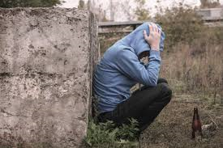
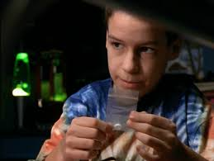
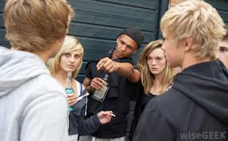
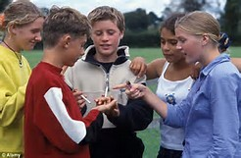
keeping safe – LEARNER ACTIVITY 3

Part 1
- The purpose of the activity is to understand basic first aid skills in drug-related situations.
- Divide pupils into 4 groups.
- Allocate one of the following four scenarios to each of the small groups :
  - Someone is very drowsy but conscious
  - Someone is overheated and dehydrated
  - Someone who is tense and panicky
  - Someone has collapsed and lost consciousness.
- Tell the group to imagine that they are with this person who has taken drugs. On their flipchart note down:
  - Which drug could be involved?
  - What they should DO and what they should NOT DO to help the person?
- Invite the groups to display, in turn, their flipcharts and to present their findings. Generate discussion about what they suggest, using the ideas of the other group members and by referring to the information handout.

Part 2
- Encourage the class to think about how they can stay safe on a night out referring back to the previous exercise.
- Encourage the class to agree on the top ten tips to stay safe on a night out.

Further activities:
- Encourage pupils to make some posters or leaflets about 'dealing with drug emergencies' or 'staying safe on a night out' and display where young people can see them.
- Look into more detailed training in first aid from staff who have been trained in your school or from an external provider. For example: Scottish Fire & Rescue
KEY MESSAGES
- Understanding basic first aid enables you to have the skills to help someone if you come across them in a drug-related situation.
- It is important to understand there are ways to avoid likelihood of becoming involved in a risky situation on a night out.

BASIC FIRST AID IN DRUG RELATED SITUATIONS
Some young people who have got into problems with drugs are only alive today because their mates knew what to do in an emergency. Others have died because the people around them panicked and didn't know what to do.

- If people are drowsy but conscious...

This usually happens with “downer” drugs like alcohol, tranquillisers and heroin but can also happen with solvents (glue and gas).

If someone is really drowsy:
  - Call an ambulance / seek medical help
  - Never leave them alone
  - Try to stimulate them. If they can walk on their own, encourage them to do so
  - If they cannot walk, put them in the recovery position
  - Try to stop them becoming unconscious and don't put them to bed, as they might lose consciousness in their sleep. (People have been put to bed in a drowsy state only to be found dead the next morning, after choking on their own vomit.)
  - If they want a drink only give them sips of lukewarm water. If they are drunk do not give them coffee to sober up. This is a myth - all it does is make the body absorb the booze more quickly so you are actually making the problem
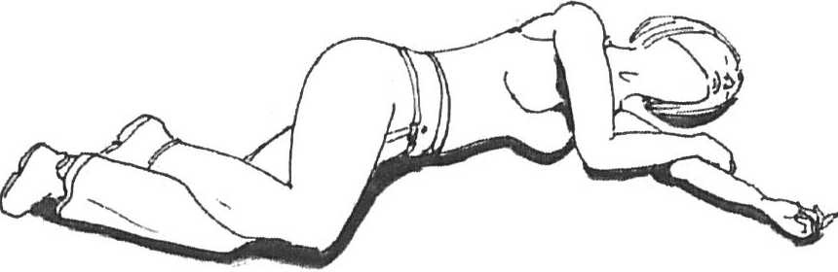
The Recovery Position

- If people are tense and panicky...

This tends to occur with hallucinogenic drugs like LSD and magic mushrooms but it can also happen with drugs like amphetamines, cocaine and ecstasy as well as high doses of cannabis.

If someone is really tense and panicky on drugs:

- Calm them down and reassure them. Talk quietly to them and explain that the panicky feelings will gradually go. Keep them away from loud noise and bright lights

- Help them if they hyperventilate. This is when someone breathes very quickly and gasps for breath. They often also get dizzy and feel sick. Explain to them what is happening. Get them to copy you in slow, regular breathing
- If someone overheats and gets dried out (dehydrates)...

This mainly happens with ecstasy. Ecstasy raises body temperature. If people use it in hot places like clubs body temperature goes even higher. Ecstasy gives an energy boost that allows people to dance for long periods and get even hotter. As people get hotter they lose a lot of body fluids - as much as a pint an hour. Overheating and dehydration can result. This can be very dangerous and has been the main reason for ecstasy-related deaths. The warning signs include cramps in the legs, arms and back; failure to sweat; headaches and dizziness; vomiting; suddenly felling very tired; feeling like a wee but not doing much when you go; fainting.

Overheating and dehydration can be prevented by:
  - Not taking ecstasy in the first place
  - Taking regular rests and relaxing in a cool area
  - Regularly drinking water or fruit juice (not alcohol - it dehydrates even more). Drinking too much water itself can be dangerous – the recommendation is to have small sips and no more than 1 litre per hour, preferably drink sports/energy drinks instead of water (i.e. electrolyte containing liquids).
  - Wearing cool clothing and not wearing hats (hats keep the heat in)

If someone is overheating:
  - Call an ambulance / seek medical help
  - Move the person to a cool area, possibly outside
  - Splash them with cold water
  - Only give them sips of water
  - Fan them to cool them down
  - Give emergency services as much information as possible including packaging or samples of what has been taken if available

- If someone has collapsed or lost conciousness

This happens mainly with large doses of downer drugs like alcohol, heroin and tranquillisers but is also quite common with solvents (glue, gas and aerosols) and poppers. It can also happen to people who react badly to any drug.

If it happens:

  - Call an ambulance / seek medical help

  - Never leave them alone

  - If they are not breathing CPD should be started – 30 compressions followed by 2 breaths, and repeat until ambulance arrives or they regain consciousness

  - Give emergency services as much information as possible including packaging or samples of what has been taken if available

SOCIAL IMPLICATIONS OF SUBSTANCE MISUSE – learner activity 4

Part 1

- Split the class into small groups and distribute paper and pens.
- In groups’ think of the individuals or groups who are, in their opinion, affected by someone else’s substance misuse.
- Encourage the groups not to restrict their thinking just to their immediate circle of family, friends and associates.
- Using the example answer sheet provided, discuss the group responses. Ask the groups to explain how they think each individual or group might be affected.

Part 2
- Give the groups the scenario sheet - Who’s Affected by Substance Misuse
- Ask each group to work through the scenarios and ask them to discuss the behaviours that may occur as a result of this substance misuse. They should make a note of this and then think about who this could affect. Encourage the pupils to think about all the different ways that others can be affected, e.g. physically, socially, mentally and financially.
- Once the groups have a list of all those affected, distribute the worksheet - Who’s MOST affected by substance misuse.
- Write these on the target with those MOST affected closer to the bullseye and those LESS affected further away.
- As a class discuss the feedback from each scenario in terms of who’s affected and in what way.

Part 3
- In groups ask pupils to discuss what could be done in each scenario to reduce the impact on others. They should think about this at both an individual and community level, e.g. Individual level - individuals can make sure they dispose of used bottles etc. safely, and at community level – more bins/drug equipment disposal bins could be made available.
- Discuss feedback on this as a class.
KEY MESSAGES
- It is important to understand that substance misuse, either their own or that of others, not only affects the user, but has wider implications and affects those around them.
- Substance misuse affects society as a whole and not just immediate family, friends and associates.
- Individual responsibility over drug decisions should take into account societal implications.

those affected by substance misuse
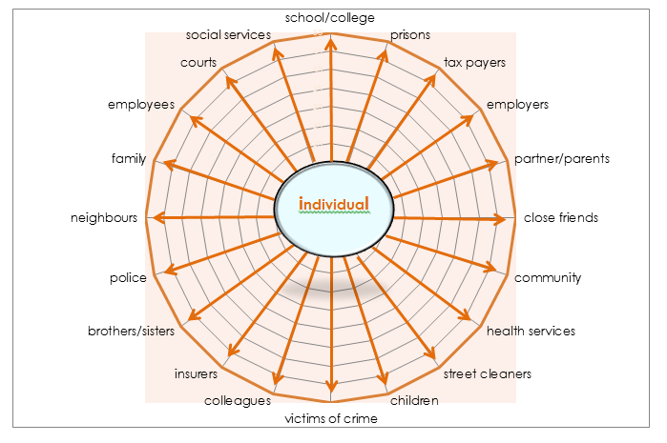
It should be noted that the individuals and groups listed above are only suggestions of those affected by an individual’s substance misuse. Pupils may be able to identify many others.

who’s affected by substance misuse

Scenario 3
A student at a party becomes unwell after taking a pill.

Scenario 1
Young people drinking and smoking cannabis in a local park.

Scenario 2
Groups of young adults getting drunk in busy pubs in residential areas on weekend evenings.

Scenario 4
A young man has too much to drink and gets into a fight resulting in the Police being called.

Scenario 5
A young woman who has too much to drink on a night out and isn’t fit to go to work the next day.

who’s most affected by substance misuse

INDIVIDUAL

