Relationships, Sexual Health and Parenthood – Home Activities – Early level (Early Years and P1)
Over the coming weeks we would have been delivering Relationships, Sexual Health and Parenthood Education lessons with your child’s class. This is a really important part of the wider health and wellbeing programme of learning and you might already find yourself answering questions about some of these themes. We thought it would be useful to provide you with some activities that we have taken from the national resource for RSHP at www.rshp.scot
Activities
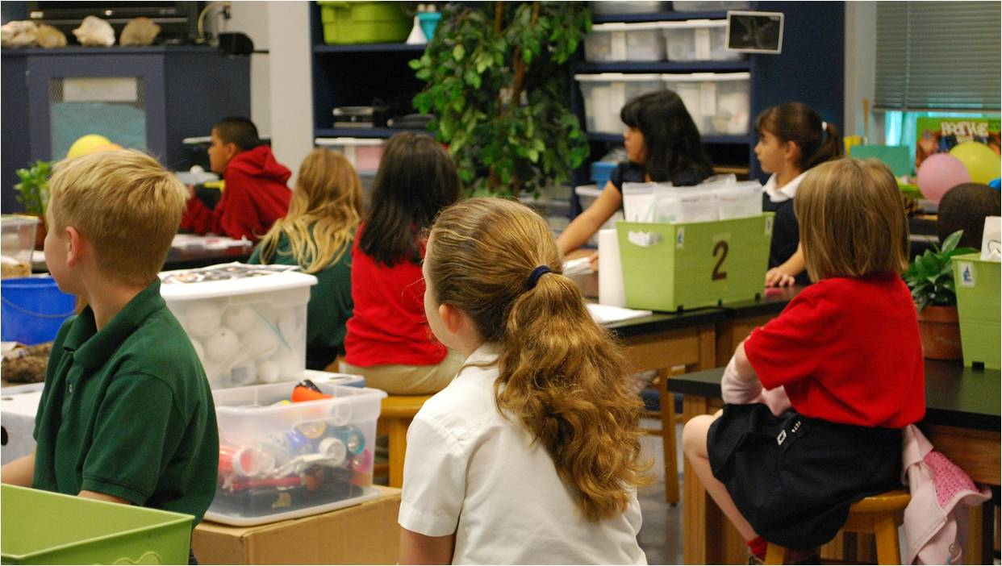
Learning can be planned or take place in what we might call those spontaneous ‘teachable moments’ when children and educators are playing and chatting, or a particular event happens. Of course, we can create those teachable moments too, and so there are suggestions here about how books, play and other activities can support RSHP learning at Early Level.
Topic/Theme | Families
Title | Our Families
Activities | Talking about my family - In conversation and play children can be encouraged to talk about family members – what they do with them, who plays with them, reads them a book or makes tea. The different names children use for family members could be acknowledged and listed. Conversations can help children to learn about immediate and extended family – some children may live with extended family of course.  Family Tree - Make a version of a family tree so that relationships can be explained and the names of family members can be identified – this is a good way to find out all the different names for parents (Mum, mama etc) and grandparents, including names used from languages spoken at home.
Learning Intentions | Children talk about their own family.  Children are able to describe the role of parents and carers.
Key messages for Parents/Carers | You might find some of these books useful for reading together:-  The Great Big Book of Families Mary Hoffman ISBN 1847805876  A celebration of the huge diversity found within contemporary families.  The Family Book Todd Parr ISBN 0316070408  The Family Book celebrates the love we feel for our families and all the different varieties they come in. Whether you have two mums or two dads, a big family or a small family, a clean family or a messy one, Todd Parr assures readers that no matter what kind of family you have, every family is special in its own unique way.  Families, Families, Families! Suzanne Lang ISBN 9780552572927  If you love each other then you are a family. Discover a whole host of silly animal families in this celebration of the love found in families big and small  Who’s in a Family Robert Skutch ISBN 1883672139  Family is important, but who's in a family? It’s the people who love you the most! This picture book has no preconceptions about what makes a family a family. There's even equal time given to some of children's favourite animal families.  We belong together: a book about adoption and families Todd Parr ISBN 0-316-01668-3  There are lots of different ways to make a family. It just takes love.  Do you sing twinkle? A story about remarriage and new family Sandra Levins ISBN 1433805391  Living apart from a parent can be a hard adjustment for a child. If that parent remarries and has stepchildren, things can get confusing. Told from a young boy's point of view, this book addresses many feelings and questions that children may have while adjusting to remarriage and a blended family after their parents' divorce.  Mommy, Mama and Me Leslea Newman ISBN 1582462631  Rhythmic text and illustrations with universal appeal show a toddler spending the day with its mums. From hide-and-seek to dress-up, then bath time and a kiss goodnight, there's no limit to what a loving family can do together  King and King Linda de Haan ISBN 1582460612  Once there lived a lovelorn prince whose mother decreed that he must marry by the end of the summer. So began the search to find the prince's perfect match and lo and behold......his name was Lee. You are cordially invited to join the merriest, most unexpected wedding of the year. A tale about finding true love and living happily ever after

Topic/Theme | Asking Questions
Title | Asking questions/Making choices/Saying Yes Saying No/ Early Consent Messages
Activities | Encouraging Questions - Explain that this is a home that loves questions. When exploring a topic or having a conversation ask your child what questions they have. They may already ask a lot of questions that start with why? So, encourage (and model) questions that start with who, what, where and how?  Making Choices - There will be many opportunities in the course of the day to provide choices for children, not so that they are overwhelmed with options but where there is a genuine choice for them to make – and time to make it – about play, food, shared tasks.  Stories and Questions - As you read together you might think about different kinds of questions:  • Literal questions ask about facts in a story. Can you remember what…?  • Inference questions ask children to look beyond the text to something that was implied: What do you think might happen next?  • Evaluative questions require children to read behind and beyond the lines: Do you think she should have done that?  These different kinds of questions help build the child’s understanding of another person’s/character’s point of view and build empathy and understanding.
Learning Intentions | Children develop an understanding of a range of feelings which they can talk about.  Children are learning about co-operating, sharing and about manners.
Key messages for Parents/Carers | The suggestions for work on encouraging questions links to Curriculum for Excellence Literacy experiences and outcomes, they are part of this list of suggested activities and approaches because RSHP is concerned with encouraging children to be both curious and autonomous, with confidence in their feelings and able to ask questions and explore the relationships they have. At this Early Level learning to say ‘yes’ and ‘no’ underpins the work that is done throughout RSHP learning on areas like bodily autonomy, consent, understanding and respecting personal boundaries.  You might find some of the following books useful for reading together:-  My many coloured days Dr Seuss (ISBN 0099266598)  'You'd be surprised how many ways I change on different coloured days. Maybe on some days you feel sort of brown, like a bear; you feel slow and low, low down. But then comes a yellow day and wheeeeeeeee you feel like a busy, buzzy bee’. Dr Seuss takes the reader on a journey through many different moods.  Wes Tank reads the book here: https://www.youtube.com/watch?v=iR0-5f-L_LQ  No Means No! Jayneen Sanders and Cherie Zamazing (ISBN 1925089223  ‘No Means No!’ is a children’s picture book about an empowered little girl who has a very strong and clear voice in all issues, especially those relating to her body and personal boundaries. Teaching personal boundaries, consent.  No No Yes Yes Leslie Petricelli (ISBN 0763632449)  For younger children, an expressive baby demonstrates different behaviours and their predictable responses.  No David! David Shannon (ISBN 1338269046)  David does a lot of things he’s not supposed to do….  Yes Day Amy Krause Rosenthal (ISBN 0545256097)  There’s one day a year when the response to every question must be YES….  I’m a Girl! Yasmeen Ismail (ISBN 1408857006)  The girl in this book likes to win, she likes to be spontaneous, fast and strong, and because she also likes to dress in t-shirt and shorts, she is forever getting mistaken for a boy. And when she meets a boy who likes wearing princess dresses and playing dolls, they both quickly discover that they share interests that are wide and varied. I am a Girl! is a wonderful celebration of being who we are and not being pigeon-holed or restricted by gender stereotypes.  Clive and his Babies Jessica Spanyol (ISBN 1846439914)  Meet Clive - and his imagination! Clive loves his dolls. He enjoys playing with them, and sharing them with his friends. A gentle, affectionate book, celebrating diversity and challenging gender stereotypes.  Oliver who was small but mighty Mara Bergman and Nick Maland (ISBN 0340930551)  Oliver is small, but he wishes he were tall and mighty - especially when he is confronted by a school of whales, a bunch of pirates and a sea monster. This story is about overcoming your fears.  I'm Worried Brian Moses (ISBN 0750221313)  Young children experience many confusing emotions in their early years. This book examines feeling worried in an amusing but reassuring way. The book contains notes for parents and teachers with suggestions of ways to help children deal with these emotions

Topic/Theme | People who help and look after me
Title | People who help and look after me
Activities | Who helps?  Who helps me at home? Draw pictures of houses and home life. Acknowledge the diversity of home lives, identifying who helps children and how, and possibly who and how your child may help - a younger sibling, a parent or grandparent.  Who helps me at nursery/school? Discuss staff in the centre/school and what their role is in the centre/school. Include staff roles such as janitor, office staff, learning assistants, etc.  Who helps people when… someone is sick or hurt, has a sore tooth, they are lost, something isn’t working? Encourage your child to explore circumstances where they need help immediately or may be worried or concerned, but they can also discuss who helps in a preventative way e.g. why we go to the dentist regularly.  The PowerPoint slides found at https://rshp.scot/early-level/#peoplewhohelpandlookafterme people who help and look after me (slides) offer some visual prompts. You can also add in other professions to incorporate other people your child may meet and know. Encourage stories about visits to the doctor, dentist, hospital or other places your child may attend.
Learning Intentions | Children understand that different adults – family and professional people – provide care for children.  Children know the jobs of the main professional people who provide care.
Key messages for Parents/Carers | You might find some of these books useful for reading together:-  This is the Firefighter Laura Godwin ISBN 1423108000  For younger children. The fire alarm sounds. The firefighter responds. He jumps in the fire truck and races to a daring rescue!  Clive is a Nurse Jessica Spanyol ISBN 9781846439919 (Board book, 2017)  What will Clive be today? Follow Clive and his friends as they explore the many things a nurse does in a day. This humorous and caring interaction of an inclusive group of playmates will inspire young readers to create their own diverse roles, free of gender stereotypes.  Clive is a Teacher Jessica Spanyol ISBN 9781846439902  Follow Clive and his friends as they explore the many things a teacher does in a day.  Topsy and Tim meet the Police Jean and Gareth Adamson ISBN 9781409308836  Topsy and Tim find themselves learning the importance of safety when their class is visited by two police officers. The book addresses safe places for children to play, and warning signs to look for that may indicate a dangerous situation.  Topsy and Tim meet the Ambulance Crew Jean and Gareth Adamson ISBN 0721428606  The twins learn about the work of an ambulance crew – the story helps children understand if family or friends need immediate help from this emergency service.  Topsy and Tim Go to Hospital Jean and Gareth Adamson ISBN 9781409304234  Tim has fallen out of a tree and bumped his head. He's a little nervous about going to hospital, but he soon finds out how nice the Doctors and Nurses are, and there are lots of other children on the ward to play with too.

