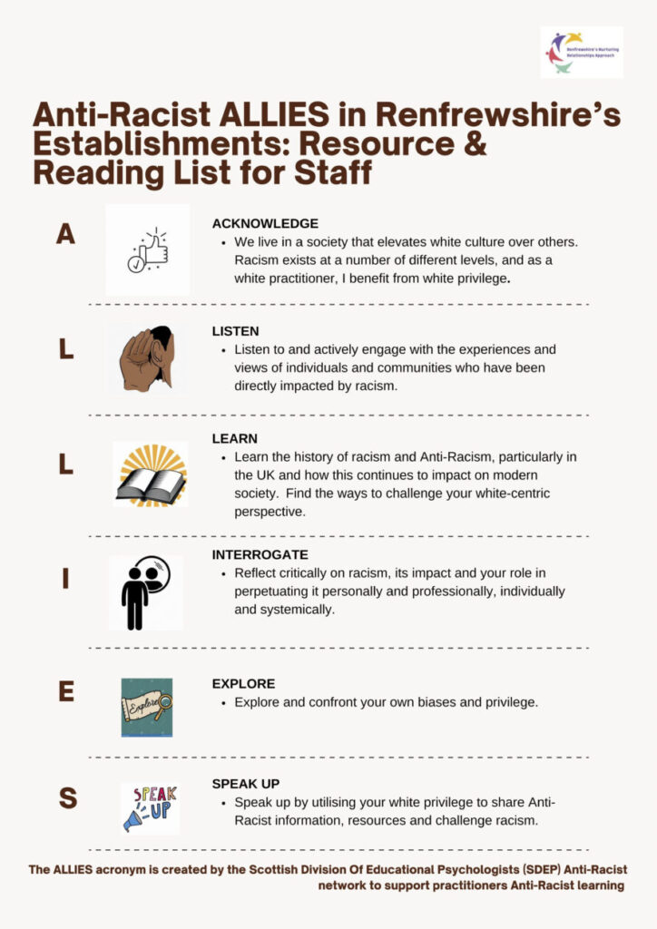

Acknowledge
…that we live in a society that elevates white culture over others. Racism exists at a number of different levels, and as a white practitioner, I have and do benefit from white privilege.
Books
- “White Fragility: Why It's So Hard for White People to Talk About Racism” by Robin DiAngelo
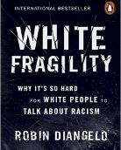
- “Me & White Supremacy” by Layla F Saad
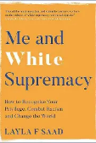
Articles & Resources
- How systemic racism affects young people in the UK | Barnardo's
- White Privilege Test (The Anti-Racist Educator Edition)
Social Media

Follow on Instagram:

Everydayracism_ (Naomi and Natalie (@everydayracism_)
Podcasts & Video
- The Anti-Racist Educator. Various podcasts available on Spotify:
The Anti-Racist Educator | Podcast on Spotify
or https://www.theantiracisteducator.com/podcast

Listen
…to & actively engage with the experiences & views of individuals & communities who have been directly impacted by racism.
Books
- “The Good Immigrant” edited by Nikesh Shukla
Audiobook also available on Spotify: The Good Immigrant | Audiobook on Spotify
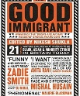

- “Its not about the Burqa: Muslim women on Faith” by Mariam Khan
Audiobook also available on Spotify: It's Not About the Burqa: Muslim Women on Faith, Feminism, Sexuality and Race | Audiobook on Spotify

- “Living While Black: Using Joy, Beauty, and Connection to Heal Racial Trauma” by Guilaine Kinouani
Audiobook also available on Spotify: Living While Black: The Essential Guide to Overcoming Racial Trauma – A GUARDIAN BOOK OF THE YEAR | Audiobook on Spotify

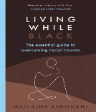

- “Hidden Histories” with Nova Reid (Audiobook):
Hidden Histories with Nova Reid Audiobook | Free with trial
Articles

“You’re reminded you don’t belong, even if you were born in Britain” (Guardian article):

You’re reminded you don’t belong, even if you were born in Britain’: after the riots, reflections on racism | Race | The Guardian

Executive summary of research into the perceptions and experiences of BAME YP in Scottish secondary schools: iys_edi_report_v1.pdf

“Mental Health and Wellbeing of Ethnic Minority Teachers” (Education Support): Mental Health and Wellbeing of Ethnic Minority Teachers
Social Media

Follow on Instagram:
Nova Reid (https://www.instagram.com/novareidofficial/ )
Akala (https://www.instagram.com/akalamusic/ )
Podcasts & Video

Epistemic homelessness (Guilaine Kinouani):

Guilaine Kinouani: Epistemic homelessness | TED Talk

The Anti-Racist Educator Podcast (available on Spotify and online here) e.g:

Racial Trauma, Black History and Black Joy: In Conversation with Ife Thompson from BLAM UK | Podcasts

In conversation with Ann: institutional racism in education, impact on family and hopes for the future. | Podcasts

Learn
…the history of racism and Anti-Racism, particularly in the UK and how this continues to impact on modern society. Find the ways to challenge your white-centric perspective.
Books
- “No Problem Here: Understanding Racism in Scotland”
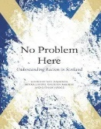
- “Natives: Race and Class in the Ruins of Empire” by Akala
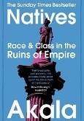
Articles & Resources
- Black care-experienced young people in the criminal justice system | Barnardo's

How systemic racism affects young people in the UK | Barnardo's

Introduction to Anti-Racist curriculum development -Coalition for Racial Equality and Rights (CRER): Antiracist curriculum development — CRER

Anti racist educator glossary (of common terms): https://www.theantiracisteducator.com/glossary
Social Media
- Talking racism and mental health in schools: podcast series (The Anna Freud Centre)
https://www.annafreud.org/schools-and-colleges/anti-racism-and-mental-health-in-schools/talking-racism-and-mental-health-in-schools-podcast-series/

The Anti-Racist Educator (available on Spotify and online here):

What is race? Is it still relevant in Scotland?

Follow on Instagram:

Justice 4 windrush https://www.instagram.com/j4windrush/
Podcasts & Video

What is colonialism? The history of racism (University of Sheffield): https://youtu.be/XQV8qCkFV9E

Glasgow slavery history (Vice): https://youtu.be/y_YDMbLXtx0

The effects of slavery today (Joy DeGruy, YouTube): https://youtu.be/Rorgjdvphek

The lie that invented racism (John Biewen): https://www.ted.com/talks/john_biewen_seeing_white

Education, Race and Class in Scottish history (Smina Akhtar): https://www.youtube.com/watch?v=2MpyiNgqyQM

Enslaved (4 part BBC series): Available on YouTube (No longer on iPlayer)

Submnormal: A British scandal (BBC documentary): BBC One - Subnormal: A British Scandal

Interrogate
…Reflect critically on racism, it’s impact and your role in perpetuating it personally and professionally, individually and systemically.
Books
- Nice Racism: How Progressive White People Perpetuate Racial Harm by Robin DiAngelo
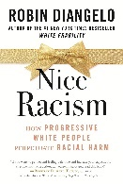
- “Wish we knew what to say: Talking with children about race” by Dr Pragya Agarwal
by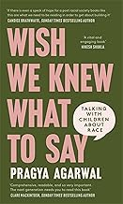
Articles & Resources
- Cultural Competence in Practice: A Reflective Tool for Education Professionals by Rachel Beattie, Ashley Cairns & Jemma Coysh (Educational Psychologists in Training). Available in interactive ThingLink version or downloadable version: https://www.thinglink.com/scene/2030670313838090084
- A toolkit from Forth valley/ West Lothian Regional Improvement Collaborative to support your anti-racism journey (ThingLink):
https://www.thinglink.com/card/1713398786262303588
- Recent research on teachers managing and responding to racism in schools:
Frontiers | Teacher responses to racially motivated bullying in Scotland (frontiersin.org)
- The Anti-Racist Educator article on pupils call for a decolonized curriculum: Pupils in Scotland Call for Change: It's Time for an Anti-Racist, Decolonised Curriculum
- Understanding the adultification of children and young people | BPS

Addressing race and trauma in the classroom: A resource for educators National Child Traumatic Stress Network:

https://www.nctsn.org/sites/default/files/resources/addressing_race_and_trauma_in_the_classroom_educators.pdf
- Introduction to antiracist curriculum development -Coalition for Racial Equality and Rights (CRER): Antiracist curriculum development — CRER
- Windows & Mirrors: Diversity in the curriculum (Education Scotland). The concept of Mirrors and Windows as a useful practical approach to embed diversity and equalities in the curriculum: iwe-mirrors-and-windows-information-note-informed-level.pdf
Social Media
- Follow on Instagram:
https://www.instagram.com/anti_racist_educators/?igsh=bDRpdHJ2aGhzdzA3#
Podcasts & Video
- “Not all superheroes wear capes” (microaggressions) Nova Reid: ttps://www.ted.com/talks/nova_reid_not_all_superheroes_wear_capes_you_have_the_power_to_change_the_world

Explore
…and confront your own biases and privilege.

Books
- “Me and White Supremacy” by Layla F. Saad
'Me And White Supremacy' Helps You Do The Work Of Dismantling Racism (summary of above book): https://www.npr.org/2020/07/06/887646740/me-and-white-supremacy-helps-you-do-the-work-of-dismantling-racism
- “The Good Ally” by Nova Reid
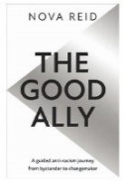
Articles & resources
- “Why I no Longer Talk to White People About Race” by Rennie Edio Lodge (article, audio version available, The Guardian)
https://www.theguardian.com/world/2017/may/30/why-im-no-longer-talking-to-white-people-about-race
- White Privilege Test (The Anti-Racist Educator Edition)
Podcasts & Video
- Not-racist v antiracist: what’s the difference? (video, BBC Bitesize): https://www.bbc.co.uk/bitesize/articles/zs9n2v4

Speak Up
…by utilising your white privilege to share Anti-Racist information, resources and challenge racism
Books
- “No offence but…” by Gina Martin
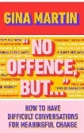
- “The Good Ally” by Nova Reid
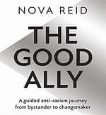
- “How to be an antiracist” by Ibram X. Kendi
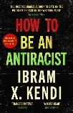
Article’s & resources
- https://www.theantiracisteducator.com/school-resources
- Resources, tools, workshops and ideas to support educators in Scotland to build an anti-racist curriculum: antiracisted.scot
- Promoting Anti-Racist Education in Scotland (Education Scotland) website: Promoting Anti-Racist Education in Scotland
- Schools - addressing racism and racist incidents: Scottish government guidance:https://www.gov.scot/publications/addressing-racism-racist-incidents-schools/
- SCOTDEC anti racist toolkit for teachers: Anti-racist toolkit for teachers – Scotdec
- Children’s books to support empathy & understanding for refugees and displaced people:
  - Saving the Butterfly
  - The Journey
  - My name is not Refugee
  - Lubna and Pebble
  - Adnan
  - The endless Sea
Social Media

Follow on Instagram:

Tinytravels_UK

Refuweegee (@refuweegee)

https://www.instagram.com/standuptoracismuk/ https://www.instagram.com/antiracismeveryday/
Podcasts & Video clips
- Not-racist v antiracist: what’s the difference? (video, BBC Bitesize): https://www.bbc.co.uk/bitesize/articles/zs9n2v4

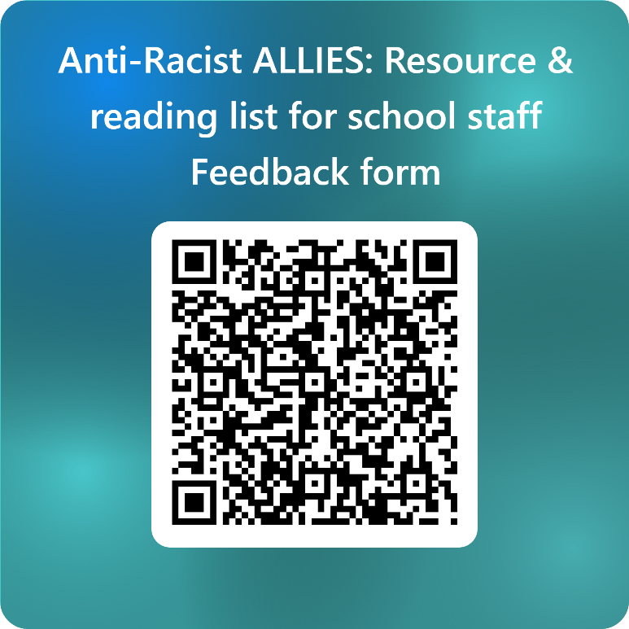
To provide feedback on this resource, please scan the QR code or click here: https://forms.office.com/e/n5WMvPeqfA

