Supporting those who have experienced loss, bereavement and change  Resources for staff in secondary settings | 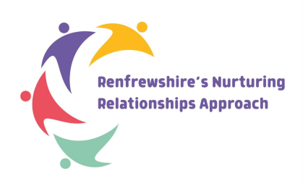  Renfrewshire Educational Psychology Service

It is suggested that educational establishments have some of these resources available in their library and that they are used in a proactive manner and not solely after a loss has occurred.
Format | Title | Author | Description
Book | Dustbin Baby | Jaqueline Wilson | April was abandoned in a dustbin as a baby on the 1st April. Having spent all her life in a children’s home and with different foster parents (one of whom committed suicide), April is struggling. Now she’s fourteen and on her birthday, determined to find out more about her past, sets off to find some important people. This is an emotive book with a great storyline in usual Jacqueline Wilson style.
Book | The Charlie Barber Treatment | Carole Lloyd | Simon’s Mum died suddenly from a brain haemorrhage and he came home from school to find she had died. With his GCSE coursework piling up and having to help around the house, Simon finds it hard and doesn’t go out much with his friends. He then meets Charlie,  and starts to enjoy life again and to re-build relationships with his family and friends. A sensitive and realistic book that conveys  some of the thoughts and emotions of a teenage boy.
Book | The Lost Boys Appreciation Society | Alan Gibbons | Teenage life is difficult enough for Gary and John, but when their Mum dies in a car accident, things get steadily worse. John struggles to keep the peace as Gary goes off the rails. With exams looming and his Dad going out on dates, things become unbearable for John. A gripping book exploring relationships and how different people react to life events.
Book | Before I die | Jenny Downham | With only months left to live, 16-yearold Tessa makes a list of things she must experience: sex, petty crime, fame, drugs and true love. Downham’s wrenching work features a girl desperate for a few thrilling moments before leukaemia takes her away.
Internet resource | When People Die | University of Dundee | Stories from Young People is a comic that tells numerous stories about death and resilience from a group of young people.
Book | Grief encounter | Shelley Gilbert | A workbook to encourage conversations between adults and bereaved children and young people. Hands on, user friendly, with many ideas to encourage communication and provide support
Website | Teenage grief | Leeds animation | Accompanying the videos is a free training resource which can used to deliver training to practitioners working with young people and their families
Website | Hope again | Youth website of Cruse bereavement support | A safe place where you can learn from other young people, how to cope with grief, and feel less alone.
App | Apart of me |  | When someone you love dies, it can feel like everything has turned upside down. But you’re not alone. Apart of Me is a beautiful world, built to guide you through your darkest moments.
Resources appropriate to support children and young people with additional support needs
Format | Title | Author | Description
Book | When mum died  When dad died | Sheila Hollins and Lester Sireling | Simple pictures and a direct approach which may be appropriate for some children with ASN.
Book | The Invisible String | Patricia Karst | Simple approach to overcoming the fear of loneliness. Reminding children that we are loved beyond anything we can imagine.  Read aloud:  https://www.youtube.com/watch?v=WlUxXexjhYI
Book | Finding your own way to grieve | Karla Helbert | A creative activity workbook for children and teens on the autism spectrum.
Website | Supporting autistic learners with bereavement | National Autism Implementation Team | Key Messages to support staff working in and with schools to support neurodivergent learners affected by a death in their family or school community.
Website | Grief and bereavement resources | Autism speaks | Links to a variety of resources to support neurodivergent learners understand and cope with tragedy and grief
Website | Supporting bereaved children and young people with a learning disability | Child bereavement UK
Website | Bereavement support for children with SEND | Child bereavement UK
Resource Pack | Bereavement and loss: Learning resource pack | PAMIS | The Bereavement and Loss Learning Resource Pack is for those supporting bereaved people with profound learning and multiple disabilities and their parents and carers.
Additional Resources
- GCC/GGC NHS resource - https://www.nhsggc.scot/downloads/a-whole-school-approach-to-loss-and-bereavement-december-2021/
- Managing a Sudden Death https://www.childbereavementuk.org/managing-a-sudden-death
- Scottish bereavement friendly workplaces toolkit
Good Life, Good Death, Good Grief :: Welcome to the toolkit (goodlifedeathgrief.org.uk)
- A copy of the recent draft critical incident and sudden bereavement guidance for educational establishments in Renfrewshire can be found here.

It is helpful for the adults supporting bereaved children to consider children’s understanding of grief at different ages. Although they will feel it just as deeply, children will express grief in different ways to adults. Adults may also want to consider how to explain death and dying to children.

Examples of creative activities to use with children who have experienced bereavement and loss.

- Child Bereavement UK's free activities for grieving children and young people

Understanding the needs, rituals and practices of different faiths and cultures can be helpful when you’re supporting someone who is bereaved or who is facing bereavement. As a professional supporting someone who is bereaved, the first principle of supporting people of different cultures, faiths and belief systems is to be aware that approaches to death and dying will vary not only between faith groups and cultures, but will also vary within faiths, groups, and families.

Talking to children and young people about imprisonment factsheet is a useful factsheet from Families Outside.

Universal curricular resources, lesson plans and creative activities

- Child Bereavement UK's free activities for grieving children and young people
- Free PSHE lessons on loss and bereavement | School resources | Winston's Wish (winstonswish.org)
- Compassionate and Connected Classroom resource from Education Scotland is a health and wellbeing resource for upper primary.
- Resilience project Falkirk is a series of lesson plans that educate and support children around death, dying and bereavement.
- Elephant’s tea party is a series of lesson plans from Child Bereavement UK to equip all children, whether bereaved or not, with the tools to help them to cope with loss now or in later life.


Useful videos about loss and grief
Traumatic Bereavement - UK Trauma Council
Talking to children who are bereaved - YouTube
How do you help a grieving friend? - YouTube
Supporting a child after a frightening event | Child Bereavement UK
Films to help children understand funerals | Child Bereavement UK
Good Grief at Gryffe - St Vincent’s Hospice on Vimeo
A guide to understanding grief – St Vincents hospice and Johnstone High School

Podcasts

- Real Voices (talkgrief.org)

- The Grief Gang on Apple Podcasts
- Griefcast on Apple Podcasts
- Dead Parent Club on Apple Podcasts
- Home (talkgrief.org)

Instagram accounts

- @thegriefspace A ‘safe haven for grievers’ with grief talks and resources and support for young people experiencing loss
- @talkaboutloss Let’s talk about loss which organizes meet ups for bereaved young people aged 18-35
- @goodgrief_uk The good grief space, an online membership space helping people with grief, anxiety, love self-esteem and identity


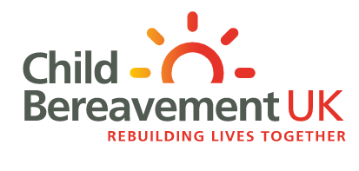
National organisations that offer support

https://www.childbereavementuk.org/

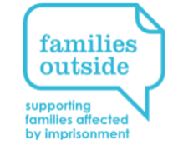
http://www.childhoodbereavementnetwork.org.uk/

https://www.cruse.org.uk/



Help, information, and support for families of prisoners | Families Outside

Helping children through separation | Gingerbread

Support and services to anyone who has been affected by the loss of a baby at any stage of pregnancy or after birth
Simba - supporting families who have experienced baby loss (simbacharity.org.uk)

Supporting People Who Are Experiencing Bereavement Grief, Trauma, and Loss (affected by murder, culpable homicide, and suicide)
PETAL Support – Supporting People Experiencing Trauma and Loss

Chris’s House is a Centre for Help, Response and Intervention Surrounding Suicide.
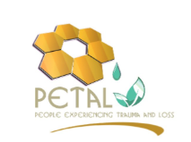
Chris's House – Centre of Help, Response and Intervention Surrounding Suicide (chrisshouse.org)

Support services to those bereaved through road traffic incidents
Brake | The Road Safety Charity



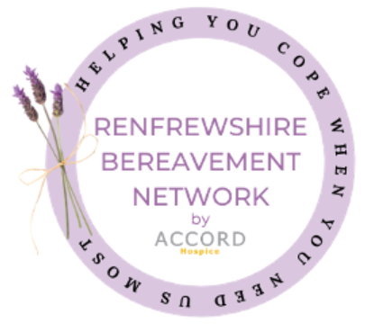
Local supports
Accord and St Vincents hospices are the two hospices that serve the Renfrewshire area.
Renfrewshire Bereavement Network - Renfrewshire Website


Renfrewshire Educational Psychology Service – Applying Psychology to Nurture Relationships, Learning, Mental Health, and Wellbeing (glowscotland.org.uk)
Renfrewshire Health and Wellbeing (glowscotland.org.uk)
REN10 – Take a breath and count to 10.
Please remember professional advice is available through your GP or through the employee counselling service Time for Talking on 03302020283 or email timeforthriving@healthisone.co.uk or you can complete an online referral: TimeforThriving - Your trusted mental health and wellbeing provider

QR codes for mental health and wellbeing signposts
Parents/carers Children and young people Staff
