Supporting those who have experienced loss, bereavement and change  Resources for parents/carers | 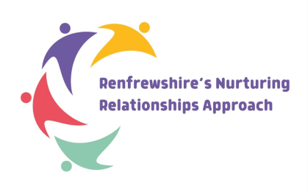  Renfrewshire Educational Psychology Service

Book list
You may find some of these books useful to support a conversation with your child around loss and change.
Title | Author | Description
I miss you: A first look at death | Pat Thomas | This reassuring picture book explores the difficult issue of death for young children. Children's feelings and questions about this sensitive subject are looked at in a simple but realistic way. This book helps them to understand their loss and come to terms with it.
My Family’s changing: A first look at family break-up | Pat Thomas | This simple and reassuring picture book that explores concerns about divorce and family break-ups for young children The fears, worries and questions surrounding this difficult experience are made accessible and approachable
I miss my pet: A first look at when a pet dies | Pat Thomas | A beautifully illustrated and reassuring picture book that explores the issue of the death of a pet in a simple but realistic way.
The little flower bulb: Helping children bereaved by suicide | Eleanor Gormally | The Little Flower Bulb tells the story of Jamie, his mom, and his twin sisters, and of how Jamie comes to deal with the death of his father. Suitable for children aged 3-10, this beautifully illustrated book will be helpful for parents when talking to children bereaved by the suicide of a close relative.
Mum and Dad Glue | Kes Gray | This comforting, reassuring picture book will help young children come to terms with divorce and separation
When parents separate: questions and feelings about | Dawn Hewitt | How to you explain to a child what happens when parents separate? This hands on picture book is designed to help children with their questions and feelings about tricky topics that can be hard to talk about.
The Invisible String | Patrice Karst | The perfect book to support children to cope with all kinds of separation anxiety, loss, and grief.
The Invisible Leash | Patrice Karst | Using the same simple but effective bonding concept from The Invisible String, The Invisible Leash illustrates the spiritual connection pet owners have with their animals.  You can access a free downloadable PDF of related activities here
Badgers Parting Gifts | Susan Varley | Badger is so old that he knows he must soon die, so he does his best to prepare his friends. When he finally passes away, they are grief-stricken, but one by one they remember the special things he taught them during his life. By sharing their memories, they realise that although Badger is no longer with them physically, he lives on through his friends.
The Secret C | Julie Stokes | This illustrated guide for children provides a sensitive introduction for a child when a parent, sibling or a person close to them is diagnosed with cancer. It is aimed at children aged 7 to 10 years and will work best when an adult is present to expand on the simple messages in the text.
Honest? What happens when a relative is sent to prison | Families Outside | A booklet for children aged 4-11 that explores the topic of what happens when a relative is sent to prison
Additional Resources
It is helpful for the adults supporting bereaved children to consider children’s understanding of grief at different ages. Although they will feel it just as deeply, children will express grief in different ways to adults. Parents may also want to consider how to explain death and dying to children.

https://www.familiesoutside.org.uk/publications/information-sheets/talking-children-young-people-imprisonment/ is a useful factsheet from Families Outside.


Useful videos about loss and grief

- What is Grief?
https://www.youtube.com/watch?v=ksG3bgy1GT8

- How do you help a grieving friend? - YouTube

- Puddle Jumping: how children can seem to move in and out of their grief
Puddle Jumping Animation | Child Bereavement UK

- Short video explaining to children how to understand grief and how to manage it
The Invisible Suitcase | Child Bereavement UK

- To help talk about bereavement for younger children
https://www.bbc.co.uk/cbeebies/grownups/archie-the-dog

- Two clips that explain what happens at a burial and what happens at a cremation
Films to help children understand funerals | Child Bereavement UK

- Supporting children after a frightening public event
Supporting a child after a frightening event | Child Bereavement UK

Podcasts

- Podcast organised by Winston’s wish Youth Team Real Voices (talkgrief.org)

- The Grief Gang: A podcast normalising grief.

- Griefcast is a podcast that examines the human experience of grief and death

- The Dead Parent Club has provides support and comfort to young adults across who are grieving the loss of their parent/s. Featuring interviews and conversations with experts and other grievers, the Dead Parent Club podcast aims to normalise the conversation surrounding grief and help others feel less alone.

Organisations that offer support to bereaved adults, families and children/young people
 | Child Bereavement UK (recently joined with Winston’s Wish)  A charity that supports children and young people (up to the age of 25) when someone important to them has died or is not expected to live, and parents and the wider family when a baby or child of any age dies or is dying | https://www.childbereavementuk.org/    Helpline 0800 0288840
 | Cruse  The UKs leading bereavement charity. They help people with bereavement support and information. They also have a Scottish branch. | https://www.cruse.org.uk/  Home : Cruse Scotland  Cruse Scotland Helpline 0808 802 6161
 | Simba  Support and services to anyone who has been affected by the loss of a baby at any stage of pregnancy or after birth  SANDS  Support to anyone affected by pregnancy loss or the death of a baby. | Simba - supporting families who have experienced baby loss (simbacharity.org.uk)      SANDS Helpline 0808 164 3332
 | PETAL  Supporting People Who Are Experiencing Bereavement Grief, Trauma, and Loss (affected by murder, culpable homicide, and suicide) |   PETAL Support – Supporting People Experiencing Trauma and Loss  Telephone 01698 324502
 | Chris’s House  A centre for help, response and intervention surrounding suicide. |   Chris's House – Centre of Help, Response and Intervention Surrounding Suicide (chrisshouse.org)  Telephone 01236 766755
 | Brake  Support services to those bereaved through road traffic incidents |   Brake | The Road Safety Charity
Organisations that offer support when experiencing a terminal illness | Marie Curie | Marie Curie | The UK’s leading end of life charity | Marie Curie    Telephone 0800 090 2309
 | Macmillan Cancer Support | Macmillan Cancer Support | The UK's leading cancer care charity    Telephone 0808 808 0000
Organisations that support families affected by imprisonment | Families Outside | 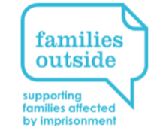  Help, information, and support for families of prisoners | Families Outside
Organisations that support families through separation | Gingerbread |   Helping children through separation | Gingerbread

Local supports
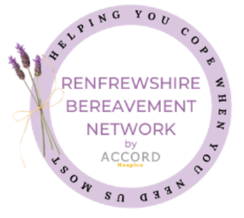
- Accord and St Vincents hospices are the two hospices that serve the Renfrewshire area.

- Renfrewshire Bereavement Network - Renfrewshire Website
If you are experiencing loss or dealing with grief following the death of someone close to you, or the loss of something that is important to you, you can get support from our network. Get in touch with at support@renfbn.org.uk or call on 0800 038 6020.

Community mental health and wellbeing supports
- REN10 – Take a breath and count to 10.

QR codes for mental health and wellbeing signposts
Parents/carers Children and young people



