Renfrewshire Educational Psychology Service (REPS)
Standards & Quality Report
June 2026

REPS now has 5 Whole Service Initiatives (WSIs) – Attendance and EBSA; Learning and Teaching (Learning and Teaching was a service improvement area, but will move to be a WSI from August 2026); NVR; RNRA and RICE. It also has 2 Service Improvement Strands – Self-Evaluation and Equalities. An evaluative discussion of these 7 topics will be captured below.

Attendance and Emotionally Based School Avoidance (EBSA)
The Attendance and EBSA WSI works with partners across education, nationally and locally, to support Renfrewshire schools and nurseries with issues related to attendance. Key to this work is developing practitioners’ understanding of EBSA.

Delivery of:
- Policy and Guidance
This year, in collaboration with multiagency partners including colleagues in schools and nurseries, social work, CAMHS, SCRA and Exchange Counselling, REPS have produced and updated local authority policy and guidance.

- Collaborative Working at Local Level
EBSA and attendance whole establishment training was delivered across early years, primary and secondary establishments. Evaluation data indicated that ‘almost all participants’ reported an increase in their knowledge in relation to supporting attendance and EBSA, with average ratings increasing from 4.5 pre-training to 7.5 post-training. Participants also reported the training as highly relevant to practice, with an average relevance rating of 8.6 out of 10.
As well as our ongoing work with establishments through link EPs, we have carried out the following projects with partners.

- Collaborative Working at National Level

At the start of the social enterprise project, just over half of the children and young people involved said they were excited about their future. After the project, this rose to three quarters of the participants. Participants in the project gave the following feedback:
“Team work, thinking out the box. Doing a power point”
“I think it’s good for me cause I struggle to sit during lessons and I’ve challenged myself for the past few weeks”
“I have became more confident“
“I think I have grown more confident as a person”

Next Steps
- SEEMIS coding ‘unauthorised absence’ analysis project to support better data gathering and analysis
- Update whole establishment training, to include REPS’ data on cultural factors and attendance
- Quality Improvement project cohort 3
- Review SEEMIS guidance to align with full guidance and SC5
- Continue to work with SCRA, SW, Family Wellbeing and education colleagues to support more effective intervention for CYPs experiencing EBSA at stages 3 and 4 of staged intervention.

Learning & Teaching
The purpose of this WSI is to learn more about the current issues facing schools and consider how the REPS can best support establishments in relation to learning and teaching.

At EPS level:
- We have trained our working group in the use of the Cognitive Abilities Profile and are piloting the use of this.
At Local Authority level:
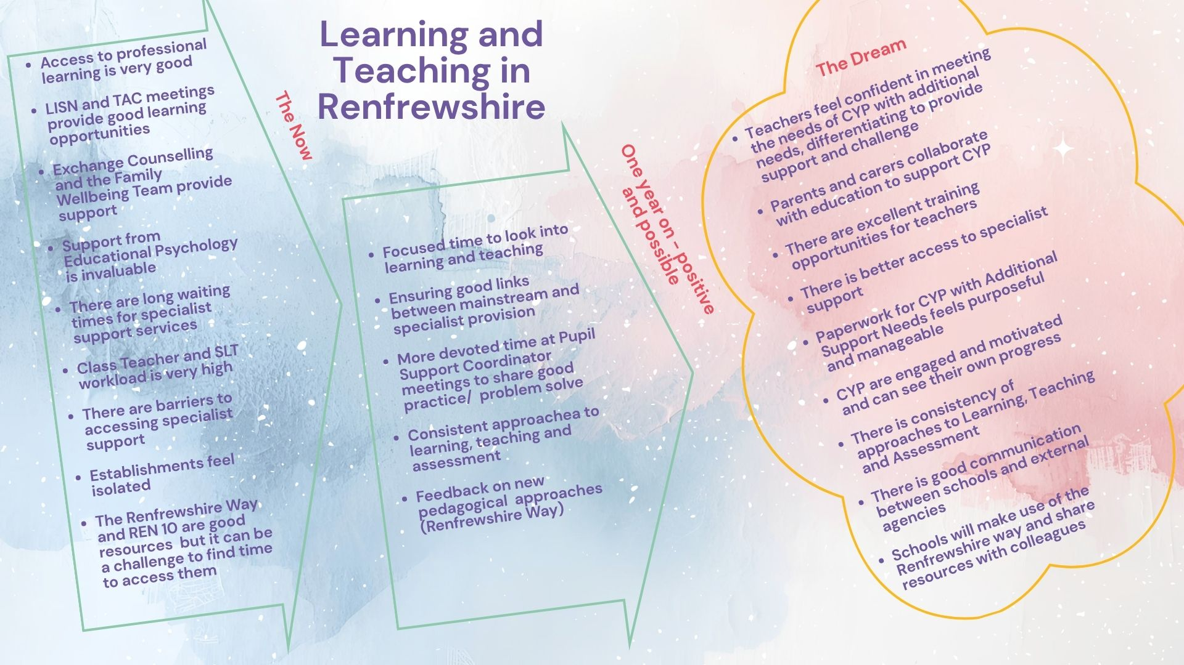
- As part of the WSI self-evaluation, we have gathered the views of colleagues within the Primary and Secondary sectors on where we are now and what we would like to work on:
PCP feedback

- We have also been looking at support for Complex Needs within Renfrewshire – considering the use of Inclusive Learning and Teaching as the focus.
Next Steps
- All EPs will feel confident in using the Cognitive Abilities Profile next session, with the WSI providing support for implementation. We will gather feedback on the impact on a case level basis throughout the session.
- As identified with stakeholders, we will develop a working party with school colleagues to create an action plan to support Learning and Teaching across Renfrewshire.
- REPS will work with colleagues within Riverbrae to support the shift from Complex Needs to Intensive Support within the school.
- Small scale research (within a local secondary) will be taken forward to explore how we effectively support all learners.
- We will also review CLPL opportunities in relation to meeting the needs of all learners, and consider this at both a REPS and LA level.

Non-Violent Resistance (NVR)

Non-Violent Resistance (NVR) was developed to support adults who are addressing distressed and distressing behaviour in children and young people. Being a systemic intervention model, NVR empowers the whole team around the child to take positive actions to end cycles of escalation. NVR is a relationships-based approach with an emphasis on connection, repair, raising adults’ presence and responding to children and young people’s hidden needs.

There are three strands to NVR within Renfrewshire; parent support groups (coordinated by the Family Wellbeing Service), whole establishment development (embedded within Renfrewshire’s Nurturing Relationships Approach (RNRA) and Renfrewshire accredited training.

We have trained over 460 professionals from across Education, Social Work, Health and wider partners in NVR approaches. In the last year, REPS has supported 55 participants through accredited Level 1 training, 27 participants through Level 2 and 5 through level 3. We have also delivered ongoing supervision for independent NVR practitioners across Renfrewshire and supported the Family Wellbeing Service with ongoing CPD. Nationally; we have delivered keynote presentations around NVR at North Ayrshire’s launch of their Relationships and Behaviour Policy and recently at the AHDS (Association of Headteachers and Deputes in Scotland) conference.

NVR data for 2025-26 continues to provide robust evidence for the positive impacts of NVR in building confidence in supporting distressed and/or dysregulated behaviour through a relational approach:
- Level 1: post-training 94.6% of participants rated themselves 7+ (out of 10) in terms of their confidence in managing and de-escalating distressed/distressing behaviour compared with only 22.7% pre-training.
- Whole establishment training:
  - Following part one of training, 100% of respondents reported increased knowledge of NVR and the ways in which relationships can be strengthened in establishments to support distressed behaviours. They scored the training 9.4 out of 10 in terms of relevance to practice.
  - Following part two of the training, 92% reported their knowledge of NVR had again increased. 84% reported increased confidence in managing and de-escalating distressed behaviour, rating the training 8.2 out of 10 for practical strategies for resisting distressed/distressing behaviour and 8.6 out of 10 for relevance to practice.
- This session, we repeated the longitudinal evaluation sent out to all previous NVR participants. 89.7% of respondents rated themselves 7+ (out of 10) for confidence in managing distressed and distressing and 79.3% were still using NVR regularly/ frequently. Amongst the impacts they reported:
- 68.9% noticed reduced instances of distressed/distressing behaviours
- 68.9% improved relationships with families
- 44.8% reduced length of time of escalations
- 41% noted increased teacher confidence and developing shared language
Over the next year we plan to continue to build capacity for training and parent group support across the service and wider LA – targeting key individuals to train at accredited practitioner level as well as bringing people through to become trainers and/or supervisors. This will ensure NVR is sustainable within the Renfrewshire longer term. We will continue to work in partnership with the family well-being service and social work colleagues and would like to work together to find ways of capturing longer term impacts on CYP and their families in their home environments as well as educational settings.

Renfrewshire’s Nurturing Relationships Approach (RNRA)

Renfrewshire’s Nurturing Relationships Approach (RNRA) is an authority wide, whole establishment, relational and trauma informed approach. It is a universal approach for supporting the wellbeing of all children, young people, and staff (HGIOS 3.1) but also recognises that some children and young people have experienced adversity and trauma and may benefit from more targeted support. RNRA aims to enhance practitioners understanding of attachment theory and nurturing approaches and embed practice based on the six principles of nurture across the whole establishment community (HGIOS 1.2).

REPS have continued to support establishments to implement RNRA and to submit for RNRA Accreditation. This year we have delivered RNRA leadership training to 23 Senior Leaders and Core Group leads. We have delivered whole establishment training (covering attachment theory and the 6 nurture principles) to 39 establishments and over 400 staff. We have supported 15 establishments to submit for Accreditation, with these Accreditation awards pending.

Extending children’s voice and involvement in leading RNRA developments in establishments have been key areas for development, and these were the focus of our 2026 Nurture Conference, ‘Voice is not enough.’ 48 children and young people presented at the conference, which was attended by 160 professionals from education, social work, health and the third Sector. We updated our RNRA Child Voice and Participation toolkit and launched this at the conference.

RNRA training evaluations continue to be extremely positive with all participants reporting increased knowledge. For nurture principle training, across all participants there was an increase in rating from 5.8 pre training to 8 post training (1-10 scale). Participants rated the training as highly relevant to their practice, with an average rating of 9.8 (1-10 scale). Accreditation submissions continue to contain robust evidence of the impact of RNRA in establishments, including quantitative and qualitative evidence.

The conference was very positively evaluated with over 90% of participants rating this 5 (scale 1-5) for how useful they had found the conference and for relevance to their practice.
‘Nurture is one of the key foundations to getting it right for our young people and we need to ensure that their voice is meaningfully heard.’ Conference participant quote
Quotes from young people at the conference also demonstrate the importance of nurturing practice to them.
‘Nurture is kind of like a hand like if someone is like there for you like you don’t always need them, but they’ll always be there for you if you need them.’ S1 young person
‘Nurturing means is like caring for someone or caring for everyone because everyone deserves a bit of nurturing in their lives even if its like being difficult and all that and people should have nurturing because it is helpful.’ S1 young person

We will continue to support establishments to implement RNRA and to submit for RNRA Accreditation through our training and coach consult implementation model.
We will build on the motivation from the Conference and continue to support establishments to implement the UNCRC Article 12 to develop child voice and participation.
Equalities considerations will continue to be at the forefront of all RNRA planning and we will continue to review and extend our resources and materials through an equality’s lens, including reflecting the needs of refugee, asylum-seeking communities and those adversely effected through immigration.
Loss & Bereavement
Bereavement, loss and change training was offered at a skilled level to establishment leads and to whole establishments at an informed level. The bereavement, loss and change resources on REPS Blog are currently being reviewed and up dated.

The vast majority of participants attending the bereavement, loss and change training rated the training as at least 8 out of 10 for relevance to their role.
‘training has built on my knowledge and will help support me when working with families and children having conversation around loss and change’

Bereavement, loss and change training was offered to establishment leads as whole day skilled level training in May. This was carried out by the REPS Loss and Bereavement lead, Family Wellbeing and Accord Hospice staff. A distilled version was offered from the Loss and Bereavement lead at informed level to ASNAs during October and February inset days and at whole-school level delivered by the establishment’s link EP. The vast majority of staff attending the sessions rated themselves as having an increase in knowledge and the vast majority scored the training as at least 8 out of 10 for relevance to their role. Feedback from the full day session included ‘whole day was perfect’, ‘training has built on my knowledge and will help support me when working with families and children having conversation around loss and change’ and ‘I thought the training was well delivered, facilitators knowledgeable and experienced and made everyone relaxed and comfortable to engage’.

Renfrewshire’s Inclusive Communication Environments (RICE)

Renfrewshire’s Inclusive Communication Environments (RICE) is a joint initiative developed by Renfrewshire’s Educational Psychology Service (REPS) and Renfrewshire’s Speech and Language Therapy Service (RSLTS), evidencing strong partnership working.

This session, there has been a focus on supporting development in the Early Years sector. Renfrewshire’s plan for the National Early Language and Communication Project has been led by REPS in close collaboration with partners in Early Years and RSLTS. A fuller SQR submission for this project has been made between the EPS and Early Years.

Training has been delivered to a number of the early years, primary, and secondary workforce.

REPS and RSLTS have also developed information for practitioners on topics including SCERTS plans, SCERTS communication stages in profiles of need, and Gestalt Language Processors.

Training
- Early Years – Support & Development Group was attended by 20 practitioners who reported an increase in confidence from 6.7 to 7.8 (out of 10).
- ASNAs and support staff – Language and Communication was attended by 30 practitioners who reported an increase in knowledge from 3.5 to 4.6 (out of 5) and confidence from 3.6 to 4.4 (out of 5).
- FLR staff– ‘SCERTS informed’ language and communication training was attended by 20 practitioners. 100% either agreed or strongly agreed the course increased knowledge in identifying how a child communicates across all 3 SCERTS communication stages. 100% of survey respondents agreed or strongly agreed the course increased their confidence in identifying developmentally appropriate advice and strategies across all 3 SCERTS communication stages.
- P1 teachers – 10 practitioners attended NAIT’s ‘Let’s not just see how it goes’. 9 out of 10 reported an increase in knowledge of supporting autistic learners. 9/10 was average rating of usefulness of training in developing knowledge and understanding of neuro-affirming practice. 9/10 was average rating for usefulness of training for developing knowledge and understanding of strategies for supporting social communication. 8.70/10 was average rating of usefulness of training in developing knowledge and understanding of strategies for supporting emotional regulation.
All training resulted in an increase in knowledge and confidence, and almost all participants reported it met their needs.

REPS and RSLTS will continue to work closely on a strategic, locality, and establishment level through development work and link practitioner work.

Training for practitioners will continue next session. We will repeat the ASNA and support staff training on ‘Language and Communication’ planned for the February in-service day.

The Support and Development group model will not continue next session due to developments with the Early Language Project and NAIT training programmes.

The NAIT whole primary school ‘We Were Expecting You’ training will be delivered for the first time next session. Nine schools will receive this training to allow us to measure impact and implementation of the training before considering an authority-wide implementation.

Due to the low numbers of P1 staff who attended the NAIT ‘Let’s not just see how it goes’ training this session, this training will be delivered every two years currently as staff changes in this group tend to be lower.

Discussions will take place with FLR provisions who have not yet accessed the SCERTS-informed training at primary level to determine a need for training next session. Mary Russell will also receive SCERTS-informed training.

Self-Evaluation

The self-evaluation SIP group was created in 2022 to improve the focus on self-evaluation across the service and consistency in approaches to self-evaluation. The group aims to develop a comprehensive and robust self-evaluation process for service delivery, covering casework and development work while also widening our self-evaluation that challenges practice aligned with local and national priorities.

Stakeholder Feedback
We reviewed our timings to ensure it was the most appropriate time to gather feedback from our stakeholders. We adapted our survey this year to include a question relating to consultation given this is a focus within our self-evaluation process and service delivery.

ASPEP Self-Evaluation Framework
This framework is now embedded throughout our self-evaluation process. Our Quad group focused on 2.1 and within Renfrewshire we specifically focused on Consultation and used the challenge questions to support consistency of practice across the service.

Self-Evaluation of Casework
REPS are now using the FORT Database system and plan to use this year to monitor and review the data we are gathering.

Consistency of Practice
The service has a shared understanding of the importance and relevance of self-evaluation in their work and carry out their own evaluation of any pieces of work completed in a WSI or SIP.

We have focused on consultation skills in relation to consistency of practice and have a working group taking this forward.

Stakeholder Feedback
The following statements were selected by respondents to reflect the EP contribution to improving outcomes for children/young people and their families.
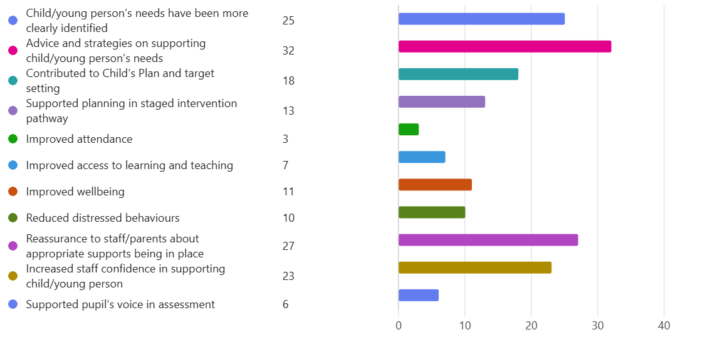
Below highlights the context in which the respondents find the EPs consultative involvement (advice and guidance) most beneficial:
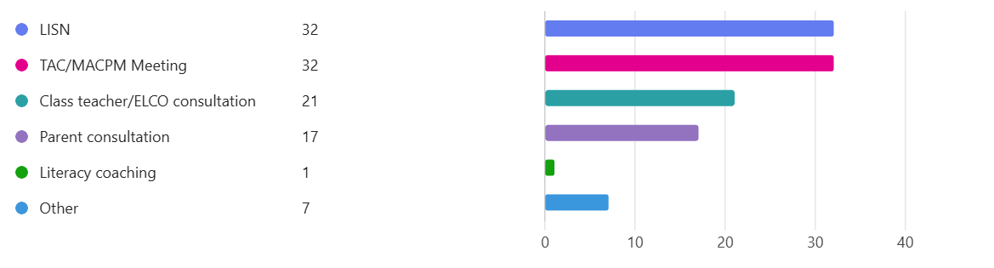
Other themes identified of impact across all EP service delivery were EP input at strategic level, EP input for individual children and young people, and partnership working. Respondents also reported that they would like more EP time, continued support with whole school initiatives, consistency of EP input and continued support as anything additional they would like REPs to support their establishment priorities in the future.

Moving forward the self-evaluation focus group intend to focus on one challenge question which addresses 2.1 (consultation and advice, assessment, and intervention) and 2.4 (partnerships and collaboration) as key focuses for self-evaluation:
Does the service work to ensure partnership working to provide a collaborative and integrated approach to consultation, assessment, and intervention?

Self-evaluation activities will be carried out to address:

2.1:
- Gathering and use of data on new FORT filing database
- EP contribution to ESRG
- Views of Funded Provider access to REPS
- Threshold of EP involvement in cases
- Consultation skills

2.4:
- Evidence of child’s voice in EP practice
- Parent voice on EP practice
- EP contribution to local authority inclusion working groups

The REPS self-evaluation cycle will also be updated to reflect current practice, and a supervision policy will be developed to outline how locality meetings and peer support act as mechanisms for supervision of EP practice.

Equalities

In our 4th year of this work, we have continued to contribute to developing equalities practice at the level of the EPS, Local Authority and nationally. Our focus has progressed from initial emphasis on Anti-Racism self-reflection and learning ahead of bringing Anti-Racist action more explicitly into day-to-day EP practice, enhancing our intersectional focus and this year increasing work supporting schools with their Anti-Racist approaches. We have also continued to support Anti-Racism nationally.

To develop an intersectional approach to our equalities practice, REPs accessed LGBTQ inclusive education training delivered by TIE.

We have also enhanced our body of research in the field of immigration, asylum seeking/ refugee experiences and racial trauma -in a context of increasing racial tensions locally and nationally. This has been presented nationally.

We now have examples of work where EPs have supported schools with their Anti-Racist approaches such as through supporting use of the Cultural Competence tool, developing an Anti-Racist resource bank for establishments, awareness raising, critical literacy input and a train the trainer model being piloted in one school. We have also had school-level work published in the Educational Psychology in Scotland journal.

- Following LGBT inclusive education training, 100% of EPs reported stronger understanding of how the 7 LGBT Learning Themes can be included in teaching practice. EP confidence delivering LGBT inclusive education rose from 5.6/10 pre-training to 8.4/10 post training.
- Anti-Racist input in one school evidenced increase in knowledge from pre-delivery to post-delivery (5.5 to 7.2) and was rated by staff an average of 9.5/ 10 for relevance to practice.
- Staff who accessed an Anti-racism train the trainer model reported an increase in staff confidence to deliver training to their whole staff from 2/ 10 pre-training to 8/ 10 post-training.
- Implementation of the Cultural Competency Tool trialled in one school evidenced increased staff awareness, confidence and reflection regarding culturally responsive and Anti-Racist practice. Staff familiarity with cultural competency increased from 2.7 to 3.6, and confidence improved across all measured areas, e.g. in discussing cultural competency with colleagues (2.82 to 3.40) and applying culturally responsive practices (2.73 to 3.20).
- EPs are also engaging in an equalities reading group to enhance their own knowledge. 100% of respondents indicated the Reading Group has enhanced or deepened their knowledge, understanding and/or skills while 83% rated that the reading material related directly back to their role as an EP
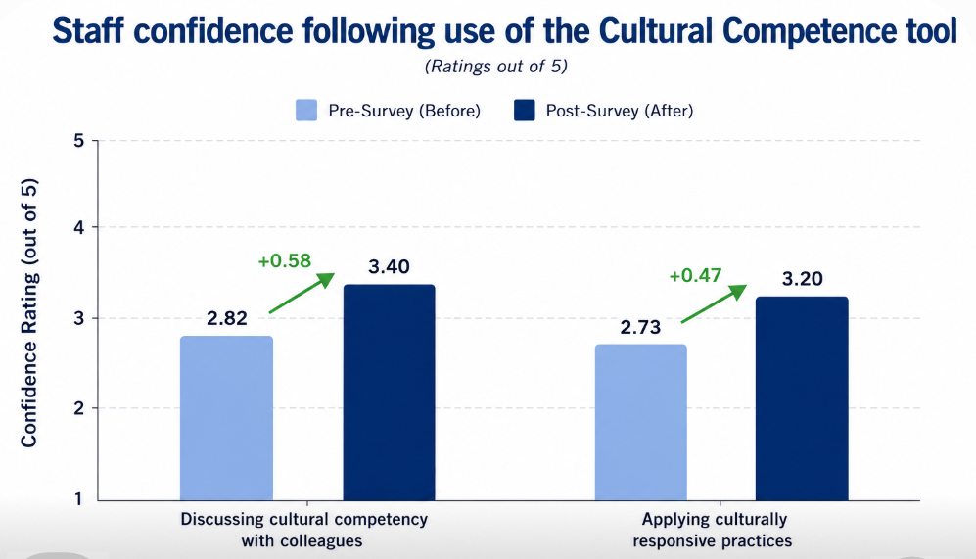
- National training delivery via the SDEP resulted in a significant increase in respondents reported knowledge, skills and tools to carry out Anti-Racist EP practice rising from 16% reporting they were confident at baseline, to 100% reporting they were confident post-training:
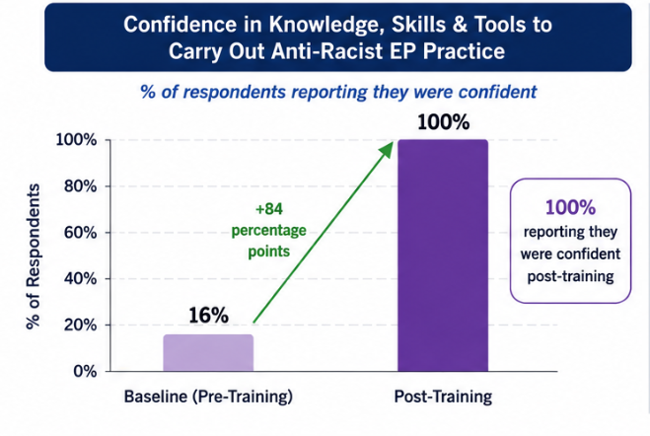
100% of respondents agreed or strongly agreed that the training increased their knowledge & understanding of racism, 100 % agreed or strongly agreed the training enhanced their skills to challenge racism, 92.4% agreed or strongly agreed the training input adequately equipped them to deliver to their own services:

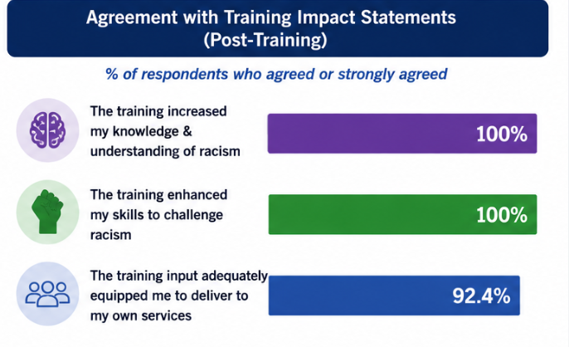

Next Steps:
- Continue to support national Anti-Racism developments via the SDEP steering group, including evaluation of the impact of the national training model
- Increase number of REPS EPs to access the SDEP Anti-Racist network to support ongoing contribution to national developments and access to learning we can continue to embed in Renfrewshire
- Continue to evaluate cultural competence being reflected across all of our service delivery and training materials (e.g via WSIs)
- Session 26-27 will see all establishments having Anti-Racism on their SIPs. We would like to increase the pockets of Anti-Racism work link EPs are supporting establishments with
- Enhance EPS links to the wider community and contribute a service delivery where needs identify for Asylum seeking, Refugee families and those who have recently migrated to Renfrewshire

