Renfrewshire Educational Psychology Service

Standards and Qualities Report (SQR) 2025

Renfrewshire Educational Psychology Service (REPS) annually reports back on the 5 Whole Service Initiatives (WSI) and the Service Improvement Plan (SIP). The 5 WSIs are as follows: Non-Violent Resistance (NVR); Renfrewshire’s Nurturing Relationships Approach (RNRA); The Promise; Emotionally Based School Avoidance (EBSA) and Renfrewshire’s Inclusive Communication Environment.

In addition to the report on the WSIs, the SIP is a focus of improvement within the service. The strands identified are Equalities; Self-Evaluation and Learning and Teaching. There is also an ongoing evaluation of the LISN and the Educational Psychology input into this forum as a major element to our service delivery.

**Whole Service Initiatives (WSIs)**

**Renfrewshire’s Nurturing Relationships Approach (RNRA)**

RNRA is an authority wide, whole establishment, relational and trauma informed approach. It is a universal approach for supporting the wellbeing of all children, young people, and staff (HGIOS 3.1) but also recognises that some children and young people have experienced adversity and trauma and may benefit from more targeted support. RNRA is based on enhancing practitioners understanding of attachment theory and nurturing approaches and embedding practice based on the six principles of nurture across the whole establishment community (HGIOS 1.2).

REPS have continued to support establishments to implement RNRA and to submit for RNRA Accreditation. Figure 1 below shows the increase in establishments that have achieved RNRA Accreditation at Jade, Ruby, Amethyst and Gold levels from 2020 – March 2025.

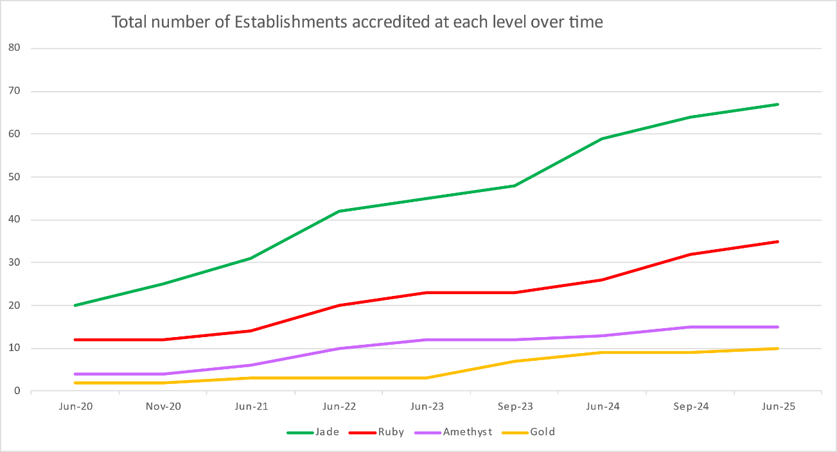

*Figure 1 Growth in the number of establishments achieving RNRA Accreditation 2020-2025*

In 2025, 22 establishments have submitted for accreditation, 5 ELCCs, 15 primary schools and 1 high school. There was 4 Jade, 10 Ruby, 6 Amethyst and 2 Gold submissions. The graph above illustrates accreditation levels awarded up until June 2025, and these figures are anticipated to increase further in September 2025.

RNRA in May

In May 2025 Renfrewshire hosted the first ‘RNRA in May’ Open Doors event. This event provided the opportunity for establishments to show the excellent work they are doing in relation to RNRA. 15 establishments across Early Years, Primary and Secondary opened their doors to welcome colleagues and share practice. 83 people signed up to attend the open doors events. Feedback gathered from both hosts and visitors proved extremely positive, and people would welcome a further open doors event in the future.

Self-Evaluation

Through self-evaluation we have collated the information about the impact of RNRA training

and the implementation of RNRA in establishments:

RNRA Leadership training

The RNRA WSI team have delivered RNRA leadership training to approximately 20 senior leaders and RNRA core group leads. Evaluations of the leadership training consistently show improved confidence in leading RNRA within establishments, and this year the improvements in confidence using Quality Improvement approaches to evidence impact were particularly high.

RNRA Establishment training

REPS have continued to deliver whole establishment training to their link schools/ELCCs.

During the time period March 2024 to April 2025 REPs have delivered 4 whole

establishment Core Trainings (69 evaluations). Participants rated this training as highly relevant to their practice (average rating 9.08).

Pre and post ratings for knowledge of attachment theory increased from an average score of 5.39 to an average score of 8.43. A paired samples t-test was conducted to compare these before and after evaluation scores. There was a statistically significant increase in scores.

Knowledge of the importance of nurturing relationships in helping all children/young people to learn and develop socially and emotionally increased from average pre-training rating 7.49 to average post training rating 8.81.

REPs have delivered Nurture Principle training to 16 establishments (250 evaluations), with training in all of the Nurture Principles delivered.

Pre-training scores ranged from 5.1 to 6.0, indicating a moderate baseline understanding. Post-training scores significantly improved, rising to between 7.8 and 8.6. All participants had increased knowledge and all participants rated the training as highly relevant to their practice, with an average rating 9.8. The table below shows how participants plan to use the knowledge gained from the Nurture Principle training:

Evidence of the Impact of RNRA in establishments

In August 2024 the RNRA lead group carried out an analysis of accreditation submissions from the previous year to identify themes in the evidence that establishments provided to show that RNRA had had an impact. The themes identified were:

Positive effect on staff knowledge and understandingarising from the implementation of RNRA. This wasdetailed across all four Accreditation stages (Jade, Ruby, Amethyst, Gold). This increased knowledge and understanding was reflected in:

*Increased consistency in using nurturing approaches*

Staff became more consistent in managing distressed and distressing behaviour, more consistent in their use of nurturing language, and, at higher levels of the accreditation process (Amethyst, Gold), in the implementation of policies and strategies.

*Increased staff confidence*

At the lower accreditation levels (Jade and Ruby), there was an increase in staff confidence using Nurture strategies to support CYP (children and young people). At the Amethyst and Gold levels, this confidence translated into a more strategic approach to implementing the nurturing framework across the establishment.

*Enhanced emotional literacy of pupils.*

This theme was identified through all four stages (from Jade to Gold). This growth not only fostered greater emotional awareness but also supported children in effectively regulating their emotions (with adult support), contributing to a more positive learning environment.

Additionally, at the upper levels in particular (Amethyst and Gold), the establishments have observed a reduction in the number of disruptive incidents and exclusions.

Other significant themes running through all the accreditation levels included the increase in pupils' emotional safety and a heightened focus on the mental health and wellbeing of both children and staff.

At the upper Accreditation levels, there was a more explicit focus on the wellbeing of CYP and staff, resulting in a positive impact on the mental health and wellbeing of both children and adults. In addition, there were increased efforts at the Gold level to incorporate pupil voice in a meaningful way, with an explicit focus on its importance, and direct involvement of CYP in developing RNRA change ideas and evaluating their impact.

**Renfrewshire’s Inclusive Communication Environments (RICE)**

RICE is a joint initiative developed by Renfrewshire Educational Psychology Service and Renfrewshire’s Health and Social Care Partnership Speech and Language Therapy Service, evidencing strong partnership working (HGIOS 2.7). The purpose of RICE is to develop the capacity of staff within our education establishments to support the language and communication skills of children and young people by focusing on how practitioners can adapt the environment and practice to remove barriers to learning, communication, and interaction. RICE is designed to be a universal intervention suitable for children with and without identified language or communication needs (HGIOS 2.4). We know that there is a strong link between speech, language and communication needs and other additional support needs including children and young people with learning difficulties, those who are care experienced, and those who have social, emotional, and behavioural needs. We also know there is a link between poverty and speech, language, and communication needs, and this context has been particularly important for introducing RICE across our establishments.

Whole Establishment Training and Accreditation

A change in service delivery has resulted in RICE primarily now being delivered through RNRA. Early years, primary, secondary and specialist routes for accessing training sit within RNRA nurture principles.

P1 NAIT Training – ‘Let’s not just see how it goes’.

52 primary school staff from 24 Primary school establishments and the Glencoats ASN and Early Years Outreach team attended our delivery of the NAIT ‘Let’s not just see how it goes’ training for supporting transition preparation for the new cohort of primary 1 pupils starting school in August 2025. The RICE team organised the delivery of this local authority offer and was supported to deliver by Speech and Language Therapy, an Inclusion Support Officer and our local authority CAHMS Education Adviser.

Qualitative and quantitative feedback collated from the post training evaluation suggests that the session received a positive overall reception wherebyparticipants described training as “useful”, “informative”, “enjoyable”, and “well-delivered”.

Participants liked:

* + Practical Strategies: reporting realistic, easy-to-implement strategies
  + Increasing their understanding of Autism
  + The balanced content of theory and realistic practical application
  + Signposting to resources/ further learning
  + Professional dialogue and peer learning

86% of participants reported increased knowledge of supporting autistic learners.

84% reported increased confidence in creating physical and social environment to meet individual needs.

Participants were asked to rate usefulness and relevance of the session which is illustrated in the chart below.

Figure 2: P1 attendee feedback on group delivery

Figure 3: Renfrewshire's One Page Plan for the National Early Language Project

National Early Language and Communication Project

Renfrewshire EPS have engaged with the launch and development of the National Early Language and Communication Project since November 2023. This is a joint project between Scottish Government and Education Scotland which aims to bring together education, health, and other relevant practitioners to improve early language outcomes for children. This project has afforded opportunities to widen partnership working through closer links with Renfrewshire early years and inclusion officers, family wellbeing, health practitioners, and health improvement colleagues. This year has focused on building the conditions and will for change through joint planning of change ideas, information gathering across early years about strengths and needs, and identifying who we need to involve in this work.

A one-page graphic plan (see Figure 3 above) was produced and has been recognised at a national level as an example of clear planning. Renfrewshire have also been asked to submit a brief summary of our work around leadership and decision making in the initial phase of this project as a national example of good practice.

SCERTS and Neuro-affirming Practice

REPS attend the NAIT West Region Network and the NAIT Neuro-affirming Community of Practice. This has enabled REPS to contribute towards the beginnings of a national neuro-affirming approach, and future work will involve identifying biases or gaps in practice with regards to neuro-affirming approaches and practice.

The research that was carried out with Autistic adults, in collaboration with Autism Connections, to gather experiences of education and views of our current framework has been shared this year. It has been included in training and presentations to establishments, West Partnership, and The University of the West of Scotland.

Support and Development Groups

Feedback from the 21 attendees of Early Years Support and Development Groups shows that there was a positive difference between pre and post scores on practitioner confidence levels in supporting children with speech, language, and communication needs with an average increase from 6.7 to 8.2 (on a scale of 1-10). Practitioners were also asked to rate the format and delivery of the sessions, and all five domains were scored an average of above 4 (on a scale of 1-5).

Figure 3: Early Years Support and Development Group Evaluations

Figure 4: Early Years Support & Development Group attendee feedback on group delivery

The main strengths of the group were noted as the information and resources provided. Participants commented that the biggest change to their practice was in relation to adult talk and interaction. They would have appreciated more discussion time in the sessions.

P1-7 Support and Development Groups were offered again this session. After initially offering two groups on CPD Manager, low numbers of registration meant only one group was run. A total of 9 staff signed up to attend this group. The group consisted of four sessions and delivered content looking at the key indicators across RICE as was delivered across previous sessions.

FLR Training

REPS and Speech and Language Therapy were asked to deliver training this year to a pilot group of FLR staff. This came from a needs analysis within one FLR team who identified gaps and inconsistencies in understanding of language and communication needs. 15 staff received training across six sessions which were structured around the three SCERTS communication stages. An aim of the training was to embed the use of the SCERTS language in assessment and identification of needs across multiple services in Renfrewshire.

Participants commented that the biggest change to their practice was in relation to considering the amount of language they use with children or their own communication. 8 out of 11 respondents felt that other practitioners have benefitted from the training through coaching and modelling.

Next Steps

REPS will focus attention on early years and primary needs for speech, language, and communication next session. This is in line with the Children’s Services Inclusion plan which features early language as a strand of improving outcomes for children in Renfrewshire.

Support and Development Groups for Early Years and Primary 1-7 will be offered next session to support staff practice.

The FLR training will be delivered next year to two further groups of FLR staff. We will also provide training on language and communication to ASNA and support staff as an optional half day session.

REPS will continue to lead on the National Early Language and Communication Project in Renfrewshire. The steering group has split into three strands of delivery looking at training and staff development, local resources, and sharing ASQ data between health and ELCCs.

The P1 training ‘Let’s not just see how it goes’ will be offered again next session. Discussions will take place within the RICE WSI regarding possible implementation planning for the NAIT Primary whole school offer ‘We were expecting you’.

The RICE team will continue to link with NAIT at their west region updates and the RICE team will continue to feedback national guidance offered by NAIT to support ongoing neuro-affirming practice within the REPS team.

**Attendance and Emotionally Based School Avoidance**

During session 2024-25, REPS Attendance & EBSA WSI team have continued to collaborate with a pilot group of secondaries and primaries with the aim to improve attendance and develop effective assessment and intervention approaches with EBSA cases. We continue to work with a multi-agency steering group to develop and implement an effective approach to supporting attendance and EBSA across Renfrewshire’s establishments.

The Renfrewshire steering group is a multi-agency forum with a focus on developing and implementing approaches to support the multi-factorial influences on attendance and EBSA and evaluating the impact of these using local authority data sets.

The REPS Attendance & EBSA team have contributed to work with a national reach, including videos for the Scottish Government’s national message campaign around school attendance and a film for Education Scotland which displays good practice. We are currently represented on a number of national groups (e.g. SDEP Attendance working group; West Partnership RIC; National Attendance Network; Included, Engaged, and Involved working group) which are focused on approaches to improving school attendance. Furthermore, we are supporting two national projects (ABSAIL and the Education Scotland Attendance Quality Improvement Cohort 2) involving five Renfrewshire secondary schools, focused on action research to identify effective change ideas and improve attendance with a particular cohort. We have also been invited to speak to a number of other Local Authorities about our work in this area and have presented at a variety of conferences.

The REPS team have developed the pilot project, moving our focus this session to bespoke planning for embedded EBSA cases. This has involved developing a thorough assessment process, informed by in depth CLPL undertaken by the team, which we are now working on in collaboration with the Family Wellbeing Team. We have continued to adapt and adjust the SEEMIS coding guidelines, and we have offered numerous information sharing and coaching sessions to all Renfrewshire establishments to improve the consistency of attendance data recording. We have worked with the data and evaluation team to improve the current data dashboard so that establishments have access to more relevant and current data around attendance. The REPS team and multi-agency steering group have begun to review Renfrewshire’s attendance guidance.

The multi-agency steering group have contributed to support and development groups for the pilot schools to develop their understanding of the multi factorial nature of EBSA and develop effective interventions through multi agency case discussions and training. We have taken some learning from the initial transitions pilot groups (session 24-25), and used this to inform and improve the transition supports for children moving from primary to secondary who are at risk of EBSA. This session, we have also extended the reach of the Attendance & EBSA pilot to include an early years working group, with the aim to scope out the needs of this sector and explore effective approaches to supporting attendance at this early stage.

We have identified the need for improved communication with parents and carers regarding attendance and EBSA. The pilot schools have developed and trialled compassionate attendance communication and individualised support (e.g. telephone calls and text messages) which have been found to be effective in improving parental understanding, reducing shame around nonattendance, and increasing the communication from the parents in return. The REPS team have developed an information and guidance leaflet for parents and carers (of both early years and school age children and young people) and including signposting to further information and supports on our website.

School average attendance rate (%), month of May comparison from the outset of the pilot in 2022:

|  |  |  |  |  |
| --- | --- | --- | --- | --- |
| School | May 2022 | May 2023 | May 2024 | May 2025 |
| Linwood HS | 90.4 | 90.1 | 89.9 | 91.7 |
| Paisley Gr | 90.4 | 89.5 | 89.6 | 90.3 |
| East Fulton PS | 89.8 | 90.1 | 91.4 | 90.1 |
| Gallowhill PS | 85.4 | 86.3 | 89.7 | 89.4 |
| Woodland PS | 89.8 | 89.4 | 89 | 91.4 |

Attendance rates in May have improved or remained stable across the five schools between 2022 and 2025, though trends vary slightly by school. Overall, the data suggests encouraging signs of progress, with an increase of 7.1% overall since the outset of the pilot.

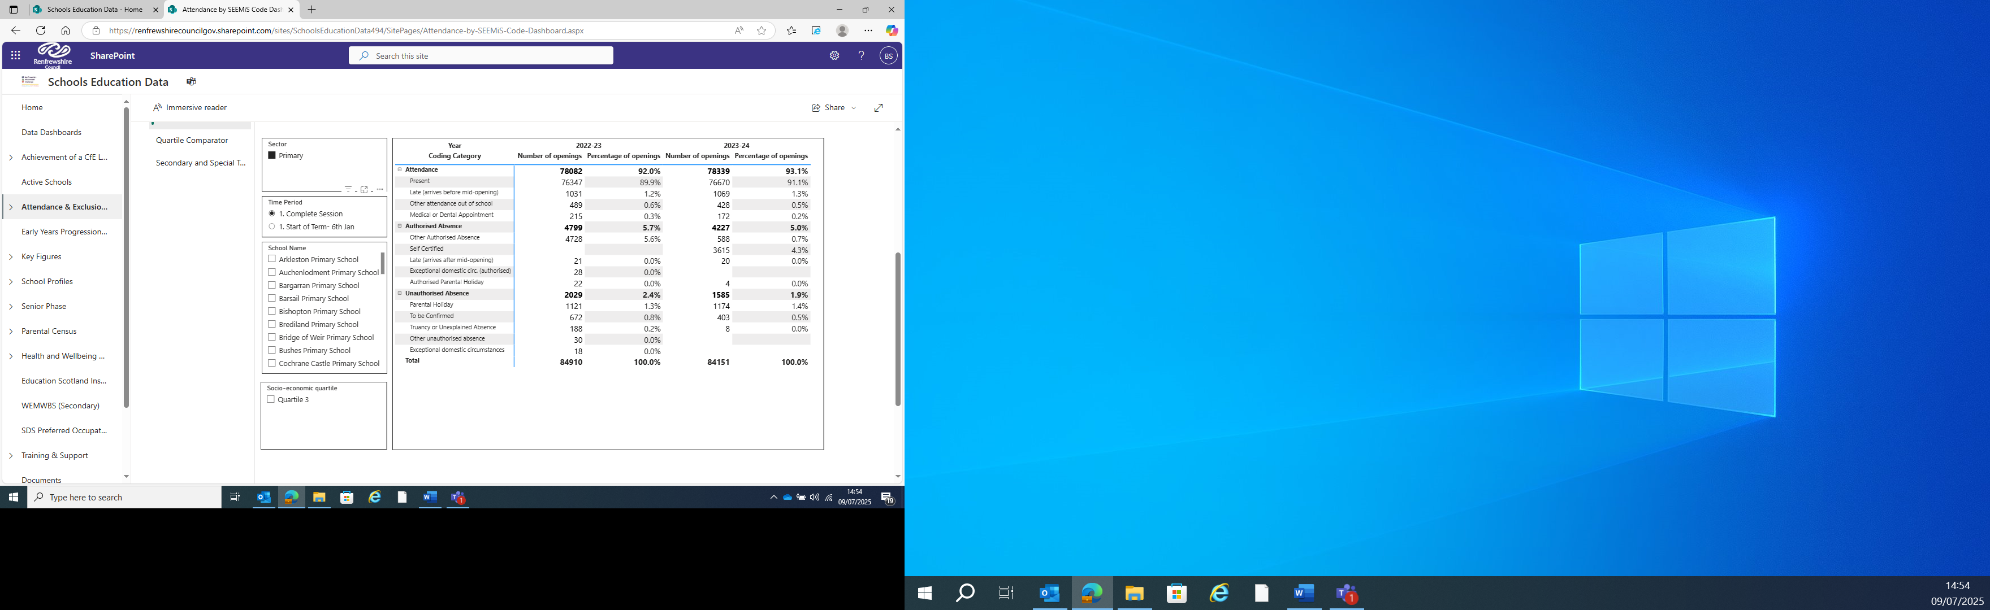

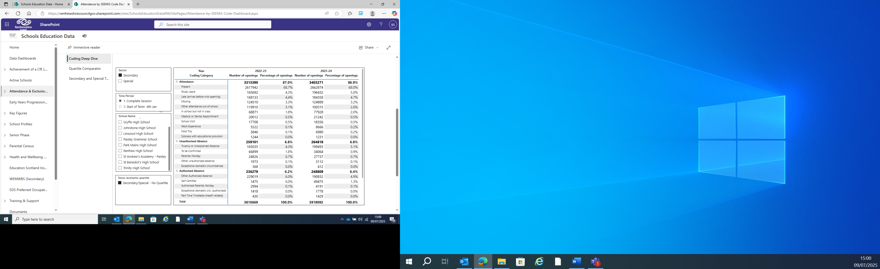

From the tables above you can see notable shifts in the recording using SEEMIS codes-in the primary school table there were no self-certified recordings in 2022-2023 but in 2023-2024 there were 3615, in the secondary school table there were 1475 self-certified recordings in 2022-2023 but in 2023-2024 there were 49475, giving us a much clearer indication of who was not at school due to self-certified illness. Prior to the SEEMIS guidelines this would have been recorded as an Other Authorised Absence.

Other significant shifts can be seen on the secondary table when looking at study leave, in school but not in class and the part time timetables. On the primary table there are shifts in the usage of the following codes: field trips and school visits, in school but not in class, part-time timetables, parental holidays and truancy. In both cases the number of to be confirmed cases have decreased. This strengthens our understanding of why some young people are not in class and can be triangulated to explore wellbeing and attainment scores.

Of particular note is the high instances of unauthorised absence in Secondary, which is higher than the national average. This means this will continue to be explored in the next session.

* The current pilot schools project will be extended into next session, as we continue to develop effective approaches for supporting bespoke EBSA planning and share the learning from the pilot project across Renfrewshire.
* Produce a summary and analysis document of stakeholder views (staff, parents, and pupils).
* Attendance processes guidelines will be finalised, bringing consistency in thresholds based on data across the school. This will inform the review of Renfrewshire’s attendance guidance.
* REPS and the data and evaluation officer will explore SEEMIS coding and work to understand the SEEMIS recording in four schools with a particular look at the use of the unauthorised absence code which is used considerably above the national average in Renfrewshire.
* REPS are currently consulting with the data and evaluation officer to build a new data dashboard in which attendance data will be available to compare current data with data from the same month in the previous
* EBSA steering group and the REPS Attendance & EBSA team will continue to work on a review of Renfrewshire’s attendance guidance which will be informed by the learning from the pilot schools and up to date research. The guidance will reflect the multi-agency roles in addressing EBSA (e.g. social work roles, CAMHS roles, education roles).
* We will develop a new pilot project with The Promise Ambassador, Social Enterprises Academy and Police Scotland, supporting young people with attendance challenges who are care-experienced and have additional support needs.
* Resources will continue to be added to the Thinglink and the EBSA development team will continue to ensure it meets the needs of the users. Usage will be monitored, and regular feedback sought from stakeholders.
* REPS will offer whole establishment EBSA training from August 2025 and establishments will be supported to develop and implement improvements through the core group model facilitated by their link EP. Action plans will include impact measures and establishments will be encouraged to submit for accreditation where appropriate.
* The REPS EBSA development team will contribute to the development of the Renfrewshire Virtual School offer.

The Promise

We aim to support a tangible improvement in the outcomes for care experienced children and young people

We will work with our partners to raise awareness of the recommendations outlined in The Promise.

* Maintaining a link to Promise Keepers Network - the whole team received Promise Keeper training in October 2024 so now all EPs are Promise Keepers and are part of the Promise Keeper Network and receive regular updates.
* 5 members of the team have signed up to be part of the Human Library initiative.
* Keynote speech at the Promise Keeper Conference in December 2024.
* Lead on Out Of Authority casework and cases continue to be distributed across the team.
* Enhanced level CLPL ‘supporting those who experience bereavement, loss and change’ offered again annually in partnership with Accord Hospice and whole family wellbeing service (data below).
* An informed level CLPL resource has been developed in response to feedback from staff who attended annual enhanced training in 2024 who were requesting this input at a whole school level. Use of a DHT as a ‘critical friend’ to review the content for this resource. This resource was then shared with all EPs at a development day in May so that this could be negotiated and offered by link EP at a school level as part of JWP process. A draft CLPL pathway has been developed for training in this area (below).

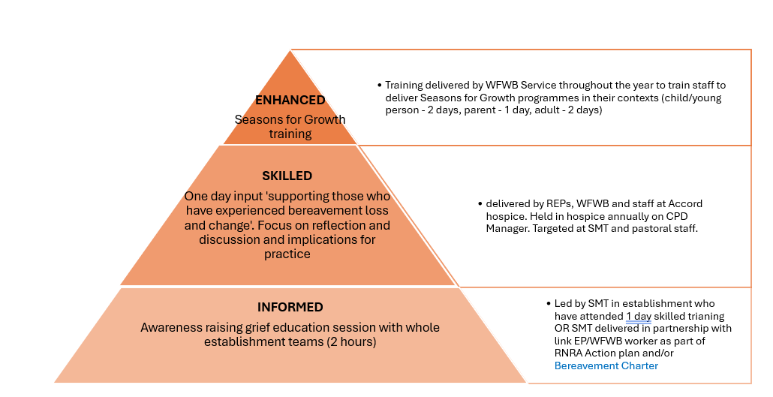

* Seasons for Growth Parent Programme with kinship carers. EPs were linked closely with Social Work kinship team and delivered bereavement, loss and change training CLPL to their team. Through this partnership kinship carers were identified to attend a ‘brew and blether’ information session and consider whether to take part in Seasons for Growth parent programme delivered by REPs. This was an initial pilot and further conversations with kinship team to consider offering this support to more kinship carers next session.
* NVR parent groups that target parents/carers of care experienced children andyoung people continue to be offered and supported by REPs.
* Sessions have now been included on supporting those who experience bereavement, loss and change to support staff this session.
* REPS in partnership with Glasgow organised and chaired a West Partnership working group with EPs, from 7 of the 8 authorities, who lead on bereavement, loss and change across the partnership.
* All CLPL resources in the area of bereavement, loss and change have been adapted to ensure content is culturally sensitive.
* A range of accessible resource banks and leaflets have been developed on the area of bereavement, loss and change and are all located on REPS blog page [Bereavement, Loss & Change – Renfrewshire Educational Psychology Service](https://blogs.glowscotland.org.uk/re/renfrewshireedpsych/bereavement-loss-change/)
* 2 EPs from the WSI attended Critical Incident Stress Management Course (CISM): Group Crisis Interventions. Further discussion with colleagues also trained to consider REPS role in critical incident management across authority and in line with guidance developed by REPS.

Supporting those who have experienced loss, bereavement and change:

Summary of training day held on 26th March 2025

As part of our response to ‘The Promise’, a one-year project was taken forward by REPS and Social Work to look at the needs of Care Experienced young people with regard to barriers to learning.

Working with the team leading on the wellbeing and care of our young people in Children’s Houses, a ‘psycho-education’ training pathway for staff was developed around psychological issues such as loss and bereavement; neurodiversity, trauma and attachment.

* 32 staff received 12 training hours with visits to the Houses to create support plans.
* All respondents agree or strongly agree that they will use their learning from this programme to develop their practice.
* All respondents agreed or strongly agreed that the materials provided were relevant and supported their learning.
* 100% of participants reported an increase in confidence post-training with 60% of participants observing a decrease in the duration of distressed behaviour of children and young people.

A piece of joint work between EPs, social workers and schools resulted in the ‘Brew and Blether’ events where Kinship Carer attendees were supported to touch on the impact of loss and then invited to a ‘Seasons for Growth’ event. Following the training, all carers were asked to rate their knowledge and confidence in this area at the start and end of the programme and there was a significant increase in both confidence and knowledge pre and post intervention.

For the Adoption and Fostering team, helping carers understand neurodiversity and the approach of schools was a highlighted area. The demographic of Fostering households can result in carers benefiting from being updated on a regular basis on new approaches taken by schools across the Council as they sometimes support children with school attendance outside of their community. A version of Renfrewshire’s Inclusive Communication Environments provided to schools was created by EPs, consulting with Speech, Language and Occupational Therapies. An in-person event was held with an online session provided and recorded with a plan to use it for both Social Work staff and Carers in an ongoing way. All participants rated the sessions between 7 and 10 for relevance with comments on helpfulness and increased clarity in their understanding and strategies they now had available.

REPS and Social Work

REPS worked in an integrated way with colleagues in both SW and Education over the course of the year, SW staff could access consultations with REPS. While the focus was often ‘readiness to learn’, supportive conversations widened out to other psychological advice.

* REPS Leadership time to be integrated into SW Services for an additional year, continuing the work established with staff and carers, focusing on inclusion and wellbeing of Looked After and Care Experienced Children
* Continue to improve access to loss and bereavement training and supports.
* Develop understanding and training of Life Story Narratives across Children’s Services as a means to practically and compassionately support the rights, identity and hope for care experienced young people.

**Non-Violent Resistance (NVR) WSI**

NVR was developed to address distressed and distressing behaviour in children and young people. It has been successfully used and adapted in several different contexts (including kinship care, fostering and adoption) and age groups (Van Holen, Vanderfaeillie & Vanschoolandt, 2018; Omer & Lebowitz, 2016). Studies have shown its value in supporting children and young people with a variety of underlying neurodevelopmental differences including ASD (Golan, Shilo & Omer, 2018; Shimshoni, Omer & Lebowitz, 2021), ADHD (Shorr-Sapir et al, 2021) and anxiety (Lebowitz & Omer, 2013). It has also been effective where child to adult violence is a concern (Omer, 2021; Newman, Fagan & Webb, 2014). Being a systemic intervention model, NVR empowers the whole team around the child to take positive actions to end the cycle of escalation. NVR is a relationships-based approach with an emphasis on connection, repair, raising adult’s presence and responding to children and young people’s hidden needs.

There are three strands to NVR within Renfrewshire; parent support groups, whole school development, embedded within Renfrewshire’s Nurturing Relationships Approach (RNRA) and Renfrewshire accredited training (HGIOS 2.4 / 2.5).

In 2024/25 representatives from the lead NVR team within REPS have delivered workshops at the Scottish Division of Educational Psychology conference and linked with the Associate Directors of Education (ADES) to discuss the promising uptake, impact, and quality of the intervention. This dialogue also focused on the implementation of NVR as an effective intervention in the areas of violence and distress which are known to be exceptionally difficult to progress (HGIOS 1.2 / 1.3). REPS have also been invited to be keynote speakers at the national NVR UK Conference, showcasing the inspirational work being carried out across Renfrewshire’s schools.

NVR Level 1 Accredited Training

Nearly 400 education, health, social work and third sector staff have been trained in NVR Level 1 since Sept 2019 with demand for training continuing to be sustained during this time. Several parents have also attended this three-day training with a view to supporting the facilitation of parent groups and establishing a parent network of support. In this academic year (2024-25), 43 professionals in a wide variety of roles, including Secondary, Primary and Early years colleagues as well as ASN staff, social work staff, health visiting team, residential workers, third sector staff and the Family Wellbeing Service have completed the Level 1 training facilitated by REPS.

Evaluation data collated for the three level 1 NVR courses held between August 2024 and June 2025, continues to build on the extremely positive outcomes of previous years:

* On a scale of 1-10, 37.7% of respondents reported impact scores of 7+ (7+ being a strong positive response) in relation to their confidence in managing and de-escalating distressed/ distressing behaviour before training, compared to 97.7% after the three-day training
* Knowledge and understanding of NVR approaches continued to increase significantly across the training with 5.7% scoring 7+ in pre-training evaluations (average 3.75 out of 10) compared with 90.9% post-training (average 7.84)
* 95.5% of respondents rated the training 7+ in terms of relevance to practice (average 9.02 out of 10)

NVR Level 2 Accredited Training

This academic year (2024-25) REPS facilitated two level 2, three-day training courses, supporting 19 professionals from across education (early years, primary and secondary) as well as an increasing number of social work and third sector colleagues to deepen their knowledge and understanding of NVR and its range of applications.

Evaluation data for the two Level 2 NVR courses which have taken place this year shows that:

* On a scale of 1-10, 11.8% of respondents reported impact scores of 7+ in relation to their confidence in supporting other adults in using NVR before the three-day training, compared to 99.4% after training
* 17.6% of respondents reported impact scores of 7+ (on 1-10 scale) in relation to their confidence in adapting NVR to the needs of CYP with various needs and presenting difficulties before the three-day training, compared to 94.4% after training
* 100% of respondents rated the training 7+ in terms of relevance to practice (average rating 9.8)
* Respondents felt strongly that NVR helped develop a shared language based on nurture, emotional wellbeing and resilience (average rating 4.9 out of 5) and was focused on prevention (4.5 out of 5)

NVR Level 2 practitioner enquiry:

As part of the Level 2 training, participants are expected to implement an aspect of NVR within their role and are invited back to present their findings and reflections to the rest of the cohort, prior to receiving their certificates. This is a key feature of the training and has been a powerful way of building confidence and encouraging aspects of training to be taken forward into practice at the end of the taught part of the course. Presentations have covered a wide range of NVR-informed practice across all sectors and included colleagues from other agencies such as health and social work. The creativity of implementation of NVR and standard of the work being carried out as part of this process, is very high.

Level 3 Accredited Training

This academic year (2024-25) REPS has succeeded in becoming accredited to deliver level 3 training and supervision, with 3 EPs achieving accredited supervisor status through our NVR-UK partners. As part of this process, REPs trainee supervisors supported three colleagues within the Family Wellbeing Team and Educational Psychology Service to achieve Level 3 and become independent NVR practitioners, all of whom were independently verified as achieving ‘Distinction’ grades in their submissions. Qualitative feedback through participants reflections indicate that they found the course valuable in consolidating their understanding of NVR and strengthening their existing practice.

Whole School NVR Implementation

Across the authority there are now 35 establishments implementing the whole school NVR approach (supported by their link EPs) and we also know several more have already identified NVR in their School Improvement Plan for session 2025-2026. Seven schools have also been accredited on the RNRA Journey through the implementation of NVR as their Nurture Principle, providing valuable evidence of positive outcomes/impact as part of their accreditation submissions.

NVR whole school training is split into two half day trainings which are delivered at least a term apart. Part one, focuses on relational repair and de-escalation, while part two, concentrates on how to target priorities for behaviour change and implement correctional strategies which limit shame and encourage connection.

Feedback continues to be positive with data collated from 197 members of staff this year who have attended part one training, shows that:

* 81% of respondents rate their knowledge of understanding of the importance of relationships and how they can be strengthened having increased because of the training.
* Similarly, the majority said that this training was relevant to their practice (8.66 out of 10).

This is particularly significant as establishments at this point in their RNRA journey have already been focusing on the importance of relational approaches through their initial RNRA core training and early nurture principle inputs, suggesting NVR has added value in developing this understanding.

Evaluation data from staff in establishments who have completed part two of training, builds on this, showing that:

* 88% of respondents feel that their confidence in de-escalating distressed and distressing behaviour has increased.
* In terms of how it supports practical strategies for resisting this type of behaviour, respondents rated it as 8.07 (out of 10) and overall rated the training as 8.56 (out of 10) regarding relevance to practice.

NVR Parent Support Groups

REPS has successfully partnered with the Family Wellbeing Service (FWBS) to support NVR parent group delivery for several years now and in 2024-25 session, the FWBS agreed to take on the lead role in parent group coordination and facilitation. REPS and the FWBS continue to work closely through our NVR liaison group and several EPs continue to support and/or lead in parent group delivery as part of their link EP work in schools. This collaborative approach has been very effective, with FWBS colleagues reporting a significant reduction in the parent group waiting list and estimate that they are providing NVR support to approximately 100 parents per term.

Survey data gathered from families who attended a parent group between August 2024 and June 2025 continues to be very positive, indicating:

* 86% of parent/carers felt more confident in managing their child’s distressed/ distressing behaviours.
* 57% of parent/carers reported that the frequency of distressed/distressing behaviour at home had decreased.
* 68% of parent/carers reported that the duration of distressed/ distressing behaviour had decreased.

These figures were taken from feedback at the end of only 8 weekly sessions. We would expect that with the increase in parental confidence and consistent application of strategies learned across the course, levels of distressed behaviour in the home would continue to improve over time. This longitudinal data is something we would like to attempt to capture in future evaluations. We hope to continue to link closely with the FWBS as we move into the 2025-26 session and support them in strengthening evaluation data and feedback so we can evidence the positive impact these groups are having on Renfrewshire’s families.

NVR and Social Work

REPS have been working closely with social work colleagues over the past year, and this has continued to improve social work access to NVR training. During 2024-2025 42% of attendees of Level 2 training were social workers. Additionally, 13 staff from a Children’s House have also accessed NVR training.

Furthermore, REPS have also been able to offer 44 carers a place on an NVR group specifically exploring the impact of trauma and the Looked After journey on distressed behaviour. Retention of participants during these groups was almost 100% over an 8-week period and qualitative feedback was highly positive.

The Intensive Family Support Service have plans in place to see all staff proficient in ‘NVR Lite’, as do the Kinship team.

Next Steps for NVR within REPS

Looking ahead to the next academic year (2025-26), we are planning to expand our training team to help facilitate delivery of training at level 1 and enable REPS NVR supervisors to support key education staff to complete level 2 and 3 training. This will build capacity within our schools for independent parent group facilitation as well as strengthening the knowledgebase to support and develop school-based applications of NVR. Our hope is that over the longer term this will make the NVR more sustainable as it is led by key individuals who are on the ground and embedded within their own school context.

We will also be looking to improve and build on our existing evaluation measures in targeted areas by:

* Developing evaluation measures for those completing Level 3 training as part of REPS quality assurance and continuous improvement
* Collating evaluative feedback which captures longer-term impacts of NVR following both professional training and parent support group sessions
* Developing case studies and conducting interviews with key individuals who are implementing NVR successfully in their respective roles
* Collating information already gathered from practitioner enquiry and RNRA accreditations to establish a bank of examples of effective NVR practice

**Learning & Teaching Working Group**

Through our stakeholders’ feedback and REPS locality meeting feedback, we have identified that schools are finding it difficult to support and differentiate for learners who are in mainstream with more complex needs. The purpose of this working group is to learn more about the current issues facing schools and consider how the Educational Psychology Service can best support establishments in this area.

This strand of work is in the early stages, and a current scoping exercise is underway. The following shows the projected timeline:

*Jan 2025 – Jun 2025 Jun 2025 – Dec 2025*

*Jan 2026 onwards*

As part of our scoping exercise, we have explored the confidence amongst the Educational Psychology Team in relation to supporting establishments and families regarding learning and teaching. Results show that EPs are least confident regarding supporting at Secondary school, and most confident currently supporting within the Early Years.

We also asked EPs to rank how much time they spend talking about specific themes within their establishments. With 1 being *most frequently discussed*, and 6 being *least frequently discussed*. (It was noted that the themes do often overlap).

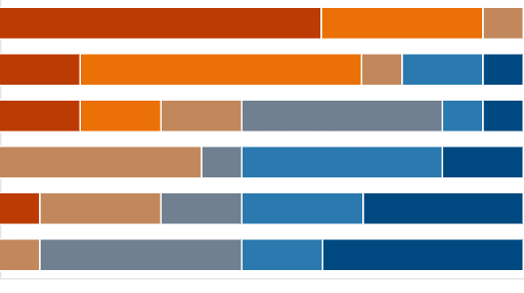first choice las last choice

1. Behaviour
2. Wellbeing
3. Communication
4. Attendance
5. Relationships
6. Learning and Teaching

This information shows us that Learning and Teaching is not currently an area of key focus when EPs are working with their establishments.

As a working group, we continue to work to understand where our input can be most helpful within establishments, and how we can best support colleagues within REPS to support establishments in relation to learning and teaching.

Next steps:

* 3 EPs to be trained in the use of the Cognitive Abilities Profile (CAP)
* Cascade this learning about the CAP to the wider REPS team
* Consider further training for REPS
* Continue to link with Education colleagues regarding learning and teaching developments in Renfrewshire
* Create a working group with colleagues from schools and nurseries to plan next steps with establishments

**Equalities SIP group**

Session 2024-25 saw the REPS Equalities SIP group lead our 3rd year of anti-racist implementation in REPS. As we have continued our anti-racism learning, a key focus this year has been how we translate our learning in anti-racist action in our EP practice. We have therefore focussed on embedding anti-racism across practice and service structures (i.e WSI’s). We have worked at varying levels to support anti-racist action; the level of the EPS, LA and nationally.

Level of the EPS

We have continued to prioritise protected time during team meetings and development days to develop our knowledge and understanding of anti-racist EP practice, considering how we embed our learning into service structures and carry out anti-racist action in our everyday practice. For example, we have critically analysed existing psychological frameworks and theories in relation to their cultural sensitivity (e.g ‘*The Myth of Attachment Theory’),* extended our understanding of trauma informed practice to racial trauma informed practice and our EPS assessment framework now includes prompts to support cultural sensitivity. The chart below illustrates a slight growth in REPS reported knowledge and confidence in anti-racist practice however in-line with the Anti-Racism literature, it is recognised that at baseline EP’s may not have yet been aware of their own knowledge gaps.

*Figure 1: Bar chart showing EPs knowledge and confidence of anti-racist practice pre-training and at 18 month follow up*

REPS WSI groups have made the following changes in session 24-25:

RNRA

* Equalities added as a standing item on WSI meeting agendas to ensure equalities considerations are at the forefront of all RNRA planning.
* Adaptations to training to reflect consideration of cultural differences in relation to models of attachment and family/community support.
* Racial trauma incorporated into the Leadership training content.
* Racial trauma input delivered to almost all of the EPS team.

NVR:

* Equalities item added to WSI action plan *‘Review language in NVR training in line with best practice for equalities and The Promise’*
* Expandedfocus on cultural bias and intersectionality in level 2 training
* Some tweaks through training materials
* Identified Barnados might be able to offer support with developing materials to help us develop culturally sensitive offers

The Promise/ Bereavement, loss and change:

* WSI lead has attended *Cultural Differences in Death Dying and Bereavement*CLPL ran by Cruse Scotland leading to references and content embedded into our informed and enhanced CLPL resources
* Organised West Partnership networking event where equalities in this area were discussed and effective practice shared including work in Glasgow Educational Psychology Service that supports understanding of death and dying across main faiths

RICE

* Adaptations within RICE framework which reflect cultural sensitivity

EBSA

* The EBSA WSI have included a statement on cultural norms within school’s EBSA training that is respectful of cultural differences
* EBSA have been exploring the intersection of attendance and different ethnic groups and the impact that this is having as well as the considerations for these groups
* EBSA have been exploring literature about race and attendance and being mindful of different cultures when creating resources

The SIP Equalities group continue to push forward the challenge of embedding anti-racism across service structures, practice and delivery and this coming session are planning to extend an intersectional lens to equalities learning with a focus on LGBT.

LGBT work

In developing our equalities knowledge and practices, we have begun a focus on LGBT learning this term. An initial needs analysis of EP knowledge and confidence within this area has been carried out. Results indicated that EPs felt more comfortable discussing LGBT inclusivity within the team than within their establishments and survey results indicated that there is work to be done in terms of LGBT themes being reflected in our service delivery. In response, the equalities group has sourced initial training for REPS.

The equalities group have compiled a reading list for EPs on LGBT themes in education as well as reading lists for primary and secondary school pupils.

In order to enhance our understanding of the need within establishments, LISN groups were surveyed to ascertain what, if any, training establishments had received on supporting LGBT young people and their families. A final review of these results will support REPS to ascertain where schools’ LGBT learning is currently sitting.

Critical literacy has been identified as an area to explore and the equalities SIP group have made contact with Glasgow University re: the importance of critical literacy for supporting the inclusion of LGBT young people.

Level of the LA:

We have continued to provide advice and guidance to the LA Building Racial Literacy (BRL) group by drawing upon on our service experience of anti-racism learning journeys and knowledge of research methodology, data analysis, improvement methodology, and implementation science to support processes for improvement. Part of this role has also involved signposting to national policy and guidance as it is published such as the recent [Schools - addressing racism and racist incidents: guidance - gov.scot](https://www.gov.scot/publications/addressing-racism-racist-incidents-schools/).

This year we have supported two focus groups with school leads interested in piloting anti-racism in their schools where we have introduced them to Cultural Competency Self-Reflection tool developed by Trainee Educational Psychologists.

We have also delivered a racial trauma awareness raising input to LA directorate.

National level:

Two EPs continue to sit on the Scottish Division of Educational Psychology (SDEP) Anti-Racism steering group enabling us to contribute to the strategic development of anti-racism within the Scottish Educational Psychology profession. Work on the SDEP has involved leading the organisation and chairing of a national Anti-Racist network open to all EPs and trainee EPs in Scotland where we have helped create a space for professional challenge, learning, and Anti-Racist action.

Some members of the Equalities SIP group have contributed to and led work strands formed from the SDEP network which have aimed to support national anti-racist policy and practice development. This has involved the development of an anti-racist EP practitioner toolkit and an anti-racist self-evaluation framework for Educational Psychology Services as well as collaboration with the Association of Scottish Principal Educational Psychologists (ASPEP) leading to the release of a position paper which sets a national context for Anti-Racist EP practice which was published in March 2025 ([Anti-Racism-Position-Paper-March-2025-1.pdf](https://www.aspep.org.uk/wp-content/uploads/2025/03/Anti-Racism-Position-Paper-March-2025-1.pdf)).

Some members of the REPS equalities SIP group developed and delivered a national SDEP anti-racism pilot training model this session. Ten LAs attended ‘train the trainer’ sessions which aimed to support EPS leads to implement anti-racism in their services. This work currently involves REPS ongoing mentoring support to services.

Next session the equalities SIP group aim to work on the following:

Next steps EPS

* In further understanding intersectionality, we will widen our equalities learning to the field of LGBTQ where all REPS EPs will complete online and in person modules created by Time for Inclusive Education (TIE).
* Equalities SIP will lead a REPS Pilot of the SDEP work strand tools (Managing Racism EP toolkit and Anti-racism EPS Self Evaluation toolkit)

WSI’s next steps:

* In RNRA, racial trauma mop up to be offered to ensure all EPs trauma informed knowledge is culturally competent.
* Consideration of an intersectional enhanced version of core RNRA training
* A more thorough review of the NVR training materials will take place to ensure content is culturally inclusive.
* Continue to link with west partnership network in sharing resources for The Promise
* Continue to expand resources and content in all CLPL resources to support culturally competent practice for The Promise.
* Introduce equalities as a standing item on meeting agendas in RICE to ensure cultural considerations remain at the forefront of decision making

Next steps LA

* Continue to provide advice and guidance to BRL group as required

Next steps national

* Continue to support national anti-racism developments through SDEP steering group
* Continue to support SDEP work strands
* Continue to support SDEP mentoring offer to pilot services
* Continue to encourage REPS EPs to access the SDEP network to support ongoing learning and contribution to national Anti-Racism developments

**Self-Evaluation SIP Group**

The self-evaluation SIP group was created in 2022 to improve the focus on self-evaluation across the service and consistency in approaches to self-evaluation. The working group explores evaluation information we currently gather and how this is used, gaps in evaluation information, and gathers annual stakeholder feedback to contribute to service improvement and development.

ASPEP Self-Evaluation Framework

By introducing the use of the ASPEP Self-Evaluation Framework across all WSIs, we have a better understanding of current self-evaluation processes across service delivery and have improved self-evaluation activities across the year in WSI work. A review of WSI returns meant we could see that all groups were using appropriate self-evaluation questions relating to service improvement and used data or information gathering to answer these as appropriate. We did not continue with formal self-evaluation returns this year but encouraged groups to continue to use the framework if helpful.

Stakeholder Feedback

We adapted our stakeholder feedback process and included both Head Teachers and Depute Head Teachers to better reflect the people we link with on a regular basis. We also sought feedback through a survey sent to all Head Teachers/Heads of Centre and Secondary LISN. A partner survey was sent to services and Children’s Services staff, and the Principal Educational Psychologist also sought evaluative feedback from the team regarding management. The self-evaluation group suggested that the PEP uses the evaluative responses alongside the ASPEP framework in relation to 1.2 and 1.3 to review leadership and use the feedback received.

Stakeholders communicated that the role of the EP is now clearer to key staff but practitioners who do not work with us often are less clear about our role, what we can offer, and how we may work with them.

In the online survey, the following statements were selected by respondents to reflect the EP contribution to improving outcomes for children/young people and their families.

Respondents were invited to expand on any other examples of impact. Themes emerging included:

* EP expertise leads to deeper understanding of a child/young person’s needs.
* EPs suggestions for specific assessment materials and resources leads to improved teacher confidence in supporting children/young people and improved outcomes.
* EPs have provided training and coaching in a range of assessments and interventions, including RNRA, NVR, EBSA, Loss and Bereavement, SCERTS, sensory profiling, Leuven Scales, selective mutism, CIRCLE, trauma informed practice, Identiplay and dyslexia. This training and coaching supports inclusion and teacher confidence and wellbeing.
* Support with loss and bereavement in an establishment.
* Support with school improvement planning.

Several respondents reported barriers to engagement, including EP availability and school factors, such as absence and difficultly getting training dates suitable for all. Other pressures on staff and establishments, such as other SIP and authority priorities, were also mentioned as barriers to engagement.

The partner survey was completed by Speech and Language Therapy who continue to appreciate our joint working approach and look forward to continuing this in the future.

Self-Evaluation of Casework

We continued to build on reporting on casework and how a database can support us with this. Reflection on how we should use demographic information, such as ethnicity, led to prompt questions being added to the Assessment Frameworks to ensure we are not collating information we do not use for a purpose.

Joint Working Plan

We do not currently use feedback from Joint Working Plan discussions in self-evaluation at service level, although EPs may use evaluative discussions in the meeting to shape their work with the establishment. The Joint Working Plan has been amended to make the planning process more streamlined and focused on planning rather than evaluation.

Next Steps

Use of the new ASPEP self-evaluation framework next session for Quad groups. This will identify challenge questions that will lead to measurement over a year.

We will carry out another stakeholder feedback exercise next session.

REPS will move to the FORT Database system, allowing greater control over casework data and demographics.

Service to review the SQR evaluation information. Any gaps will be identified and team development needs progressed if there are needs.

As we further explore consistency of EP practice, we will take a closer look at consultation skills.

**Locality Inclusion Support Network (LISN)**

LISN is a forum that facilitates the understanding and application of staged intervention and inclusion within a peer support setting of senior school leaders across education clusters. LISN is led by the EPS, growing from a pilot of two school clusters to a structure that covers the entire Local Authority for both schools and early years. Every education establishment in Renfrewshire has access and is supported to be part of a LISN.

LISN is underpinned by national policy and legislation, namely the Additional Support for Learning Act (2004) and Children’s and Young Person’s Act (2014) GIRFEC where the expectation is set out that any assessment and intervention is timely, proportionate and appropriate to meet a young person’s needs. It especially seeks to support early intervention. Principles of co-creation and joint ownership with Head Teachers have always been central to the model, so while time is given to every LISN group by a systematic organisation of EP time, the Chair and administration role is carried out by a Head Teacher.

LISN is a highly evaluated year on year as having impact for children and staff. SLT wellbeing and professional expertise are two areas that are indicated as improving as an outcome of LISN. Every year the EPS conducts an evaluation on behalf of LISN Chairs to ensure effectiveness. Each LISN meets for a half day for 7 months of the school calendar. EPs attend nineteen LISNs per month, equating to 9 days of EPS time; 133 LISNs across the year, equating to 67 days of EPS time. A snapshot would suggest that there is capacity for approx. 500 children to be discussed and reviewed across the year and that the majority of children discussed have an ASN or are Care Experienced or on the edge of care.

REPS brings enhancement to the LISN model in the following ways:

* Leading and resourcing training for all participants in a rolling manner on an evidence-based meeting structure, namely Solution Oriented Approach (SOA)
* Modelling the use of this structure within monthly meetings and in many cases facilitating planning through minute taking in an SOA format that identifies small, measurable targets that can be reviewed and updated.
* Providing Psychological consultation for the multiple cases discussed in the forum and supporting the extension of concepts between cases or across issues in the cluster through knowledge of schools gathered during link EP visits.
* Supporting good practice connections between practitioners in the cluster through springboard training events and through knowledge of the locality.
* Supporting the use of LISN to facilitate moderation of applied staged intervention across establishments e.g. the use of GIRFEC planning across schools; responding to parental anxiety; appropriateness of referral to CAMHS; universal thresholds between Local Authority and partnership nurseries.
* Supporting transparency and equity in support structures and processes across establishments

In addition to LISN attendance, the EPS continues to lead the model 7 years on from its conception, organising, agenda-setting and minuting a school age and early years LISN Chairs meeting termly.

As well as structured time to share good practice and areas of concern, there are inputs to the meetings about early intervention resources; new initiatives and training opportunities e.g. Families affected by imprisonment; Ren10 and use of VR Headsets and the Promise which allow the Chairs to cascade this information to the SLT members of their cluster LISNs.

Chairs indicate how highly they value these meetings: ‘I find this the most helpful event I go to and a one-stop shop for finding out everything I need to know about inclusion’.

Below are the responses from the evaluation currently underway regarding LISN over the 2024-2025 academic session:

*Please scale how well you feel your LISN group has gone this year- (1 being not at all well and 10 being extremely well)*

responses to date