RNRA Development Team
Renfrewshire educaitonal psychology service June 2021
parental involvement and engagement in Renfrewshire’s Nurturing relationships approach (RNRA)
Renfrewshire’s Nurturing Relationships Approach (RNRA) is a relational and trauma informed approach to supporting the mental health and wellbeing of children and young people. RNRA is grounded in a rich evidence base and has been found to positively impact on staff practice and the wellbeing of children and young people (Nolan, 2020). Positive relationships across the school community (parents/carers, pupils & staff) and a focus on the development of resilient children and young people are considered some of the key features of whole-establishment nurturing approaches.
The information in this document is intended to clarify the criteria used to determine where establishments are in their plans and actions to embed parental engagement in their approach to RNRA and to support establishments to plan their approach to parental engagement with RNRA.
Based on the information found in appendices 1-3, REPS RNRA development team has mapped the nurture framework features of highly effective practice onto a continuum of parental involvement and engagement in whole-establishment nurturing relationships approaches.

The school/ELC setting has clear vision, values and aims which embed an understanding of attachment theory and reflects the importance of positive relationships.
The shared values, aims and vision of the whole community are evident in the positive, respectful relationships that can be seen between staff, parents/carers, children and young people and partners
Families are aware of and understand the school/ELC settings nurturing approach and this extends to how they learn with and support their own family.
There is a supportive, caring and inclusive community that fosters connectedness and child participation.
The school/ELC setting recognises the part it plays in being at the heart of the community and makes as much provision as possible to fully involve the wider community.
Self-evaluation is used to specifically monitor and evaluate the emotional wellbeing of an organisation and how well supported learners, staff and parents/carers feel within the school/ELC setting.
Families are invited to contribute to the school/ELC settings nurturing approach by way of consultation and focus groups
Provision is made to support families in an understanding of attachment and the key role that they have in supporting development, self-esteem, language and positive behaviour.

Increasing engagement

This continuum has been further refined to produce practical examples which would indicate that parental involvement and engagement in RNRA has been considered, developed, and embedded. The purpose of these indicators is to support establishments to plan effective approaches to parental engagement with RNRA.
1. Consideration of parental involvement in RNRA
2. Developing parental engagement in RNRA
3. Embedding parental engagement in RNRA
1. Evidence of 0-2 of:
- Informing parents about RNRA in the establishment e.g. newsletter, website, information session.
- Gathering information from parents at any stage e.g. surveys, focus groups etc.

2. In addition to all at stage 1, evidence of at least 1 of:
- Involving parents in at least 1 change idea (detailed in action plan) e.g. development of a space for family learning, family team building events etc.
- Working with parents to develop their knowledge & understanding of RNRA theory/practice e.g. workshops on attachment theory, trauma, nurture principles, mental health

3. In addition to all at stages 1 & 2, evidence of at least 2 of:
- Involving parents in more than 1 change idea (detailed in action plan)
- Working with parents to develop their knowledge & understanding of RNRA theory/practice and supporting parents to use these concepts with their children e.g. establishment staff as NVR supporters for a parent, parent/child groups in the establishment
- Parents collaborate with the establishment about the development of RNRA in the establishment and/or community e.g. parent council representative links with RNRA core group, parents contribute to development and refinement of a change idea etc.

Appendix 1: Parental engagement: Nurture framework self-evaluation quality indicators (extracted from ‘Applying nurture as a whole school approach)
Indicator | Feature of highly effective practice | Challenge question/s
1.1.2  Self evaluation | Self-evaluation is used to specifically monitor and evaluate the emotional wellbeing of an organisation and how well supported learners, staff and parents/carers feel within the school/ELC setting. | - How do leaders invite comments from staff, children and young people and parents/carers about their attitudes and opinions on how welcome and included they feel within the community?  - In what way do leaders and staff understand what factors impact on the overall wellbeing of an organisation, for example, how happy staff feel coming to work; how confident parents/ carers feel to approach staff?
1.3.3  Leadership of change | The school/ELC setting has clear vision, values and aims which embed an understanding of attachment theory and reflects the importance of positive relationships. | - Are children and young people, parents/ carers and other stakeholders fully aware of the school/ELC setting’s nurturing approach and stage of implementation?
2.4.6  Personalised support | There is a supportive, caring and inclusive community that fosters connectedness and child participation. | - To what extent are structures put in place to ensure that all staff, children and young people, parents/ carers and partners feel part of a community and identify with this?
2.5.2  Family learning | Provision is made to support families in an understanding of attachment and the key role that they have in supporting development, self-esteem, language and positive behaviour. | - Are there programmes or approaches available in the establishment that support families in understanding the importance of attachment?
2.5.4  Family learning | Families are aware of and understand the school/ELC settings nurturing approach and this extends to how they learn with and support their own family. | - In what way is the school/ELC settings nurturing approach communicated with families in a range of ways, for example, workshops, displays, discussions?  - To what extent do parents/carers understand the vision of the school/ ELC setting and what they are trying to achieve and are supportive of this?  - To what extent do families engage in a nurturing approach when learning within their own context?
2.5.5  Family learning | The school/ELC setting recognises the part it plays in being at the heart of the community and makes as much provision as possible to fully involve the wider community. | - In what way does the school/ELC setting use its data and intelligence to determine the needs of families within the community?  - Does the school/ELC setting attempt to put into place initiatives that will support those needs, for example, healthy living initiatives, good sleep habits, mental health workshops?  - To what extent do staff work closely with partner agencies to ensure that families are fully supported to engage in family learning with their children and young people.
2.5.7  Family learning | Families are invited to contribute to the school/ELC settings nurturing approach by way of consultation and focus groups | - To what extent has the school/ELC setting engaged with parents/carers in establishing its nurturing approach?  - Have there been a range of opportunities for parents/carers to comment and give feedback on their nurturing approach?
3.1.1  Successes & achievements | The shared values, aims and vision of the whole community are evident in the positive, respectful relationships that can be seen between staff, parents/carers, children and young people and partners | - To what extent is the community involved in establishing the nurturing approaches that underpins the shared values, aims and vision?  - What mechanisms are in place to ensure staff, parents/carers, children and young people and partners demonstrate positive behaviour and respectful relationships?  - How well are nurturing approaches clearly communicated throughout the school/ELC setting as integral to its shared values, aims and vision?

Appendix 2: Parental engagement: involvement continuum (extract from ‘Parental engagement evaluation toolkit, Renfrewshire Council 2018)
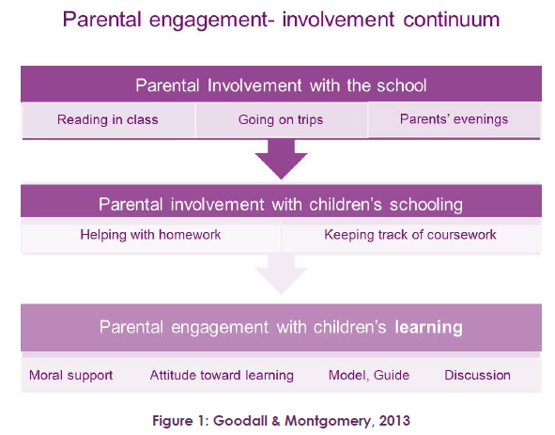
“Goodall and Montgomery (2013) have acknowledged the importance of all parental involvement but also note that parental involvement and engagement are situated on a continuum, with the goal being to support parents to engage with their child’s learning. This continuum starts with activities that are establishment led (i.e., parental involvement with schools), moves to activities where the establishment and parents have a similar level of agency (i.e., parental involvement with schooling) and finally to parent-led activities (i.e., parental engagement with children’s learning at home). This continuum aligns well with research evidence that parental engagement is most effective when it relates to learning in the home rather than attendance at activities (Harris & Goodall, 2008).”

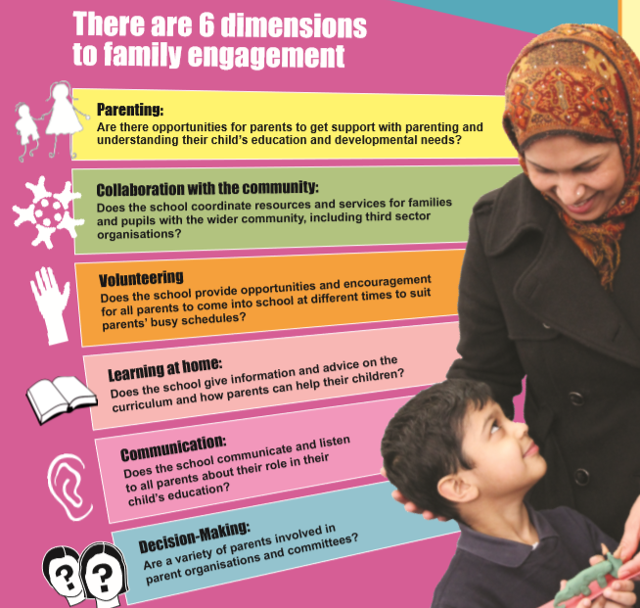
Appendix 3: Family engagement dimensions (extract from ‘Engaging with families’ poster, Education Scotland
“Six dimensions of engagement have been identified (Epstein et al., 2002). These are: parenting, collaboration with the community, volunteering, learning at home, communication, and decision-making.”

