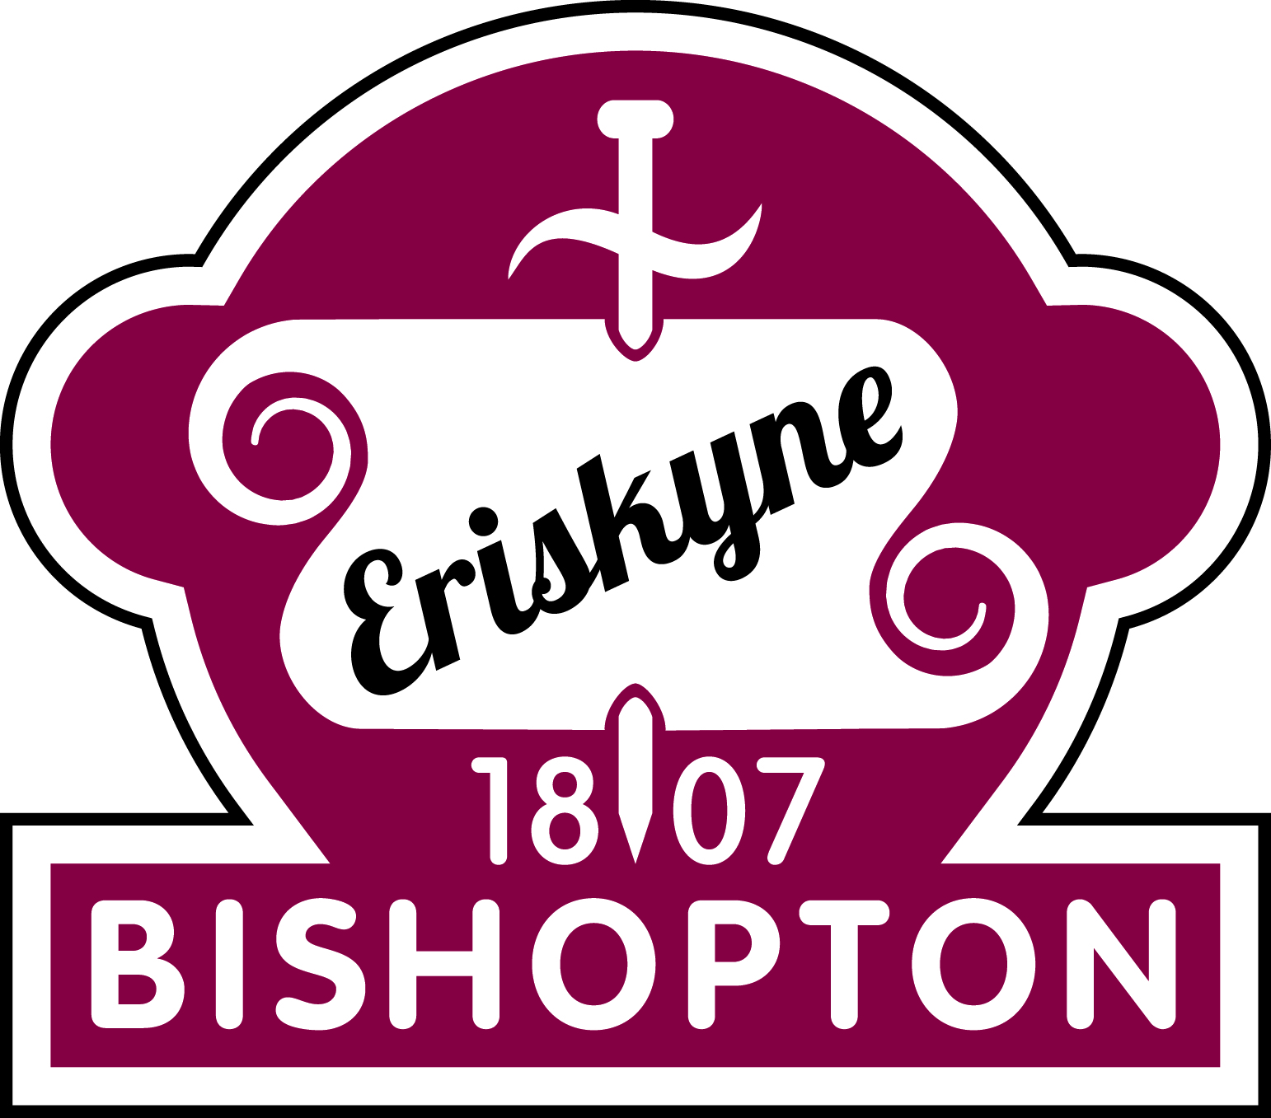 | P2 Welcome and Information Letter | August 2021

Dear Parents/Carers,

Welcome to a new school year! P2 have an exciting time ahead of them. Throughout the year, as well as the children gaining knowledge and understanding through their learning, a large emphasis will be placed on developing their skills of collaboration, problem solving, communication and decision making.

Please visit the class blogs at:
P2B - https://blogs.glowscotland.org.uk/re/primary2bps/category/primary-2b/
P2F - https://blogs.glowscotland.org.uk/re/primary2bps/category/primary-2e/
P2K - https://blogs.glowscotland.org.uk/re/primary2bps/category/primary-2k/
The homework will be posted on the blog every week so you can check what is expected of your child. We are not using Homework Diary this year but on a Monday the tasks will be introduced and explained. This year we will be using a mixture of jotters and teams for homework.
Literacy homework
- Spelling homework will be issued on the Monday and should be handed in on the Friday. Spelling homework should be done in their homework jotters.
- Reading books will be issued on the Friday and should be handed in on the following Thursday.
Maths homework
- Maths homework will be an active maths grid. Your child should complete only 1 maths activity a week. The work should be uploaded to teams. An assignment will be set up every week on your child’s class Teams page.
Expectations
Reading – Each week your child will be given a reading book to read at home which has been prepared in class. They should be able to read this book and should try to read most nights. When reading with your child please use the 3 P’s – Pause, Prompt and Praise if they are unable to read a word. Another strategy you could use is the Three Sharings: 1. What are your likes/dislikes about the book? 2. What are your puzzles/questions about the book? 3. Can you find any connections in the book? Does it remind you of anything in your life or a book or film/TV you have seen?
Spelling – All pupils will have a weekly spelling rule to focus on. Each child will be given 4 words which follow the spelling rule and 4 common words each week. You will find these in their Spelling Homework jotter and on the blog each week. Your child should rewrite these words twice at home using the Look, Say, Cover, Write, Check method. They should write one sentence using a spelling rule word. To help them focus on the spelling, they should underline the spelling word they have used. Finally, to encourage self-assessment they should check their work for any quick fixes .e.g. missing capital letters or punctuation. We are continuing using the Wraparound Spelling method where your child should record any shoot words they can think of.
Maths – Each term, a Maths Homework grid will be uploaded to Teams with enough activities for each week of the term. Each week, your child should complete one of these tasks. Maths homework will either consolidate learning of their current maths topic or will cover various topics to allow the pupils to continually revise maths and number concepts.
Other curricular areas - As the topics develop, homework may be issued to accompany learning from class.
Please do not allow your child to become upset/distressed about homework. If we can provide you with any advice or help to support your child with their work, please do not hesitate to get in touch.

As Maths homework will require access to the internet to demonstrate completion, we would be grateful if you could let us know if there will be any problems with your child using a computer. It will be possible for paper-based exercises to be given. If you would like to speak to us regarding any issues or concerns, please do not hesitate to contact us.

Kind regards,
Mrs Kane, Mrs Brown, Miss Grant and Miss Frew

