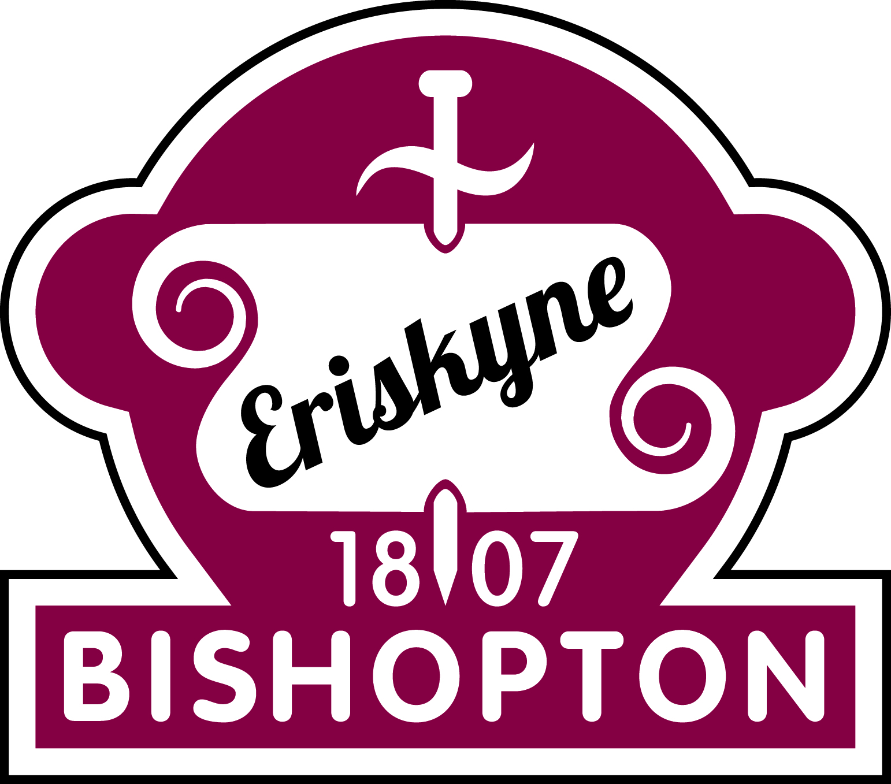 | P2 Welcome and Information Letter | August 2020
Dear Parents/Carers,

Welcome to a new school year! P2 have an exciting time ahead of them. Throughout the year, as well as the children gaining knowledge and understanding through their learning, a large emphasis will be placed on developing their skills of collaboration, problem solving, communication and decision making.

Please visit the class blogs at:
P2G -https://blogs.glowscotland.org.uk/re/primary2bps/category/primary-2g/
P2F - https://blogs.glowscotland.org.uk/re/primary2bps/category/primary-2f/
P2J – https://blogs.glowscotland.org.uk/re/primary2bps/category/primary-2j/
P2E – https://blogs.glowscotland.org.uk/re/primary2bps/category/primary-2e/
P2H - https://blogs.glowscotland.org.uk/re/primary2bps/category/primary-2h/

The homework will be posted on the blog every week so you can check what is expected of your child. We are not using a Homework Diary this year, but on a Monday the tasks will be introduced and explained. As much as possible, we would like the homework to be uploaded to Teams or emailed to the class teacher. Please do not allow your child to become upset/distressed about homework. If we can provide you with any advice or help to support your child with their work, please do not hesitate to get in touch. All homework will be issued on a Monday and is due on the Thursday or Friday of the same week, unless otherwise stated.
Reading – Each week your child will be given a reading book to read at home which has been prepared in class. They should be able to read this book and should try to read most nights. When reading with your child please use the 3 P’s – Pause, Prompt and Praise if they are unable to read a word. We also encourage you to discuss the stories with your child, you could use the Three Sharings: 1. What are your likes/dislikes about the book? 2. What are your puzzles/questions about the book? 3. Can you find any connections in the book? Does it remind you of anything in your life or a book or film/TV you have seen? Reading books will be given out on a Monday and should be returned on the Friday of the same week.

Spelling – All pupils will have a weekly spelling rule to focus on. Each child will be given 4 words which follow the spelling rule and 4 common words each week. You will find these on the class blog each week and also on your child’s Teams assignments page. Your child should rewrite these words twice at home using the Look, Say, Cover, Write, Check method. They should write a sentence using one or more of the spelling rule words. To help them focus on the spelling, they should underline the spelling word they have used. Finally, to encourage self-assessment they should check their work for any quick fixes .e.g. missing capital letters or punctuation. We are continuing to use the Wraparound Spelling method where your child should record any shoot words they can think of and any words which also have the spelling rule. Spelling will be issued on the Monday and should be returned via Teams on the Friday of the same week.
Maths – Each term, a Maths Homework grid will be given to your child. The grid will have a mixture of numeracy and math activities. There will be enough activities for each week of the term. Your child should complete one of these tasks per week. Maths homework will either consolidate learning of their current maths topic or will cover various topics to allow the pupils to continually revise maths and number concepts. The maths homework should be evidenced on Teams for the Thursday of the same week.

Other curricular areas - As the topics develop throughout the year, homework may be issued to accompany learning from class.

As many of the homework activities will require access to the internet, we would be grateful if you could let us know if there will be any problems with your child using a computer. It will be possible for paper-based exercises to be given. However, to reduce items being brought back and forwards from school, we will try to use Teams.

If you would like to speak to us regarding any issues or concerns, please do not hesitate to contact us.

Kind regards,

Miss Grant, Miss Finnigan, Miss Gilbert, Miss Frew and Miss Hunter

