*Love Respect Positive Attitudes Community Effort Charity Honesty*

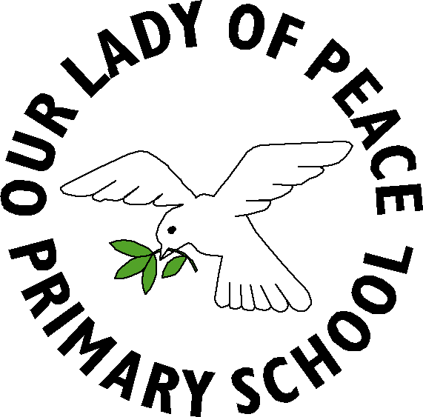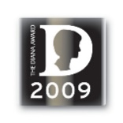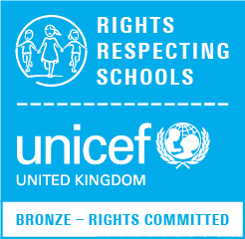



Renfrewshire Council

Education and Leisure Services

Our Lady of Peace Primary School

Erskinefauld Road,

Linwood,

Paisley

PA3 3PR

Tel: 0300 300 0173 ourladyofpeaceenquiries@renfrewshire.gov.uk

Head Teacher: Lesley-Anne Dick

21/04/21

Dear Parent/Carer,

**Primary 7 Sacrament of Confirmation**

As you know, in Primary 7 our children are presented for the Sacrament of Confirmation.

In order to be presented for this Sacrament, the children must first be Baptised into the Catholic Church and have received the Sacraments of Reconciliation and Holy Communion.

This year due to the current restrictions the children will receive the Sacrament of Confirmation in St Conval’s Church with Fr Michael. The date for this is Thursday 20th May 2021 at 6pm. The numbers able to attend will depend on restrictions set out by the Scottish Government at the time.

Sponsors – children should have chosen a sponsor. The sponsor MUST BE OVER 16 years of age, a Catholic and not the parent of the child. A sponsor should be a person other than the parents, who will support the faith journey of the child. If you have any questions about a sponsor please contact the school and we will be happy to support you. Mr Docherty will continue to prepare the children for this special Sacrament.

Please do not hesitate to contact me at the school should you require any further information.

Yours faithfully,

Claire McLaren

Depute Head Teacher