*Love Respect Positive Attitudes Community Effort Charity Honesty*

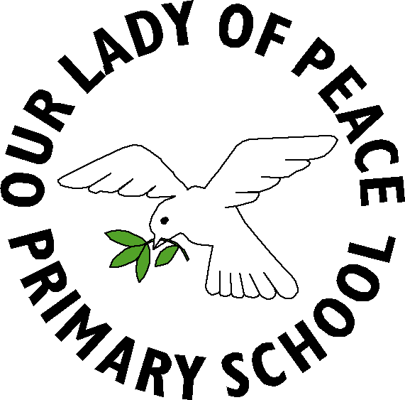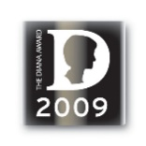

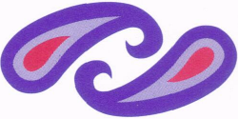

Renfrewshire Council

Education and Leisure Services

Our Lady of Peace Primary School

Erskinefauld Road,

Linwood,

Paisley

PA3 3PR

Tel: 0300 300 0173 ourladyofpeaceenquiries@renfrewshire.gov.uk

Head Teacher: Lesley-Anne Dick

21/04/21

Dear Parent/Carer,

**Sacraments of Reconciliation and First Holy Communion**

We can confirm that Primary 4 children will celebrate the Sacrament of Reconciliation (Confession) in Our Lady of Peace Primary School during school time on Tuesday 18th May.

Due to the relaxation of restrictions we will no longer be required to have two celebrations of the Sacrament of First Holy Communion. There will be one celebration for all children on Saturday 22nd May at 11am.

There will still be a requirement to strictly limit our numbers to two adults per child. This celebration will still be live-streamed and a video capture will be available on the Parish YouTube channel shortly after.

Face coverings will be worn by all (unless exempt) except for the act of receiving Holy Communion. Only the photographer will take a group photograph after Mass. Any family photographs will need to be taken outside the Church or at home.

**Your child must have been Baptised** in order to celebrate their First Holy Communion. If for any reason you are reluctant to put your child forward at this point, we will all understand this and will be happy to celebrate this sacrament at a later date.

Please do not hesitate to contact me at the school should you require any further information.

Yours faithfully,

Claire McLaren

Depute Head Teacher