

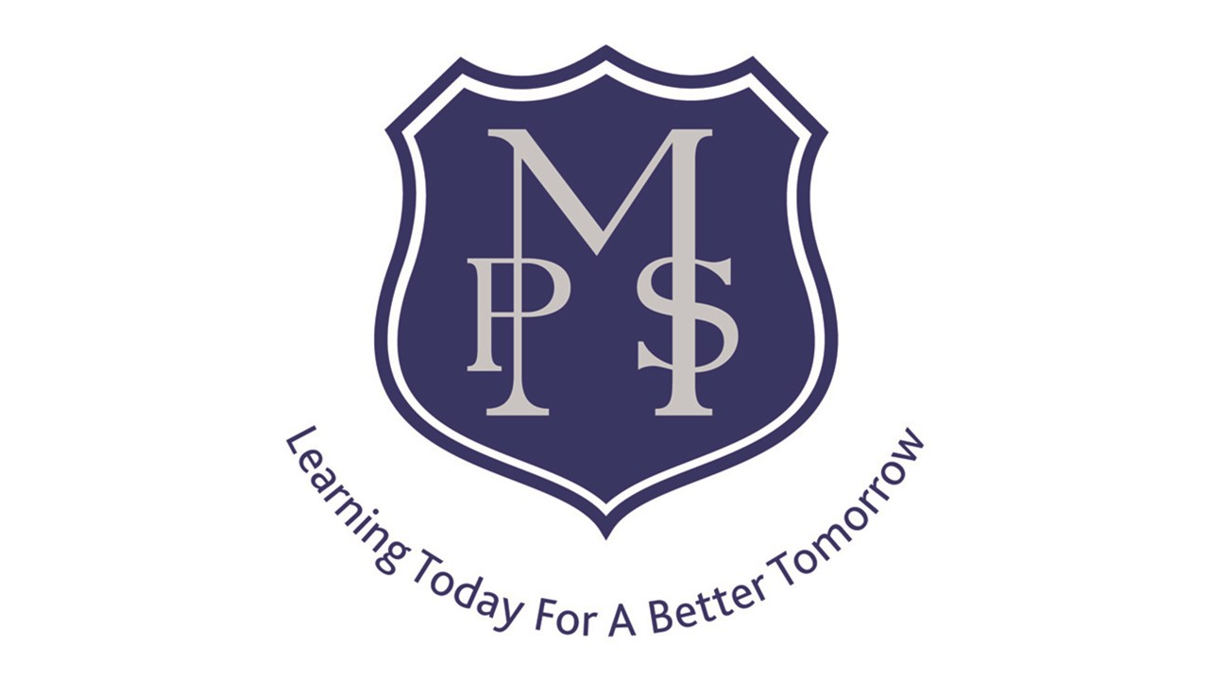

Renfrewshire Coucil

Mossvale Primary School & ELCC

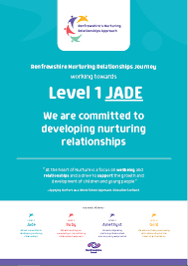 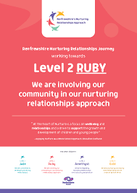

STANDARDS AND QUALITY REPORT

June 2021

This report will inform you of the school’s progress and achievements in the last session and let you know about our plans for 2021-2022. I hope that you find it helpful and informative.

Jane Houston

Head Teacher

MAIN SUCCESSES AND ACHIEVEMENTS 2020-2021

This session has undoubtedly been one of the most challenging we have ever experienced. The impact of the Covid 19 pandemic has been profound and presented us with unprecedented challenges. However, despite these challenges, progress was made pre and post lockdown, of which we are very proud.

* All staff and parents felt confident with all the school/ELCC protocols implemented to keep them safe during the Pandemic. This was validated by a UNISON inspection.
* The high quality remote learning that was swiftly implemented in January 21 resulted in higher engagement, provided live learning sessions and supported children to continue their learning journey. This was built on feedback from the prior Lockdown and research into high quality provision.
* The creation of our new School Rationale which captures all that we aspire for our children in their time at Mossvale PS and ELCC and this was compiled through consultation with all stakeholders.
* Time created for collegiate working that has allowed the staff to feel valued, empowered and fully engaged in all developments which then ensures new approaches are embedded across the school and ELCC. All staff have clearly identified responsibilities and Leadership roles.
* The staff have worked to create a new Planning Approach which encourages more meaningful and progressive learning experiences with bundled outcomes ensuring all children get a depth of experiences.
* All SMT and staff have a confident understanding of attainment across the school and progress for each child based on wide variety of evidence both summative and formative. This has allowed us to clearly identify our areas for development and create our focussed SIP.
* Staff have worked as a group to refresh the Behaviour policy for consistency and renewed focus on encouraging positive behaviour built around our values and RNRA approaches.

OUR SCHOOL

**Mossvale Primary School & ELCC** is a non – denominational school located in Shortroods, Paisley. Our School has a school roll of 193 pupils and also houses a nursery which provides support for up to 50 children including some with recognised additional support needs. Our school is unique in that we share the campus with St. James’ Primary School and we were the first joint campus in the UK when we opened as such in 1992. Our school has built positive links with the local community and agencies over the years to provide a nurturing environment for our pupils so that they can maximise their learning. This has been more challenging this session with the varying restrictions but we have used IT creatively to keep connected.

OUR VISION, VALUES AND AIMS

Vision All children to be the best they can be!

Values **P**ositivity **R**espect **I**ntegrity **D**etermination **E**quality

Take **PRIDE** in ourselves, our school and our community

Aims To provide a positive and caring environment where everyone follows our values and are encouraged to do their best.

To give children, parents and staff a strong voice which is always valued.

To achieve the best outcomes for pupils and equip them with skills required to lead an active, healthy lifestyle with positive relationships.

To actively involve children in their learning, encourage ambition and celebrate their achievements.

**HOW SUCCESSFUL HAVE WE BEEN IN IMPROVING OUR SCHOOL?**

**School Leadership**

* The school is committed to a more collegiate approach to Improvement and all staff have a leadership role including support staff. This is recorded in the SIP.
* All school staff have been involved in working parties to develop Planning, Literacy and Assessment and have participated in Teacher Learning Community (TLC) sessions to share effective practice in implementing effective **RNRA** strategies.
* Staff planned and led the new whole school IDL for Finance Fortnight which allowed pupils to learn in a contextualised and meaningful way.
* Mossvale Primary School continues to play an integral part in local LISN group which meets to discuss supports for pupils.
* HT/PT are part of an Authority Early Years group looking at developmental milestones.

**Staff Professionalism**

* Staff have undertaken personal learning to support delivery of high quality Home Learning activities, parental engagement and Live Sessions for example, Google Classroom, Google Meet, and See-Saw.
* All staff have been involved in creating our new school and ELCC rationale taking account of our particular strengths and needs of all children
* To support recovery, all staff have developed knowledge of wellbeing indicators & GIRFEC which now informs daily practice with pupils. This builds on our previous RNRA/ Nurture training
* In our recent inspection, the Care Inspectorate highlighted the very good practice of staff in supporting our children and families
* As a result of new and robust data analysis, staff across the whole community have been involved in the creation of our new Literacy Policy which will our support pupil recovery

**Parental Engagement**

* Parents and carers have not been able to physically access the school due to Covid but have been kept informed and engaged through weekly bulletins, weekly virtual assemblies on Seesaw as well as regular contact with Class Teachers, SMT and Key Workers in ELCC.
* Parents attended virtual **Parent Council** meetings via Zoom which enabled them to keep updated with all school information. We also created a Twitter account.
* Families were issued devices to support both pupils’ Home Learning engagement and communication with parents. Individual parents were also given IT support where required.
* SMT & SELCOS maintained pastoral support to vulnerable families and pupils throughout the session which for some included access to the EP COVID Helpline Service

**Assessment of Children’s Progress**

* **Regular Tracking** **meetings** throughout session 2020-2021 involved staff in discussing the progress of pupils. A new policy was introduced with a more detailed focus on gathering and using data and then analysing this data to inform planning. Tracking meetings were held in levels to encourage professional dialogue and share good practice.
* SIP is now written with clear, measurable targets for improvement to show how we intend to make progress and how this will be measured. This allows us to clearly understand our gaps and how we aim to close them.
* New Reading coaching cards have been created to allow children to be much more secure in knowing their own learning journey and confidently share this. There is a real focus on pupils understanding their own learning journey and how they can progress in their learning.

**School Improvement**

* Level based tracking meetings now feature in our annual calendar. These meetings are pivotal in securing increased pupil attainment & achievement & ensuring pupils receive the correct support and challenge.
* Positive parent and pupil feedback recognises improvements made in our Home Learning throughout the session with the success of Live Sessions particularly highlighted.

**Performance Information : We would usually record data for last 3 years but due to Covid this as not available.**

|  |  |  |  |  |  |  |  |  |  |
| --- | --- | --- | --- | --- | --- | --- | --- | --- | --- |
|  | Read 18/19 | Writing  18/19 | Numeracy/Maths  18/19 | Read  19/20 | Writing 19/20 | Numeracy /Maths  19/20 | Read  20/21 | Writing  20/21 | Numeracy/Maths  20/21 |
| P1 |  |  |  |  |  |  | 40% | 40% | 40% |
| P4 |  |  |  |  |  |  | 46% | 46% | 46% |
| P7 |  |  |  |  |  |  | 63% | 63% | 69% |

* School & ELCC staff have analysed a range of evidence to identify **individuals** and **groups of pupils** to who are now receiving additional **targeted support** in key aspects of literacy, numeracy and wellbeing.
* Improvements now noted in Literacy at P1-4 as a result of interventions following data analysis
* Through new assessment approaches, P.5-7 staff are fully aware of pupil attainment needs, and improved attainment at these stages is now anticipated during next session
* ELCC tracking data shows gaps in learning as a result of lockdowns have been addressed

PUPIL EQUITY FUNDING

To support Recovery for our children much of the PEF budget for this session has been allocated to staffing to allow us to have additional class teachers and ASNAs. Tracking has ensured we are clear on school attainment and led to us creating boost groups to support gaps in children’s learning.

**KEY STRENGTHS OF THE SCHOOL**

All staff, pupils and many parents completed an online survey in December 2020 to allow us to create our school rationale. We asked them to consider the key strengths of our school and the consistent responses were:

* *Positive Relationships*
* *Being a Nurturing and Inclusive School.*
* *The great Teamwork and Partnerships*
* *The Joint Campus*
* *Our Environment*
* *The collegiate working*
* *Fun ways to Learn*
* *Support given to families especially by Early Years staff.*

**OUR NEXT STEPS – PRIORITIES FOR 2020 - 21**

The Covid 19 pandemic hindered our progress and our ability to achieve all our improvement priorities. Some priorities and actions will therefore be carried forward to academic session 2021 – 22. We believe that we have made good progress during session 2020-21 and we will use the improvement priorities listed below to build on this progress moving forward.

* Implement the new Reading policy and learning and teaching approaches with confidence and consistency to enable us to achieve our SIP targets. This will be further enhanced by developing a Reading Culture in the school through our work on the Reading School project.
* Further develop **Pupil Led Learning approaches** in all classes to promote independence and challenge. This will be delivered through our Tree of Knowledge Resilience Project which will be a focus for next session with additional Growth Mindset Work and additional Pupil Leadership roles.
* Update **ICT resources** and train staff to encourage independent learning in pupils as well as developing ICT skills using platforms such as Google Classroom, Sway and Seesaw.
* Fully implement our **Assessment & Data** policy to provide a consistent approach to gathering assessment evidence to inform next steps in learning and show/measure impact.
* Liaise with St. James’ Primary School to organise sustainable and consistent **joint campus events** throughout the year to rebuild relationships as we have had to work in isolation this session due to Covid.
* Undertake staff development looking at Numeracy and Maths Assessments to ensure they show pupil application of skills and deeper knowledge.
* Implement our new Staged Intervention policy which will ensure all staff working with each child know their targets and can contribute to their plan.
* Explore as a school and ELCC how we approach Learning for Sustainability.

**School Name Mossvale Primary**

**School & Nursery Class**

**School Address 3/5 Gockston Road,**

**Paisley, PA3 2QB**

**Phone 0300 300 1449**

HAVE YOUR SAY!

Please take the opportunity to share your thoughts with us as we use feedback to help us make improvements to the school. You can do this by speaking to staff, participating in Parent Council meetings, responding to questionnaires/surveys and by completing evaluations at school events. Thank you.

Full details of the school’s improvement priorities and actions are detailed in the school improvement plan which can be accessed on our website or by contacting the school office.