



Renfrewshire Coucil

Mossvale Primary School & Nursery Class

STANDARDS AND QUALITY REPORT

June 2019

This report will inform you of the school’s progress and achievements in the last session and let you know about our plans for 2019-2020. I hope that you find it helpful and informative.

Thomas J McCormick

Head Teacher

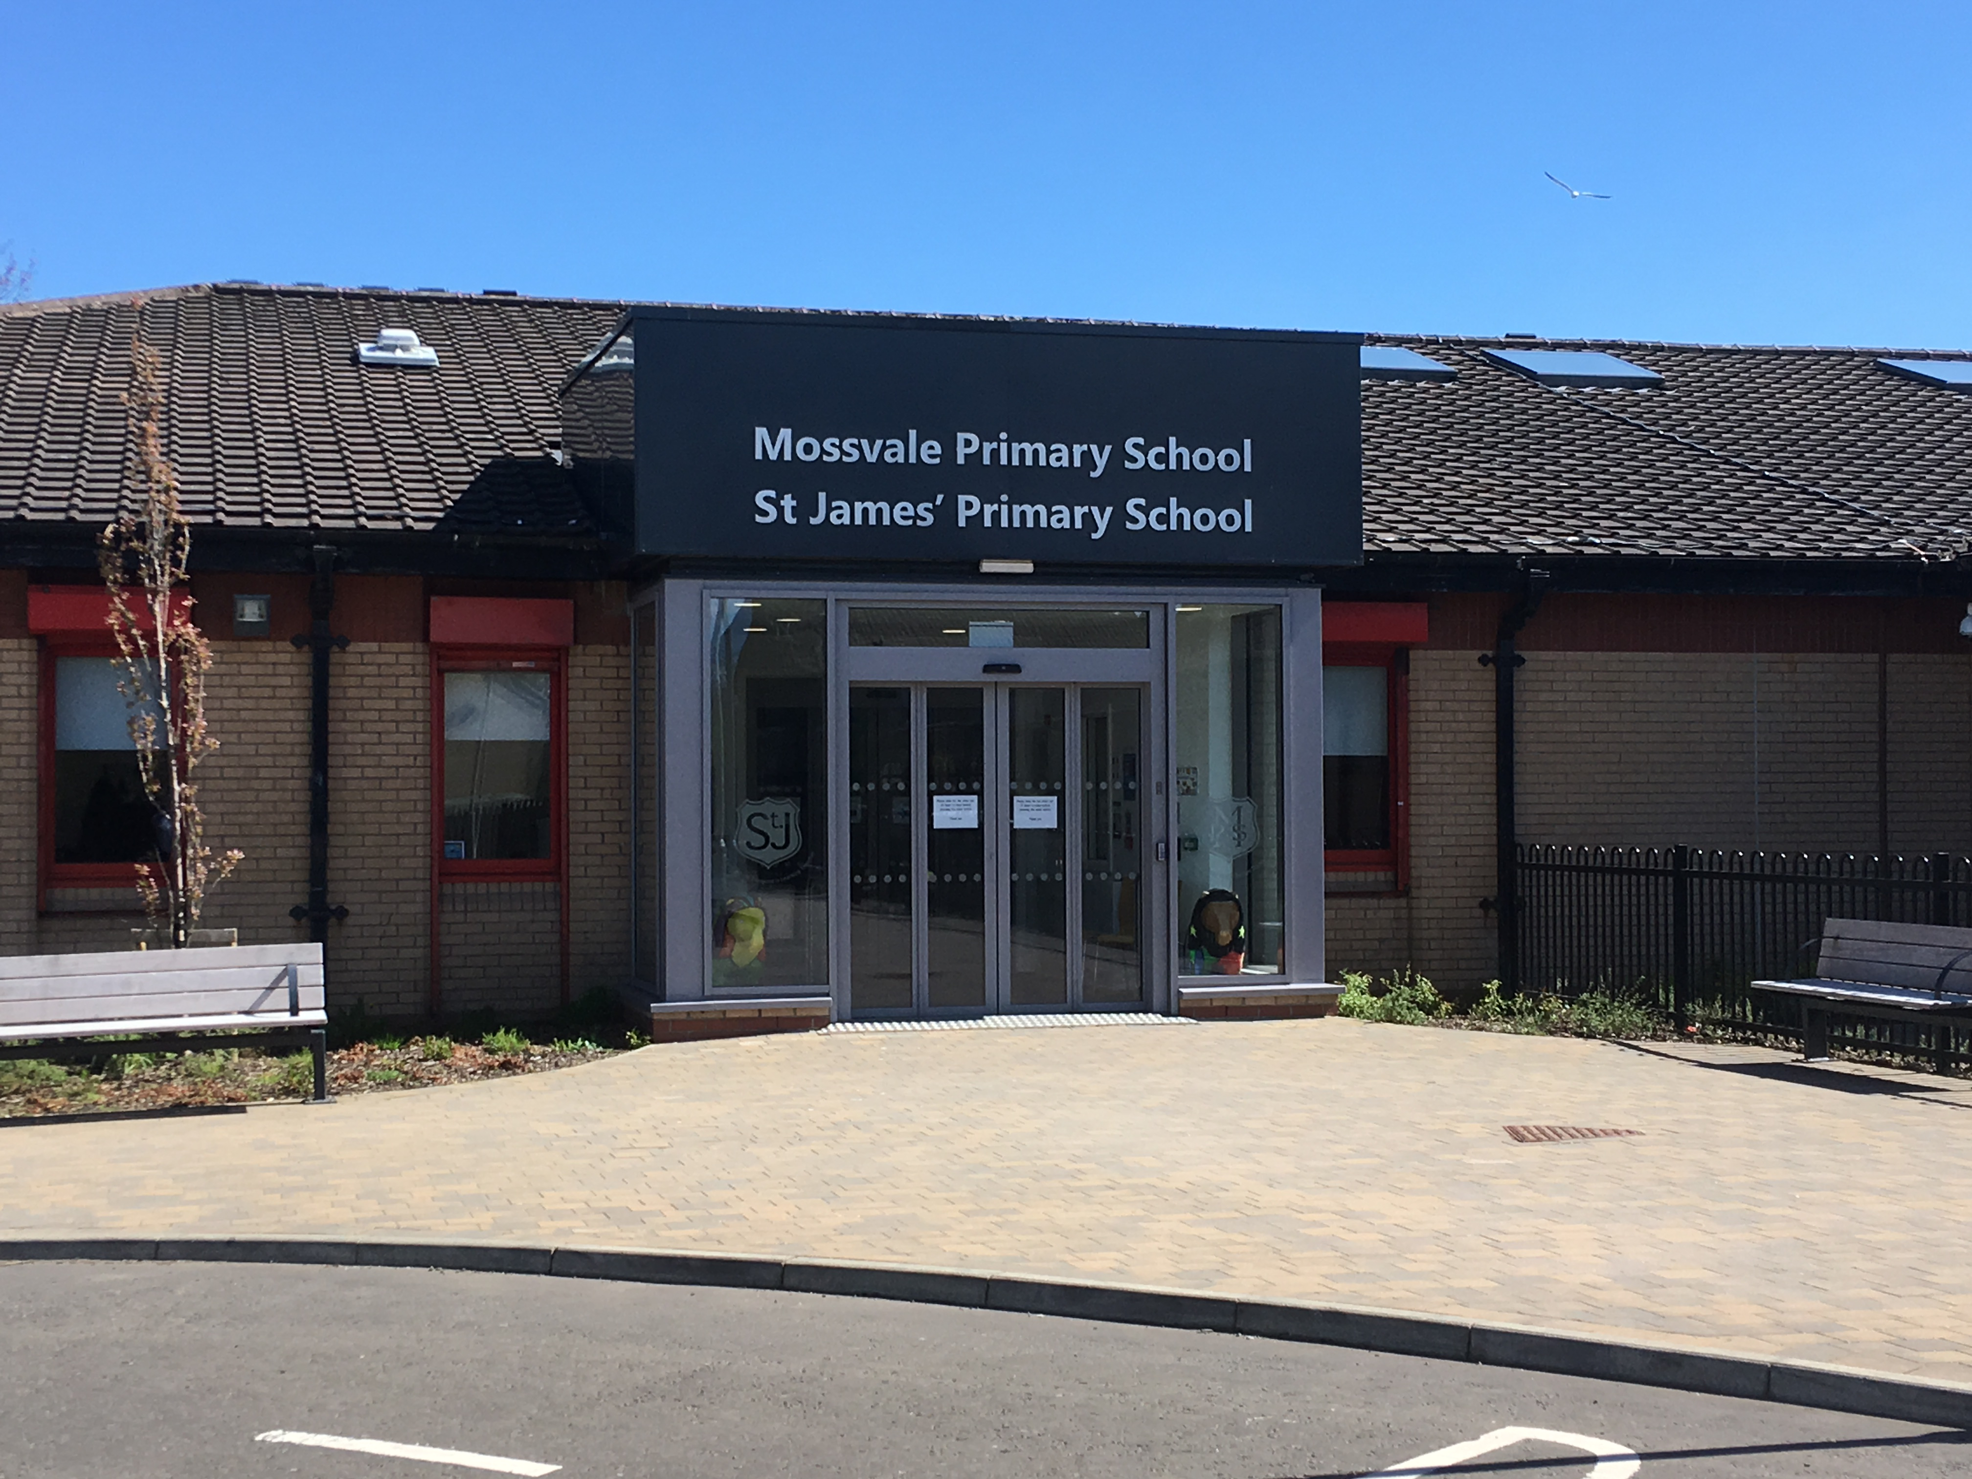

OUR SCHOOL

**Mossvale Primary School & Nursery Class** is a non – denominational school located in Shortroods, Paisley. Our School has a school roll of 175 pupils and also houses a nursery which provides support to up to 50 children including some with recognised additional support needs to 33 pupils each morning and afternoon. Our nursery also supports some children with additional support needs. Our school is unique in that we share the campus with St. James’ Primary School and we were the first joint campus in the UK when we opened as such in 1992. Our school has built positive links with the local community and agencies over the years to provide a nurturing environment for our pupils so that they can maximise their learning.

MAIN SUCCESSES AND ACHIEVEMENTS 2018-2019

* **All parents and carers** have had opportunities to **share learning** with pupils across all stages by attending open days throughout the year which have been received very positively.
* The school employed a **Key Worker** and **Nursery Officer** this session, using our Pupil Equity Fund, which has resulted in providing support for many children to develop their academic skills as well as emotional support and practical support to children and parents.
* Most teachers have undertaken training to develop **writing** across the school which will provide a consistent approach to teaching writing.
* Pupils are experiencing more **Outdoor Learning** activities and this will be explored further next session.
* ICT resources such as **IDL** and **Clicker 7** are now being used to develop pupils’ spelling and writing skills.
* For The second year, **House Events** organised by teachers and pupils have resulted in more wonderful experiences for our pupils - Talent Show, Children In Need Day, Comic Relief Day & Outdoor Learning Focus Day.
* Parental involvement in the nursery has increased through, e.g. , cooking sessions

OUR VISION, VALUES AND AIMS

Vision All children to be the best they can be!

Values **P**ositivity **R**espect **I**ntegrity **D**etermination **E**quality

Take **PRIDE** in ourselves, our school and our community

Aims To provide a positive and caring environment where everyone follows our values and are encouraged to do their best.

To give children, parents and staff a strong voice which is always valued.

To achieve the best outcomes for pupils and equip them with skills required to lead an active, healthy lifestyle with positive relationships.

To actively involve children in their learning, encourage ambition and celebrate their achievements.

**HOW SUCCESSFUL HAVE WE BEEN IN IMPROVING OUR SCHOOL?**

**School Leadership**

* All teachers and some nursery staff have been trained using **Video Interactive Guidance (VIG)** which has improved relationships with targeted pupils.
* All teaching staff have undertaken training to develop the use of **IDL** and **Clicker 7** to develop spelling and writing skills for all stages.
* All staff have participated in Teacher Learning Community (TLC) sessions to share effective practice in using ICT and numeracy resources.
* As last year, all teachers have continued to lead a range of **House** **Events** for the whole school which has resulted in all pupils being involved in relevant and motivational experiences.
* School now integral part of LISN group which meets to discuss supports for pupils.

**Staff Professionalism**

* All staff have participated in a variety of training sessions in and out of school to develop **literacy, numeracy**, **cooperative learning** and **relationships** **(VIG)** across the school.
* All teachers have continued to engage very effectively with the new **benchmarks** for all curricular areas in their **day to day planning** and **Pupil Learning Plans** which help to assess pupils’ progress, especially in the area of literacy (reading, writing, talking and listening).
* Senior Nursery Officers are now delivering outreach support to other nurseries across the authority

**Parental Engagement**

* Almost all parents and carers have made very positive comments when attending **open days** across the school and nursery class to share their child’s learning.
* A minority of parents attended an **Anti-Bullying** workshop to help create a new policy to support pupils, parents and staff.
* **Annual questionnaire** returns clearly indicate that parents and carers recognise many strengths of the school and few steps for improvement.
* Our **Parent Council** organise events such as Bingo Nights and Family Movie nights which help create a community feel in the school.

**Assessment of Children’s Progress**

* **Regular Tracking** **meetings** throughout session 2018 - 2019 involved all teaching staff in discussing the progress of pupils. Supports were put in place to help specific pupils progress with their learning, such as ICT resources or more teacher support. Pupils’ progress in literacy is tracked using our **Pupil Learning Plans** which involve tracking the new standards called **benchmarks.** Pupils consistently receive **feedback** across literacy and numeracy to help them with their learning. Staff provided parents and carers an annual report on progress which were well received.
* All teachers have been involved in cluster moderation of assessment in **writing** to help share their understanding of appropriate activities to assess children’s progress. They are becoming more confident in making professional judgements about children’s progress in writing.

**School Improvement**

* All of the teaching staff and some nursery staff undertook **VIG** training which promoted the importance of interacting positively with pupils. The whole process encouraged staff to work well as a team which has enhanced our positive and caring ethos across our establishment.
* **ICT** is being more effectively to improve spelling and writing across the school.

**Performance Information**

* The school has provided **planned, regular** and **targeted support** for identified pupils through additional staffing and regularly and rigorously **tracked the progress and attainment** of all pupils at all stages. Attainment has improved over the past three years in many areas e.g. In June 2019 72% of P7 pupils were secure at second level in writing which is an increase of 9% from June 2018. This exceeds similar schools attainment level and almost matches Renfrewshire’s average of 75%.

**KEY STRENGTHS OF THE SCHOOL**

Many parents and pupils completed an annual questionnaire in **April 2019** and highlighted strengths of the school.

* Welcoming environment
* Motivated teaching staff
* Great teachers
* Friendly and inclusive school
* Care attitude of staff and being approachable
* Children are stretched by teachers to reach their potential
* Wide opportunities provided for pupils
* Clear communication
* Problems solved easily and quickly
* Parent Council

**OUR NEXT STEPS – PRIORITIES FOR 2019-20**

We believe that we have made **good** progress during session 2018-19 and we will use the improvement priorities listed below to build on this progress moving forward.

* Introduce a **new reporting format** for parents and carers which clearly identifies **targets** for pupils (literacy, numeracy and health and wellbeing) and next steps in learning.
* Implement some themes in **Renfrewshire Nurturing Relationship Approach** to help all children learn and develop socially and emotionally.
* Further develop **Cooperative Learning** in classes to promote social skills.
* Develop **reading strategies** and **review reading resources** across the school to improve attainment.
* Introduce **“Take Your Marks”** to promote physical activity in the classroom to motivate pupils to learn.
* Implement use of “Numeracy Boards” to develop further **mental maths skills**.
* Review **music** to ensure consistency of experiences across all stages.
* Liaise with St. James’ Primary School to organise sustainable and consistent **joint campus events** throughout the year.
* Improve delivery of ECO & Enterprise activities in the nursery

Full details of the school’s improvement priorities and actions are detailed in the school improvement plan which can be accessed on our website or by contacting the school office.

**School Name Mossvale Primary**

**School & Nursery Class**

**School Address 3/5 Gockston Road,**

**Paisley, PA3 2QB**

**Phone 0300 300 1449**

HAVE YOUR SAY!

Please take the opportunity to share your thoughts with us as we use feedback to help us make improvements to the school. You can do this by speaking to staff, participating in Parent Council meetings, responding to questionnaires/surveys and by completing evaluations at school events. Thank you.