
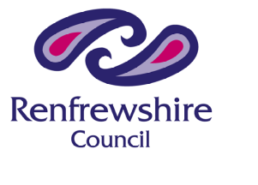

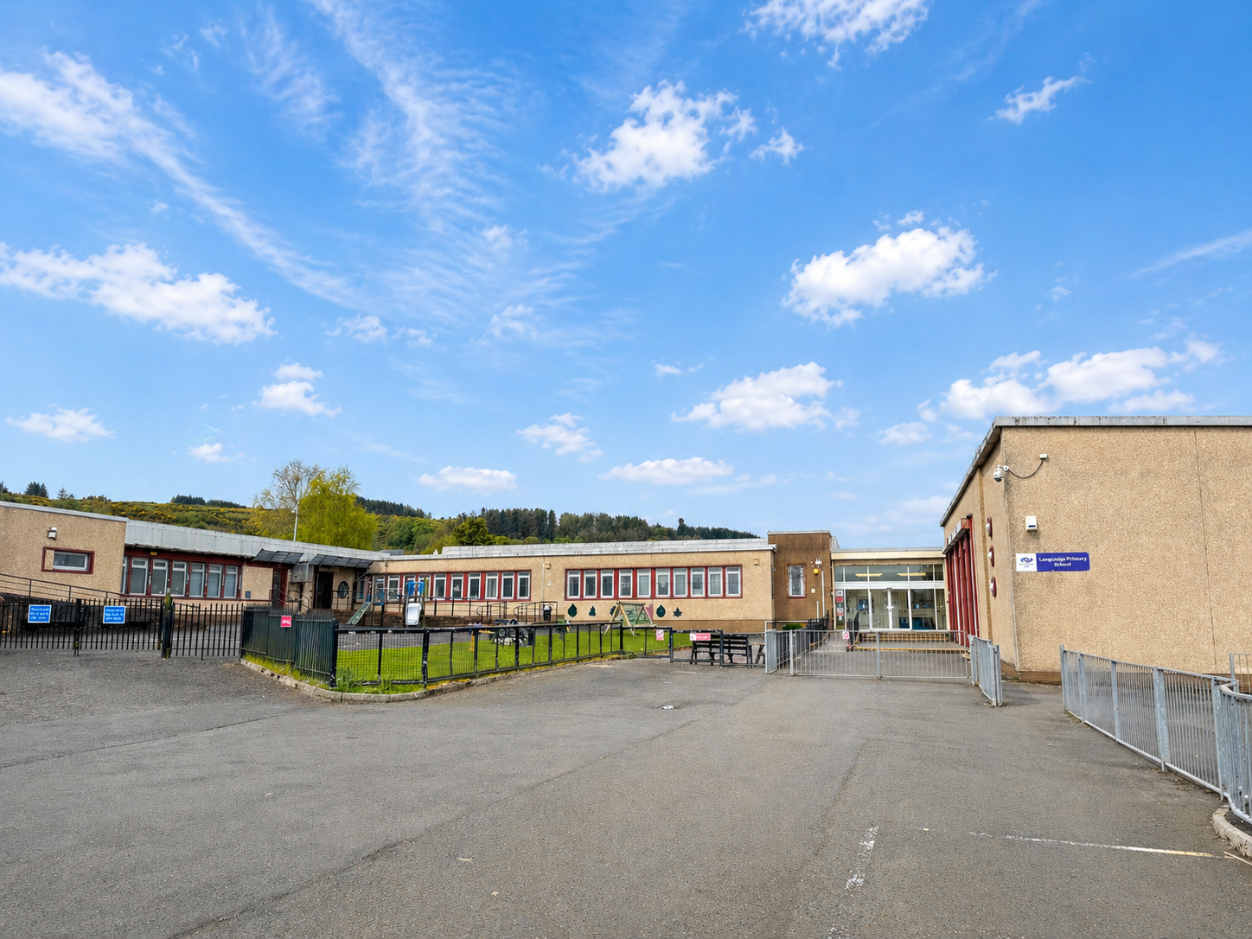

Langcraigs Primary School

STANDARDS AND QUALITY REPORT
June 2026

This report will inform you of the school’s progress and achievements in the last session and let you know about our plans for 2026-2027. I hope that you find it helpful and informative.

Lisa Robertson

Head Teacher

Our School

Langcraigs Primary School was built in 1956 and serves the south area of upper Glenburn in Paisley. We are housed in a solid traditional building and the school has good accommodation and is well resourced to meet the demands of delivering the curriculum.

Langcraigs is a non-denominational school catering for children between 4 and 12 years of age, in Primary 1 to Primary 7. The school roll is currently 266 pupils and we have 11 classes. 69% of our pupils live in Deciles 1 - 2. The school enjoys a positive standing in the local community.

Langcraigs is one of the primary schools associated with Gleniffer High School. We have strong links and work closely with our cluster schools. Most of our children start their education in Glenfield ELCC and we have links with many more early years establishments. We have strong links with our local library and makes good use of the facilities in Paisley and the surrounding area. We also make good use of the Gleniffer Braes, which are on our doorstep, and our local parks.
We aim to deliver a broad, balanced and engaging curriculum which, through careful planning and development of learning and teaching methods, offers all our pupils the opportunity to achieve their potential. By promoting caring, tolerant and respectful attitudes towards others, we hope that our pupils will take their place as responsible citizens within society.

Our Vision
To provide all our pupils with a range of experiences, which will equip them with the skills and knowledge required to meet the challenges they will face throughout their lives.

Our Values
Respect Effort Ambition Caring Honesty

Our Aims
We aim to provide a broad spectrum of educational opportunities for all pupils by:
- Promote a positive ethos which reflects our five core values.
- Encourage and enable all our pupils to be Successful Learners, Confident Individuals, Responsible Citizens and Effective Contributors.
- Provide a broad, relevant, coherent and progressive curriculum, which offers our pupils challenge, choice and enjoyment.
- Provide a range of teaching and learning approaches, which take account of individual needs.
- Provide equal opportunities for all our pupils.
- Promote healthy lifestyles.
- Provide appropriate resources, which support learning and teaching.
- Provide our community with a welcoming, efficient and effective school.

Successes and Achievements
August
- All staff took part in the mandatory annual Safeguarding update.
- Our new Primary 1 cohort started, and their Big Buddies helped them to settle in.
- We had a whole-school focus on Children’s Rights and GIRFEC, with each class creating a Class Charter and learning about the Wellbeing Indicators.
- Class Dojo was introduced to improve communication with families, and Wider Achievement Wednesday was established, where children’s successes are shared with the whole school community.
- Our new Parent Council was established, with monthly meetings organised.
- Almost all of our parents linked with their child’s Class Dojo account, where they can see Class Stories, giving them a snapshot of their child’s time in school.
- The Community Club for P1–P3 launched with this session’s theme, ‘Growth’. Pupils took part in a range of activities to improve and enjoy our school grounds.
- We welcomed back our reading volunteers from St George’s Church, who visit to support reading throughout the school.
- We are a Silver UNCRC-accredited school, and this month we began looking at an ‘Article of the Week’ at assembly. These are also shared with our families via Dojo.
- Free Active Schools clubs started again, with football and netball on offer for P4–P7.
- Our school choir restarted, meeting at lunchtime on a Thursday.
- We were delighted to continue our partnership with St Mirren Football Club, with a free home game family season ticket made available via a ballot.

September
- This year, we brought together Climate Action Week and Maths Week Scotland into one action-packed celebration of learning, exploration and fun — all with an environmental twist.
- We received a commendation for our work on Learning for Sustainability as part of our Eco Flag submission.
- A brass instructor began working with some pupils from the upper school.
- We received Ruby accreditation for Renfrewshire’s Nurturing Relationships Approach (RNRA) for demonstrating a strong commitment to developing nurturing approaches across our school community.
- Pets as Therapy, a charity that brings specially trained therapy dogs into schools to help children build confidence and improve reading skills in a calm, friendly and non-judgemental environment, started visits to the school.

October
- Following a recruitment process, we were delighted to appoint five P7 Prefects.
- The school football team played in their first tournament.
- The Pupil Council was re-established, with representatives elected from our P4 – P7 classes.
- The Young Leaders of Learning team met with children from Bushes Primary, getting to know each other, sharing ideas and exploring the similarities and differences between our schools.
- Termly class visits to Glenburn Library began.
- We welcomed our parents and carers into the school for Pupil Progress Meetings.
- The Pupil Council organised a Halloween Costume Swap and a Halloween Fun Day.
- Our Parent Council held Halloween discos for our children.
- We took part in the Be Bright Be Green active travel challenge.
- Bikeability Level 2 training sessions took place for P6.
- Digital Leaders were re-established, and they selected monthly themes to deliver at assembly.
- Beat Buddies Music began working with our P3–P5 children every Monday.
November
- Prefects canvassed the school community to create a school charter for our Rights Respecting School journey.
- Our lunchtime Play Pals club for P1 began, led by P6.
- Primary 1 received Bookbug Bags, and Primary 2 and 3 were gifted Read, Write, Count packs as part of Book Week Scotland.
- During Book Week Scotland, the whole school enjoyed a wonderful variety of activities.
- Primary 6 pupils visited Glenfield Nursery to share stories with the younger children.
- A Christmas Fayre was held to raise money for our School Fund
- P6 attended a series of swimming lessons at the Lagoon.
- P6 led a poignant assembly on World War 2.
- Staff received training from a nurse from the diabetic team.

December
- M&M Productions performed Snow White for the whole school.
- Our Nativity performance was enjoyed by the school community and parents.
- All classes enjoyed Christmas celebrations with dancing, games and party food.
- Children enjoyed eating a Christmas lunch together.
- Our school choir visited the residents of Hillside View Care Home.
- We held our annual Advent Assembly, alongside our local Minister, Hazel Shaw.
- We celebrated Computer Science Education Week.
- Our P3–P5 children showcased their learning with Beat Buddies.
- We held our annual Values Raffle.

January
- Children wore tartan to school and celebrated we Burns Day with a Scottish performance from every class.
- Classes across the school took part in the RSPB Big Garden Birdwatch.
- During National Storytelling Week, the whole school explored the picture book Quest.
- In partnership with the RAF Charitable Trust, P6/7 and P7 took part in a live online STEM event.
- Our UNCRC Steering Committee spoke about National Holocaust Day at assembly.

February
- We began our Citizenship activities, where children explored themes such as Eco-Schools, UNCRC, Coding and Nurture.
- The Parent Council hosted their annual Valentine’s discos.
- Safer Internet Month kicked off with summarised Cyber Resilience Toolkits being shared with the school community.
- A Child-Friendly Digital Wellbeing Policy, designed by children for children, was introduced.
- Some of our children celebrated World Thinking Day by wearing their club uniforms to school.

March
- Move More This March challenged primary school and nursery children and their families to be more active.
- Our school was awarded the Core Reading Schools Award.
- Our Primary 7 pupils visited Gleniffer High School to take part in a sports transition event.
- We dressed up in our pyjamas for World Book Day and shared some of our favourite stories.
- Five of our talented pupils achieved success in Renfrewshire’s Inspired Art Competition, with only 100 winning entries chosen from hundreds of submissions.
- The winners of the Cyber Safety Mascot designs were announced. Cyber Safe Craig and I-Bote help everyone at Langcraigs be cyber resilient and internet safe.
- P4, P4/5 and P5 pupils proudly presented their Extreme Earth assembly.
- Bushes Young Leaders of Learning visited, with the children sharing ideas for school improvement and development.
- P1 and P1/2 worked alongside P4/5 and P6 to create Pocket Gardens behind the P1 classrooms.
- P6/7 and P7 visited Glasgow Science Centre for a BodyWorks – The Vitals workshop.
- P6/7 were invited to visit Glasgow School of Art to participate in a Craft and Textiles workshop with the Royal Society of Edinburgh.
- During National Smile Month, Childsmile visited the school, and P4 took part in the National Smile Month Oral Health Creativity Competition.
- The Eco-Committee launched an exciting new initiative in partnership with our school meals service - The Clean Plate Club.
- Pupil Progress Reports were issued to parents and carers.
- The P6 cohort attended the ‘Easter Code’ workshop at St George’s Church.

April
- LPSHub, a uniform shop, was launched. This is a free service using donated uniform items.
- We held our Easter Assembly with input from our brass instrumentalists, our minister, and the school choir.
- Fèis Phàislig visited the school and performed for our children, encouraging them to get involved in the traditional arts and Gaelic culture.
- Our new primary 1 children for next session started their weekly visits to Langcraigs.
- Members of our school community took part in the Kiltwalk, raising over £1800 for Diabetes UK.

May
- Primary 6 visited St Mirren Park and took part in the Safe Kids event, learning how to keep themselves safe.
- Children in Primaries 1, 4 and 7 sat Scottish National Standardised Assessments (NSAs) in Literacy and Numeracy.
- Children in Primaries 3–7 completed Literacy and Numeracy assessments from the GL Assessment Suite.
- Parents were surveyed for their opinions on how the Pupil Equity Fund should be spent.
- We invited our new P1 intake for a visit to meet their buddies and one of the class teachers.
- Primary 7 children visited Gleniffer High School as part of our transition programme.
- Bikeability Level 1 lessons began for all Primary 5 children.
- The Parent Council held a car boot sale in the school grounds – a fantastic community event!
- During Health Week, children and parents enjoyed a fun evening taking part in a wide range of experiences, and we raised over £1700 through our Sponsored Walk through the Braes.
- Our P7 children enjoyed a residential trip to Ardentinny.

June
- We received the Digital Wellbeing Award and the Equitable Creative Coding Award for our dedication to being a digital school.
- The Parent Council hosted our summer discos, and we piloted an accessible disco for children who struggle with crowds or noise.

- Primary 7 danced the night away at their ceilidh.
- We all enjoyed a whole-school trip to Five Sisters Zoo.
- Primary 7 presented an emotional leavers’ assembly.
- Citizenship Awards were presented to two children who have gone above and beyond in demonstrating our school values throughout their time at Langcraigs Primary.
- Primary 7 Sports Champion winners were announced and received trophies.
- Children met their new teacher and visited their new classroom during a ‘Meet the Teacher’ event.
- The choir performed some pieces from Annie, the musical, to the whole school and to their parents.
How successful have we been in improving our school?

Session 2025/26

Improvement Priority 1 – To enhance self-evaluation and school improvement activities by further involving learners in the process.
- Mrs Mullen (Principal Teacher), along with Mrs McLeod (Principal Teacher) from Bushes Primary School, successfully established Young Learners of Leadership (YLL) groups, providing pupils with meaningful opportunities to contribute to self-evaluation and school improvement.
- Training equipped YLs with the skills and confidence to represent the views of others effectively, provide constructive feedback and engage responsibly in improvement activities.
- The collaborative sessions between Langcraigs and Bushes fostered positive relationships and established a shared sense of purpose amongst our YLs. Through professional dialogue and discussion of the programme aims, they developed greater confidence in sharing ideas and working collaboratively.
- Through reviewing and discussing UNCRC Articles, our YLs developed a deeper understanding of children’s rights, particularly the right to express views and be heard.
- Reciprocal school visits provided valuable opportunities for our YLs to engage in evaluative discussions about health and wellbeing within both settings. Pupils were able to confidently identify strengths and areas for development.
- Through completing self-evaluation activities linked to Theme 4: Health and Wellbeing from How Good is OUR School?, our YLs played an active role in evaluating the school’s approaches to wellbeing. Pupils engaged thoughtfully in professional dialogue, sharing honest reflections on their experiences and identifying strengths and areas for improvement.
- The action planning process empowered pupils to influence future school improvement priorities, ensuring that pupil voice played a meaningful role in shaping improvement planning for session 2026–2027.

Improvement Priority 2 – Reducing inequalities and delivering improved outcomes for children.
- The introduction of ‘Article of the Week’ supported a more consistent whole-school approach to children’s rights education. Linking weekly assemblies to rights-based themes and global events helped pupils develop a deeper understanding of equality, fairness and respect, contributing to a more inclusive and rights-respecting school culture.
- Sharing our Article of the Week with families strengthened home–school partnerships and extended children’s rights learning beyond the classroom, encouraging meaningful conversations at home around fairness, respect and inclusion.
- By embedding children’s rights across curricular learning experiences, staff created meaningful opportunities for pupils to explore concepts such as equity, dignity and inclusion within real-life contexts. Pupils demonstrate an increased awareness of their rights and responsibilities.
- Senior leaders successfully linked rights-based learning to the school vision, values and motto, strengthening pupils’ understanding of how these underpin daily school life.
- Opportunities to explore and celebrate diversity throughout the school year broadened pupils’ understanding of the lived experiences of children locally and globally. promoting respect and inclusion.
- The increased visibility of children’s rights displays across the school environment reinforces an understanding of where and how rights are being upheld in everyday school life. High-profile displays support ongoing dialogue around rights, encouraging children to recognise themselves as valued members of a rights-respecting community.
- Termly assemblies led by our UNCRC Pupil Steering Group provided meaningful leadership opportunities and strengthened pupil voice across the school. Pupils developed confidence in presenting and promoting key rights-based messages.
- Regular reference to Class Charters and the Article of the Week embedded rights-respecting language within classroom practice and daily interactions. This consistency supported positive relationships, improved understanding of mutual respect and helped create an inclusive learning environment.
- Initiatives such as Playground Pals and Community Club promote inclusion, friendship and pupil leadership across the school. By selecting activities linked to specific rights, pupils developed a greater understanding of empathy, kindness and responsibility, contributing to a nurturing ethos.
- The school effectively used next steps from the Silver Rights Respecting Schools Award accreditation process to further strengthen rights-based practice. This ongoing reflective approach supported continuous improvement in promoting equity, inclusion and pupil participation, contributing to improved outcomes and experiences for children across the school. We are looking forward to our Gold accreditation visit in August.

Improvement Priority 3 – To provide high quality learning for all.
- The introduction of The Renfrewshire Way has strengthened staff understanding of high-quality learning and teaching through increased engagement with professional reading, CLPL opportunities and collegiate dialogue.
- Through collaborative self-evaluation of Q.I. 2.3 Learning, Teaching and Assessment, alongside observed lesson feedback, staff developed a stronger shared understanding of high-quality learning and teaching. Learning conversations with pupils provided valuable insight into classroom experiences, the learning environment and approaches that support engagement and progress. This evidence directly informed next steps for improvement.
- The review and adaptation of our Learning, Teaching and Assessment Policy enabled staff to reflect critically on current practice and align approaches more closely with HGIOS 4. The revised policy is now reflective of the needs and views of the whole school community.
- As part of the school’s ongoing commitment to children’s rights, pupils were meaningfully involved in shaping the revised Learning, Teaching and Assessment Policy. Learners felt listened to and valued, strengthening pupil voice and promoting a culture where children are recognised as active partners in school improvement.
- The exploration and introduction of assistive technologies, including Read and Write software, has helped to reduce barriers to learning for targeted pupils. Staff confidence in using digital supports increased, leading to improved accessibility, greater learner independence and enhanced participation for children requiring additional support. As such, we were accredited with the Digital Wellbeing Award in June!
- The introduction of Class Dojo has strengthened communication and engagement between home and school by providing regular opportunities to share learning experiences and celebrate success. Increased parental engagement has improved our partnerships with families.
- The continued celebration of success across the school, including the introduction of Wider Achievement Wednesdays, has raised the profile of pupil achievements both within and beyond the classroom. This has contributed to improved pupil confidence, motivation and sense of belonging, while reinforcing the value of recognising the wider talents, skills and contributions of our learners.
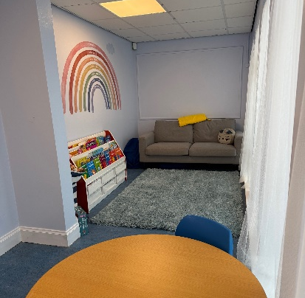

Pupil Equity Funding
The school used a robust range of self-evaluation evidence, including attainment and attendance data, wider achievement tracking, stakeholder questionnaires and pupil voice activities, to identify barriers to learning and inform the strategic use of Poverty Equity Funding (PEF). Analysis highlighted significant attainment gaps in writing and numeracy between the 30% most deprived and 70% least deprived pupils, particularly at Primary 3–5.
Children, families and staff contributed to identifying PEF priorities through questionnaires, pupil groups and professional dialogue, ensuring interventions were responsive to the needs of targeted learners. PEF funding supported 0.86 FTE surplus teaching staff and a 1.0 FTE classroom assistant to deliver targeted interventions in literacy and numeracy for identified pupils within SIMD 1–3. Resources including IDL, Toe-by-Toe, Sumdog and Reading Eggs provided personalised support and contributed to improved engagement, confidence and attainment for most targeted learners.
PEF funding also supported targeted wellbeing and attendance interventions. Breakfast Club provision, managed by PEF-funded support staff, provided a nurturing start to the school day, with the purpose of encouraging and improving attendance amongst identified pupils. Unfortunately, this venture was unsuccessful this session and we didn’t meet our target, despite adjustments across the session.
The impact of interventions was monitored through attainment, attendance and wider achievement tracking. Most identified pupils demonstrated progress in learning, increased independence and improved participation in class. PEF also supported wider achievement opportunities through partnership working with Active Schools and the introduction of Wider Achievement Wednesdays, resulting in increased participation, confidence and sense of belonging for targeted pupils. The impact of this is that 89% of our pupils took part in a wider achievement activity this session.
Overall, PEF has had a positive impact on reducing barriers to learning, improving engagement and narrowing aspects of the poverty-related attainment gap.
June 2026 - Achievement of Curriculum for Excellence Levels (ACEL)
Curricular area | P1 | P4 | P7
Listening and Talking | 94% | 92% | 98%
Reading | 77% | 89% | 86%
Writing | 77% | 62% | 73%
Numeracy | 81% | 84% | 73%
 | Listening & Talking |  | Reading |  | Writing |  | Numeracy
 | June 25 | June 26 | June 25 | June 26 | June 25 | June 26 | June 25 | June 26
P2 | 22% | 7% | -6% | -13% | -12% | -23% | 10% | -23%
P3 | 9% | -4% | 26% | 18% | 26% | 15% | 17% | 19%
P4 | 6% | 10% | -7% | 6% | -16% | -13% | -7% | -2%
P5 | 3% | -1% | 1% | 5% | 9% | 9% | 5% | 1%
P6 | 4% | 4% | -8% | -9% | -5% | -10% | -12% | -2%
P7 | 10% | -3% | -13% | -2% | -19% | -19% | -6% | -4%

Attainment Gaps
The table below shows that we have narrowed the gap between those living in the 70% least deprived areas and those living in the 30% most deprived areas in the majority of areas.

Key Strengths of the School

- Our clear and shared vision and values, which are embedded across all aspects of school life and underpin positive relationships and learning experiences.
- The welcoming and respectful ethos which promotes inclusion, diversity and a strong sense of belonging for all members of the school community.
- The caring and supportive environment which enables children to develop confidence, resilience and positive relationships.
- The strong culture of teamwork and collaboration across the school, with staff committed to continuous improvement and achieving the best possible outcomes for all learners.
- The meaningful opportunities for pupil leadership, enabling children to contribute confidently to school improvement and decision-making.
- Our nurturing, inclusive approach, which supports children’s wellbeing and ensures that all learners feel safe, respected and valued.
- The school’s commitment to children’s rights and the development of a rights-respecting ethos across all aspects of school life.
- The effective use of self-evaluation and reflective practice to inform improvement priorities and enhance learning and teaching.
- The positive partnerships with parents, carers and the wider community, which support children’s learning and wellbeing.
- The wide range of opportunities for wider achievement, helping children develop confidence, skills for life and a sense of success.
- The creative and engaging learning opportunities which encourage curiosity, independence and learner motivation.
- The high quality of support provided for children with additional support needs, helping to reduce barriers to learning and promote equity.
- The increasing use of digital technologies to enhance learning, accessibility and pupil engagement.
- The strong focus on celebrating achievement and recognising success both within and beyond the classroom.
- The commitment of staff to professional learning and collegiate working, leading to increasingly consistent approaches to learning and teaching.
- The effective transition arrangements which support children and families at key stages of learning.
- The school’s proactive approach to promoting equality, fairness and inclusion for all learners.

Some comments from our annual parental questionnaire
‘Fantastic school! My daughter is thriving and that is thanks to the wonderful work all of the staff do. Thank you!’
‘Langcraigs has always been great at supporting school discos, sports day, day trips and getting involved in the community.’

Some comments from our pupils
‘Our school is amazing!’
‘I like the way we do Health Week.’
‘Everything is quite fun and quite normal. I give our school a 9.4 out of 10.’

Our Next Steps – Priorities for 2026-27

We have made very good progress during session 2025-26 and we will use the improvement priorities listed below to build on this progress moving forward.

- Use our Pupil Equity Fund (PEF) to improve attendance and reduce persistent absence across the school to maximise learning opportunities and improve outcomes for all learners. Improving attendance will contribute directly to raising attainment, reducing inequity and ensuring all learners have equitable access to high-quality learning experiences. Through robust monitoring, early intervention and partnership working with families and agencies, we aim to increase attendance rates, reduce persistent absence and improve outcomes for all learners.

- To raise attainment in Literacy with a priority focus on writing. Attainment data demonstrates an ongoing need to raise attainment and narrow the poverty-related attainment gap, specifically in relation to writing. Evaluation of the data collected within our whole school tracker has identified writing as a main area for improvement in Primaries 3, 4 and 5.

- To enhance school self-evaluation and improvement by further involving learners in the Young Leaders of Learning Programme, (Year 3 of priority). In 2025/2026, the YLL focus aligned with Theme 4. Through reciprocal visits and self-evaluation activities, pupils identified the playground as a key area for further development. Feedback highlighted a desire to improve opportunities for positive play, inclusion and social interaction during break times. In response, the YLL team initiated the PATHS Playground Buddies programme, with Primary 6 pupils taking a leadership role in planning and delivering activities. This initiative aims to strengthen relationships, support emotional wellbeing, encourage inclusive play and provide meaningful leadership opportunities for older pupils.

- To develop Racial Literacy and Anti-Racist Practice. By developing racial literacy and embedding anti-racist approaches across the school, we aim to strengthen pupils' understanding of equality, foster a greater sense of belonging for all learners and ensure that our curriculum reflects the diverse world in which our children live.
HAVE YOUR SAY!
Please take the opportunity to share your thoughts with us as we use feedback to help us make improvements to the school. You can do this by speaking to staff, participating in Parent Council meetings, responding to questionnaires/surveys and by completing evaluations at, or after, school events.

Langcraigs Primary School
Glenfield Road
Paisley
PA2 8QE
Tel. 0300 300 0166
Email:
langcraigsenquiries@renfrewshire.gov.uk
Website: https://blogs.glowscotland.org.uk/re/langcraigs

Full details of the school’s improvement priorities and actions are detailed on the school improvement plan which can be accessed on our website or by contacting the school office.

