|  |
| --- |
| Langbank Primary School |

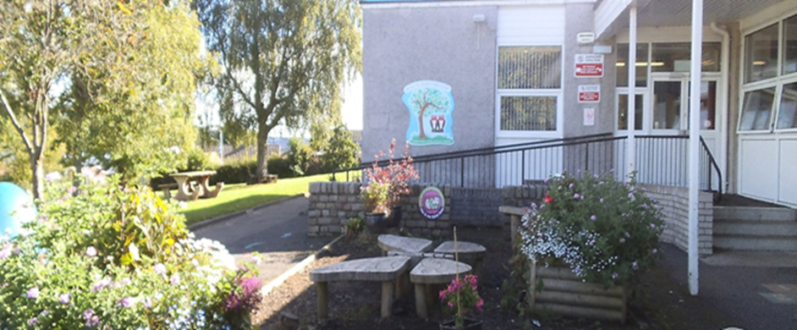  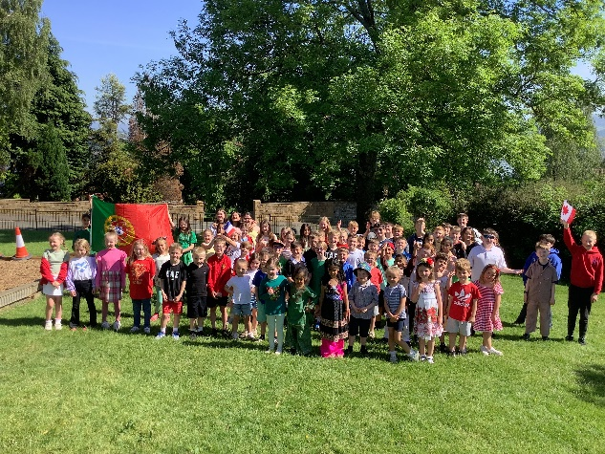

|  |
| --- |
| STANDARDS AND QUALITY REPORT  June 2025  This report will inform you of the school’s progress and achievements in the last session and let you know about our plans for 2025-26. I hope that you find it helpful and informative.  Patricia Lawson  Head Teacher |

|  |
| --- |
| OUR SCHOOL  Langbank Primary School is a non-denominational co–educational rural school which serves the village of Langbank. The current role is 72 and is organised over 4 classes. The leadership team consists of the Head Teacher and Principal Teacher.  The school has a main building and an annexe which has two classrooms. The annexe is connected to the school and is accessed by walking under the canopy. The school grounds have a trim trail, outdoor classroom, outdoor reading area, quiet area for use during playtimes and lunchtimes and a school garden. The school make use of the village field for other outdoor activities as well as the Community Muga and Village Hall.  Langbank Primary provides a warm supportive environment where children are encouraged and supported to achieve their best both in school and the wider community. The school enjoys an excellent reputation in the community and has an active and supportive Parent Partnership. |
| **OUR VISION, VALUES AND AIMS**  **Our School Community Vision**  “At Langbank Primary School we learn together, play together and succeed together”  **Our School Values**  Kindness Confidence Commitment Achievement  **School Aims**  At Langbank Primary we aim to know each individual and nurture the development of the whole child.  For our Children to be:  At the heart of the school, with their voices heard and valued.  Safe, happy and confident in being themselves.  Respectful, kind, committed learners who are motivated to grow and achieve.  For our staff to be:  Nurturing and supportive of all children.  Kind and sensitive to the needs of our children and families.  Committed to our learning community and motivated with high expectations and standards.  Respected and valued by our whole school community.  For our families to be:  Welcomed, respected and supported.  Fully engaged in their child’s learning journey and involved in key decisions.  Important partners of the school, providing skills and experiences to enrich learning events.  For our school environment to be:  Safe and welcoming with an inclusive ethos which promotes strong positive  relationships that inspire a love of learning. |
| SUCCESSES AND ACHIEVEMENTS   * Our new school vison, values and aims have been embedded this academic year across the school community and local community. Children can confidently talk about these and can explain why they are important for our school community. The Pupils have designed symbols to represent each school value using their digital skills. These will be revealed in August 2025. * Relationship policy created and launched by Mrs Coleman at our Parent Progress Meeting * Whole School trip to Calderglen Country Park and Zoo in June. * Visitors were welcomed into our school to enhance learning and teaching. * Improving approaches to supporting learners needs through ‘Children’s Learning is Understood Developmentally’ through development of Renfrewshire’s Nurturing Relationship Approaches. * Received Jade accreditation for our Nurture journey and celebrated together. * Digital Xtra Project funding - £4700. Staff training and creating ‘Sphero Indi’ after school clubs. This was fully subscribed across the school with further opportunities provided at lunch time. * Whole school celebrations: Cultural Diversity Day, Maths week Scotland, Book Week Scotland, Dyslexia Awareness Week, Internet Safety, Sports Day, Jade accreditation for our RNRA Journey,   Leavers Celebrations, Burns Afternoon and Christmas shows and Community Lights switch on.   * Parental Stay and Learn sessions for parents/carers of our P1 class and Meet the Teacher   for P2 – P7 session have been greatly received with excellent parental attendance.   * We carried out an induction programme for children transferring to primary 1 in August 2024. This involved a series of visits for the children and information sessions for parents/carers to ensure a smooth transition for the children and their families. The ‘Teddy Bears Picnic’ was a great success. * Induction visits took place to support Primary 7/S1 transitions including visits to Park Mains High School (or other receiving secondary school) for all children. P7 enjoyed transition visits throughout the year with Dargavel PS building relationships. * Our school website and Seesaw and Blue Sky were utilised regularly by staff, children and parents/carers and many evaluated these as positive methods of communication. * Regular features on Renfrewshire Council Facebook page to highlight school achievements and celebrations. * Pupils led and participated in enterprising activities to raise funds for charity and the school. We donated to our school charity The Butterfly Trust. We also continue to support Renfrewshire Food Bank once per term with food donations. * Improved family engagement and partnership working with our ‘Social Media’ workshop in collaboration with Police Scotland. * Primary 6 participation and achievement of Levels 1 & 2 Bikeability Award. * We successfully enjoyed another health week with various visitors such as Police Scotland, Fire Brigade, Renfrewshire’s Active Schools, Dogs Trust and a Judo specialist joining us to support activity throughout the week. * P6 participated in Playground Leadership Training with Active Schools. * Our P7 enjoyed a weeks residential stay at Auchengillan Activity Centre with Dargavel Primary School. * Teachers have reported increased confidence in teaching and assessing writing following our team commitment to engaging in Talk 4 Writing training throughout the year and our in-house moderation. * Primary 6/7 received gold, silver and bronze awards for participation and achievement in the Scottish Mathematical Challenge. Some children attended an awards ceremony at Strathclyde University. * GO Dance Performance at Theatre Royal, Glasgow. * Health and Wellbeing – P6 participated in Swimming lessons at Erskine Swimming Pool. * Music: Whole school Gaelic singing workshops, P6 Clarinet Lessons, P7 Saxophone Lessons. * P1 – P7 Committees established, pupils can select the group they wish to join and support. * Pupil Community competition to switch on Langbank Christmas Lights. * Langbank Parent Partnership funding to improve the school grounds and funding towards transport. * Fundraising Committee raised funds to purchase new playground equipment. * Artwork displayed at INSPRIE Art Exhibition * Winner and highly commended of for entries to Renfrewshire’s Road Safety Calendar Competition |

|  |  |  |  |  |  |  |  |  |  |  |  |  |  |  |  |  |  |  |  |  |  |  |  |  |  |  |  |  |  |  |  |  |  |  |  |  |  |  |  |  |  |  |  |  |  |  |  |  |  |  |  |  |  |  |  |  |  |  |  |  |  |  |  |  |  |  |  |  |  |  |  |  |  |  |  |  |  |  |  |  |  |  |  |  |
| --- | --- | --- | --- | --- | --- | --- | --- | --- | --- | --- | --- | --- | --- | --- | --- | --- | --- | --- | --- | --- | --- | --- | --- | --- | --- | --- | --- | --- | --- | --- | --- | --- | --- | --- | --- | --- | --- | --- | --- | --- | --- | --- | --- | --- | --- | --- | --- | --- | --- | --- | --- | --- | --- | --- | --- | --- | --- | --- | --- | --- | --- | --- | --- | --- | --- | --- | --- | --- | --- | --- | --- | --- | --- | --- | --- | --- | --- | --- | --- | --- | --- | --- | --- | --- |
| HOW SUCCESSFUL HAVE WE BEEN IN IMPROVING OUR SCHOOL?  **Leadership**   * All staff have continued to enjoy leadership roles connected to their skills and talents and are keen to use these to develop our curriculum and ethos while contributing to ongoing school improvement. * Our pupil council and school committees across the school meet regularly and have been successful in their aims ensuring pupil voice continues to be a priority. * Almost all children are motivated to engage in reading for enjoyment. This has been evident in children accessing our new recommended bookshelves in the lunch hall and access to the reading barrow during breaks. * Our pupil council have focused on ensuring pupil voice is evident in decisions on school improvement. They held a pupil council surgery each Friday where their peers could speak with them to share ideas on school improvement. They created a wall display ‘Our Ideas in Action’ so the school community to see the impact of their ideas. * All pupils continue to be given opportunities to be leaders of their own learning and speak with school staff about their successes and progress while being supported in identifying their next steps. * Our parent council worked extremely hard to continue to ensure the parent forum is kept up to date with educational developments across the year via email and Facebook. * SLT have been leading on many aspects of school improvement such as ‘Talk for writing’, ‘Maths Journalling’, ‘Coding’, ‘Staged Intervention’. * A member of the senior leadership team has engaged with 'Thinking About Headship' programme, further developing their leadership skills and strategic thinking. This has had a positive impact on whole-school improvement, capacity building, and leadership at all levels.   **Workforce Professionalism**   * All staff members have continued to engage in relevant quality assurance activities and training to enhance teaching and learning in Literacy, Numeracy and Health & Wellbeing. * All teaching staff are becoming increasingly confident at analysing data and planning appropriate interventions to encourage children’s attainment in Literacy, Numeracy and Health and Wellbeing. * All teaching staff engaged in high-quality CLPL provided by Renfrewshire Council, including Charanga Music, Poetry, GIRFEC Refresh and training on the principle that Children’s Learning is Understood Developmentally. As a result, staff are confident in identifying gaps in learning and are proactive in addressing these areas to ensure continued progress for all learners * Two members of staff are recognised Apple Teachers and continue to provide ongoing support across the school. They deliver training to colleagues and work directly with children who require digital accessibility tools to effectively access the curriculum. * All staff participated in Renfrewshire’s Nurturing Relationships Approach training on ‘‘Children’s Learning is Understood Developmentally’’ which has provided deeper understanding of how children grow, learn and behave at different stages. * All staff worked collegiately and supported one another throughout the school year, continuing to build a positive and supportive working environment. Staff training on Professional Capital has led to a clearer understanding of individual and collective strengths and areas for development, which has informed school improvement planning * All teaching staff engage in the Professional Review and Development process, reflecting on their practice using the General Teaching Council for Scotland (GTCS) standards. This contributes to their ongoing professional learning and development. * Staff participate collegiately in self-evaluation activities, offering honest and constructive feedback to help identify relevant and meaningful priorities for school improvement.   **Parental Engagement**   * We have used digital platforms effectively to link with our parents/carers. Lots of information regarding aspects of school life and planned events have been communicated via our monthly newsletter, email, text messaging via Group CALL, School Website and Blue Sky. All classes make excellent use of seesaw, it strengthens home–school communication by providing parents with real-time insight into their child’s learning and fostering greater engagement. It supports pupil voice, records pupil progress and enables communication with families to share information with parents/carers about their child’s learning. * Our parental survey carried out in March indicated that almost all parents strongly agreed that Langbank Primary was effective in many areas. The results from the survey indicated that parents/carers would like to be further informed by school on how to support their child’s learning at home and further information on Curriculum for Excellence and Assessment. This will be addressed within the next school session. * Our Head Teacher attends all Parent Partnership meetings on a termly basis and maintains contact with Parent Council Chairpersons by email regarding business matters. Strong, positive partnership enabled our parent forum to raise funds which have enhanced teaching and learning opportunities for our children. * Langbank Parent Partnership carried out a survey to parents in March 2024 to find out what parents want from the meetings – feedback was input from school on certain topics. In response, the Head Teacher has delivered targeted information sessions on Cfe Health and Wellbeing, the School Environment and Learning and Teaching to strengthen home–school partnership and address parent priorities. * This year we had a high number of events our parents/carers could attend such as Meet the Teacher, P1 stay and learn, Christmas Show, Christmas service, Fun Run, Sports Day, Ground Force Day P3/4 Learning Showcase, Culture Diversity Day and Leavers Service. * Our families support the school by volunteering on school trips, marshalling at the fun run or supporting/coaching our football team, providing learning experiences by supporting Health Week such as Rugby lessons and Dance Lessons.   **Assessment of children’s progress**   * Every teaching staff member prepares a transition folder for each child, which is shared with the receiving teacher to provide key information on learning styles, needs, and progress. This supports teachers and support staff in building on prior learning from the outset, helping children to settle quickly and confidently into their new class. * Staff meet termly with our Senior Leadership Team to discuss children’s attainment across the curriculum with a particular focus on Literacy, Numeracy and Health & Wellbeing. The wellbeing indicators and benchmarks are used effectively as the basis for discussion. This information is recorded using our attainment tracker and used to identify development needs for individual learners. * Our P1 teacher will utilise information from Renfrewshire Council’s ELCC Progression Toolkit to effectively prepare and plan for children starting in August 2025. This toolkit offers valuable insights into children’s attainment, facilitating discussions about next steps in learning and ensuring children are working at the appropriate level for optimal progress. * A well-structured assessment programme is in place, providing teachers with a variety of data sources to inform decisions about attainment levels. This includes Granada Learning (GL) assessments, Scottish National Standardised Assessments (SNSA), Glasgow Motivational and Wellbeing Profile (GMWP), Assessment for Learning (AfL), and in-house tools such as the numeracy pathways.   **Establishment Improvement**   * Pupil voice has been central to school improvements this year. A recent pupil self-evaluation revealed an increase in the number of children who feel they are not being listened to. In response, the Pupil Council took this feedback seriously and created opportunities for pupil voices to be heard and clearly acted upon. They ensured that even when requests could not be fulfilled, explanations were provided so pupils understood the reasons behind decisions. The Pupil Council regularly shared updates during assemblies and created a wall display highlighting actions taken, demonstrating to their peers that their views are valued and considered, even if the outcome is not always what they hoped for. * The quiet zone in our playground is popular with all our children and is accessed during breaks and lunchtime. This has been used very well across the school providing our children with a safe space to regulate their emotions and feel ready to return to the classroom to continue their learning. Children have continued to develop the space by providing suggestions such as gentle music being played, bubbles, scented flowers. * All staff celebrate our children’s achievements in and out of school, so our children understand how these achievements help them develop knowledge and skills for life, learning and work. * Physical changes have been made around the school to improve the learning environment and to provide breakout areas for wellness. A nurture space was created within the annex open area for use by all pupils. * Whole school committees have enabled almost all children to develop leadership skills and experience increased autonomy. * As a staff team, we regularly come together to collaboratively review our progress on the school improvement plan and identify areas for further development. We maintain a strong partnership with our Education Manager, whose support plays a key role in our ongoing journey and achievements.   **Performance Information**   * We use a range of standardised assessments and we have a body of evidence folder, including Literacy, Numeracy and health and wellbeing information to support teachers’ professional judgement based on curriculum for excellence benchmarks. * We continue to have very high levels of attainment across all stages of the school with almost all learners making very good progress. * Our aim is always to ensure that all children reach their learning goals and fulfil their potential. * At staff meetings, we discuss how the school is performing against comparator schools and across Renfrewshire. Teachers are provided with lots of important information about the children in their class and planned interventions are put in place to support those experiencing barriers to learning. Interventions are evaluated regularly with parents.   **Achievement of a Curriculum for Excellence Level**   |  |  |  |  |  |  |  |  |  |  |  |  |  |  |  |  |  | | --- | --- | --- | --- | --- | --- | --- | --- | --- | --- | --- | --- | --- | --- | --- | --- | --- | |  | **Reading %** | | | | **Writing %** | | | | **Talking and listening %** | | | | **Numeracy %** | | | | | **2022** | **2023** | **2024** | **2025** | **2022** | **2023** | **2024** | **2025** | **2022** | **2023** | **2024** | **2025** | **2022** | **2023** | **2024** | **2025** | | **P1** | 100 | 100 | 100 | 100 | 100 | 100 | 100 | 100 | 100 | 100 | 100 | 100 | 100 | 100 | 100 | 100 | | **P4** | 67 | 100 | 100 | 100 | 60 | 100 | 100 | 100 | 100 | 100 | 100 | 100 | 67 | 100 | 100 | 100 | | **P7** | 88 | 100 | 100 | 75 | 88 | 100 | 88 | 75 | 100 | 100 | 88 | 100 | 88 | 100 | 88 | 75 | |

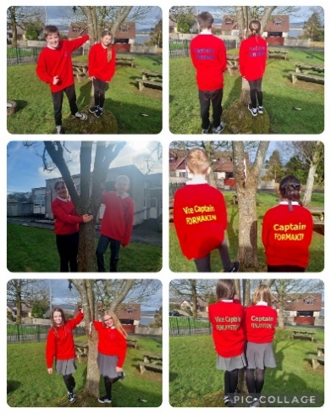 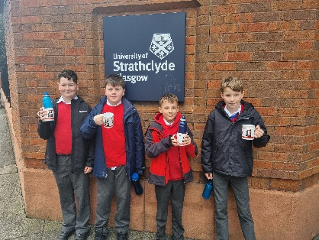 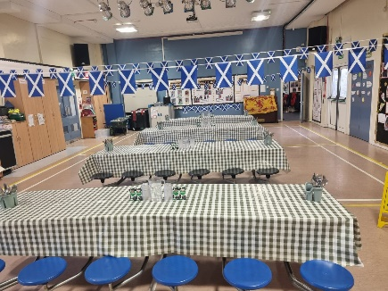

|  |
| --- |
| KEY STRENGTHS OF THE SCHOOL   * A strong commitment and enthusiasm from everyone in the school community towards the principle of Getting It Right for Every Child. * Consistently high expectations across the school community to achieve the highest levels of attainment and achievement. * Children who are motivated and are eager to succeed. * Positive and enthusiastic relationships between children and staff, fostering a supportive and inclusive school environment. * Significant progress in creating a nurturing and caring atmosphere where every child and their family feel valued and supported. * A school vision, values, and aims that are fully embraced and authentically reflect the identity of the school community. * A dedicated and supportive staff team that consistently goes above and beyond, actively developing their professional skills and sharing leadership to meet the diverse needs of our children. * Strong, positive partnerships with parents, who play a vital role in their child’s educational journey. * Excellent collaboration with external agencies, ensuring comprehensive support for the educational and emotional wellbeing of our whole school community. * At Langbank Primary School we are proud of our children’s very high levels of attainment, achieved through a rich curriculum, excellent teaching and our strong school – home partnership. |

|  |  |
| --- | --- |
| OUR NEXT STEPS – PRIORITIES FOR 2025-26  We have made very good progress during session 2024-25 and we will use the improvement priorities listed below to build on this progress moving forward.   * The Park Mains Cluster will continue our focus on developing and embedding the six key skills. Each school lead practitioner will develop a skills overview and progression pathway to be shared with all teaching staff. Further collaborative work will take place in stage groups to share good practice and provide feedback through peer observations. * The cluster will engage in focused discussions on current approaches to teaching and assessing reading comprehension. Through these collaborative discussions and ongoing tracking meetings, staff will share and review a variety of assessment information. This collective reflection will help to enhance the accuracy and consistency of professional judgments regarding pupil progress. * A whole-school approach to enhancing pupil voice focuses on actively involving children in setting personalised targets for Literacy, Numeracy, and Health and Wellbeing. Additionally, we are expanding opportunities for pupil voice through increased outdoor learning and play, ensuring their voices help shape both their learning goals and experiences. * A key priority for the school is to engage with the STEM Nation programme to support a whole-school approach to improving STEM learning and teaching through professional collaboration, leadership development, and curriculum improvement.   Full details of the school’s improvement priorities and actions are detailed on the school improvement plan which can be accessed on our website or by contacting the school office. | |
| **Langbank Primary School**  **Dennistoun Road, Langbank PA14 6XH**  **Phone 0300 300 0165**  **Website https://blogs.glowscotland.org.uk/re/langbankprimary**  **BlueSky @LangbankPrimary.bsky.social** | **HAVE YOUR SAY!**  Please take the opportunity to share your thoughts with us as we use feedback to help us make improvements to the school. You can do this by speaking to staff, participating in Parent Council meetings, responding to questionnaires/surveys and by completing evaluations at school events. |