Meeting Minutes
October 8, 2020, 19:30
via Google Meet

Present:
- Committee: Claire Lyle, Lindsey Reid, Nick Sharpe, Lynne Moore, Karen Rodger, Kirsty Huddleston
- School: Michelle Ferguson, Carmen Coleman
- Parents: Julie Gilmour, Carly Deheer, Jacqueline Docherty
- Apologies: Jayne Lasley, Susan McGarrigle, Caroline Mullan, Lisa McFadden

AGM
Committee indicated they would serve another year, with no opposition raised to this:
- Committee
  - Claire Lyle, Chair
  - Lindsey Reid, Treasurer
  - Nick Sharpe, Secretary
- Fundraising Committee:
  - Karen Rodger
  - Lynne Moore
  - Lisa McFadden
  - Natalie Donald
- Education Liaison
  - Kirsty Huddleston

Treasurer’s report
- Lindsey Reid advised that the current bank balance is £ 1867.89.
- £497.32 was raised by the Dance-a-thon, for which the Committee thanked Karen Rodger.
- The Treasurer’s report is provided as an annex.

Items noted
- It was noted that the AGM should take place in August. Due to the COVID-19 pandemic this was not possible.
- It was noted that minutes of Parent Council Liaison Meetings will now be shared more widely with parents by Kirsty Huddleston or a substitute.

Previous meeting
Minutes of the LPP meeting held on February 20, 2020, were approved.

Headteacher’s report
- The school is keen to do more outdoor learning. Monies raised from the Dance-a-thon will support improvements which are to be made.
- Funding has been received through the Edina Trust Bulb Project which will allow children to plant two bulbs as part of an ongoing project.
- Money has also been received from the Edina Trust for science training for teachers and for science equipment, and two of the three required training sessions have already taken place.
- Maths Week, held w/c Sept 28, was a success, with much positive feedback received from the children. Thanks go to Mrs Coleman for her planning of this event.
- The children will be producing Christmas cards which will go to local care homes as part of a connection with the I Am Me charity.
- The Head has had to restrict access to the library because of COVID-19 but wants to do more with this resource in future.
- Halloween: Children are encouraged to dress up for Halloween and will be having parties within their own classrooms, but will not be able to bring props (broomsticks etc) due to COVID-19 restrictions. LPP agreed to provide funding for treats for children at this event.
- Christmas plans are still uncertain.
- COVID-19 issues:
  - Risk assessments are being updated frequently as things change.
  - Children and in separate playgrounds and having staggered breaks and lunches.
  - Staggered entry and exit times have been removed to counter increased risk of parents spending time in the road outside the school while waiting to collect children who may be in different years.
  - Children are now eating in the canteen
  - The relaxed uniform is helping with outdoor learning, and it is hoped this can be continued into winter
  - The janitor is being paid for extra hours and is carrying out enhanced cleaning.

Fundraising
- Events which have been able to proceed despite COVID-19 include a Valentine’s Day disco and a dance-a-thon which was held in school in October.
- The LPP Fundraising Committee will meet again before Christmas to discuss fundraising options.

Finlaystone pass
- Lynne Moore suggested that the school could purchase a pass for Finlaystone so children could visit in class groups.
- The headteacher agreed to seek advice on this.
- Claire Lyle offered to ask Finlaystone about prices for this.

Parking
- Issues with parents parking on yellow zigzags seem to have abated.
- The Pupil Council has launched a competition to design a poster to encourage safer parking.
- It is Road Safety Week soon and messages around safer parking will be transmitted then too.

School dinners
- The school is currently receiving cooked meals from Bishopton. This situation will remain in place, but is hoped to be temporary.

City Mission
- Julie Gilmour suggested a food bank collection on behalf of Glasgow City Mission be reinstated.
- The Head said she would ask the House Captains to take this on and donation details would be circulated in a school newsletter at the end of October.

Next meeting
- Thursday November 19, 1930, via Google Meet. Email langbankpp@gmail.com to join.

Annex – Treasurer’s report

Treasurers Report
For the year ended 30 June 2020

Events organised by the LPP last year raised a net toal of £815.96 and included:

£

Toast | 12/30/2019 | - | 22.00-
Christmas disco | 12/30/2019 | - | 292.46-
Valentines disco | 3/3/2020 | - | 389.50-
Toast | 6/1/2020 | - | 60.00-
Toast | 6/30/2020 | - | 52.00-

- 815.96-

During the year the money raised paid for the following :
 |  |  | £
Mr Cundy leaving gift | 12/12/2019 |  | - 50.00-
Annual insurance | 3/18/2020 |  | - 89.00-
Mrs Cloudsley leaving gift | 6/28/2020 |  | - 50.00-
Donation to Primary 7 leavers prom | 6/30/2020 |  | - 200.00-
 |  |  | - 389.00-
Reconciliation
Opening 1-Jul-19 |  |  | - 943.61-
Income |  | - 815.96-
Expenditure  Closing 30-Jun-20 |  | - 389.00- | - 1,370.57-
Balance per bank statement as at 30/06/20 | - 1,349.57-
Cash float | - 21.00-
 | - 1,370.57-
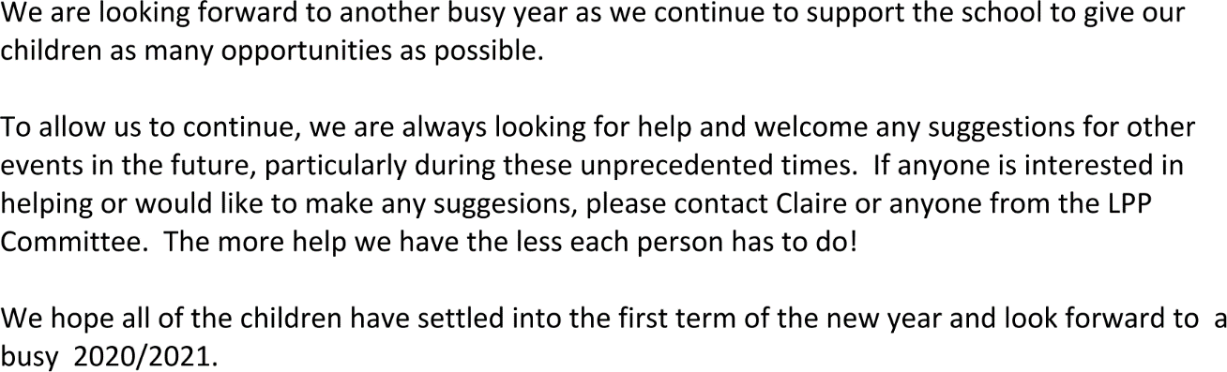

Lindsey Reid
Treasurer 10/8/2020

