Primary 1 Newsletter
September 2019

Busy, busy, busy!
We have been really busy so far this term. We have been learning lots of letter sounds and actions and are now beginning to put these sounds together to start reading simple words. We have also been looking at numbers 0-10, we can recognise numbers and are beginning to write them independently.
Mouse skills | Important Dates
We are fortunate to have access to desktop computers both in the class and resource area. Unfortunately many children are finding it difficult to use the computer mouse. If you have access to a mouse at home it would be beneficial if you could allow your child opportunities to use it. A good website to support mouse skill is https://tvokids.com/preschool/games/bees-and-honey | Monday 9th-Friday 19th September – individual parent ‘Play and Learn’ sessions  Friday 27th/Monday 30th September -September weekend holiday
Class topics | Pencil Control
This session the children will be involved in devising and planning their class topic. This month they would like to learn about aeroplanes and helicopters. We will be following the children’s lead and seeing where the topic takes us ...watch this space. | Using the correct pencil grip is vitally important to your child’s muscle development and writing success. Please encourage your child to hold their pencil correctly at all times. We use the following language in class; hold the pencil in your pincey fingers, support the pencil with the middle finger and tuck the ring and pinky fingers away. Rest you hand on the table and hold the paper with your other hand.  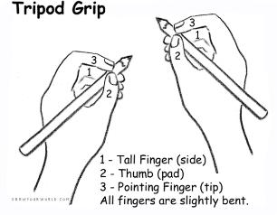
Homework | This month we are look for...
Your child has been given a word wallet containing individual sounds. Words will also be added to the wallet over the coming weeks. Please practise these as often as possible, little and often will best support your child’s learning.  Topmarks is a useful website that has a wide range of activities to support learning in both literacy and numeracy. | - Dressing up items, scarves, material, hats, jewellery, belts, bags etc  - Any items linked to aircrafts, helicopters, aeroplanes, playsets, clothing, small luggage items, tickets, documents.  - Old telephones, computer keyboards, headphones.

