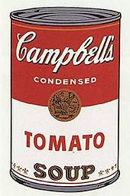
S1 Influential Artists- Andy Warhol
Andy Warhol was a successful American magazine and ad illustrator who became a leading artist of the 1960s Pop art movements. He ventured into a wide variety of art forms, includingPainting, printmaking, performance art, filmmaking, video installations and writing. He is famous for showing everyday sometimes throw away items as being important and of using mass media as part of his art. Some of his best known works include the silkscreen paintings Campbell's Soup Cans (1962) and Marilyn Diptych (1962),

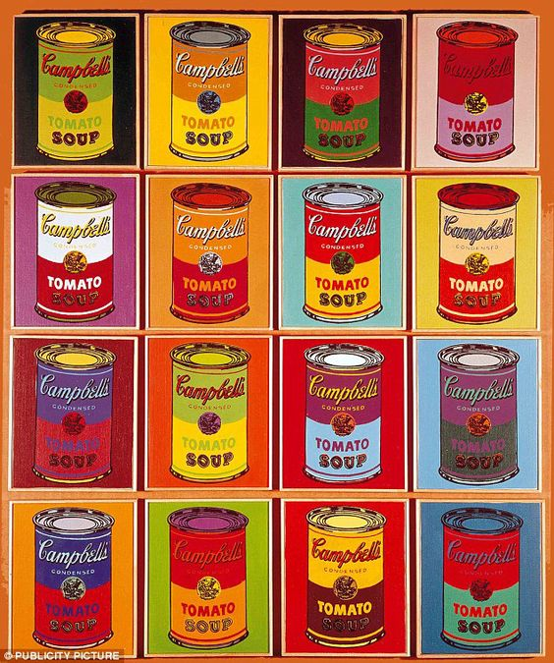TASK
- Find an everyday household product such as a food packet or cleaning product ( something throw-away)
- Create a grid of at least 6 squares on a sheet of paper (more if you want to)
- Sketch a simple drawing of the object on scrap and outline in dark felt pen
- Trace and repeat the dark outline into your 6 or more squares
- Create variations of the object using different colours like Warhols soup cans (right)

Note- felt pens work really well here but pencils will work too!

