Van Gogh Landscape
Vincent Van Gogh- is one of the most famous artists who ever lived. He had a troubled life but painted throughout it. He is best known for his sunflower paintings in bright swirling lines and dashes and this one called Starry Night.
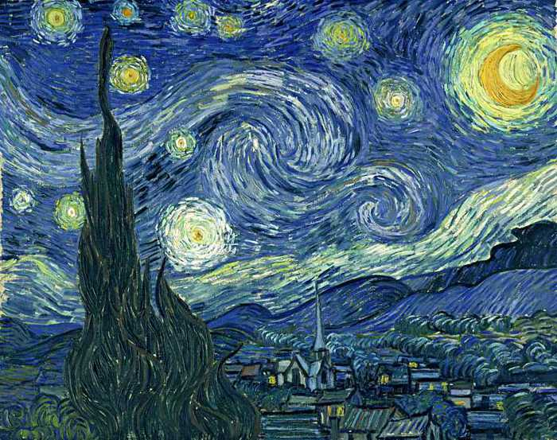

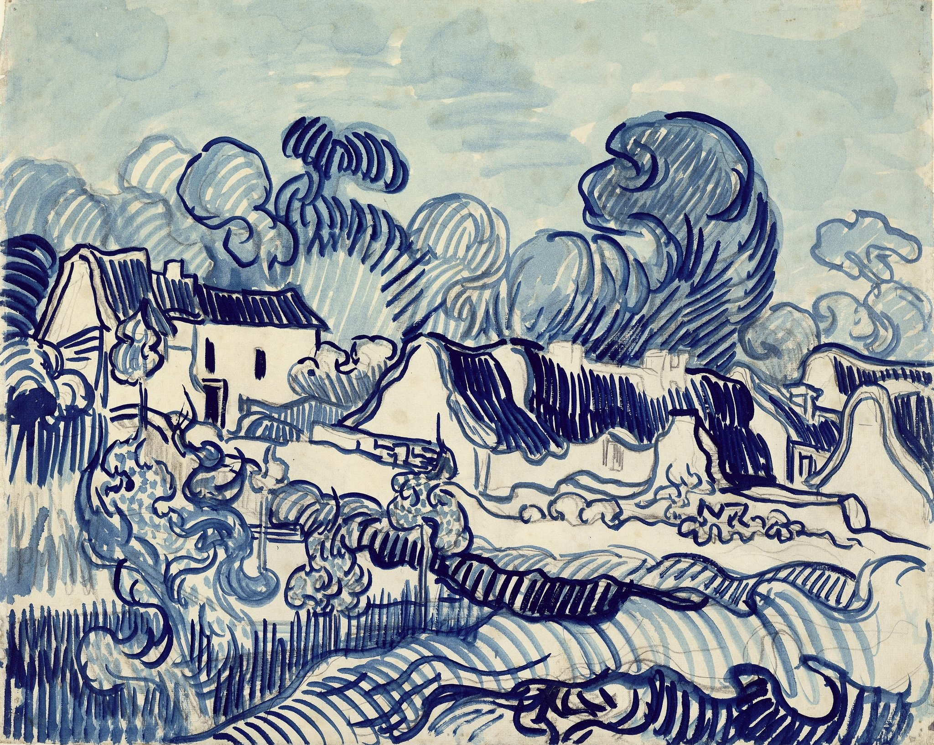
Task
Create a simple line drawing of a landscape or view from a window. If you can get a more distant view all the better. You may even have one on your phone gallery already. Draw in the main lines in dark pen and then add repeating lines in pencil going ever outward till you hit the next pen line…like ripples on the water.
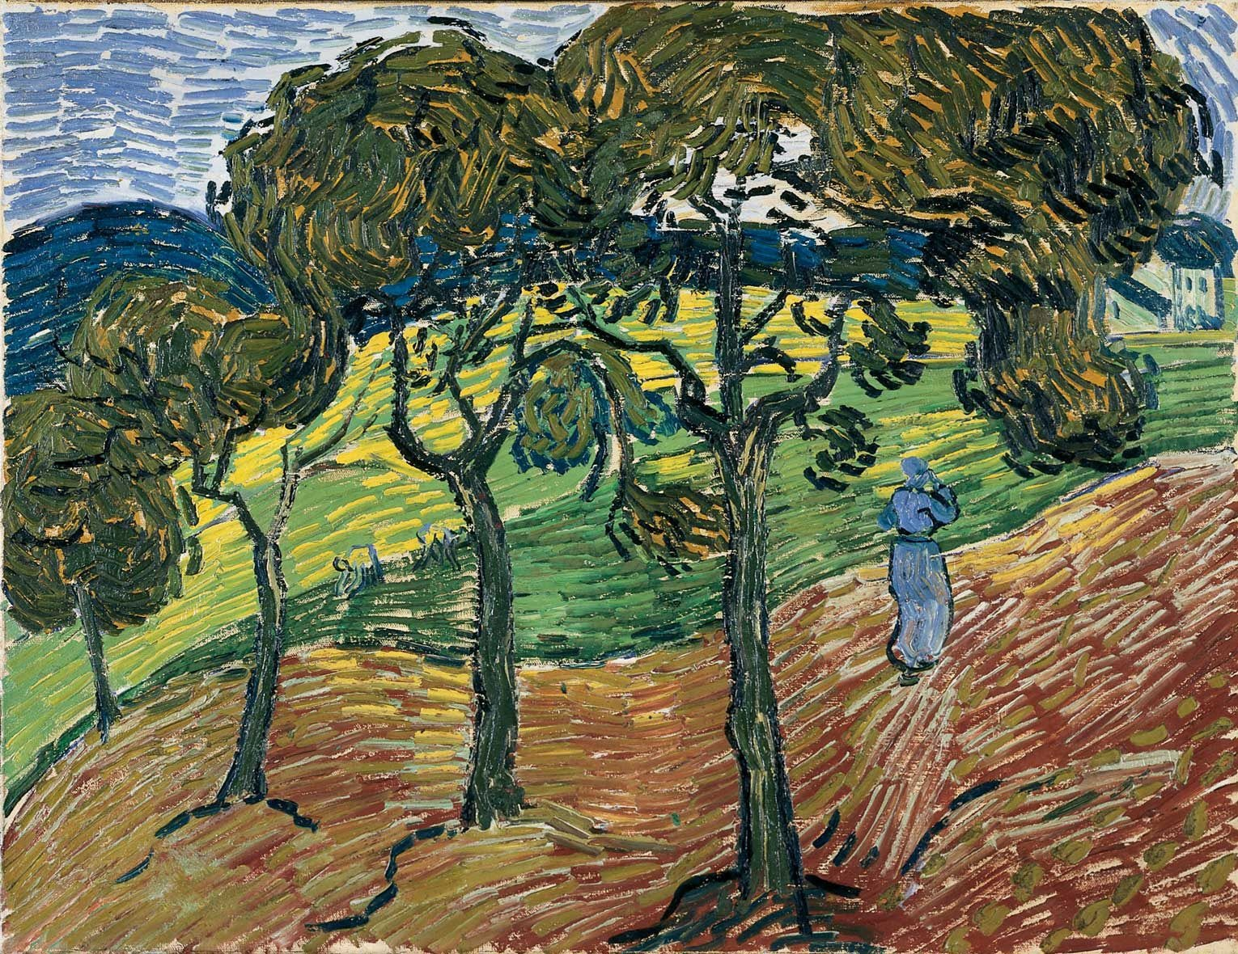Check out this link to show you how to build up the pattern and rhythm in your landscape with line
https://www.youtube.com/watch?v=LsQr9_5XnI0

