Roy Lichtenstein was a pop artist working in the 1950’s and 60’s. He is famous for using words, text and bright colour in his work and simplifying scenes as if they were in a comic.
Below are a series of interior house images he created.
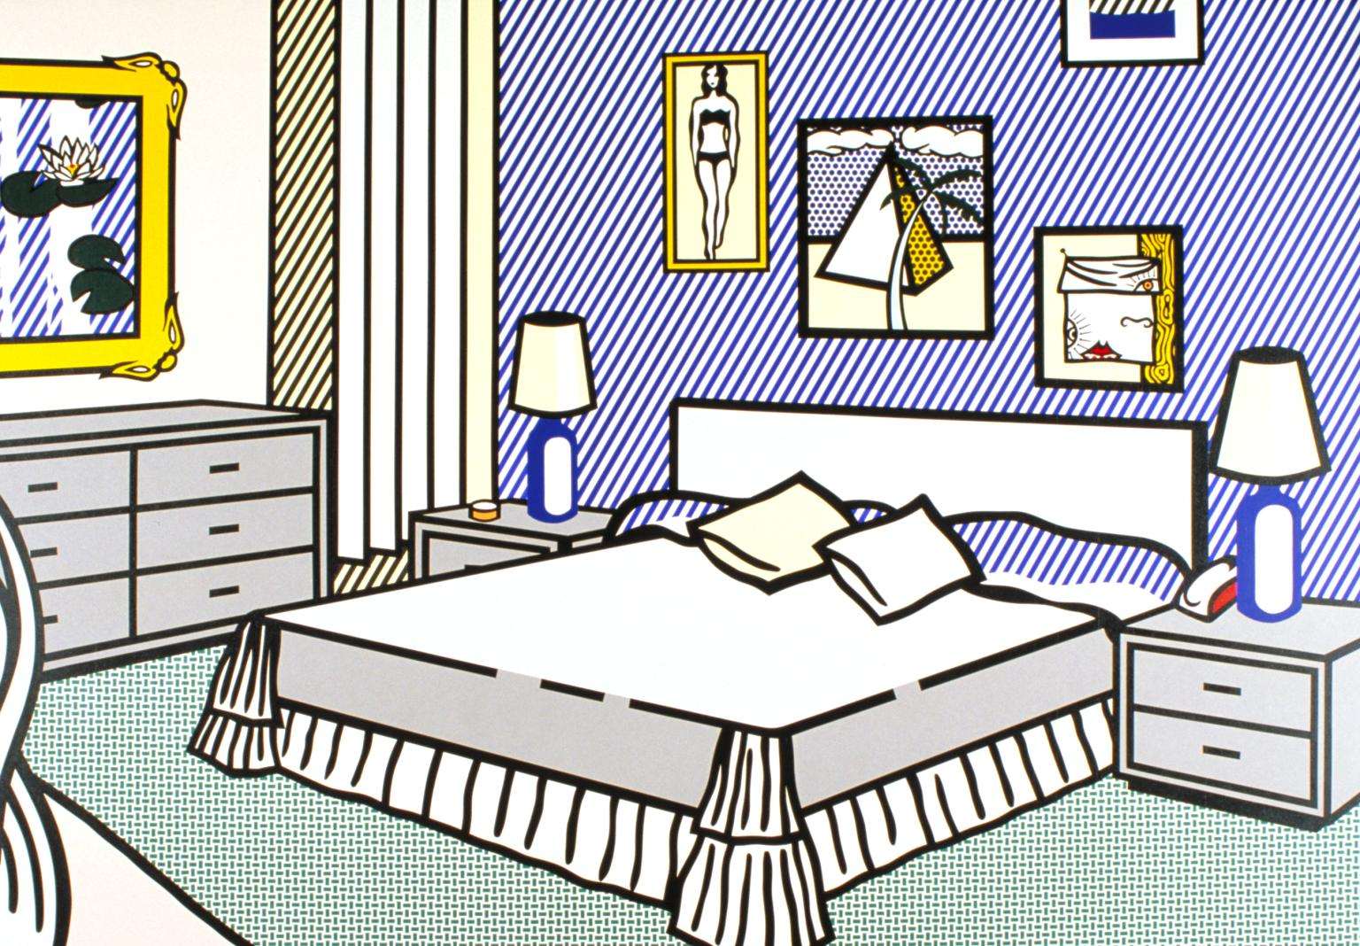Look at them carefully and follow the instructions to create a Lichtenstein Pop Art style drawing of a room in your house
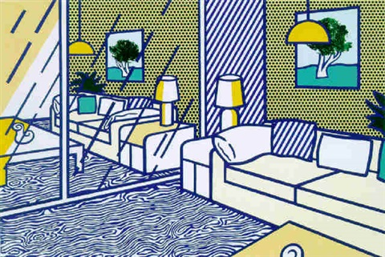
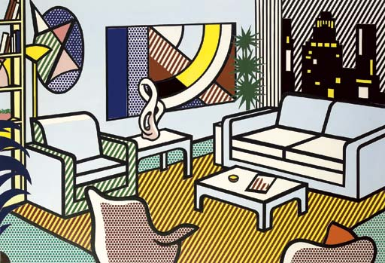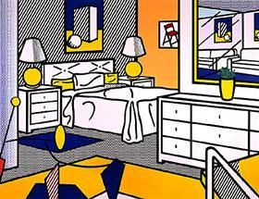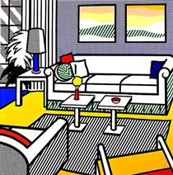
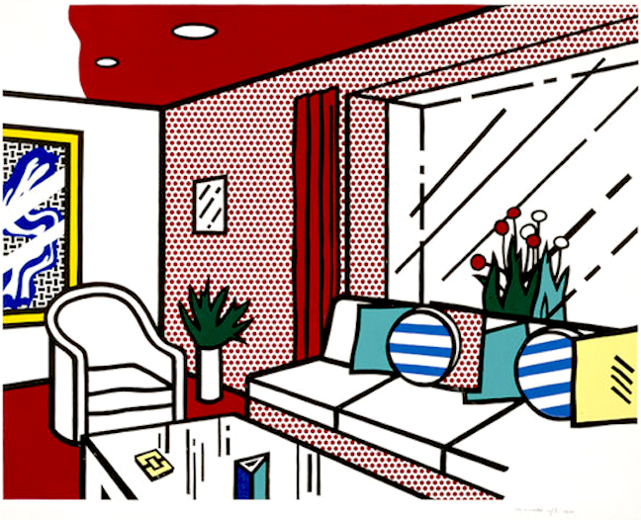
- Sketch the very basic lines of the room of your choice. Start with the walls, ceiling and floor
- Add in the furniture…You can try to get some perspective drawing into it if you can but don’t worry too much about how accurate the sketch is.
- When you are happy go over the outline in black pen making the objects bold. Go round furniture, cushions etc.
- Next fill in some areas with a tight dot pattern or stripe in any colour, pens or pencils will work well and use a ruler to keep your dots or fine stripes precise and evenly spaced.
- Some areas can be a filled with a block colour now
- Next, leave some areas the white of the paper
- If there is a window or a mirror put in a few steak lines to show simple ‘shine’ like Lichtenstein

Send via SMH or gw07mcgregoreuan@glow.sch.uk

